**Order to Cash**

**Reports:**

**To Get Report on Customer Statement**

**To Get Report**

1. You have to select a Customer name from list of Customers.

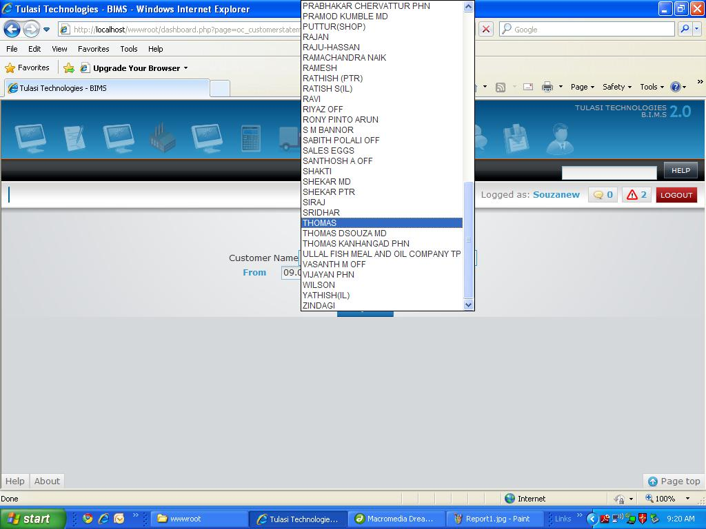

1. Pick *From*date with the help of calendar.

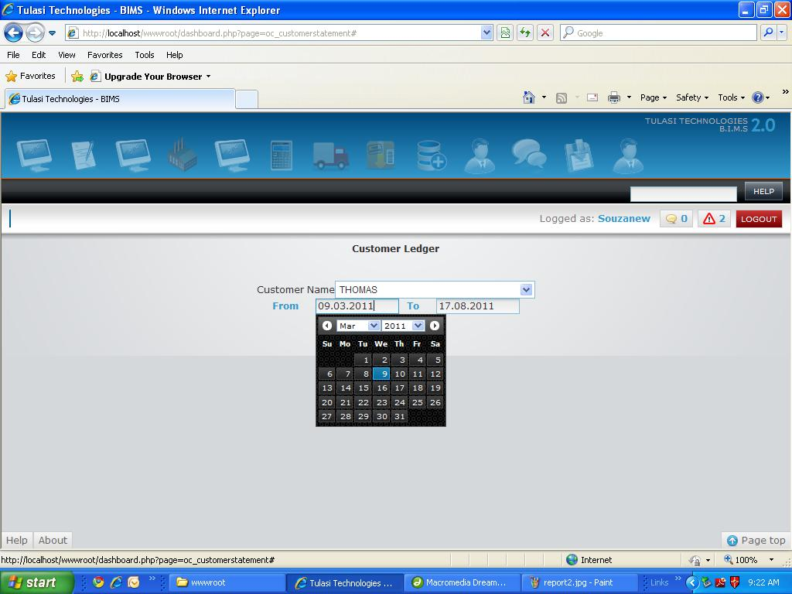

1. Pick *To*date with the help of calendar.

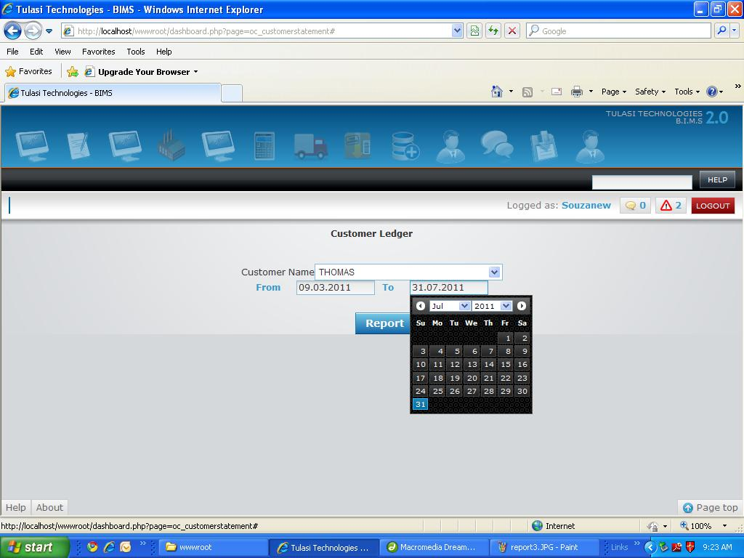

1. Now Click on *Report*to generate report.
2. Here is the report with all details *Document No*,*Document Type*,*Original Amount* ,*Adjusted Amount* and *Balance*

**To Get Report on Customer Ledger**

**To Get Report**

1. You have to select a Customer name from list of Customers.



1. Pick *From*date with the help of calendar.



1. Pick *To*date with the help of calendar.



1. Now Click on *Report*to generate report.
2. Here is the report with all details *Document No.*, *Document Type*, *Mode Of Receipt/Payment*, *Instrument No*, *Description/Narration*and *Balance*

**To Get Report on Ageing Analysis**

**To Get Report**

1. You have to select a Customer/Supplier name from list of Customers.

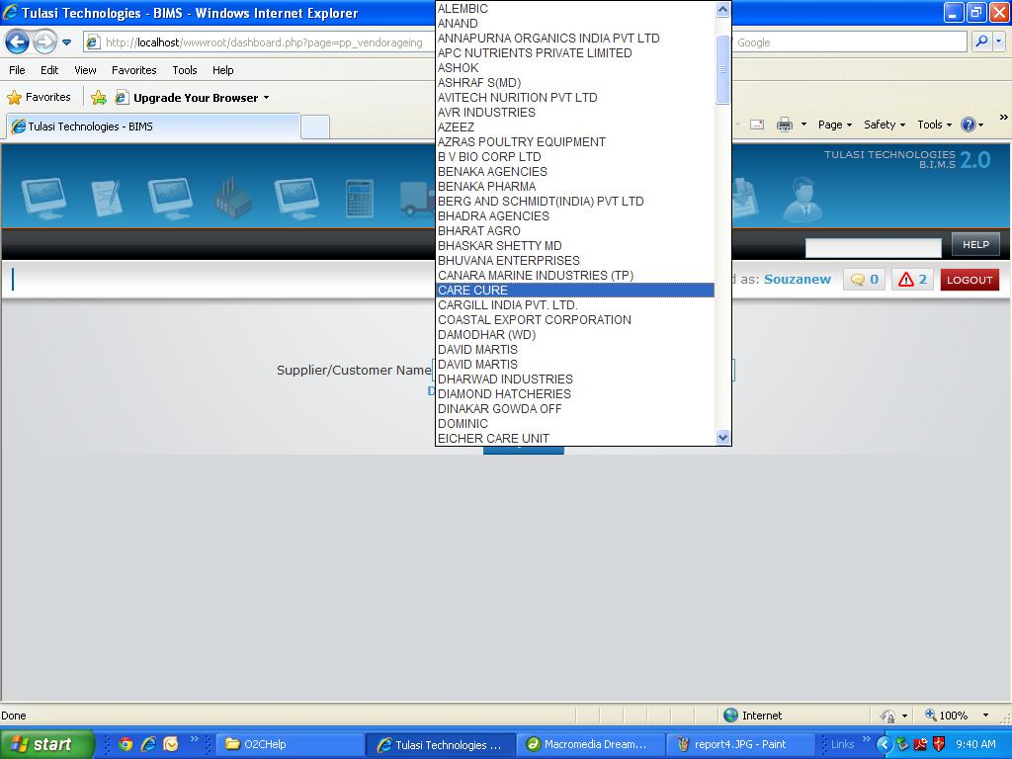

1. Pick *Date*with the help of calendar.

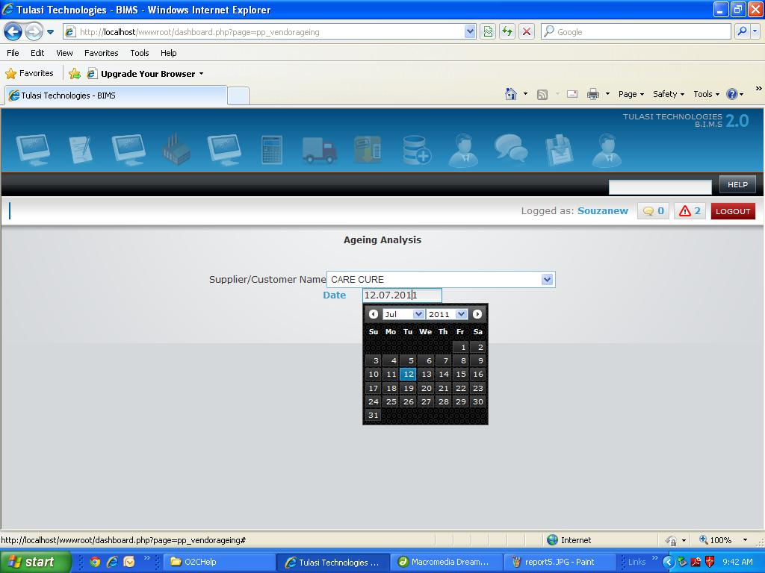

1. Now Click on *Report*to generate report.
2. Here is the report with all details *Supplier Name Date*, *Invoice No.*, *0 To 30 Days*, *31 To 60 Days*, *61 To 90 Days*, *91 To 120 Days*, *121 To 150 Days*, *151 To 180 Days*, *181 Days And More* and *Grand Total.*