**Procure to Pay**

**Masters:**

**Create Supplier**

1. You have to enter the values "Name", "Address", "Place", "Phone", "Mobile", "TAX NUMBER" and "Note".
2. Select the values for "Contact Type" and "Supplier Group" from dropdowns.  
   **Eg:** If suppose the Name of Supplier is "Obafemi Trading Co.", Address is "Lagos", Phone Number is "08042111111", Mobile Number is "09010203040", Contact Type is "Vendor" and Supplier Group is "00458" you have to enter *Obafemi Trading Co.* for "NAME”, *Lagos* for "ADDRESS",*08042111111* for "PHONE" and *09010203040* for "MOBILE".  
   Now select *Vendor* for "CONTACT TYPE" and *00458* for "SUPPLIER GROUP”.

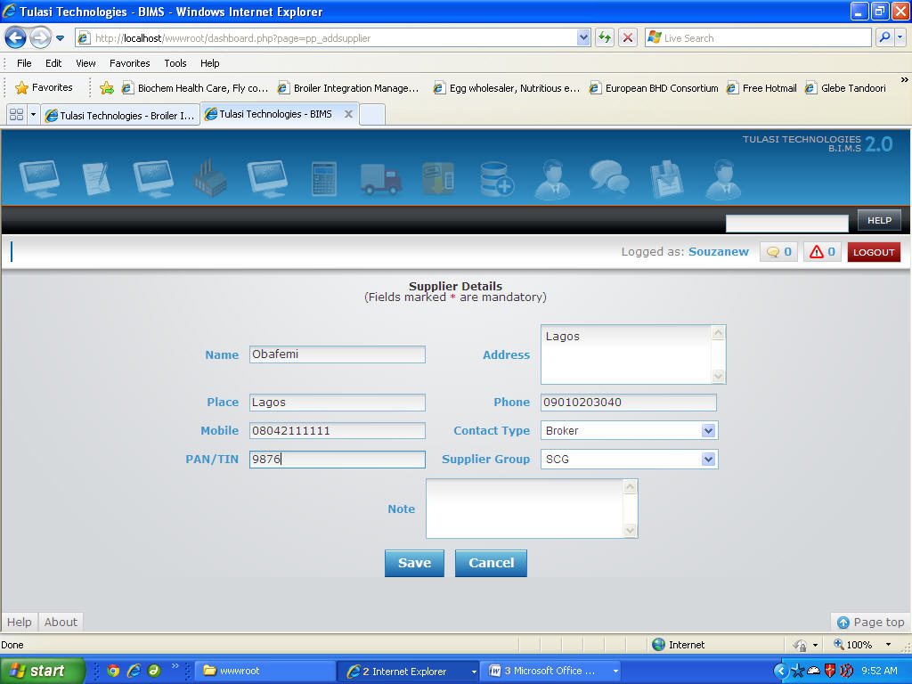

1. Once filled click on 'SAVE' button to save or 'CANCEL' to exit.

**Add New Tax Master**

1. You have to enter the values of "Tax Code" and "Description"
2. You have to select the value of "Deductions”, if it is "Charges" you have to select the value of "Charge Type" also.
3. Now select the value for "Rule", if it is "Exclude" you have to select the value of "CoA".
4. Select either "Formula" or "Flat" by selecting the appropriate radio button and enter the values of "Tax Code Value" and "Formula ".  
   **Eg :**Suppose Tax Code is "tax001", Description is "taxcode001", Deductions is "Charges", Charge Type is "Brokerage", Rule is "Exclude", CoA is "IT401", Tax Code Value is "1.5" and Formula is "A+(A * tax001/100)" then,  
   you have to enter *tax001* for "Tax Code", *taxcode001* for "Description", select *Charges* for "Deductions", *Brokerage* for "Charge Type", *Exclude* for "Rule", *IT401* for "CoA".  
   Now enter *1.5* for "Tax Code Value" and *"A+ (A * tax001/100)* for "Formula".

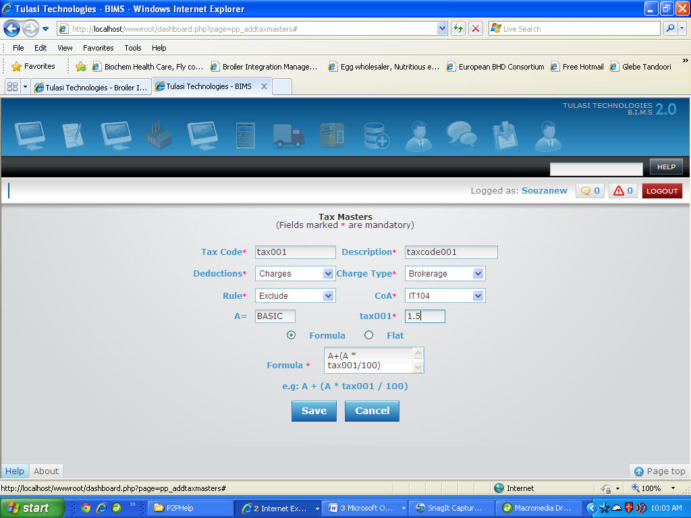

1. Once filled click on 'SAVE' button to save the Tax Master or 'CANCEL' to exit without saving.

**Add New Vendor Group Mapping**

1. You have to enter the values for "Vendor Group Code", "Vendor Group Description" and "Currency ".
2. Select the values for "Vendor Controll A/C" and "Vendor Prepayment A/C" from dropdowns.  
   **Eg:** If suppose the Vendor Group Code is "00345", Vendor Group Description is "State Vendors Group", Currency is "Rs", Vendor Controll A/C is "VA505" and Vendor Prepayment A/C is "VP500" you have to enter *00345* for "Vendor Group Code”, *State Vendors Group* for "Vendor Group Description" and *Rs* for "Currency".  
   Now select *VA505* for "Vendor Controll A/C" and *VP500* for "Vendor Prepayment A/C”.
3. Once filled click on 'SAVE' button to save or 'CANCEL' to exit.

**NOTE:**If there are no values displayed in the "Vendor Controll A/C" or "Vendor Prepayment A/C" dropdown lists or to New "Vendor Controll A/C" or "Vendor Prepayment A/C" you have to create add them using the **Chart of Accounts** available in **Masters Section** of **ACCOUNTS**.

**Transactions**:

**Add New Direct Purchase**

1. You have to select the "Date" of the Purchase, "Vendor", and enter the value of "Book Invoice"(if not available make it "0"(Zero)).  
   The "Invoice" value will be generated automatically based on which Payments will be made

**Eg:** If suppose for the Invoice "SOBI-0111-0020", Purchase Date is "05.01.2011" and Vendor is "ALTECH" you have to select *05.01.2011* for "Date" and *ALTECH* for "Vendor".  
Note that the Invoice Number *SOBI-0111-0020* will be generated automatically.

1. You can select "Category" and "Code".  
   As and when the "Code" value is selected the "Description" and "Units" of the selected item will be displayed automatically.
2. Now enter the "Quantity Sent"(By Vendor), "Quantity Received", (No of)"Bags" and "Price/Unit".
3. Select the values for "Type"(of Bags) and "VAT"(“None" if no VAT).  
   The "Basic Amount" will be calculated based on the "Quantity Received" and "VAT" and displayed in the appropriate box given.  
   Suppose to enter a purchase with Category "Birds", Code is "BRD101", Description is "BIRDS", Units is "Numbers", Quantity Sent is "100", Qty Received" is "99", NO of Bags is "2", Type of Bags is "GBS101", Price/Unit is "12" and VAT is "None"   
   You have to select *Birds* for "Category", *BRD101* for "Code", *GBS101* for "Bags" and *None* for "VAT".  
   As and when the "Code" value is selected the *BIRDS* for "Description" and *Numbers* for "Units" will be displayed automatically.  
   Now enter *100* for "Qty Sent", *99* for "Qty Received" and *2* for "Bags". NOte that now the Basic Amount is *1188*.
4. Repeat the steps 2 to 6 until the information of all Purchased items is filled.
5. To enter the Discount in % select "%" Radio button or if you want to enter the Discount Amount select the "Amt" Radio button and enter the appropriate "Discount" value in appropriate input box provided.  
   The "Total Price" will be calculated automatically based on the "Discount" and the "Basic Price".  
   Suppose Discount Amount is "38" you have to select *Amt* radio button and enter *38* for "Amount". Now the Total Price is displayed as *1150*.
6. Enter values for "Vehicle No.", "Driver Name" and select appropriate value for "Broker Name" from the dropdown provided.  
   Let Broker Name is "Ehigha", Vehicle Number is "KA 54X 1234" and Driver Name is "Obafemi" then you have to enter *KA 54X 1234* for "Vehicle No", *Obafemi* for "Driver Name" and select *Ehigha* for "Broker Name".
7. Select value for "Frieght" as Included (in the Price/Unit) or Excluded, Account Code and enter "Frieght Amount".  
   Based on "Total Price" and "Frieght Amount" the value of "Grand Total" will be calculated.
8. You have to select the Payment Mode for Frieght from dropdown named "Via" such as CASH, CHEQUE or OTHERS.  
   If it is CASH you have to select "Cash Code" and value for "Dated"  
   If it is CHEQUE you have to select values for "Bank A/C No", "Dated" and enter value for "Cheque"(Cheque Number).  
   Suppose Frieght is "Included", Frieght Amount is "30", A/C code is "IE108", Payment is Via "Cash", Cash Code is "CIH", Date is "06.01.2011" then   
   you have to select *Included* for "Frieght", *IE108* for "A/C Code", *Cash* for "Via", *CIH* for "Cash Code", *06.01.2011* for "Dated" and enter *30* for "Frieght Amount". The "grand Total" now is *1120*.
9. Once filled click on 'SAVE' button to save the Direct Purchase or 'CANCEL' to exit without saving.

**Processing:**

**Add New Purchase Return**

1. You have to select the values for "Vendor Name", "SOBI" and "Date".  
   As and when the value of SOBI is selected the details such as "Item Code", "Description", "Purchased Quantity" and "Amount" will be displayed automatically.
2. Now enter the value of "Returned Quantity" and select value for "Goods Status" for all the purchased items.  
   **Eg:** If suppose you want to enter the Returned Quantity(which you want to remove from stock) of "10" to Item Code "BROC101" for SOBI "SOBI-0611-0015" of Vendor "SRI SAI" on "15th June, 2011"   
   you have to select *SRI SAI* for "Vendor", *SOBI-0611-0015* for "SOBI", *15.06.2011* for "Date".  
   Now enter *10* for "Returned Quantity"(of item code BROC101) and select *Remove From Stock* for "Goods Status".
3. Once filled click on "SAVE" button to save purchase return or "CANCEL" button to exit without saving the purchase return.

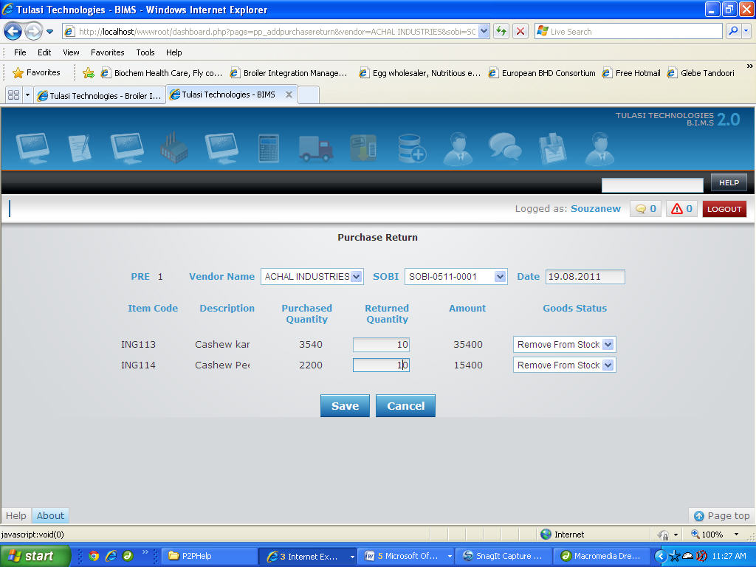

**Add New Payment**

1. Select the "Date" of Payment, "Vendor", "Payment Method" and "TDS".
2. If the selected value of "Payment Method" is "Pre Payment",

Select the value for "Choice" as either "POs" or "ON A/C".

If the selected value of "Choice" is "POs" you have select the value for "PO" and enter the value for "Amount Paid".

OR  
If the selected value of "Payment Method" is "Payment",

Select the value for "Choice" as "SOBIs" or "Credit Notes" or "ON A/C".

If the selected value of "Choice" is "SOBIs" you have select the value for "SOBI" and enter the value for "Amount Paid".

1. Select values for "Payment Mode".
2. If the selected value for "Payment Mode" is CASH

You have to select the value for "Cash Code".

As and when the Cash Code value is selected the "Code" and "Description" values will be displayed automatically.

Now you have to enter the value of "Amount".

OR  
If the selected value for "Payment Mode" is CHEQUE

You have to select the value for "Bank A/C No".

As and when the Bank A/C No. value is selected the "Code" and "Description" values will be displayed automatically.

Now you have to enter the value of "Amount", "Cheque #" and "Cheque Date".

1. Now enter "Amount", "Cheque #" and "Cheque Date".
2. If the selected value of "TDS" is WITH TDS,

You have to select the value for "Code" and enter the value for "Amount" until the values for all the Payments are filled.  
**Eg :**Suppose the payment Date is "06 Jan, 2011", Vendor is "Obafemi", Payment Method is "Payment", TDS is "Without TDS", Choice is "SOBIs", Payment Mode is "Cash", Cash Code is "CIH", Code is "AS111", Description is "1.CASH", Amount is "5000" SOBI is "SOBI-0111-0020" and Amount Paid is "4000",  
you have to select *06.01.2011* for "Date", *Obafemi* for "Vendor", *Payment* for "Payment Method", *Without TDS* for "TDS", *SOBIs* for "Choice", *Cash* for "Payment Mode", *CIH* for "Cash Code". As and when the Cash Code value is selected the value of "Code" will be displayed as *AS111* and "Description" is displayed as *1.CASH*.  
Now enter *4000* for "Amount", select *SOBI-0111-0020* for "SOBI" and enter *4000* for "Amount Paid".

1. Once filled click "PAY" button to Save the Payment or click "CANCEL" button to exit without Saving the Payment.

**Add New Receipt**

1. Select the "Date" of Receipt, "Vendor", "Receipt Method", "TDS", "Choice" and "Receipt Mode".
2. If the selected value for "Receipt Mode" is CASH

You have to select the value for "Cash Code".

As and when the Cash Code value is selected the "Code" and "Description" values will be displayed automatically.

Now you have to enter the value of "Amount".

OR  
If the selected value for "Receipt Mode" is CHEQUE

You have to select the value for "Bank A/C No".

As and when the Bank A/C No. value is selected the "Code" and "Description" values will be displayed automatically.

Now you have to enter the value of "Amount", "Cheque #" and "Cheque Date".

1. If the selected value of "TDS" is WITH TDS,

You have to select the value for "Code" and enter the value for "Amount" until the values for all the Receipts are filled.  
**Eg :**Suppose the Receipt Date is "06 Jan, 2011", Vendor is "Obafemi", Receipt Method is "Receipt", TDS is "Without TDS", Choice is "On A/C", Receipt Mode is "Cash", Cash Code is "CIH", Code is "AS111", Description is "1.CASH", Amount is "5000" then,  
you have to select *06.01.2011* for "Date", *Obafemi* for "Vendor", *Receipt* for "Receipt Method", *Without TDS* for "TDS", *SOBIs* for "Choice", *Cash* for "Receipt Mode", *CIH* for "Cash Code". As and when the Cash Code value is selected the value of "Code" will be displayed as *AS111* and "Description" is displayed as *1.CASH*.  
Now enter *4000* for "Amount"

1. Once filled click "PAY" button to Save the Receipt or click "CANCEL" button to exit without Saving the Receipt.

**Add New Credit Note**

1. You have to select the values of "Date", "Vendor" and enter "Amount"(Credit Amount = Total of Dr. - Total of Cr.).  
   **Eg :**Suppose Date is "31 Dec, 2010" , Vendor is "Obafemi Trading Co." and Amount is "100" you have to select *31.12.2010* for "Date", *Obafemi Trading Co.* for "Vendor" and enter *100* for "Amount".
2. Now select the values for "Code", "Cr/Dr" and enter the value of "Cr" or "Dr" depending on the select value of "Cr/Dr".
3. Repeat the above step any number of times you want (Until all the entries are filled).  
   **Eg:** If suppose you want to enter 2 entries with code "00104" with Cr value of "400" and Code "00502" with Dr value of "500" respectively.  
   You have to select *00104* for "Code", *Cr* for "Dr/Cr" and *400* for "Cr" for the first entry and   
   select *00502* for "Code", *Dr* for "Dr/Cr" and *500* for "Dr" for second entry.
4. You can enter "Narration" in the Textbox provided.
5. Once filled click on 'SAVE' button to save the Credit Note or 'CANCEL' to exit without saving.

**NOTE:**You can Save the Credit Note only when the value of Total of Dr. - Total of Cr. = Amount.

**Add New Debit Note**

1. You have to select the values of "Date", "Vendor" and enter "Amount"(Debit Amount = Total of Cr. - Total of Dr.).  
   **Eg :**Suppose Date is "31 Dec, 2010" , Vendor is "Obafemi Trading Co." and Amount is "100" you have to select *31.12.2010* for "Date", *Obafemi Trading Co.* for "Vendor" and enter *100* for "Amount".
2. Now select the values for "Code", "Cr/Dr" and enter the value of "Cr" or "Dr" depending on the select value of "Cr/Dr".
3. Repeat the above step any number of times you want (Until all the entries are filled).

**Eg:** If suppose you want to enter 2 entries with code "00104" with Cr value of "500" and Code "00502" with Dr value of "400" respectively.  
You have to select *00104* for "Code", *Cr* for "Dr/Cr" and *500* for "Cr" for the first entry and   
select *00502* for "Code", *Dr* for "Dr/Cr" and *400* for "Dr" for second entry.

1. You can enter "Narration" in the Textbox provided.
2. Once filled click on 'SAVE' button to save the Debit Note or 'CANCEL' to exit without saving the Debit Note.

**NOTE:**You can Save the Debit Note only when the value of Total of Cr. - Total of Dr. = Amount.