**VEHICLE MANAGEMENT**

**Masters:**

**Add Vehicle Type**

**To Add New Vehicle Type**

1. Enter the Vehicle Type.  
   **Eg :** Suppose the Vehicle Type is "Truck".  
   You have to enter *Truck* for "Vehicle Type.  
     
   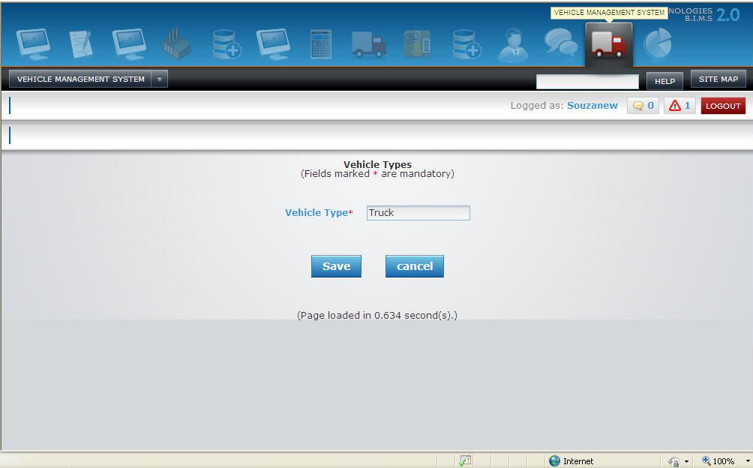
2. Once filled click on 'SAVE' button to save the Vehicle Type or 'CANCEL' to exit without saving the Vehicle Type.

**Add Vehicle Masters**

**To Vehicle Masters**

1. Select the Vehicle Type.  
   **Eg :** Suppose the Vehicle Type is "Car".  
   You have to select *Car* for "Vehicle Type".
2. Enter the Vehicle Number   
   **Eg :** Suppose the Vehicle Number is "AP07AV8288".  
   You have to enter *AP07AV8288* for "Vehicle Number".
3. Pick the Purchase Date
4. Enter the Purchase Cost
5. Select the Unit   
   **Eg :** Suppose Unit is "Head Office".  
   you have to Select *Head Office* for "Unit".

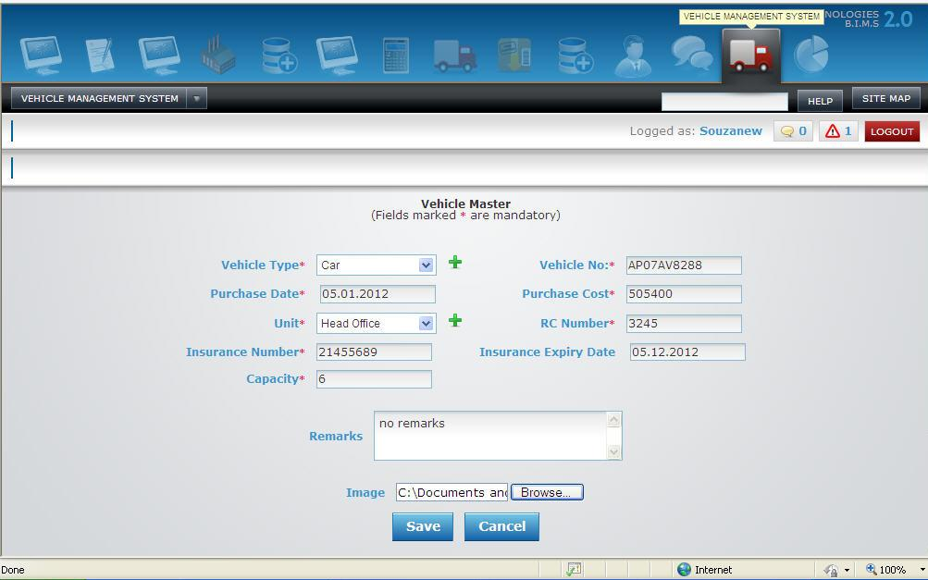

1. Enter the RC Number
2. Enter the Insurance Number
3. Pick the Insurance expiry date
4. Enter the capacity
5. Enter the remarks, if any
6. Browse for image
7. Once filled click on 'save' button to save Vehicle Masters details or 'CANCEL' to exit without saving the Vehicle Masters details.

**Add Vehicle Spare Parts**

**To Add New Spare Parts**

1. Select the Vehicle Types

**Eg :** Suppose the Vehicle Types are "Car", "Lorry" and Jeeps.  
you have to enter *Car, Lorry and Jeeps* for "Vehicle Types.

1. Enter the Spare Parts

**Eg :** Suppose the Spare Part is "Tire".  
you have to enter *Tire* for "Spare Part".

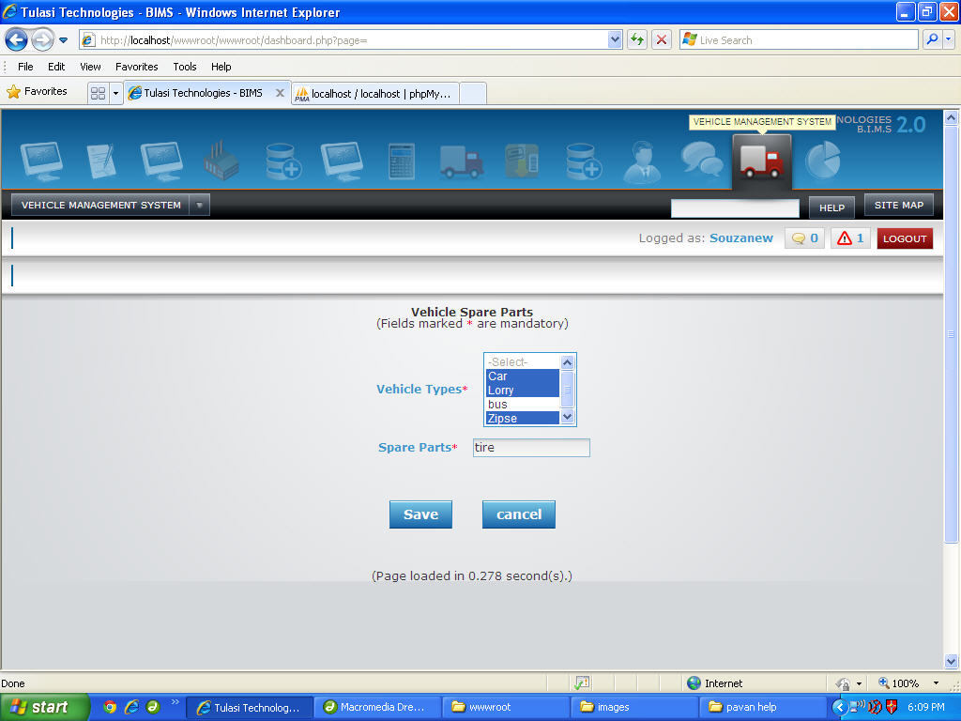

1. Once filled click on 'SAVE' button to save Spare Part details or 'CANCEL' to exit without saving the Spare Part details.

**Add Vehicle Service**

**To Add New Vehicle Service Details**

1. Enter the Service Code
2. Enter the Service Description
3. Select the Vehicle Types   
   **Eg :** Suppose the Vehicle Types are "Car", "Lorry" and "Jeeps".  
   you have to enter *Car, Lorry and Jeep* for "Vehicle Types".
4. Select the Included Parts   
   **Eg :** Suppose the Included Parts is "Seat".  
   you have to enter *Seat* for "Included Parts".

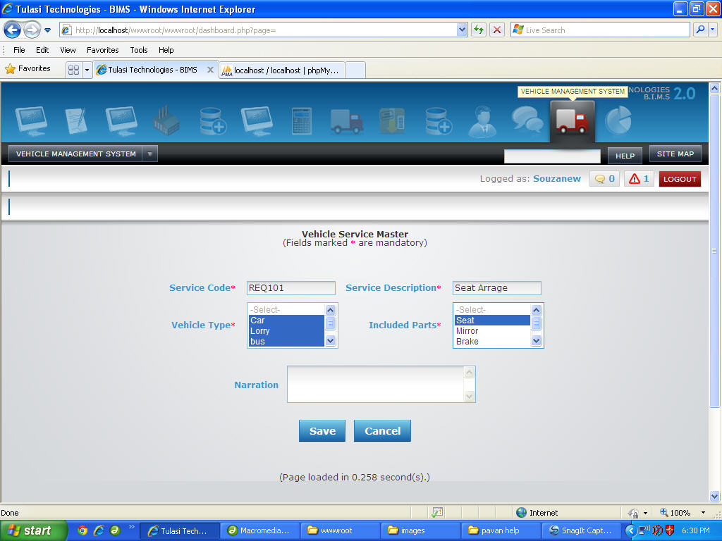

1. Once filled click on 'Save' button to save Vehicle Service Master details or 'CANCEL' to exit without saving the Vehicle Service Master details.

**Vehicle Charge Masters**

**To Add New Vehicle Charge Masters**

1. You have to enter Charge Code.  
   **Eg :** Suppose if charge code is "C12" then, you have to enter*C12* as "Charge Code".
2. You have to enter Charge Description.  
   **Eg :** Suppose if charge description is "Charge 12" then, you have to enter *Charge 12* as "Charge description".
3. You have to select vehicle type whether it is car or lorry or bus etc...  
   **Eg :** Suppose if it is "Car" then, you have to select *Car* as "Vehicle Type".
4. If you want to write something about Renewal write it down as Remarks.
5. Once filled click "SAVE" button to Save "Charge Masters" or click "CANCEL" button to exit without Saving "Charge Masters".

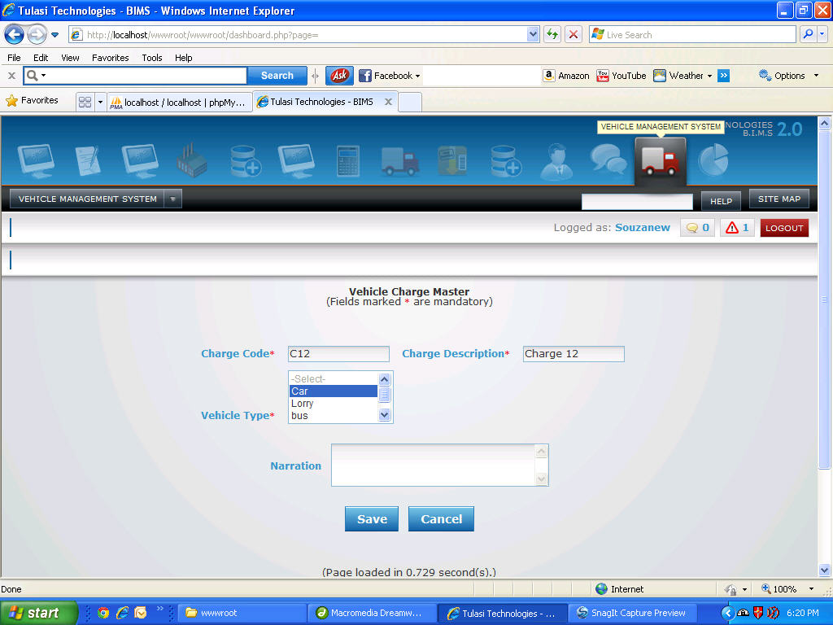

**Transactions:**

**To Add Vehicle Trip Details**

1. You have to select vehicle type whether it is car or lorry or bus etc...  
   **Eg :** Suppose if it is "Car" then, you have to select *Car* as "Vehicle Type".
2. You have to select Vehicle Number.(the unique no assigned to that vehicle).  
   **Eg :** Suppose if it is "46061" then you have to select*46061* as "Vehicle Number".
3. you have to select driver of vehicle.  
   **Eg :** Suppose if driver is "Azim" then, you have to select *Azim* as "Driver".
4. You have to select start date.  
   **Eg :** Suppose start date is "05.01.2012" then, you have to select *05.01.2012* for " Start Date".
5. You have to enter start time.  
   **Eg :** Suppose start time is "07.30" then, you have to enter*07.30* for " Start Time".
6. You have to select start Place.  
   **Eg :** Suppose start place is "Bangalore" then, you have to select *Bangalore* for " Start Place".
7. You have to enter start reading.  
   **Eg :** Suppose if starting reading is "4587" then, you have to enter*4587* as "Start Reading".
8. You have to select end date.  
   **Eg :** Suppose end date is "05.01.2012" then, you have to select *05.01.2012* for " End Date".
9. You have to enter end time.  
   **Eg :** Suppose end time is "07.30" then, you have to enter*07.30* for " End Time".
10. You have to select End Place.  
    **Eg :** Suppose End place is "Mysore" then, you have to select *Mysore* for " End Place".
11. You have to enter End reading.  
    **Eg :** Suppose if end reading is "4882" then, you have to enter*4882* as "End Reading".
12. You have to enter Expenses Incurred.  
    **Eg :** Suppose if expenses are "3000 Rupees" then, you have to enter*3000* as "Expenses Incurred".
13. You have to select whether the vehicle is travelled with load or without load.  
    **Eg :** Suppose it is "With load" then, you have to select *With load*.
14. If you want to write something about Renewal write it down as Remarks.
15. Once filled click "SAVE" button to Save "Vehicle Trip" or click "CANCEL" button to exit without Saving "Vehicle Trip".

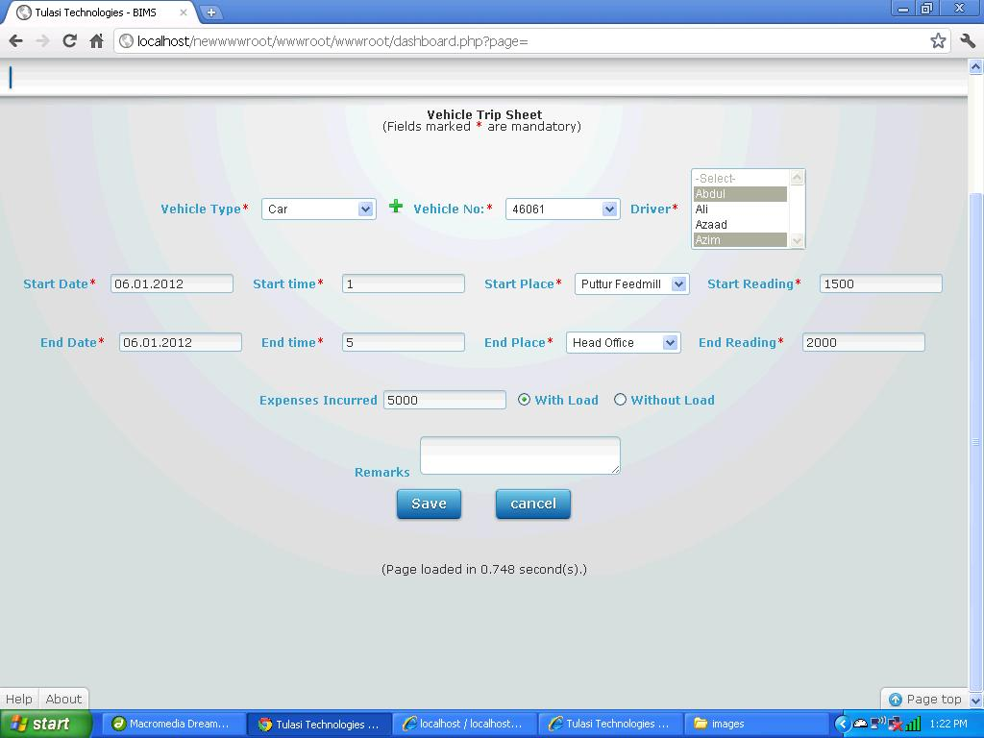

**To Add New Vehicle Servicing Details**

1. You have to select servicing date.  
   **Eg :** Suppose date is "05.01.2012" then, you have to select *05.01.2012* for "Date".
2. You have to select vehicle type whether it is car or lorry or bus etc...  
   **Eg :** Suppose if it is "Car" then, you have to select *Car* as "Vehicle Type".
3. You have to select Vehicle Number.(the unique no assigned to that vehicle).  
   **Eg :** Suppose if it is "46061" then you have to select*46061* as "Vehicle Number.
4. You have to select Service Code.  
   **Eg :** Suppose if it is "S3" then, you have to select *S3* as "Service Code".
5. You have to select next servicing date.  
   **Eg :** Suppose date is "05.04.2012" then, you have to select *05.04.2012* for "T.Next S.Date".
6. You have to enter Warranty in days.  
   **Eg :** Suppose if Warranty is "90 days" then, you have to enter*90* as "Warranty Date".
7. You have to enter service charges.  
   **Eg :**Suppose if service charges are "4500 Rupees" then, you have to enter*4500* as "service charges".
8. you have to select driver of vehicle.  
   **Eg :** Suppose if driver is "Abdul" then, you have to select *Abdul* as "Driver".
9. If you want to write something about Renewal write it down as Remarks.
10. Once filled click "SAVE" button to Save "Vehicle Servicing" or click "CANCEL" button to exit without Saving "Vehicle Servicing".

**Processing:**

**Fuel Filling**

1. You have to select date on which fuel is filling.  
   **Eg :** Suppose date is "05.01.2012" then, you have to select *05.01.2012* for "Date".
2. You have to select vehicle type whether it is car or lorry or bus etc...  
   **Eg :** Suppose if it is "Car" then, you have to select *Car* as "Vehicle Type".
3. You have to select Vehicle Number.(the unique no assigned to that vehicle).  
   **Eg :** Suppose if it is "46061" then you have to select*46061* as "Vehicle Number".
4. you have to select fuel type. Whether it is petrol or diesel etc...  
   **Eg :** Suppose if it is "Petrol" then, you have to select *petrol* as "Fuel Type".
5. You have to enter how much fuel is filled in liters.  
   **Eg: Suppose** if fuel filled is "15 liters" then, you have to enter*15* as "Fuel Filled".
6. You have to enter cost of fuel per liters.  
   **Eg :** Suppose if fuel cost is "75 Rupees" then, you have to enter*75* as "Fuel Cost".
7. You have to enter the current reading of vehicle.  
   **Eg :** Suppose if current reading is "6756" then, you have to enter*6756* as "Current Reading".
8. You have to select driver of vehicle.  
   **Eg :** Suppose if driver is "Abdul" then, you have to select *Abdul* as "Driver".
9. If you want to write something about fuel filling write it down as Remarks.
10. Once filled click "SAVE" button to Save "Fuel Filled entry" or click "CANCEL" button to exit without saving "Fuel Filled entry".

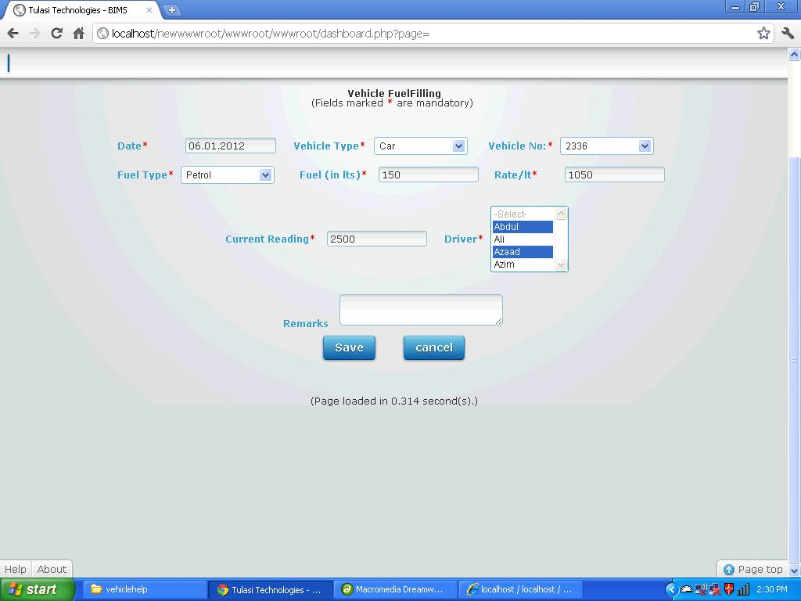

**Vehicle Renewal**

1. You have to select date on which fuel is filling.  
   **Eg :** Suppose date is "05.01.2012" then, you have to select *05.01.2012* for "Date".
2. You have to select vehicle type whether it is car or lorry or bus etc...  
   **Eg :** Suppose if it is "Car" then, you have to select *Car* as "Vehicle Type".
3. You have to select Vehicle Number.(the unique no assigned to that vehicle).  
   **Eg :** Suppose if it is "46061" then you have to select*46061* as "Vehicle Number".
4. you have to select Charge Code.  
   **Eg :** Suppose if it is "REN6785" then, you have to select *REN6785* as "Charge Code".
5. You have to enter how much amount you are paying.  
   **Eg :** Suppose if amount paying is "5000 Rupees" then, you have to enter*5000* as "Amount Paying".
6. You have to enter Validity Duration.  
   **Eg :** Suppose if validity Duration is "2 Years" then, you have to enter*2* as "Validity Duration".
7. If you want to write something about Renewal write it down as Remarks.
8. Once filled click "SAVE" button to Save "Vehicle Renewal" or click "CANCEL" button to exit without Saving "Vehicle Renewal".

