OFFICE MANAGEMENT
Reports:
Call Register Report
You have to select Call Register in Reports.
As and when you select Call Register, a new window will be opened.
The Report shows Employee, Time From, Time To, Dialed and Narration of farms.
Client Appointment Report
You have to select Unit Details in Reports.
As and when you select Unit Details, a new window will be opened.
The Report shows Entry Date, Client Name, Employee, Appointment Time From, Appointment Time to, and Narration.
1. You can select single or all employees at a time using Employee drop down list box.
Based on the selected Employee corresponding details will be shown to you.
Client Assessment Report
You have to select Client Assessment in Reports.
As and when you select Client Assessment, a new window will be opened.
The Report shows Client Name, Type, Employee, Date From and Date To.
- You can select Single or all Clients’ at a time using Client Name drop down list box.
Based on the options you select corresponding details will be shown to you.
Client History Report
You have to select Client History in Reports.
As and when you select Client History, a new window will be opened.
The Report shows Client, Employee, Interaction Type, Document Number and Narration.
Client Ledger Report
You have to select Client Ledger in Reports.
As and when you select Client Ledger, a new window will be opened.
- Select Client, from the drop down list.
- Select From Date and To Date.
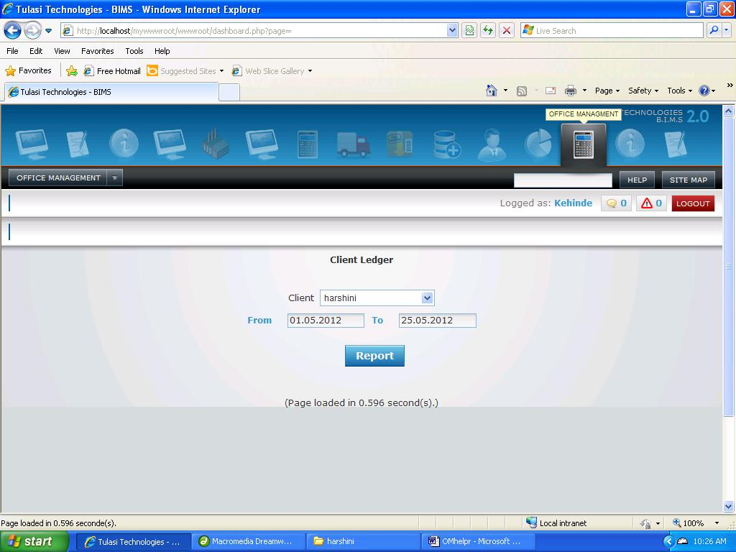
- Click on Report Button.
Report will be displayed in a new window showing, date, Transaction Type, Document Number, Debit and Credit details of selected Client.
Client List Report
You have to select Client List in Reports.
As and when you select Client List, a new window will be opened.
The Report shows Client Name, Place, Mobile, Land Line, Email, Unique Id, TIN, TAN, Category, and Ward.
Tax Filing Report
You have to select Tax Filing in Reports.
As and when you select Tax Filing, a new window will be opened.
The Report shows Date, Client Name, Employee, From Date, To Date and Acknowledge Number.

1. You can select single or all employees at a time using Employee drop down list box.
Based on the selected Employee corresponding details will be shown to you.

