OFFICE MANAGEMENT

Masters:

Add Client Masters

To Add New Client Master
- You have to enter Name.
Eg : Suppose Client name is "Steven".
You have to enter Steven for "Client Name”.
- You have to enter Surname.
- You have to enter Father's Name.
Eg : Suppose Father's Name is "Johnson".
You have to enter Johnson for "Father’s Name”.
- You have to select Sex.
- You have to enter Office Address. "Tulasi technologies, Bangalore"
Eg : Suppose Office Address is " Tulasi technologies, Bangalore ".
You have to enter Tulasi Technologies, Bangalore for "Office Address”.
- You have to enter Office Place (location of your office).
Eg : Suppose Office Place is "Bangalore ".
You have to enter Bangalore for "Office Place”.
- you have to enter Residential Address & residential place.
- You have to enter Annual Income.
Eg : Suppose Annual Income is "50000".
You have to enter 50000 for "Annual Income”.
- You have to select Category.
Eg : Suppose Category is "CAT01".
You have to enter CAT01 for "Category”.
- You have to select Ward.
Eg : Suppose Ward is "WARD01".
You have to enter WARD01 for "Ward”.
- You have to enter landline Number & Mobile Number.
- You have to enter E-mail ID.
Eg : Suppose E-mail ID is “steven@gmail.com".
You have to enter steven@gmail.com for "E-mail ID”.
- You have to enter TIN (Tax Information Network),TAN(Tax deduction Account Number) and UID(Unique Identity Number).
- You have to Select Client Group.
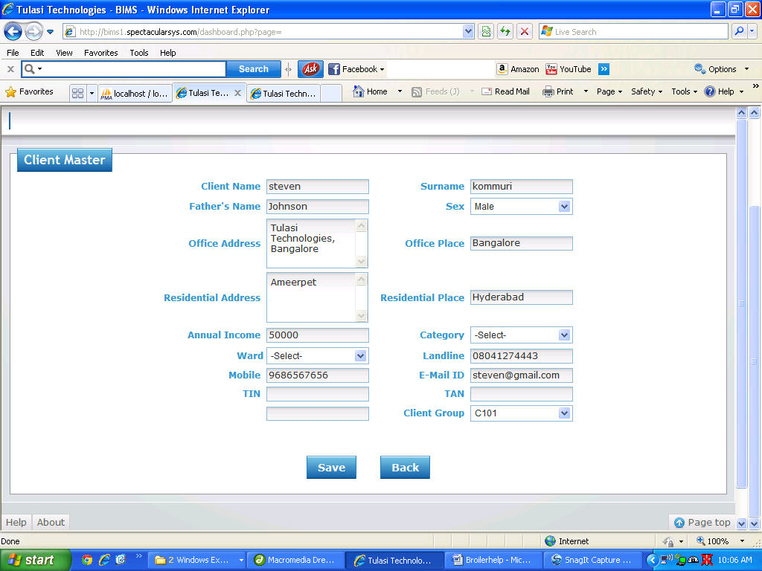
- Once filled click on 'save' button to save details or 'CANCEL' to exit without saving the details.

Add Category Masters
To Add Category Masters
- Enter the Category.
Eg : Suppose the Category is "CAT01".
You have to select CAT01 for "Category".
- Once filled click on 'SAVE' button to save the Category or 'CANCEL' to exit without saving the Category.
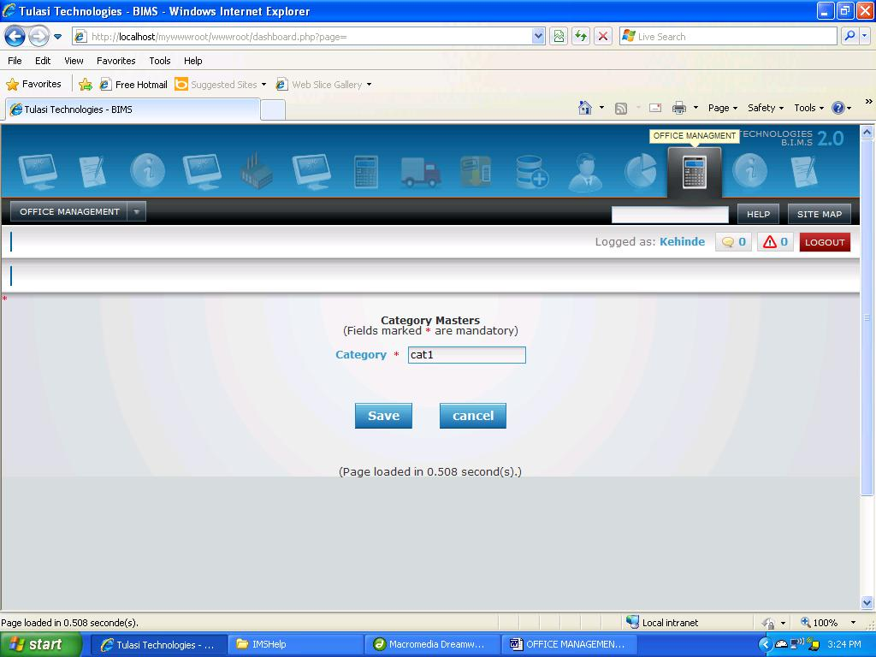

Add Form/Certification
To Add Form/Certification
- Enter the "Form/Certification".
Eg : Suppose the Form/Certification is "HR23".
you have to enter HR23 for " Form/Certification”.
- Once filled click on 'SAVE' button to save the Form/Certification or 'CANCEL' to exit without saving the Form/Certification
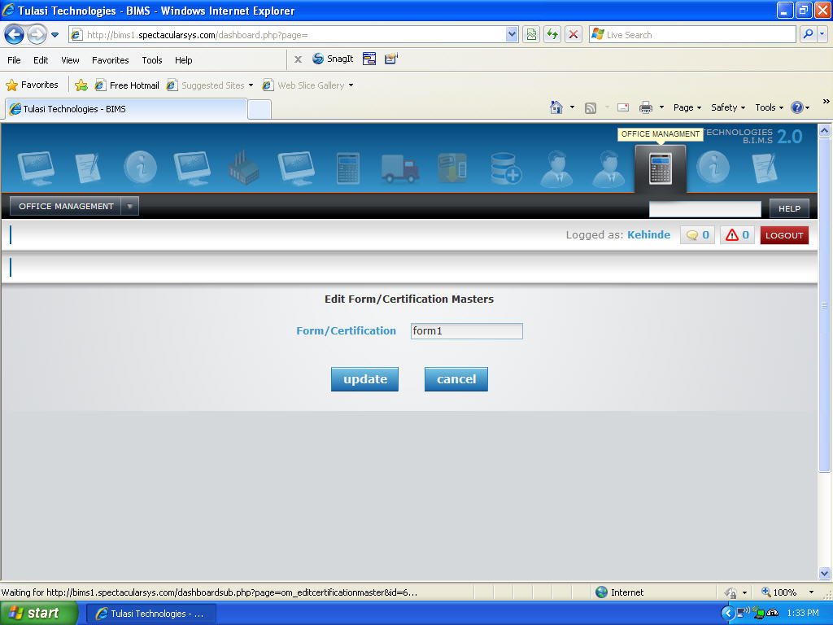

Add Tax Master
To Add New Tax Master
- You have to select From Date, To Date.
- You have to enter values in From Range and To Range.
- Select Ward and Category.
- Enter the Tax% and select Male (OR) Female.
- Select the Vehicle Types
Eg : Suppose the From Date is "6th June, 2011",To Date is "7th August, 2011",From Range is "1000",To Range is "2000",Ward "AAA", Category "CAT01",Tax% "11",sex "female",Forms required "form1".
you have to select 06.06.2011 for "From Date", 06.06.2011 for "To Date", 1000 for "From Range",
2000 for "To Range", AAA for "Ward", CAT01 for "Category", 11 for "Tax%", Female for "Female", and Form1 for "Forms Required"
- Once filled click on 'SAVE' button to save the Taxation Master details or 'CANCEL' to exit without saving the Taxation Master details l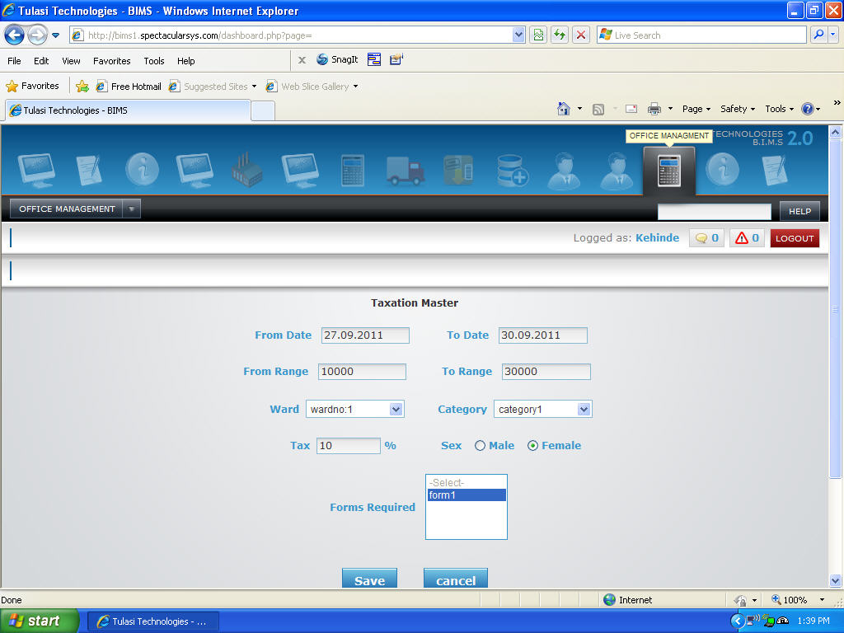
Add Ward
To Add New Ward
- You have to enter Ward.
Eg : Suppose if it is "WARD1" then, you have to enter WARD1 for "Ward".
- Once filled click on 'SAVE' button to save the Ward or 'CANCEL' to exit without saving the Ward.
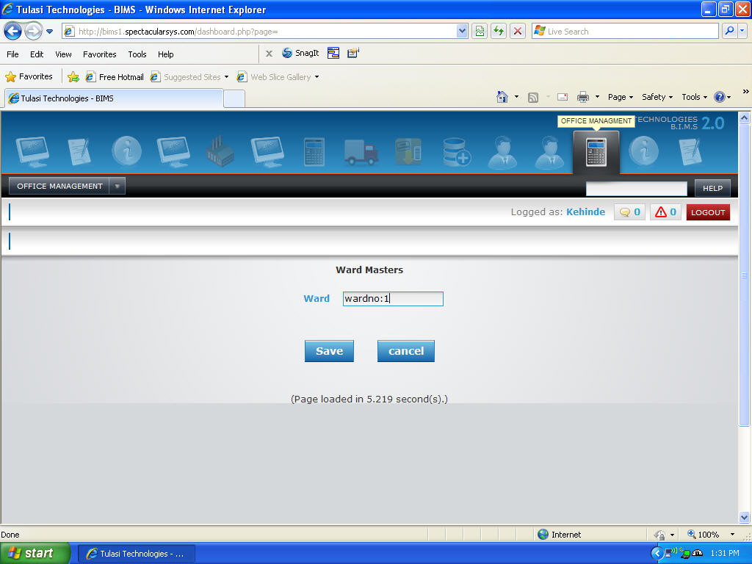
Add Unique Id
To Add New Unique Id
- You have to enter Unique Id.
Eg : Suppose if it is "UID5672" then, you have to enter UID5672 for "Unique Id".
- Once filled click on 'SAVE' button to save the Unique Id or 'CANCEL' to exit without saving the Unique Id

Transactions:

To Add Client Appointment Details
- You have to select date, on which date appointment is fixed
Eg : Suppose date is "05.09.2011" then, you have to select 05.09.2011 for "Date".
- You have to select employee to whom appointment is to be assign
Eg : Suppose if employee is "Steven" then you have to select Steven as "Employee".
- You have to select Unique Number it may be PAN(Permanent Account Number) or PASSPORT Number
Eg : Suppose if Unique ID is "UID4537" then, you have to select UID4537 as "UID".
- You have to select Appointment Date.
Eg : Suppose appointment date is "29.01.2012" then, you have to select 29.01.2012 for "Appointment Date".
- You have to enter Time From and Time To.
Eg : Suppose if Appointment is from "08:30" to "11:30" then you have to enter 08.30 for "Time From" and 11.30 for "Time To" .
- If you want to write something about Appointment, write it in narration box.
- Once filled click "SAVE" button to Save Client Appointment or click "CANCEL" button to exit without Saving Client Appointment.
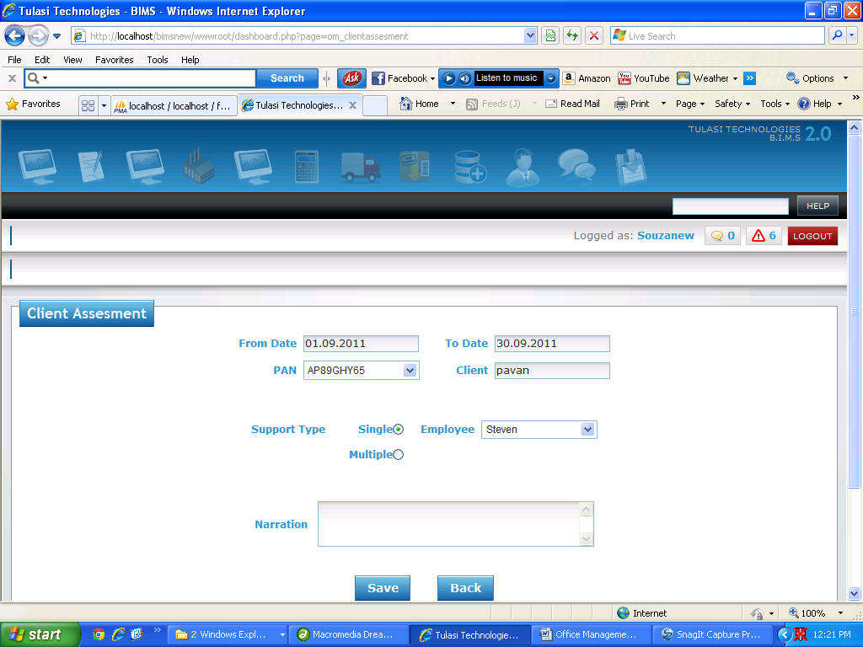

To Add New Call Register Details
- You have to select date on which the call takes place.
Eg : Suppose date is "25.09.2011" then, you have to select 25.09.2011 for "Date".
- You have to select employee who receive or make the call
Eg : Suppose if it is "Steven" then, you have to select Steven as "Employee".
- You have to select Unique Number it may be PAN (Permanent Account Number) or PASSPORT Number.
Eg : Suppose if it is "UID4537" then you have to select UID4537 as "Unique Id”.
- you have to select dialed/out no.
Eg : Suppose if it is "9656764656" then, you have to enter 96567646563 for "Dialed/out no ".
- You have to select the call type, whether is it incoming call or out going call.
- You have to enter call Start Time and End Time.
Eg : Suppose if call duration is from "08:30:45" to "08:36:25" then you have to enter 08:30:45 for "Start Time" and 08:36:25 for “End Time”.
- If you want to write something about call, write it in narration box.
- Once filled click "SAVE" button to Save Call Register or click "CANCEL" button to exit without Saving Call Register.
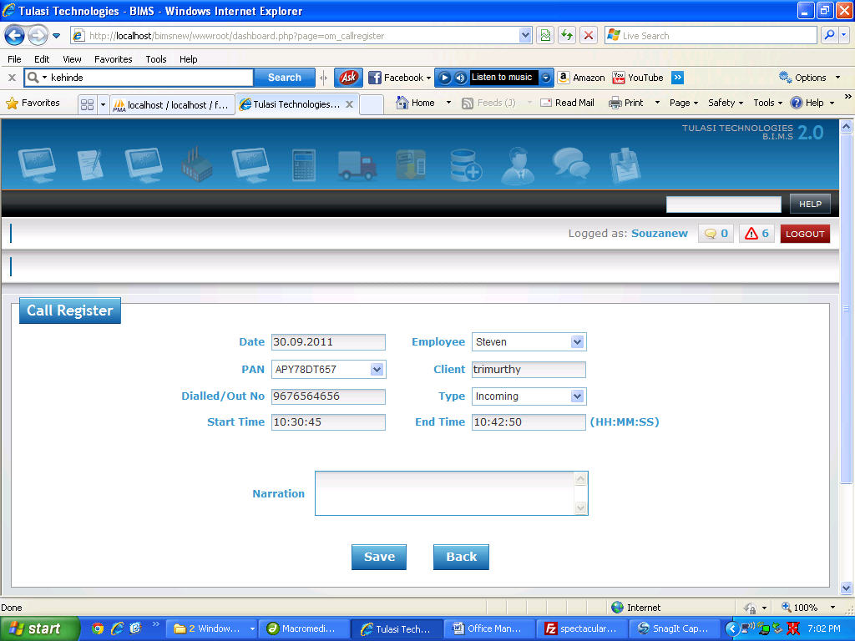

To Add New Tax Filing Details
- You have to select "Date".
Eg : Suppose date is "25.09.2011" then, you have to select 25.09.2011 for "Date".
- You have to select “Employee”.
Eg : Suppose if it is "Steven" then, you have to select Steven as "Employee".
- You have to select Unique Number it may be PAN (Permanent Account Number) or PASSPORT Number.
Eg : Suppose if it is "UID4537" then you have to select UID4537 as "Unique Id”.
- You have to Select "Period From" and "Period To".
Eg : Suppose if Period is "06.07.2011 " to "16.07.2011 " then you have to enter 06.07.2011 for "Period From" and 16.07.2011 for “Period To”.
- You have enter "Acknowledge Number".
- If you want to write something about Tax Filing, write it in narration box.
- Once filled click "SAVE" button to Save Tax Filing or click "CANCEL" button to exit without Saving Tax Filing.
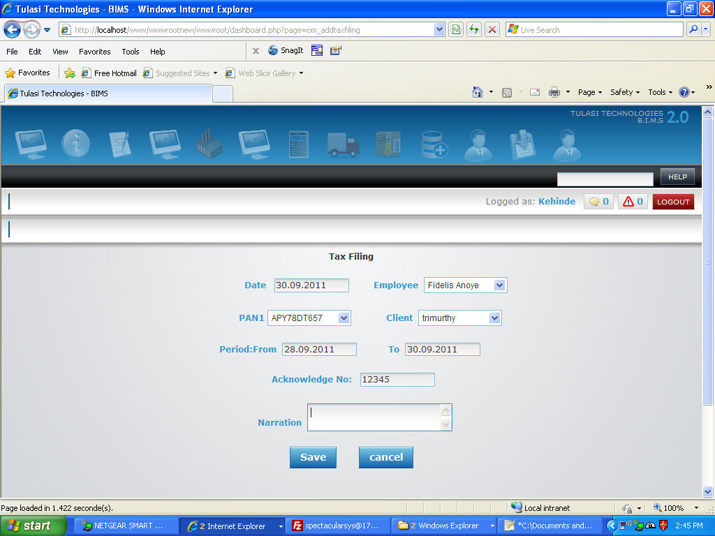

Processing:

Client Assessment
- You have to select from date and to date
Eg : Suppose from date is "05.01.2012" and to date is "25.11.2012" then, you have to select 05.01.2012 as "From Date" and 25.01.2012 as "To Date".
- You have to select Unique Number it may be PAN (Permanent Account Number) or PASSPORT Number.
Eg : Suppose if it is "UID4537" then you have to select UID4537 as "Unique Id”.
- You have to select Support Type.
Eg : Suppose if your are contacting with only one employee of the company then you have to select single as "Support Type" or if your are contacting with more than one employee of the company then you have to select multiple as "Support Type".
- If you select Support type as "Single", you have to select employee from the list box
- If you select Support type as "Multiple", you have to select More than one employee from the list box (Hold control key to select multiple employees).
- If you want to write something about assessment, write it in narration box.
- Once filled click "SAVE" button to Save Assessment or click "CANCEL" button to exit without Saving Assessment.

Invoice
- You have to select date.
Eg : Suppose date is "05.01.2012" then, you have to select 05.01.2012 for "Date".
- You have to select Unique Number it may be PAN (Permanent Account Number) or PASSPORT Number.
Eg : Suppose if it is "UID4537" then you have to select UID4537 as "Unique Id”.
- You have to select client, to whom invoice is to be generate
Eg : Suppose if client is "Steven" then you have to select Steven as "Client".
- You have to enter Consultancy or Service Charges
Eg : Suppose if Consultancy or Service Charges are 5500 then you have to enter 5500 as " Consultancy / Service Charges".
- You have to enter Other Charges.
Eg : Suppose if Other Charges are 5500, you have to enter 5500 as "Others".
- You have to enter Discount Amount.
Eg : Suppose if Discount Amount is 500, you have to enter 500 as "Discount Amount".
- Net Amount will be displayed automatically while you enter discount Amount.
- If you want to write something about invoice, write it in narration box.
- Once filled click "SAVE" button to Save Invoice or click "CANCEL" button to exit without Saving Invoice.
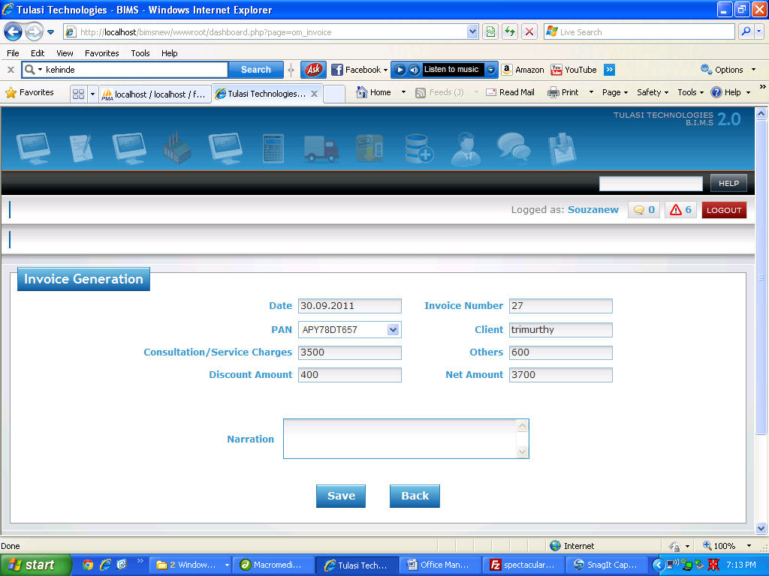
Document Receiving
- You have to select "Date".
Eg : Suppose date is "25.09.2011" then, you have to select 25.09.2011 for "Date".
- You have to select Unique Number it may be PAN (Permanent Account Number) or PASSPORT Number.
Eg : Suppose if it is "UID4537" then you have to select UID4537 as "Unique Id”.
- You have to select “Employee”.
Eg : Suppose if it is "Steven" then, you have to select Steven as "Employee".
- You have to Select "Period From" and "Period To".
Eg : Suppose if Period is "06.07.2011 " to "16.07.2011 " then you have to enter 06.07.2011 for "Period From" and 16.07.2011 for “Period To”.
- Select "Form Type" and Click Browse to select a document.
Eg : Suppose if Form Type is "Form1",Attach Document is "xyz.txt" then you have to select Form1 for "Form Type" and browse xyz.txt as “Document”.
- Repeat step 5 until all the details are filled.
- If you want to write something about document, write it in narration box.
- Once filled click on 'SAVE' button to save the Document Receive details or 'CANCEL' to exit without saving the Document Receive details.

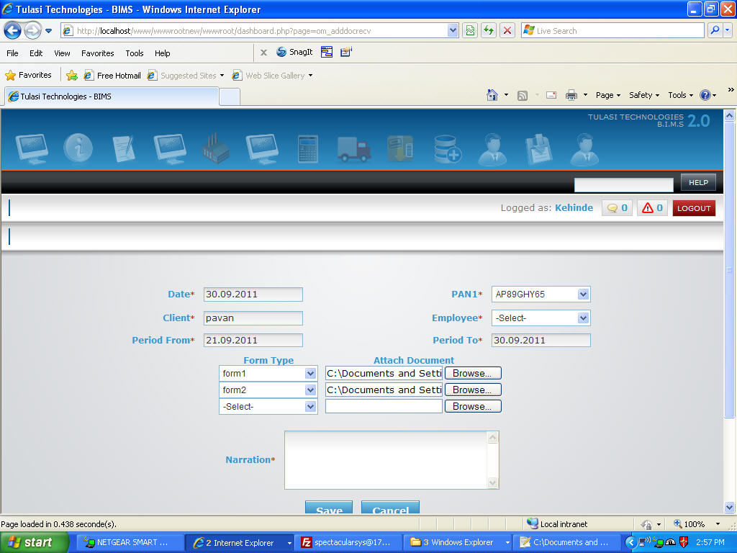

Document Submission
- You have to select "Date".
Eg : Suppose date is "25.09.2011" then, you have to select 25.09.2011 for "Date".
- You have to select Unique Number it may be PAN (Permanent Account Number) or PASSPORT Number.
Eg : Suppose if it is "UID4537" then you have to select UID4537 as "Unique Id”.
- You have to select “Employee”.
Eg : Suppose if it is "Steven" then, you have to select Steven as "Employee".
- Select Yes in submit to submit the form.
- If you want to write something about document, write it in narration box.
- Once filled click on 'SAVE' button to save the Document Receive details or 'CANCEL' to exit without saving the Document Receive details.

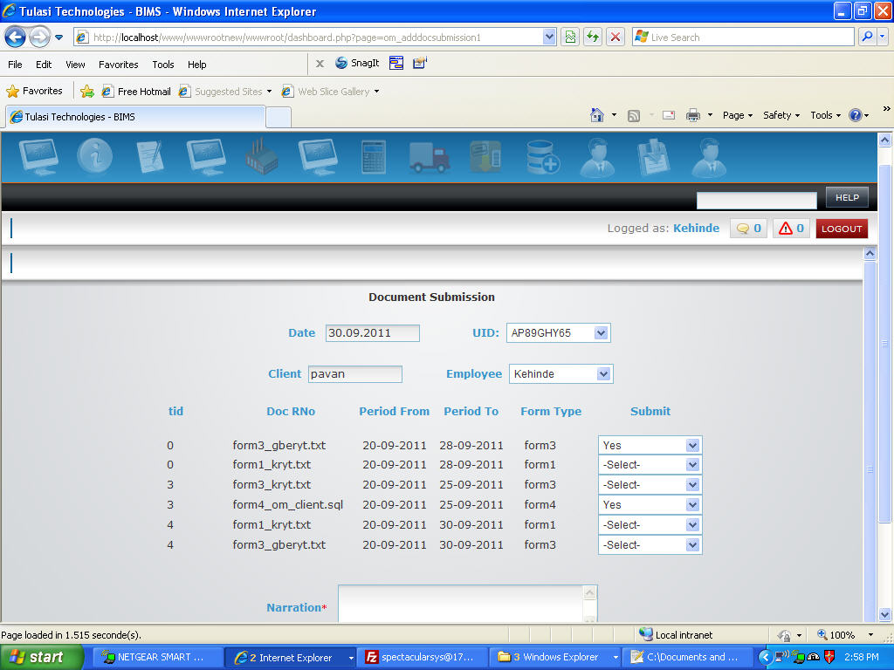
Receipt
- You have to select "Date".
Eg : Suppose date is "25.09.2011" then, you have to select 25.09.2011 for "Date".
- You have to select Unique Number it may be PAN (Permanent Account Number) or PASSPORT Number.
Eg : Suppose if it is "UID4537" then you have to select UID4537 as "Unique Id”.
- You have to select "Choice".
Eg : Suppose if you paying amount On Account then you have to select On A/C as "Choice" if you paying for individual invoices then you have to select Invoice as "Choice"
- You have to select "Reception Mode".
Eg : Suppose if amount received by cheque then you have to select Cheque as "Reception Mode" If you received cash then you have to select Cash as "Reception Mode"
- You have to select cash code or bank account number (based on the option you selected for Reception Mode, it will automatically give the options regarding it).
Eg : Suppose if Cash Code is "CH" then you have to select CH as "Cash Code" If you received cash then you have to select Cash as "Reception Mode".
- If you selected choice as "On A/C". then you have to enter Amount, Bank, Branch, Cheque Number, Cheque Date(if Reception mode is Cheque then only cheque number and cheque date is required). Eg : Suppose if Amount is "10000" then you have to select 10000 as "Amount", Bank is "ICICI" then you have to select ICICI as "Bank", Branch is "Bangalore" then you have to select Bangalore as "Branch", cheque number is "956847659" then you have to select 956847659 as "Cheque" and cheque date is "19.09.2011" then you have to select 19.09.2011 as "Cheque Date" .
- If you selected Choice as "Invoice", then the list of invoices will displayed of particular customer. You have to enter received amount for each invoice.
- If you want to write something about Reciept, write it in narration box.
- Once filled click "SAVE" button to Save Receipt or click "CANCEL" button to exit without Saving Receipt.
