# ACTIVITY DIAGRAM

Activity diagram is another important diagram in UML to describe dynamic aspects of the system.

Activity diagram is basically a flow chart to represent the flow form one activity to another activity. The activity can be described as an operation of the system.

So the control flow is drawn from one operation to another. This flow can be sequential, branched or concurrent. Activity diagrams deals with all type of flow control by using different elements like fork, join etc.

**Purpose:**

The basic purposes of activity diagrams are similar to other four diagrams. It captures the dynamic behaviour of the system. Other four diagrams are used to show the message flow from one object to another but activity diagram is used to show message flow from one activity to another.

Activity is a particular operation of the system. Activity diagrams are not only used for visualizing dynamic nature of a system but they are also used to construct the executable system by using forward and reverse engineering techniques.

It does not show any message flow from one activity to another. Activity diagram is some time considered as the flow chart. Although the diagrams looks like a flow chart but it is not. It shows different flow like parallel, branched, concurrent and single.So the purposes can be described as:

* Draw the activity flow of a system.
* Describe the sequence from one activity to another.
* Describe the parallel, branched and concurrent flow of the system.

**How to draw Activity Diagram?**

Activity diagrams are mainly used as a flow chart consists of activities performed by the system. But activity diagram are not exactly a flow chart as they have some additional capabilities. These additional capabilities include branching, parallel flow, swim lane etc.

The main element of an activity diagram is the activity itself. An activity is a function performed by the system. After identifying the activities we need to understand how they are associated with constraints and conditions.

So before drawing an activity diagram we should identify the following elements:

* Activities
* Association
* Conditions
* Constraints

Once the above mentioned parameters are identified we need to make a mental layout of the entire flow. This mental layout is then transformed into an activity diagram.

**EXPERIMENT-15**

**Aim** : Draw activity diagram for ATM

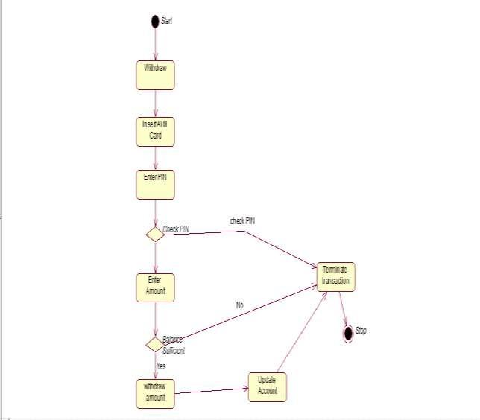

**EXPERIMENT-16**

**AIM:** Draw activity diagram for AIRLINE RESERVATION SYSTEM.

Book Flight

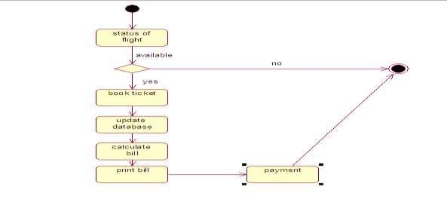

Cancel ticket

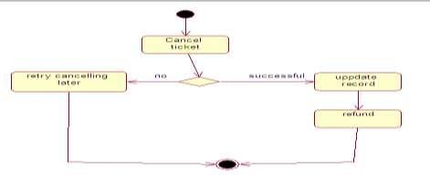

**EXPERIMENT-17**

**AIM**: Draw Activity diagram for Library Management System

Issue Book

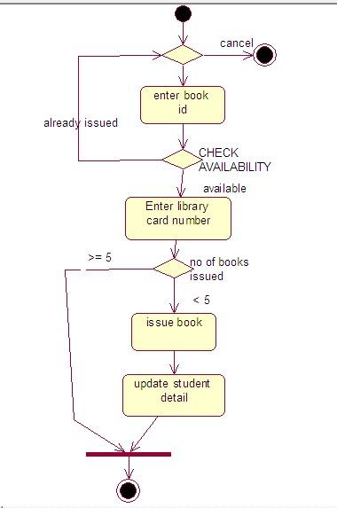

Return Book

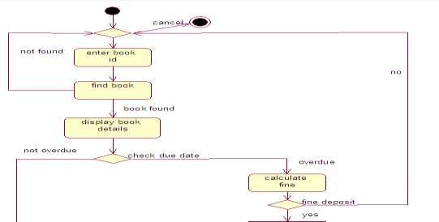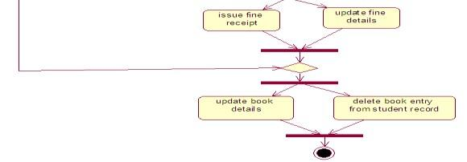

**EXPERIMENT-18**

**Aim**: Draw activity diagram for HOTEL MANAGEMENT SYSTEM

Book room

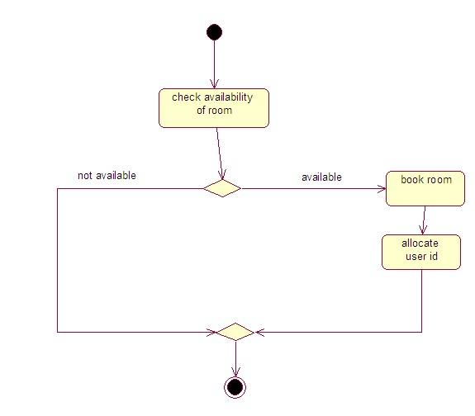

Cancel booking

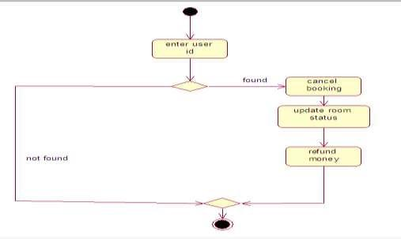

Generate bill

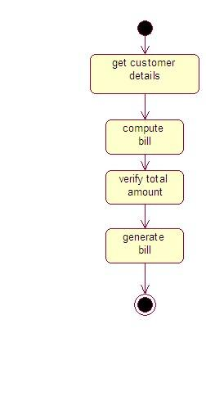

## STATE TRANSITION DIAGRAM

The name of the diagram itself clarifies the purpose of the diagram and other details. It describes different states of a component in a system. The states are specific to a component/object of a system.

A State chart diagram describes a state machine. Now to clarify it state machine can be defined as a machine which defines different states of an object and these states are controlled by external or internal events.

State chart diagram defines states it is used to model lifetime of an object.

**Purpose:**

State chart diagram is one of the five UML diagrams used to model dynamic nature of a system. They define different states of an object during its lifetime. And these states are changed by events. So State chart diagrams are useful to model reactive systems. Reactive systems can be defined as a system that responds to external or internal events.

State chart diagram describes the flow of control from one state to another state. States are defined as a condition in which an object exists and it changes when some event is triggered. So the most important purpose of State chart diagram is to model life time of an object from creation to termination.

State chart diagrams are also used for forward and reverse engineering of a system. But the main purpose is to model reactive system.

Following are the main purposes of using State chart diagrams:

* To model dynamic aspect of a system.
* To model life time of a reactive system.
* To describe different states of an object during its life time.
* Define a state machine to model states of an object.

**How to draw State chart Diagram?**

State chart diagram is used to describe the states of different objects in its life cycle. So the emphasis is given on the state changes upon some internal or external events. These states of objects are important to analyze and implement them accurately.

State chart diagrams are very important for describing the states. States can be identified as the condition of objects when a particular event occurs.

Before drawing a State chart diagram we must have clarified the following points:

Identify important objects to be analyzed.

* Identify the states. Identify the events.

**EXPERIMENT-19**

**AIM**: Draw a state chart diagram for AIRLINE RESERVATION SYSTEM.

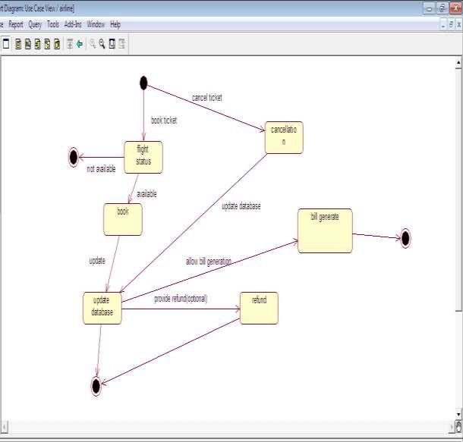

**EXPERIMENT-20**

**AIM:** Draw a state chart diagram for AIRLINE RESERVATION SYSTEM.



**INDEX**

|  |  |  |  |
| --- | --- | --- | --- |
| SNo | Experiment | Date | Signature |
|  |  |  |  |
|  |  |  |  |
|  |  |  |  |
|  |  |  |  |
|  |  |  |  |
|  |  |  |  |
|  |  |  |  |
|  |  |  |  |
|  |  |  |  |
|  |  |  |  |
|  |  |  |  |
|  |  |  |  |
|  |  |  |  |
|  |  |  |  |
|  |  |  |  |
|  |  |  |  |
|  |  |  |  |
|  |  |  |  |
|  |  |  |  |
|  |  |  |  |
|  |  |  |  |
|  |  |  |  |
|  |  |  |  |
|  |  |  |  |

|  |  |  |  |
| --- | --- | --- | --- |
|  |  |  |  |
|  |  |  |  |
|  |  |  |  |
|  |  |  |  |
|  |  |  |  |
|  |  |  |  |
|  |  |  |  |
|  |  |  |  |
|  |  |  |  |
|  |  |  |  |
|  |  |  |  |
|  |  |  |  |
|  |  |  |  |
|  |  |  |  |
|  |  |  |  |
|  |  |  |  |
|  |  |  |  |
|  |  |  |  |
|  |  |  |  |
|  |  |  |  |
|  |  |  |  |
|  |  |  |  |
|  |  |  |  |
|  |  |  |  |
|  |  |  |  |