Reproducible Research: Peer Assessment 1, Martin Salvo

## Loading and preprocessing the data

ActivityData <- read.csv("activity.csv")  
ActivityData2 <- read.csv("activity.csv")  
ActivityClean <- ActivityData[which(ActivityData$steps!= "NA"), ]

## What is mean total number of steps taken per day?

stepsperdate <- aggregate(steps ~ date, data=ActivityClean, FUN=sum)  
meansteps <- mean(stepsperdate$steps)  
mediansteps <- median(stepsperdate$steps)  
barplot(stepsperdate$steps , main="Total Steps per Day", names.arg= stepsperdate$date)

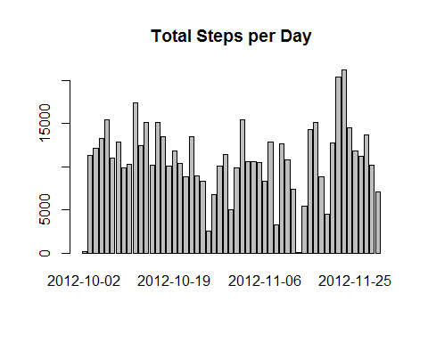

The mean steps taken per day is 1.076618910^{4} and the median 10765.

## What is the average daily activity pattern?

mean.step.5min <- aggregate(steps ~ interval, data=ActivityClean, FUN="mean")  
plot(steps~interval,data=mean.step.5min,type="l", main="Steps Pattern")

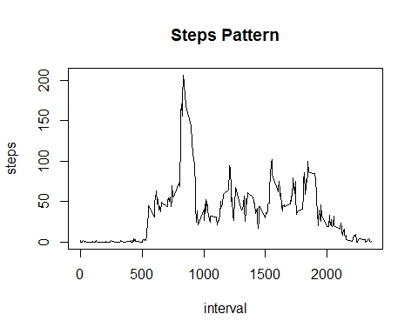

max.step <- mean.step.5min[which.max(mean.step.5min$steps),]$interval

The max step inteval contains 835

## Imputing missing values

NAsCount <- sum(is.na(ActivityData2$steps))  
count = 0  
##NAs are replaced with the Interval Mean of all days  
for(i in 1:nrow(ActivityData)){  
 if(is.na(ActivityData[i,]$steps)){  
 ActivityData[i,]$steps<- mean(mean.step.5min$steps)  
 count=count+1  
 }  
}

Here is the histogram of all intervals adjusted

AdjActivity <-aggregate(steps~date,data=ActivityData,sum)  
barplot(AdjActivity$steps , main="Histogram of Adjusted Total",)

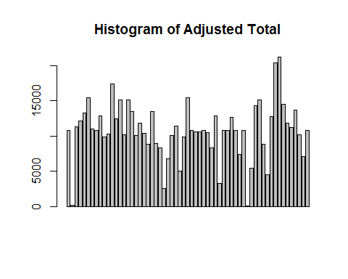

Adjmean <- mean(AdjActivity$steps)  
Adjmedian <- median(AdjActivity$steps)

The adjusted mean and median are, 1.076618910^{4} and 1.076618910^{4}, respectively.The are not significant differences, between clean data and adjusted data.

## Are there differences in activity patterns between weekdays and weekends?

There are differences between weekdays and weekends??

ActivityClean$day=ifelse(as.POSIXlt(as.Date(ActivityClean$date))$wday%%6==0,  
 "weekend","weekday")  
# Grading levels: weekend and weekday   
ActivityClean$day=factor(ActivityClean$day,levels=c("weekday","weekend"))  
#Making panel plot  
weekdayData=aggregate(steps~interval+day, ActivityClean ,mean)  
library(lattice)  
xyplot(steps~interval|factor(day),data=weekdayData ,aspect=2/1,type="l", main= "Pattern regarding weekday and weekend")

