June 4 2024 POSTMAN AUTOMAITON

GET http://localhost:3000/v1/user/presignedUrl

pre-request script :
if(!pm.globals.get("numberOfUrl")){
pm.globals.set("numberOfUrl", 4);
}

if(!pm.environment.get("urlCounter")){
pm.environment.set("urlCounter", 0) ;
}

if(!pm.environment.get("presignedUrlsData")){
pm.environment.set("presignedUrlsData", JSON.stringify([])) ;
}

test script (technically post-response script) :

var jsonData = pm.response.json();

const presignedUrlsData = JSON.parse(pm.environment.get("presignedUrlsData")) ;
presignedUrlsData.push(jsonData) ;

console.log(presignedUrlsData) ;
pm.environment.set("presignedUrlsData" , JSON.stringify(presignedUrlsData)) ;

const urlCounter = parseInt( pm.environment.get("urlCounter") , 10) + 1 ;
pm.environment.set("urlCounter" , urlCounter) ;

const numberOfUrl = parseInt( pm.globals.get("numberOfUrl") );
if(urlCounter < numberOfUrl){
// pm.sendRequest("GET getPresignedUrls") ;
postman.setNextRequest("getPresignedUrls") ;
}
else{
pm.environment.set("urlCounter" , 0 );

No need the below while running with Collection runner because the runner will automatically call the next main request("postObjectToS3") when there is not any child request in the currect request ("getPresignedUrls")

// pm.sendRequest("POST postObjectToS3") ;
// postman.setNextRequest("postObjectToS3") ;
}

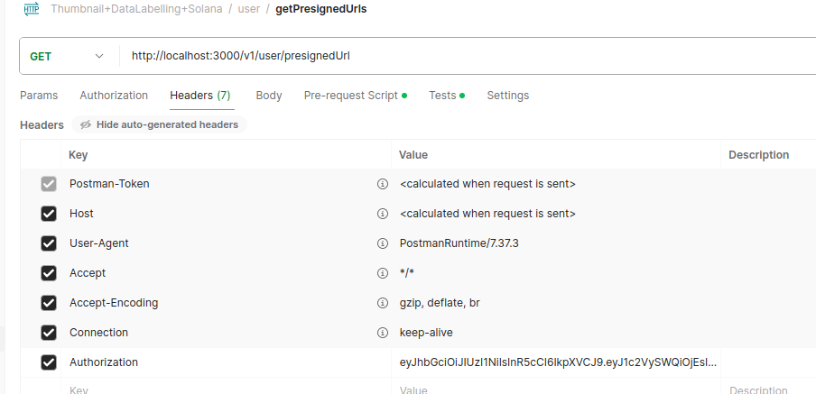

POST https://tinesh-all-buckets.s3.eu-north-1.amazonaws.com/

pre-request script :

console.log("Now at postObjectToS3") ;

const presignedUrlsData = JSON.parse(pm.environment.get("presignedUrlsData")) ;
let urlCounter = parseInt(pm.environment.get("urlCounter") , 10) ;

console.log(presignedUrlsData) ;

if (urlCounter >= presignedUrlsData.length) {
console.error("urlCounter exceeds the number of presigned URLs.");
return;
}

test script (technically post-response script) :

const jsonData = presignedUrlsData[urlCounter] ;

urlCounter++
pm.environment.set("urlCounter" , urlCounter) ;

// Set the environment variables
pm.environment.set("Content_Type", jsonData.fields['Content-Type']);
pm.environment.set("bucket", jsonData.fields['bucket']);
pm.environment.set("X_Amz_Algorithm", jsonData.fields['X-Amz-Algorithm']);
pm.environment.set("X_Amz_Credential", jsonData.fields['X-Amz-Credential']);
pm.environment.set("X_Amz_Date", jsonData.fields['X-Amz-Date']);
pm.environment.set("key", jsonData.fields['key']);
pm.environment.set("Policy", jsonData.fields['Policy']);
pm.environment.set("X_Amz_Signature", jsonData.fields['X-Amz-Signature']);

// For debugging purposes
console.log("Content-Type:", pm.environment.get("Content_Type"));
console.log("bucket:", pm.environment.get("bucket"));
console.log("X-Amz-Algorithm:", pm.environment.get("X_Amz_Algorithm"));
console.log("X-Amz-Credential:", pm.environment.get("X_Amz_Credential"));
console.log("X-Amz-Date:", pm.environment.get("X_Amz_Date"));
console.log("key:", pm.environment.get("key"));
console.log("Policy:", pm.environment.get("Policy"));
console.log("X-Amz-Signature:", pm.environment.get("X_Amz_Signature"));

const urlCounter = parseInt(pm.environment.get("urlCounter")) ;
pm.environment.set("urlCounter" , urlCounter) ;

const presignedUrlsData = JSON.parse(pm.environment.get("presignedUrlsData")) ;
pm.environment.set("presignedUrlsData" , JSON.stringify(presignedUrlsData)) ;

if(urlCounter < presignedUrlsData.length){
postman.setNextRequest("postObjectToS3") ;
}

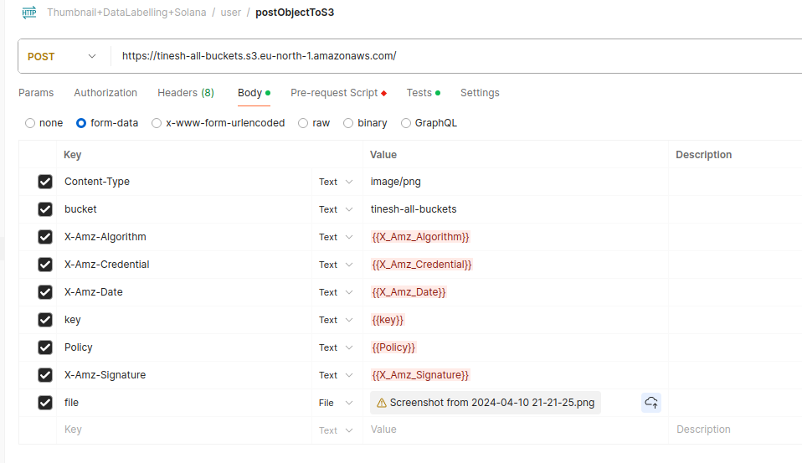

POST http://localhost:3000/v1/user/task
pre-request script :
let presignedUrlsData = JSON.parse(pm.environment.get("presignedUrlsData"));
let taskInfo = {
options: presignedUrlsData.map(item => item.fields.key),
signature : "myPaymentSignature" ,
title : "TitleForCheckingTask"
};

// Set the task information in the environment variable
pm.environment.set("taskInfo", JSON.stringify(taskInfo));
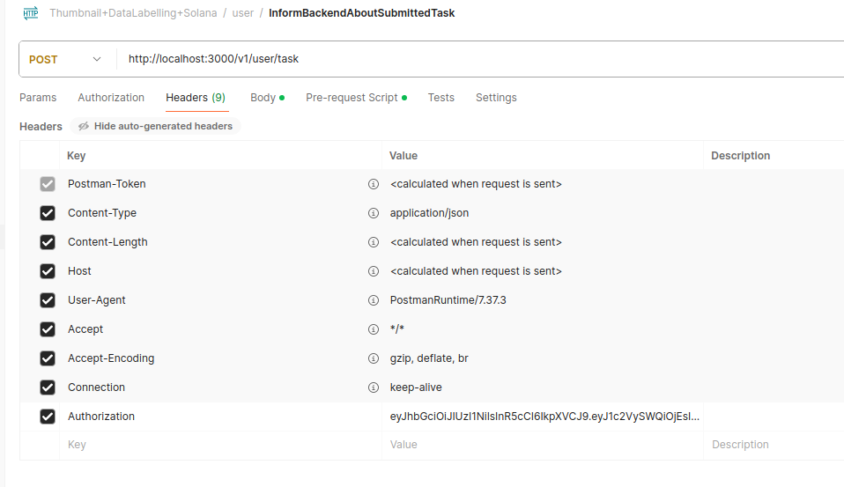

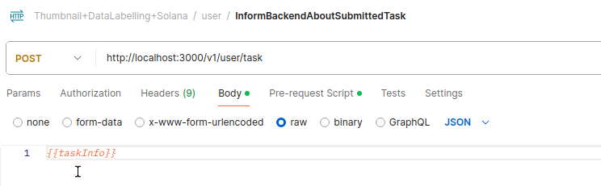

Overall Workflow for automation :

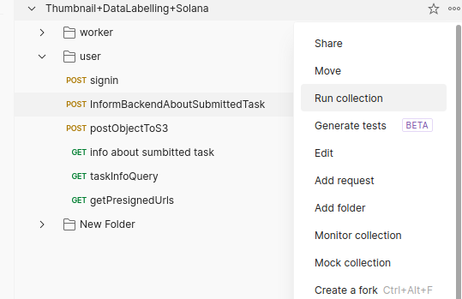

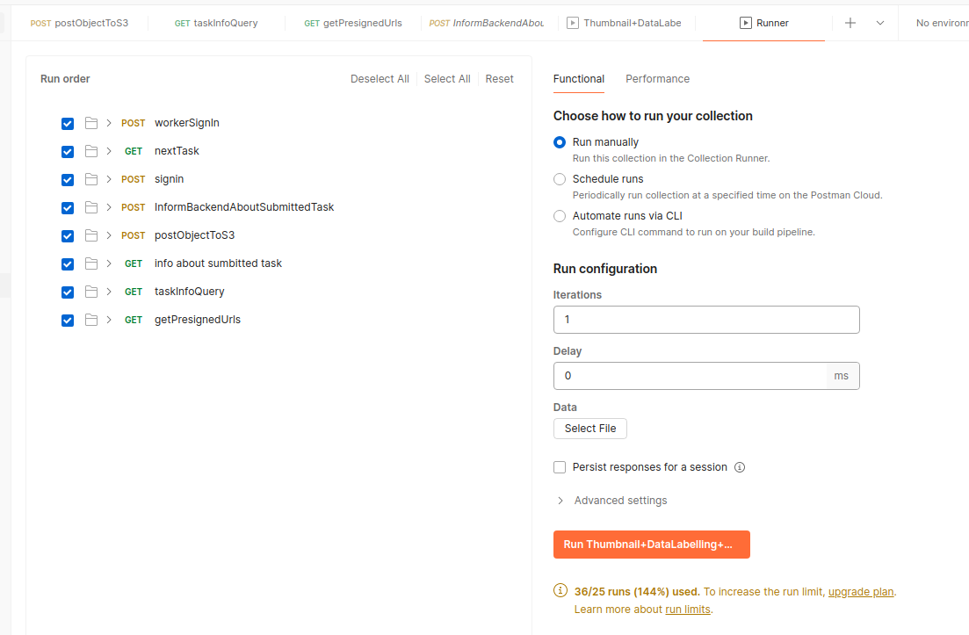
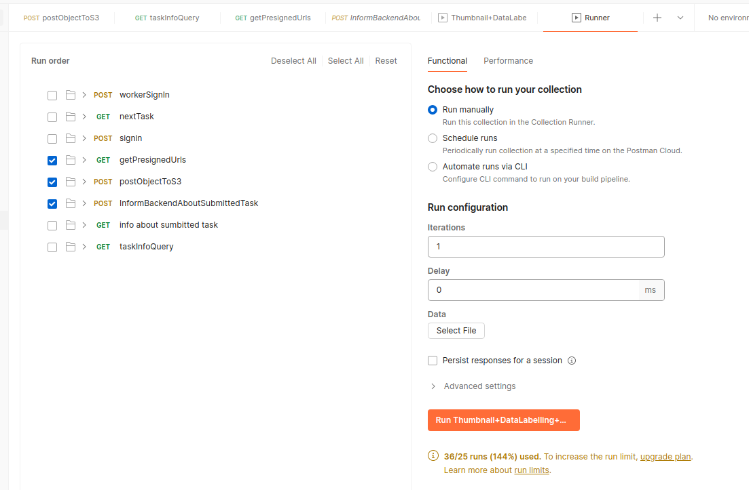
Select only the required and order them in the chronological order :

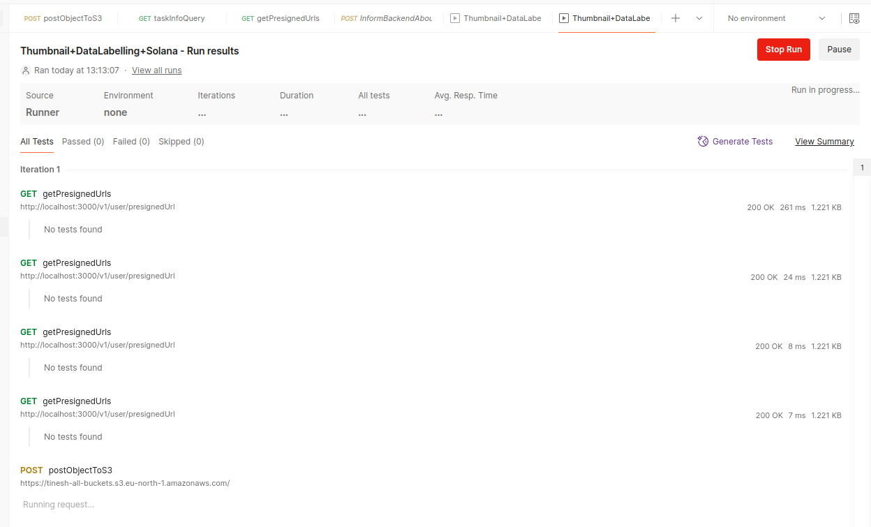

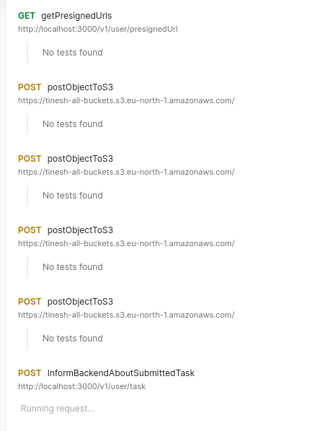

Next Comming soon..................

June 6

Global variable in Postman
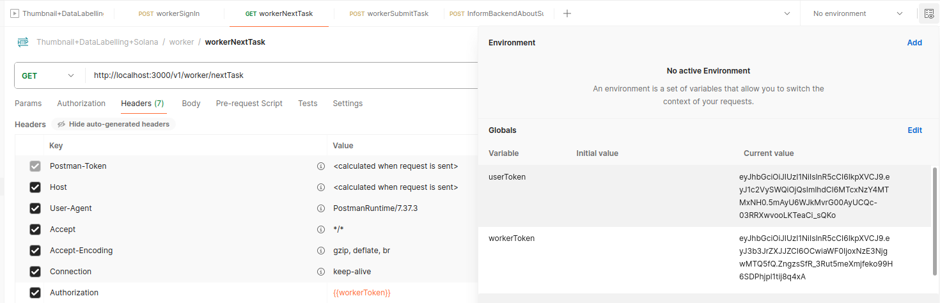

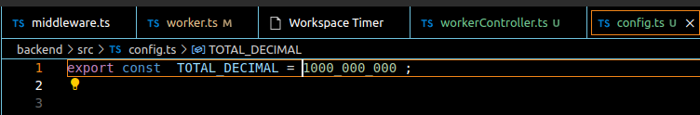
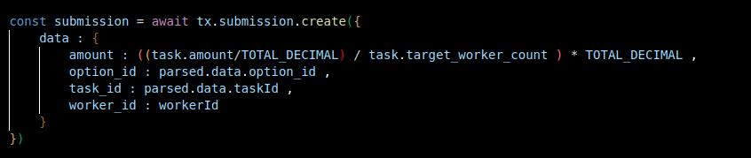
Storing Float Point values as Lamport to Avoid precision errors :
If we store in decimal points it will eventually comes at some point to bite as.............

Api Document :
Thumbnail+DataLabelling+Solana
﻿

worker
﻿

POST
workerSignIn
http://localhost:3000/v1/worker/signIn
Worker Sign In
This endpoint is used to sign in a worker.

Request Body

walletAddress (string, required): The wallet address of the worker.

Response
The response for this request can be documented as a JSON schema.

﻿

Body
raw (json)
json
{
"walletAddress" : "worker1WalletAdress"
}
GET
workerNextTask
http://localhost:3000/v1/worker/nextTask
This endpoint sends an HTTP GET request to fetch the next task for a worker. The response of this request can be documented as a JSON schema.

﻿

Request Headers
Authorization
{{workerToken}}
POST
workerSubmitTask
http://localhost:3000/v1/worker/submission
Worker Submission
This endpoint is used to submit worker data.

Request Body
taskId (number) - The ID of the task.

option_number (number) - The option number.

option_id (number) - The ID of the option.

Response
The response of this request follows the JSON schema below:

JSON
{
"type": "object",
"properties": {
"status": {
"type": "string"
},
"message": {
"type": "string"
}
}
}
﻿

Request Headers
Authorization
{{workerToken}}
Body
raw (json)
json
{
"taskId" : 10 ,
"option_number" : 1 ,
"option_id" : 25
}

GET
workerBalance
http://localhost:3000/v1/worker/balance
This endpoint sends an HTTP GET request to retrieve the balance of a worker. The response for this request can be documented as a JSON schema to provide a structured description of the response data format.

﻿

Request Headers
Authorization
{{workerToken}}
GET
payout
http://localhost:3000/v1/worker/payout
Worker Payout Details
This endpoint retrieves the details of the worker's payout.

Response
The response will be a JSON object with the following properties:

payoutId (string): The unique identifier for the payout.

amount (number): The amount of the payout.

currency (string): The currency in which the payout is made.

date (string): The date of the payout.

Example:

JSON
{
"payoutId": "12345",
"amount": 100.00,
"currency": "USD",
"date": "2022-01-01"
}
﻿

Request Headers
Authorization
{{workerToken}}
user
﻿

POST
signin
http://localhost:3000/v1/user/signin
﻿

Body
raw (json)
json
{
"walletAddress" : "user1WalletAddress"
}
POST
InformBackendAboutSubmittedTask
http://localhost:3000/v1/user/task
﻿

Request Headers
Authorization
{{userToken}}
Body
raw (json)
json
{{taskInfo}}
POST
postObjectToS3
https://tinesh-all-buckets.s3.eu-north-1.amazonaws.com/
﻿

Body
form-data
Content-Type
image/png
bucket
tinesh-all-buckets
X-Amz-Algorithm
{{X_Amz_Algorithm}}
X-Amz-Credential
{{X_Amz_Credential}}
X-Amz-Date
{{X_Amz_Date}}
key
{{key}}
Policy
{{Policy}}
X-Amz-Signature
{{X_Amz_Signature}}
file
/home/tinesh/PostmanFiles/Screenshot from 2024-04-10 21-21-25.png
GET
info about sumbitted task
http://localhost:3000/v1/user/task?taskId=13
﻿

Request Headers
Authorization
{{userToken}}
Query Params
taskId
13
GET
taskInfoQuery
﻿

GET
getPresignedUrls
http://localhost:3000/v1/user/presignedUrl

