Ultimate AWS Data Engineering Bootcamp: 15 Real-World Labs 3
Lab1: Batch data processing of music streams using Airflow & Redshift 3
Introduction: TechStack, Common Interview Quetions 3
Q. What is Data warehouse? 4
Q. What is redshift? 4
Q. Redshift Types (two types, how to choose)? 4
Q. What is Airflow? 5
Q. What is AWS Fully Managed Service? 5
Q. What is Airflow DAG? 5
Q. Airflow core features? 5
Lab1.1 Setup Redshift serverless 6
Lab1.2 Setup Airflow Environment on AWS 11
Lab1.3 local Python development with code 14
Lab1.4 Airflow DAG visual dataflow 15
Lab1.5 Airflow Dag code explanation 16
Lab1.6 End-to-end execution (实操是再细看步骤) 19
Improve this project: How to make it automatically? -> become my personal project 19
Lab2: Distributed music streams processing using Airflow, Spark & Dynamodb 19
Introduction: Tech Track, Interview Questions 19
Q. What is AWS Glue? 21
Introduction to DynamoDB 22
Q. What is DynamoDB? 22
Lab 2.1 Execute Pyspark locally using Glue Docker image 22
Lab 2.2 Delpoy the Pyspark code on AWS Glue 25
Lab 2.3 End to end Execution 25
Lab3: 25
Introduction: Tech Track, Interview Questions 25
Q. What is? 25
Lab3.1 25
Lab4: 25
Introduction: Tech Track, Interview Questions 25
Q. What is? 25
Lab4.1 25
Lab5: 25
Introduction: Tech Track, Interview Questions 25
Q. What is? 25
Lab5.1 25
Lab6: 25
Introduction: Tech Track, Interview Questions 25
Q. What is? 25
Lab6.1 25
Lab7: 25
Introduction: Tech Track, Interview Questions 26
Q. What is? 26
Lab7.1 26
Lab8: 26
Introduction: Tech Track, Interview Questions 26
Q. What is? 26
Lab8.1 26
Lab9: 26
Introduction: Tech Track, Interview Questions 26
Q. What is? 26
Lab9.1 26
Lab10: 26
Introduction: Tech Track, Interview Questions 26
Q. What is? 26
Lab10.1 26

Ultimate AWS Data Engineering Bootcamp: 15 Real-World Labs
Master AWS Data Engineering with hands-on Labs: Batch, Event driven and Real time data processing on AWS. Last updated 8/2024
https://www.udemy.com/course/ultimate-aws-data-engineering-bootcamp-with-real-world-labs/?utm_campaign=Search_Keyword_Alpha_Prof_la.ES_cc.ROW-Spanish&utm_source=google&utm_medium=paid-search&portfolio=ROW-Spanish&utm_audience=mx&utm_tactic=nb&utm_term=aws+certification&utm_content=g&funnel=&test=&gad_source=1&gad_campaignid=21487757262&gbraid=0AAAAADROdO0IR7VyPaB85nsz_CjsCI-P7&gclid=CjwKCAiA9aPKBhBhEiwAyz82J1iiIPXFgKc33ftD952LAlvEwDVjaRy6iP8kjhJMkpwhYHxgOmXW5BoCjgoQAvD_BwE&couponCode=PMNVD1525
IT & SoftwareOther IT & SoftwareAWS cloud

Github source code: https://github.com/sidoncloud/udemy-aws-de-labs
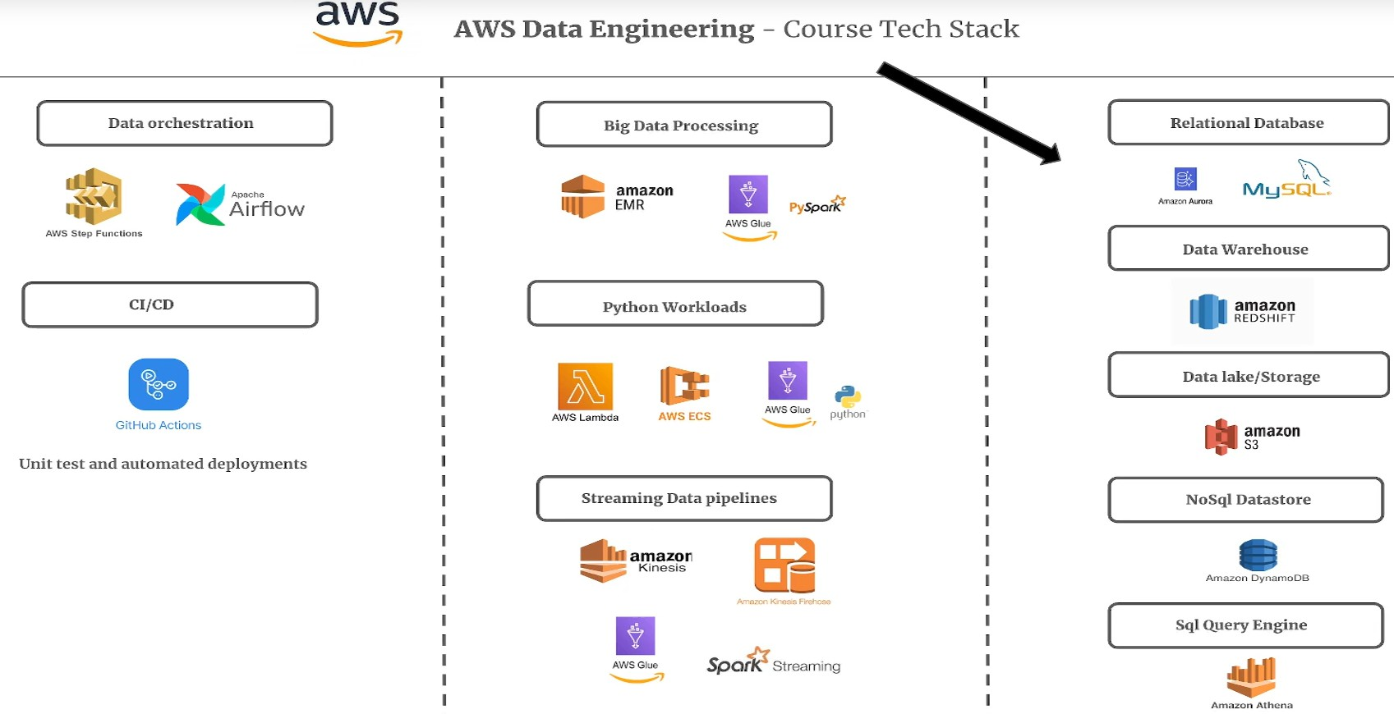
Install docker engine and aws CLI

Lab1: Batch data processing of music streams using Airflow & Redshift
Imagine you are working in a Music streaming platform where has thousands users streaming music. For reporting and analytical use cases.

Introduction: TechStack, Common Interview Quetions
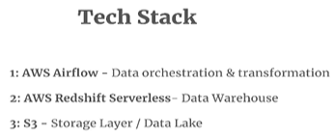
4. Python pandas – data cleaning, transformation

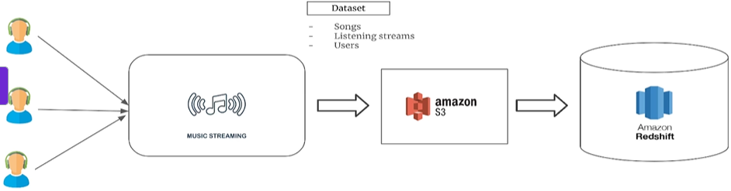
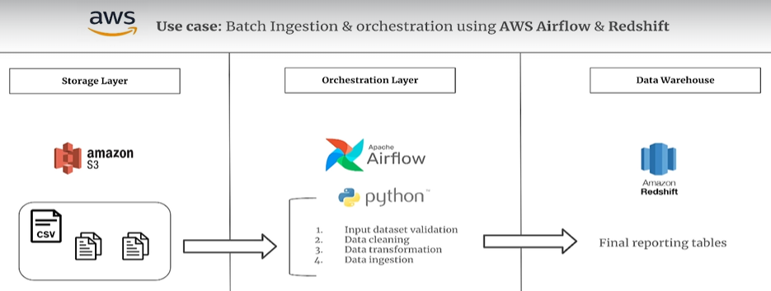

Q. What is Data warehouse?
A data warehouse is a centralized repository that stores large volumes of data from different sources. And the whole purpose of a data warehouse is to support reporting, data analysis, and data science, thus contributing to the overall decision making, which is driven by data, essentially.

Q. What is redshift?

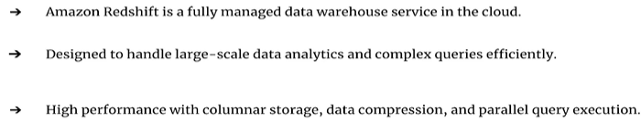

just like airflow on AWS, which is a managed service. Redshift is also a managed service, meaning once you set up redshift on AWS, all you do is use it for your analytical workloads without worrying about the underlying maintenance or infrastructure.
Redshift is also Columnar, meaning the data is stored in the form of columns as opposed to rows, which is more for traditional relational databases like MySQL, SQL server, and the like.

Q. Redshift Types (two types, how to choose)?
Now, when it comes to actually using redshift. you have two types.
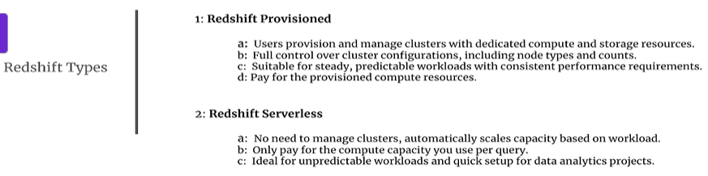
With provisioned redshift, you need to set up dedicated compute and storage resources, which means you will have full control over your cluster configurations, including the node types, the Ram, the CPU, the storage of each nodes, and the number of nodes you want for your cluster. Provisioned redshift is ideal if your workloads are predictable and consistent. Meaning if you know for a fact that the size of the data and bandwidth used by your pipelines won't change drastically over a period of time, then redshift provision makes a lot of sense.

Q. What is Airflow?
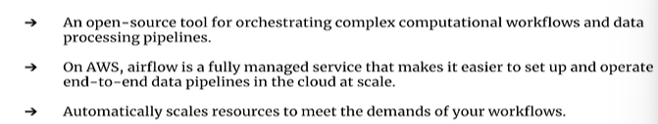
Airflow is an open source framework for orchestrating workflows and data processing pipelines.
Now, when we speak about airflow on AWS, it's also known as MWAA, which stands for Amazon Managed
Workflows for Apache Airflow. Refers to a fully managed airflow service running on AWS.
Managed airflow on AWS even allows you to automatically scale up the number of worker nodes as the demand increases, and when the demand goes down, it can automatically tear down the worker nodes, and this feature makes airflow extremely cost effective.

Q. What is AWS Fully Managed Service?
When you hear the term managed on any cloud, not just AWS, it basically means the service is fully managed by that cloud provider, meaning you don't need to worry about the provisioning, setting up of the underlying servers, installing the frameworks or any softwares and the related networking aspects as well. The entire maintenance of the underlying infrastructure, including the software installation, updates and patches, is handled by the cloud provider itself.
All you need to do is set up the service the way you want it, which can be done either using the web console or the command line, and that's pretty much it. In general, using managed services on cloud makes it easier to set up and operate end to end data pipelines at scale and even for software development.

Q. What is Airflow DAG?
Dag which is directed acyclic graph. Dag is a collection of all the tasks you want to run in one single pipeline or workflow.
And these tasks within a Dag are organized in a way that reflects their relationships and dependencies.

Now let's look at this example on the slide where you have one workflow or one pipeline in one single
Dag containing four tasks. the flow is sequential from tasks one through four, where each task depends on the completion of the previous task.

Q. Airflow core features?
we'll be implementing some core features of airflow, which are extremely crucial for
anyone who wants to deploy production level pipelines on airflow. (Hooks, Operators, Xcoms)
Hooks are interfaces to external systems, such as storage layers or databases. They make it easy for you to interact with external systems in a reusable manner.
For example, you have MySQL hooks which let you connect to a MySQL database within your airflow tasks. Similarly, you have S3 hooks, DynamoDB hooks, and so forth.

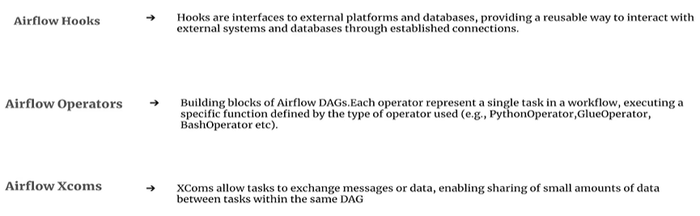
e.g. Python operator -> to invoke a simple Python function.
a glue operator -> invoke a glue job which you've deployed.

Lab1.1 Setup Redshift serverless
you don't really provision any clusters or nodes. We will create a work group and a namespace. The whole idea behind work groups and namespaces is resource allocation or resource segregation, meaning you can have multiple work groups and namespaces, and have different compute storage, users, databases allocated to each one of them. So it's basically for a resource allocation and segregation depending on your workloads.
You're not paying for creating work groups and namespaces. You only pay when you execute queries in redshift serverless.

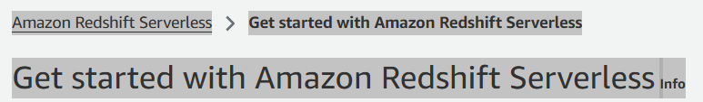
To start using Amazon Redshift Serverless, set up your serverless data warehouse and create a database.
When you create and use your serverless data warehouse for the first time, a $300 credit toward Redshift Serverless usage is applied to the account.
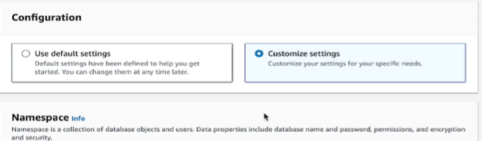

1. created a work group and a namespace
1.1 namespace. Default name

Admin User name: admin, password. make sure you store this password safely somewhere because you will need it later when we connect to redshift using our pipelines.
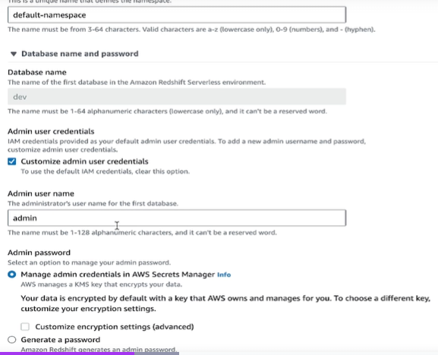

Under permissions
I am going to click on this drop down and say create an IAM role.
Select any S3 bucket And select create IAM role. Now you can also make a note of this role because we might add permissions and policies to this role later on. Once you created IAM role, check the box.
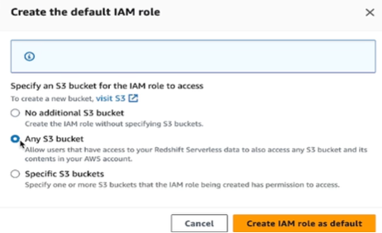
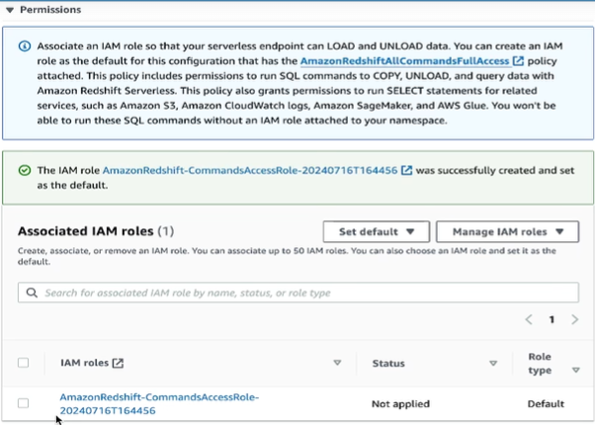

1.2 Workgroup. Default name

Base capacity. -> starting from eight all the way to 512. select eight, which means we are selecting or allocating eight RPUs or redshift processing units, where each processing unit comes with 16 gigs of memory, which is quite a lot if you think about it.
And also considering the the workloads that will be executing throughout this course in redshift the
lowest value is more than sufficient.

Network and security
default VPC (virtual private clous).
default VPC security group and the default Subnet under the security group and VPC.
So in case you don't see the default subnets selected just click on this drop down and select all the
subnets here.
Save Configuration. -> Create serverless -> After a couple of mimuntes -> The serverless environment has been created.

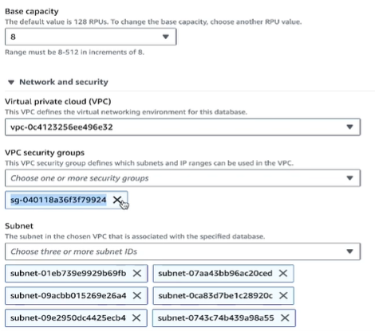

Extra screenshots when 实际操作时：
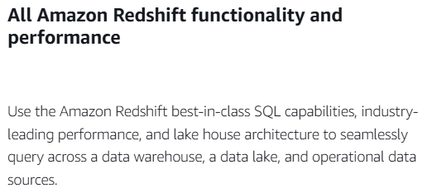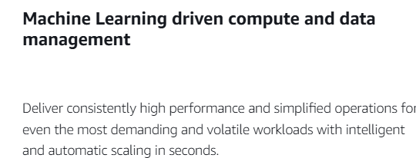

2. reload this page (Serverless dashboard) to check
reload this page. -> You will see your default namespace and work group, an option to query data. this is your query editor is called V2 editor(Redshift query editor V2).
when 实际操作时：
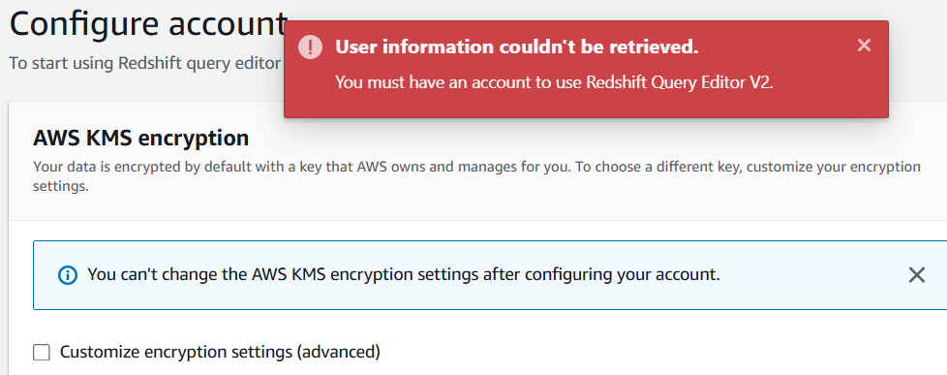
Configure account

(left, is default work group, you will see a sample databases) : running SQL queries in redshift.
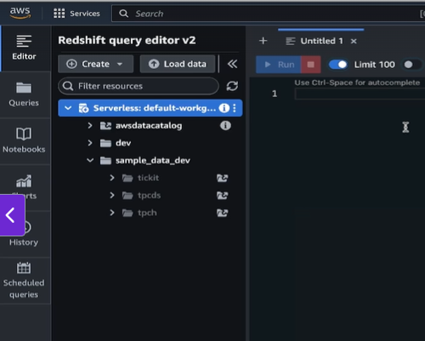

3. tweak the accessibility settings of redshift
3.1 turn on the publicly accessible
go back to the redshift console and click on the work group.
down here under the Data Access tab. Under Networking Security, you will see the publicly accessible setting which is turned off by default. And we need to turn this on.
And the reason behind this is because our scripts, either from airflow or any other framework, will
need to connect to redshift, right? For which this setting needs to be turned on.
3.2 VPC security group-> inbound rules -> add rule (allow incoming connections on port 5439)
click on the VPC security group under the same tab. And now we are going to allow incoming connections on port 5439, which is the port on which redshift runs.

click on the VPC security group. And now I'm going to select the group ID.
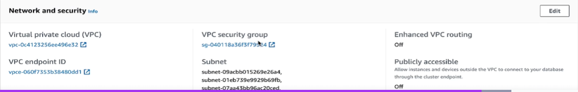
And this is my security group that I have been using for other purposes as well. But in your case you might not see so many rules by default.
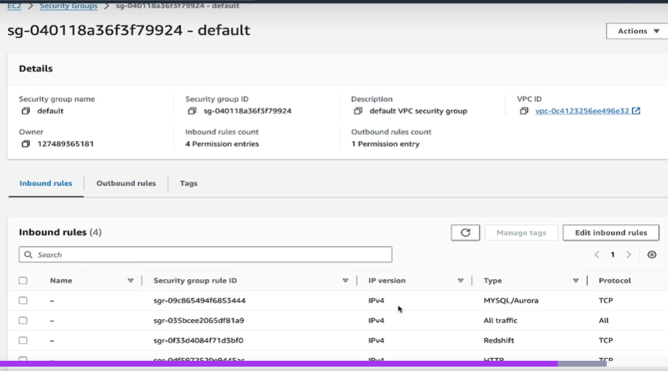
So under inbound rules, select Edit Inbound rules.
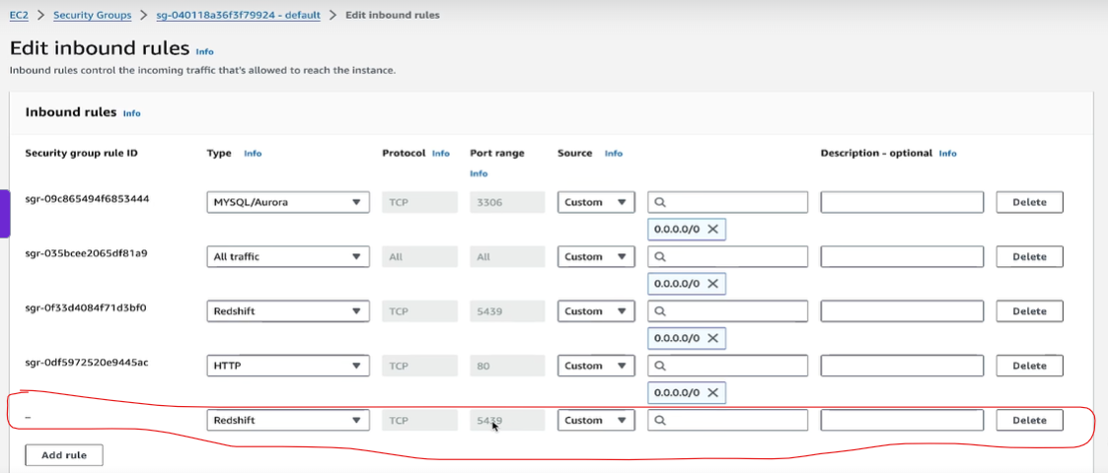
Now you've got to click on Add Rule and from the drop down select redshift.
As soon as you select redshift you will see the port is auto populated to 5439. Because that's the redshift port.
And under source you can just select 0.0.0.0, which basically means you are allowing incoming connections
from everywhere from across the globe to your redshift. Now this is not recommended in a production level environment, but since this is for the sake of completion of the labs for this course, it should be okay.
And also, it's not the worst setting because in order to connect to redshift, you will still need to authenticate yourself using the username and password. So just click on it and then add the rule and then click on Save rules.
That should be it.
I'm not going to do it because I've already added the the rule here. So I'm just going to delete it and click on cancel.

Study Note1: price of Redshift?? serverless: only pay for running time
https://calculator.aws/#/createCalculator/Redshift?refid=3b4be86f-331f-4790-b4fe-8abf35448c27
From amazon:
Amazon Redshift offers two deployment options: Provisioned and Serverless. Redshift Provisioned starts at $0.543 per hour, while Redshift Serverless begins at $1.50 per hour.
Redshift Serverless: You pay for the workloads you run in RPU-hours on a per-second basis (with a 60-second minimum charge), including queries that access data in open file formats in Amazon S3. There is no charge for data warehouse startup time. Automatic scaling and comprehensive security capabilities are included.
Redshift Serverless automatically manages capacity by starting up, shutting down, and scaling based on your application’s needs. You pay only for compute capacity on a per-second basis, with no charges during idle periods. Redshift Serverless also offers Serverless Reservations, managed at the AWS payer account level and shareable between multiple AWS accounts, reducing compute costs by up to 24% on all Redshift Serverless workloads.
From google AI:
1. Amazon Redshift Serverless
This is best for unpredictable or "spiky" workloads. You pay only for the compute capacity you consume when the warehouse is active.
- Compute: ~$0.375 per RPU-hour (Redshift Processing Unit), billed per second with a 60-second minimum. 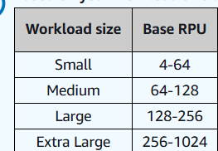
- Storage: ~$0.024 per GB-month (Redshift Managed Storage).
2. Provisioned Clusters
Ideal for steady-state workloads with predictable demand. You choose specific node types and pay an hourly rate.
- Dense Compute (DC2): Starts at $0.25/hour for a dc2.large node (best for datasets under 1TB).
- RA3 Nodes: Starts at $0.543/hour for ra3.large. These nodes allow you to pay for compute and storage independently.
- Managed Storage (RA3): Fixed rate of $0.024 per GB-month.
3. Savings & Add-ons
- Reserved Instances: Committing to a 1- or 3-year term can save you up to 75% compared to on-demand pricing.
- Redshift Spectrum: Query data directly in S3 for $5.00 per terabyte scanned.
- Concurrency Scaling: Provisioned clusters get 1 free hour of scaling credits per day; excess is billed at your cluster's on-demand rate per second.
- Redshift ML: Training is billed based on "cells" processed, starting at $20 per million cells for the first 10 million.
For an exact estimate based on your specific region and data volume, you can use the AWS Pricing Calculator.
Note: If you are looking for the Redshift 3D Renderer by Maxon, it is typically sold as a subscription starting around $22/month or as part of the Maxon One bundle.

Lab1.2 Setup Airflow Environment on AWS -AWS has problems.
实操：Desn’t work!! “Create environment has bugs”. Create workflow can’t set up Amazon SageMaker Unified Studio

EC2 price:
On-Demand Pricing
On-Demand Instances let you pay for compute capacity by the hour or second (minimum of 60 seconds) with no long-term commitments. This frees you from the costs and complexities of planning, purchasing, and maintaining hardware and transforms what are commonly large fixed costs into much smaller variable costs.
To save money on Amazon EC2, you can "pause" instances("Stop instance.") by stopping them when not in use, which stops hourly compute charges (EBS storage costs still apply). Manually stop them via the Console, or automate this using AWS Instance Scheduler, Lambda functions with EventBridge, or CloudWatch alarms for idle instances.
If you terminate your instance, it's gone - you can't get it back (unless you made an AMI image or a volume snapshot).
Shutting it down, does allow you to turn it back on in the same state the next day. However, the mere existence of it costs, far less when it's not running, but still you pay for the storage you use it.
So it's a bit hard to generalize, but in most cases don't terminate your instance every day only to launch it next day. Just make sure to shut it down when you finish and you are able to continue where you left off. That would be a personal opinion based on my own experience, if course - your case might be different.

StudyNotes based on Udemy video:
set up our airflow environment on AWS with airflow. it's not a serverless offering from AWS. We have to set up the environment with the basic configuration.
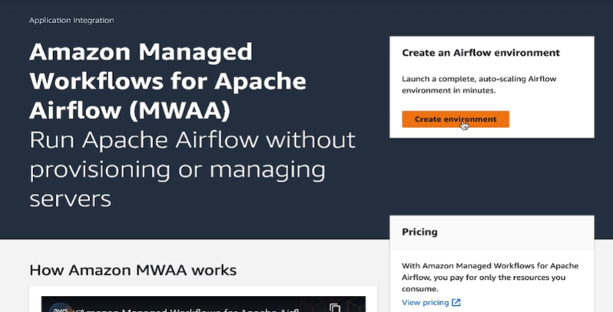
Create Environment. ->
Step1. Specify details
Environment details> give our environment a name.
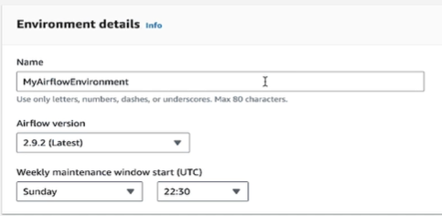
DAG code in Amazon S3 -> specify an S3 bucket.
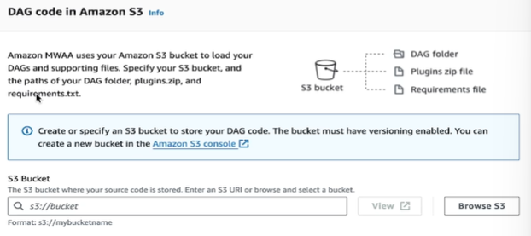

I've already created a bucket (nl-airflow-dags). So go ahead and create a bucket or you can use the existing one.
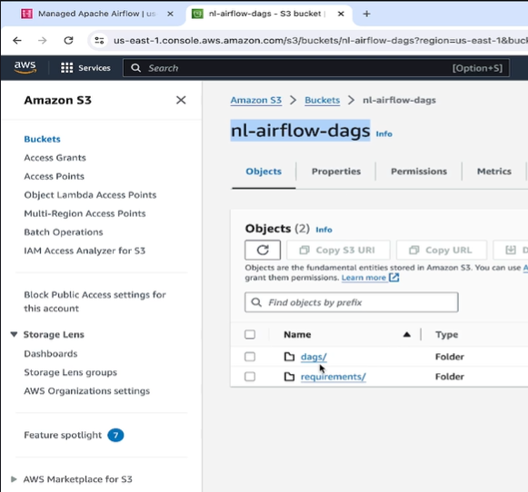
Now inside of this nl-airflow-dags bucket, create two folders dags and requirements.
Now the DAGs folder can be empty for the time being, but inside requirements.
Upload the requirements.txt file and this txt file will only have one library that we need installed
at runtime, which is pandas. So once you're done with that, you can come back and just type the bucket name.
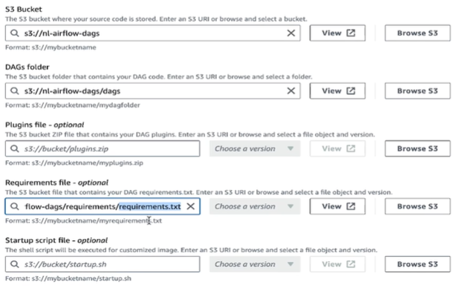
Next ->
Step2. Configure advanced settings
Under Neworking > Virtual private clouds(VPC) -> Create MWAA VPC new tab(Provide a Stack name create stack )
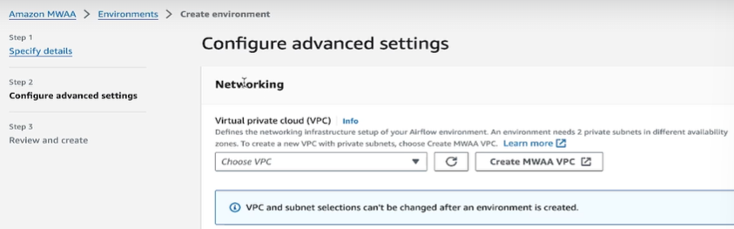
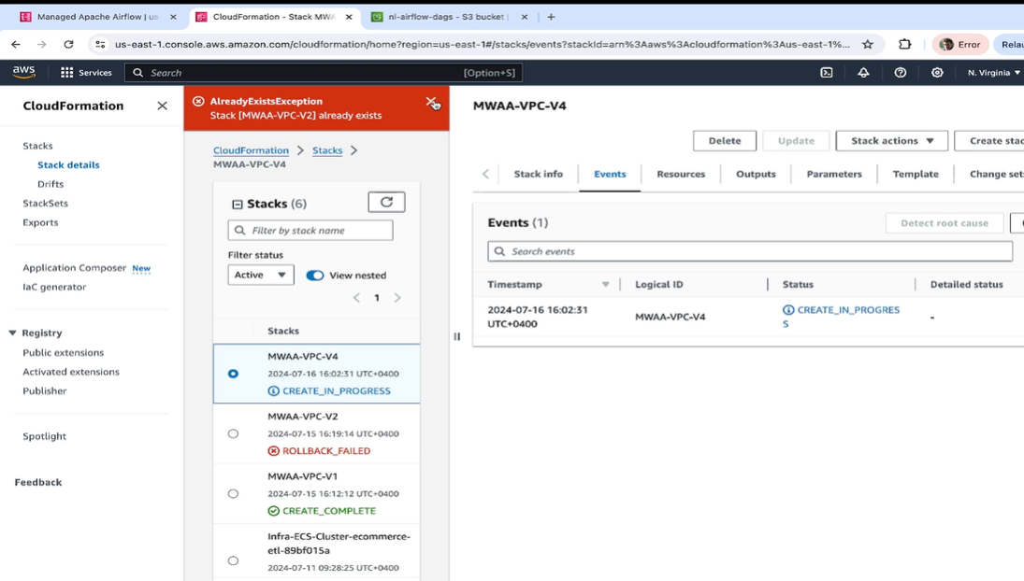
-> once it’s done, go back Step2, Networking>VPC (select the vpc just created);
Web server access: select Public network(internet accessible)
Security groups : select Create new security group
Environment class: select mw1.small; Maximum worker count: 3 (this does not mean three worker nodes will be spun up at the time of creation of your airflow environment. This means your air flow, If the demand goes up, we'll scale up to three worker nodes. And that's only when the demand goes up. So by default it's just going to keep one worker node alive which is the minimum worker count. )
Permissions: Execution role> Create a new role; Role name: xxx ; -> next

Step3: Review and create -> create environment
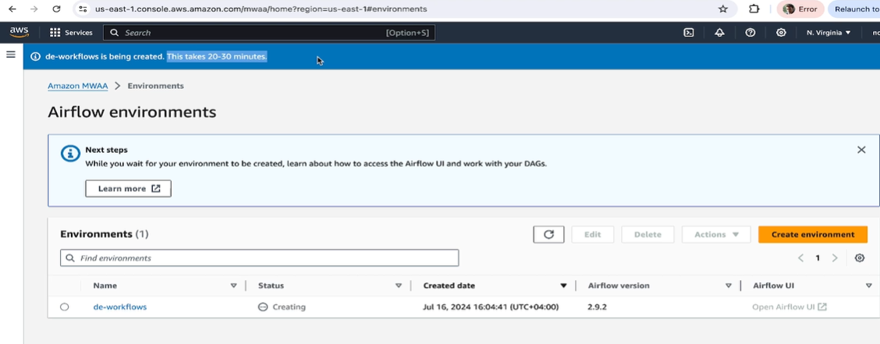

Study Note1: price of Airflow on AWS?? Hourly rate
The service is priced hourly based on environment size (Small/Medium/Large/XL) and additional worker/scheduler usage ($0.055–$0.44+ per hour).
Amazon Managed Workflows for Apache Airflow (MWAA) costs approximately $500–$600+ per month for a typical small-to-medium production environment, with prices depending on worker count, scheduler instances, and region.
Key Pricing Components for AWS MWAA (US East - N. Virginia):
- Environment Charge: Covers the web server and base components. Small environments start around $0.49/hour, Medium at $0.74/hour, and Large at $0.99/hour.
- Worker Costs: Additional workers for scaling tasks are billed by the hour, costing approximately $0.055/hour for small workers.
- Scheduler Costs: Extra schedulers (beyond the included amount) cost around $0.055/hour for small.
- Metadata DB/Storage: Costs are minimal, roughly $0.10 per GB-month.
Cost-Saving Tips:
- Small Environment: Using a mw1.small environment is the cheapest entry point ($0.49/hour).
- Auto-scaling: Configure minimum workers to 1 to reduce idle costs.
- Alternative Deployment: Self-managing Airflow on EC2 can be cheaper but increases operational overhead.
You pay for the time your Airflow Environment runs plus any additional auto-scaling to provide more worker or web server capacity.

Study Note2: if i have scheduler in airflow every day, should I keep airflow running?
Yes, you need to keep your Apache Airflow environment (scheduler, webserver, and workers) running continuously for it to operate as intended and execute your daily scheduled tasks reliably [1].
Here is a breakdown of why:
- The Scheduler is the Engine: The Airflow scheduler is a persistent service that continuously monitors all Directed Acyclic Graphs (DAGs), evaluates their schedules, and triggers tasks when their dependencies are met [1]. If the scheduler is not running, no new tasks will be enqueued, and no existing tasks will start.
- Persistent Services: Airflow is designed as a platform with long-running components, not as a command-line tool you run once a day [1]. It relies on these background services to manage its state, schedule, and execute workflows.
- Webserver and Workers: The webserver is necessary for monitoring the status of your tasks and viewing logs, while workers (like the Celery worker or KubernetesPodOperator in a production setup) are needed to actually run the task logic [1].
In summary: If you stop the Airflow services, the daily scheduled tasks will not run. To ensure your workflows execute every day, maintain the continuous operation of your Airflow environment.

Lab1.3 local Python development with code (pandas->need practicing pandas coding)
In a typical scenario, you develop the transformation logic using Python with pandas or Pyarrow or
any other framework in your local environment first, and once you're sure of it, you deploy it to
cloud. understand the output of the transformation logic by executing the scripts locally
from your system before deploying it to airflow.
Local system: Jupyter notebooks with python and pandas

the data folder contains the input CSV files.
so you have the song CSV, which contains a bunch of song attributes such as the song name, artist name, album name, duration of the song, a unique identifier
called track ID for every song, and so forth.
Then you have users dot CSV, which contains the details of the users who have signed up in your platform.
And finally, you have the streams split into three files. Now streams contains the details of the songs which the users have streamed or listened to. And streams dataset is quite simple. All it has is the user ID, the track ID and the listen time indicating the timestamp at which that user stream that specific track or song.
Now you can open up these CSV files and just glance through them so you have a basic understanding of
the input data structure.

So for now, I'm going to open up a Jupyter notebook by navigating into this folder, which is local
development. So you can see there are two IPython notebooks here.

The genre level KPIs, as the name suggests, calculates some metrics on a date and songs genre level.
Right.
So you can see I'm reading the two required CSV file songs and streams into a pandas dataframe, and
then we apply a bunch of transformations to it.
So if I run this code block and finally the data frame dot head, you will see the final output here.
So you have the listen date which can be thought of as the report date. You have the genre the number of times the track was streamed, popularity index, average duration, and the track ID or the most popular track ID.
So this is the final data frame of the first set of transformations.

Similarly, you have hourly KPIs, which makes use of all three data sets.
Now this transform these transformations, they calculate metrics on an hour level like I mentioned.
So we read the input CSV files into the data frame. And then we have df.head.
And this is your final output from Ali. So you have the date the hour and all other metrics which are calculated on an hourly and daily basis. Because you have unique listeners, top artists, listen counts, average sessions, diversity index and finally most engaged age groups. So these are our final set of metrics.
Just execute both these scripts locally and most importantly go through the transformations so you have
a basic understanding of it.
To summarize the two output data frames that we have seen one in Ali KPIs and the other one is this
one.
These two data frames are going to be our final result sets, which will be written into redshift tables.
And the transformations that we just executed locally will be happening inside of airflow scripts.

Lab1.4 Airflow DAG visual dataflow

The input datasets that we saw in the previous lecture will be actually residing in an S3 bucket.
Our pipeline is going to be one single Dag, meaning one single Python script deployed in airflow,
which will have three major tasks.

The first task, which is called validate input files, will read the input files from S3, and this
task is going to check if the necessary columns exist in the files or not.
This validation result will be passed to the next task via Xcom.
The next task is the one that says check conditions, and this one is more like a branch which decides
what to do next.
If the validation results have failed, then this task will end the Dag by calling the end Dag dummy
operator.
And if the validation looks fine, meaning if the files have the necessary columns, then it's going
to invoke the next task, which performed the necessary transformations, which we have already executed
locally, and it's going to write the transformed data into the respective redshift tables.
So that's the high level flow of our Dag.

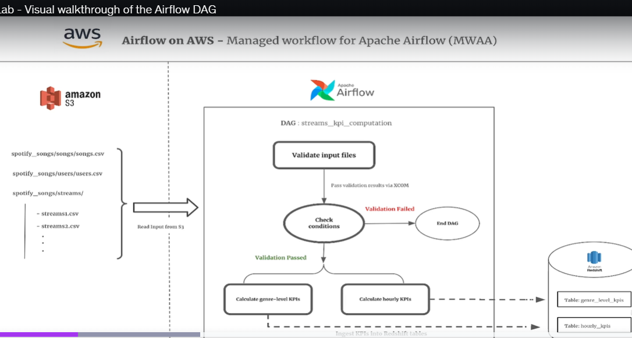

Now let's understand how we will use the hooks and operators.
As we already know, hooks are nothing but interfaces to external systems, right?
And if you think about it, the only external system that's involved in this lab is redshift.
So in order to write the transform data to redshift, we'll be using PostgreSQL hooks. Keep in mind redshift is PostgreSQL compatible and hence we'll use the PostgreSQL hook. And also there is no such thing as redshift hook in airflow.
Coming to operators, like I mentioned, can be thought of as a block that executes a specific
task. Since we'll be encapsulating our data transformation logic to calculate the necessary metrics along
with the data set validation and also branching in four different Python functions, we will be using
Python operators throughout this lab.

Lab1.5 Airflow Dag code explanation
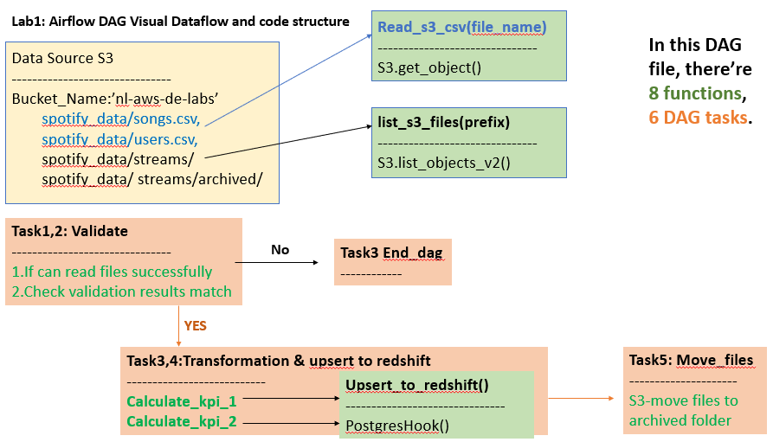
importing the necessary libraries:

Python operator branch.
Operator.
Dummy operator.
We import the hook the PostgreSQL hook in order to connect to redshift.
Pandas for data transformation Boto3.
As we are utilizing the AWS resources using Python, we need Boto3 and then logging.
We then define a bunch of default arguments that will be passed to our Dag.
We have some constants here, such as the bucket name.
Make sure to change the name of your bucket on line number 22.
Then we have the path to where we will keep the songs file, which is going to be inside Spotify data
followed by the name of the file songs dot csv.
Similarly, you have users dot CSV, and if you pay attention for streams, we have not specified the
path because streams will be read dynamically.
Now this means any file that's inside of the streams folder will be considered for processing and ingestion
into redshift, and then we have something called arXiv or arXiv prefix.
This is where the streams file, after being processed and ingested into redshift, will be moved.
So once the data is ingested from the streams folder into redshift, we're going to move it and place
it inside the archive folder.

So this is to ensure the same file does not get processed again unnecessarily.
And we have a Python dictionary called required columns which has a set of key value pairs.
Now the key is the name of the data set.
And the value is the set of input attributes that's supposed to exist in each of the data sets, which
basically means songs is supposed to have all these input columns.
Similarly, you have streams and users.
We then have a couple of utility functions which are being invoked in the subsequent functions.
Now let's scroll all the way down to where the Dag begins.
So on line 255 you will see the Dag execution starts.
It's called data validation and KPI computation.
You can change the name as you wish.
We pass the default arguments to it, and it is scheduled to run every day.
The very first task inside this Dag is called Validate datasets, which invokes the function validate
datasets, and you can see how I'm invoking it using the argument Python callable.
So this is the name of the function that will be invoked.
And this is just the unique identifier for that task.
So let's go to validate datasets which is a function defined above.
And you can see this function is pure and simple Python.
All it does is return a Python dictionary with a set of key value pairs.
The key is going to be the name of the dataset, and the value is going to be true or false, depending
on whether the validation for that dataset passed or failed.
So this is going to return true for all the three datasets if the required columns exist in the CSV
files.
So you can see I'm validating the songs dataset the users dataset.
And finally you have the streams.
And what's returned is a simple Python dictionary.
So that's your first task.

And next we have a task called check validation, which invokes a function called branch task.
And if you pay attention, you will see a new argument here called provide context.
The value of which is set to true.
Now this basically means we're using Xcom in order to pass data between these two tasks.
All right.
So if you set the value of provide context to true, this is going to pass a task instance to the function
that is being invoked which in this case is branch task.
So let's go to this function.
And you can see there's an input argument called t which stands for task instance.
You can change the name or call it whatever you want.
And using T I am invoking Xcom underscore pool in order to pull the value which is returned by this
task, which is validate data sets.
All right.
So if you remember validate data sets returns a Python dictionary called validation results.
And using Xcom underscore pool I'm able to access it and store it inside a Python variable called validation
results.
And in the next line, all I'm doing is checking if the validation has passed, and if all the three
data sets have been validated successfully, then this function is going to return a string called calculate
genre level KPIs.
It's a string, and if any of the three data sets fail, then it's going to end the Dag, which basically
means it's going to return a string called end Dag.
And we'll see how the strings string values are being used.
So after validating the data sets and calling the branch operator, the next two tasks have our data
transformation logic that we've already seen and executed from our local system.
Right.
So you have the calculate genre level KPIs and the hourly KPIs.
So let me go to this function.
Which is right here.
And it's quite simple.
It's the same line of codes.
It's just that by leading we are reading the input files from S3 as opposed to reading from a local
system.
That's the only difference.
And right at the end you will see I'm invoking a function called upsert to redshift, and this function
writes the data into the respective redshift table, which in this case is genre level KPIs.
All right.
So the insert is not a straightforward insert.
It's an absurd merge operation.
So if you go to this function you will see it accepts a panda's data frame, the name of the table and
the ID columns on which to join.
We're using the PostgreSQL hook here and we pass the connection ID to the hook.
It's called redshift underscore default.
And this is a connection that we have not created yet.
We will create the connection using the airflow UI when we get to the execution of it.
So we define the the hook.
We create a connection.
We create a cursor.
And this is where the execution begins.
So at first every time a new batch of data arrives, we ingest that data into a temp table for that
respective table.
All right.
So it's temp underscore table name, whatever the table name is at the genre level KPIs or hourly KPIs.
Now once the data is ingested into the temp table then we begin our transaction.
So we delete from the main table using the temp table on the delete conditions, and once the data has
been deleted from the main table, we ingest into the main table using the data from the temp table.
All right.
And finally we truncate the temp table and commit the transaction.
So that's what's happening inside Upsert to redshift.
Let's go further down now.
So these are the two tasks which is which are performing the data transformation logic and ingesting
it into redshift.
And then we have something called move files which is a task which invokes the function move processed
files.
All it does is moves the file from the streams directory into the archive folder, as I already mentioned
before.
And finally you have the n dag which does nothing but ends the dag.
That's pretty much it.
The last two lines are quite important.
This, um, greater than sign that you see here is called a task dependency operator, which is used
to set dependency between two tasks.
Now this line means check validation depends on validated datasets, obviously, because it is expecting
the validation results from this task.
Right.
And after check validation, which is basically a branching condition, we pass two tasks to it in a
Python list.
Now depending on what is returned by the check validation, if you remember this function branch task
returns two possible strings right depending on the validation result.
So if it passes the string calculate genre level KPIs, then this task is going to be invoked next.
And if it returns end string then n dag is going to be invoked.
All right.
Now in case calculate genre level KPIs is going to be the next task after check validation.
Then the task after that will be calculate all the KPIs.
And finally you have move files where we move the process files from streams to archive.
So that was your Dag execution in airflow.

Next up we will deploy this to our S3 bucket and execute it inside of airflow.

Lab1.6 End-to-end execution (实操时再细看步骤)

Redshift > create db, tables run Airflow DAG(tasks)
（+aws access settings）

Next plan: Improve this project automatically
How to make it automatically? -> become a personal project
1. 结合Zoomcamp, 升级下这个project (terraform, automatically)
2. 使用不同的data, 重做下升级后的project. 但需要 local develop python code(transform, columns, metrics).

StudyNotes: Steps for code part of this project from scratch
Data:
Goal: get kpi
Write code:
- 1. local development: jupyter notebook to do with data using pandas.
Genre-level-kpis.ipynb: import libraries(pandas) -> pd.read_csv(‘./xx.csv’) -> get a glance at the data, check columns, data type: (.head(5) .info()) -> prepare data for calculation: cast column type, extract useful data from raw data -> compute kpis > get results as a dataframe table.
Hourly-kpis.ipynb: similar, but calculate different kpis
Drew data ERD in ppt

- 2. organize code into python.
Organize code or repeat code into functions for reuse.

- 3. DAG
Get data from S3 -> check data -> data validation -> caculate Genre-level-kpis -> calculate Hourly-kpis -> ingest result table into data warehouse (redshift)

Lab2: Distributed music streams processing using Airflow, Spark, AWS Glue & Dynamodb

Introduction: Tech Track, Interview Questions
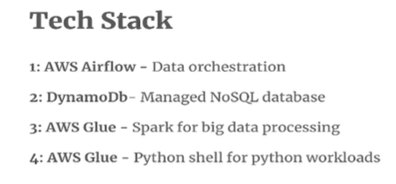
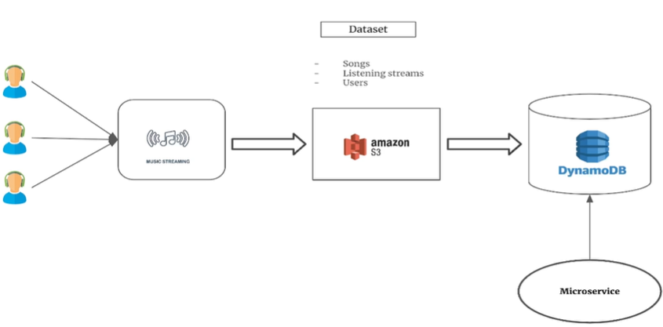

In the last lab, we saw how to use airflow for orchestration and data transformation both. But a lot of times it only makes sense to use airflow for what it's mainly meant for, which is data orchestration, and keep the heavy lifting data transformation bit outside of airflow. And that's exactly what we'll be doing in this lab.
In this lab, we'll be using airflow purely for data orchestration. DynamoDB is going to be a database. And we'll be using glue for data transformation.
Now glue on AWS is an ecosystem in itself. It has a lot of services. (An ecosystem is a community where living organisms (biotic) interact with each other and their non-living environment (abiotic) like soil, water, and sunlight) But when it comes to data transformation, using Spark and Python, you have two options which are widely used. And if you're going to be working on AWS, then there's no way to avoid either of these because they can come in extremely handy. The two variants on glue are spark jobs and Python shell jobs, and as the name suggests, glue for spark is used for running spark jobs both batch and streaming, while Python Shell is for running Python workloads.
In this lab. We'll be making use of both of these.

Scenario: So imagine a scenario where the data arrives from a music streaming platform, or the back end of the platform in random intervals to your S3 bucket, and your objective is to perform transformations on
these data sets in order to calculate some metrics and make these metrics available to a downstream
microservice application as soon as possible.
Keep in mind this is not a batch ETL or batch transformation or BI reporting requirement. Here, the catch is that you don't know how frequently the files will arrive to your S3 bucket. It could be every 20 minutes, every ten minutes, maybe an hour even. And the business requirements are such that the metrics need to be made available not too long after the data arrives to your S3 bucket. 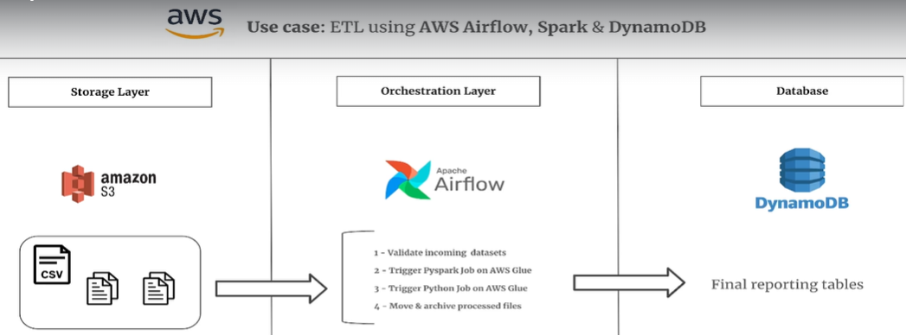
So our storage layer is going to be S3.
Airflow is going to be used for orchestration. And the airflow Dag will have a sequence of steps or tasks, as we've seen in the previous lab. The first task will validate the incoming data sets from S3, meaning it will make sure the necessary columns, which are required for data transformation exist in the data sets. If these data sets are valid, it will trigger a PySpark job, which we will deploy on AWS glue followed by another glue job which will purely run Python scripts. The last task in the airflow, Dag will move and archive the processed files into a separate archive folder.
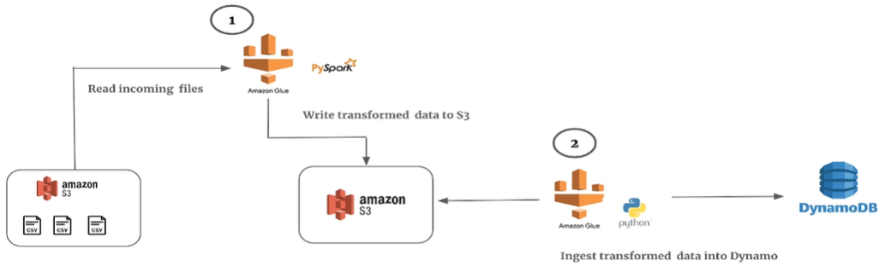
Now let's look at what the spark job and python shell job deployed on AWS glue will be handling.
So the spark job will read the incoming files containing the streams from S3. It will perform the necessary transformations in order to calculate some metrics, and write the output to a different directory in an S3 bucket. So that's the job of PySpark here.
The second glue job, which is running Python script, will just read the output of the spark job, which are the metrics, and ingest them into DynamoDB tables.
So you can see spark is just doing what it's supposed to do, which is heavy lifting and distributed
data processing, and it simply writes the output to S3. You can also handle the logic of writing the transform output within your spark script directly to DynamoDB tables, but that might not be very cost effective. Keep in mind with spark on AWS glue, you're paying for the execution time and it can get very expensive. A simple Python job is good enough to read the data from S3, reshape or rename any columns wherever necessary, and write this data into DynamoDB tables. Also, the cost of running Python jobs on glue is negligible in comparison to running spark jobs.

Q. What is AWS Glue?

Introduction to DynamoDB
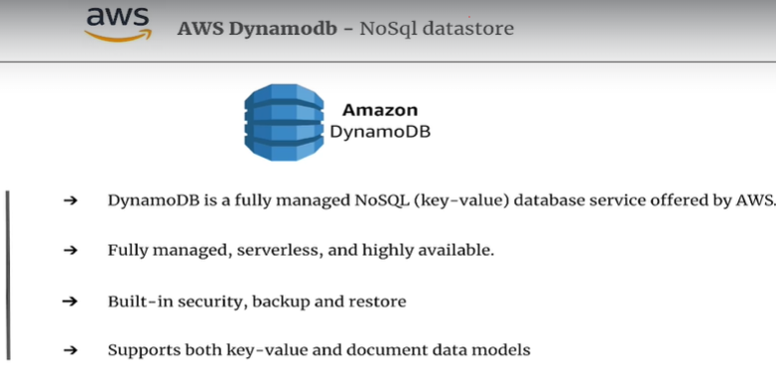
what is DynamoDB?
It's a fully managed NoSQL database service offered by AWS. It's basically a key value database that delivers single digit millisecond performance at any scale. It's fully managed, serverless, and highly available, and as per the documentation, DynamoDB can handle more than 20 million requests per second. It offers built in security, backup and restore, and supports both key value and document data models, and this gives you a lot of flexibility to design your tables that best fit the needs of your applications.

Now, let's look at some popular use cases where DynamoDB is used, as DynamoDB is extremely versatile.
It's technically suitable for a wide range of use cases, which demand extremely fast reads and writes. And by fast I mean a couple of milliseconds.
Use cases:
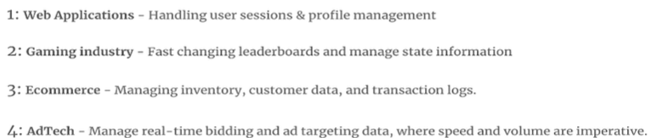
A dynamo is quite common for web based applications, which handle user sessions, profile management,
and other scenarios where high throughput and low latency are crucial.
It's also used extensively in the gaming sector, where you need to maintain fast changing leaderboards
and frequently changing state information in session based multiplayer games.
It's also quite popular among e-commerce platforms, where you need to maintain the inventory, customer
data and transaction logs.
Due to Dynamo's extremely fast read and write capabilities, the systems can scale up in microseconds,
literally to handle high volumes during peak times without compromising the performance.
Even when it comes to martech or Adtech companies, which require managing real time bidding and ad
targeting data. DynamoDB becomes an ideal candidate to handle the high throughput.

Q. What is DynamoDB?

Lab 2.1 Execute Pyspark locally using Glue Docker image

In this lecture, we will walk through the PySpark code and run it locally before deploying it on AWS glue.
To test and execute the spark code locally, we will run it inside a Docker container using the official glue Docker image provided by AWS. And this is extremely helpful, especially with spark code, because developing spark code is more interactive and you really cannot execute your spark code on cloud when developing spark code. Because that will cost a lot of money, also, it doesn't make any sense to run your spark code and test it on cloud until the development is complete, which should ideally happen in your local systems.
Pyspark Code Walkthrough
Import; read input data as spark dataframes; do basic typecasting; aggregate data(); apply window function (Rank(xx partition by date and track genre, order by total-listens));
----------
Now let's walk through the spark job or spark code, which is called glue pyspark.py.
So we start with the import statements.
We define a spark session variable and we define some constants such as the bucket name and the location
to our input files.
We read each of the input data sets into the respective spark data frames, and once the data frames
are ready we do some basic typecasting. So we convert the string values to date types and remove the nulls from the track ID columns.
We then aggregate the data in the data frame by each song and report date as you can see, in order to fetch the total listens, the total number of unique users, the total listening time, and the average listening time per user.
Once the data frame is aggregated, we then join this data frame with the songs data frame on track ID and the result is stored inside a data frame called songs KPI with details underscore df.
Now in the next two lines, we are applying a window function called rank, which is exactly the same
as rank in SQL. If you used rank or row numbers in SQL, which are typical window functions, it's exactly the same concept.
So we partitioned by the date and the track genre, and we order it by total listens.
You can actually translate this to SQL because it's even syntactically speaking it's more or less the
same.
And then we create a new column called ranks.
Now post creation of this column ranks, we just get the top three songs per genre per day by applying
a simple filter where we say rank is less than or equal to three. So this data frame Top songs per genre contains the top three songs for every genre.
And once we have that again, we apply a window analytical function to get the top five genres based
on total listens across all songs and all the dates.
So our final data frame, which is called Final Underscore DF, will contain all of these columns. It will have the report date, the track ID, track name, artist, genre listings, unique users, total listening time, and average listening time per user.
And finally, we write this data frame to the specified location, which is inside our bucket insideSpotify data output song KPIs.
So that's pretty much all the spark code is doing.

Run Pyspark Code locally
Firstly you must ensure that your Docker engine or Docker daemon is running in the background.
You just start Docker and make sure it's running. Otherwise your Docker commands won't be recognized.

Next you can open up the bash file which is called local Docker development sh which has a couple of
simple commands.
Now firstly we create a couple of variables. You have the workspace location, the value which is set to the current working directory. So you can see PWD means current working directory. And then you have the script file name which has the name of a PySpark script which is pyspark.py.
Now once we define the variables, we then get to the docker run command, which looks a bit complex. When you run this command, it will download the glue image from the docker repository and run your
PySpark code inside the container in your local system.

Now let me break down this docker run command for you.
We start by saying docker run hyphen id, which basically means you are telling the docker to run the
container in an interactive mode. We then use hyphen v, which basically mounts your local AWS configuration directory, which is this one right here tilde backslash aws onto the container's working directory which is home glue user.
This allows the container to use your AWS credentials because your code is running inside a container
which is not authenticated to use your AWS account. Since we ran AWS configure in our terminal, in our local terminal, our credentials which are saved in this location will be mounted to that of the container's working directory, which is home glue glue user.
Then we have another mount. So you can see hyphen v again. Now here we are mounting the current working directory which is saved inside workspace location to the containers directory. Now this makes your local files accessible inside the container.
We then have hyphen E followed by AWS profile which is set to default. Here we are setting the environment variable called AWS profile to default inside the container. Now this tells the container to use the default profile from your AWS configurations.
We then map the containers of our ports to that of our local machines. So the containers in question here are 4040 and one 8080. This allows you to access services running on these ports from your local machine. So that's the whole purpose behind mapping the ports.
We then give our spark container a name. You can call it whatever you want. It's called Glue spark Submit.
It's a custom name.
And then we specify the image that we want to use in order to run our spark job using the latest image,
which is Glue's latest version 4.0.0.
And then we have the spark submit command, which basically submits your spark job inside the container.
Right now, before you run these commands, you need to upload the input CSV files to your S3 bucket
because the spark code expects the input files to be in these locations right now.
So inside the bucket at the root of the bucket, you have a folder Spotify data, inside of which you
have songs and songs I've uploaded. Sample songs dot csv. Similarly, for user streams, I've uploaded sample streams, which is roughly 8 to 10% of the main data, and you don't really need to use the main data while testing your spark code from your local system, because you might run out of memory as the data is big in size. So once you have uploaded the sample data to S3, You can now come back.

Open up a terminal either in your Visual Studio Code editor or separately as well, whichever works. Just make sure you have navigated to the right working directory. So if I type LS here, I have my spark script in this current location blue spark.py.
So let me define the variables first.
And now we run the docker run command.
Now if you've never used glue Docker images before in your local system, then running this command
will first download the image to your local system, which itself will take a few minutes depending
on your internet download speed. Because the image is not small in size, and then it's going to execute your spark code inside the container. So overall, the entire execution will take could take up to 15 to 20 minutes.
So you have to be a bit patient.
So let's copy this and run it now.
I made one small change to the spark code instead of writing the output to an S3 bucket. Since we are testing the script locally, I have replaced it with DataFrame dot show, which is going to print out the final data frame.
The first ten rows of the final data frame on the terminal.
So the spark job is running inside a container. I'll return once the execution is done. So that's your final output as you can see with the necessary columns. You can also print out the intermediate steps and test out the script locally before you deploy it to AWS glue.

Lab 2.2 Delpoy the Pyspark code on AWS Glue

Lab 2.3 End to end Execution

Lab3: ETL for Rental apartments using Step functions, AWS Glue and RedShift (source: AWS Aurora)
In the past, we used airflow as our data orchestration framework. In this lab, you're going to use and learn step functions, which is also purely a data orchestration or a workflow automation framework offered by AWS.

Introduction1: Scenario, Objective, Considerations
Scenario: Now imagine a scenario where you're working for a company which offers a marketplace for rental apartments, something similar to Airbnb. Now, the application or the website of this platform uses AWS, MySQL as the relational database, which basically means MySQL. Aurora is going to be your source of data (AWS Aurora with MySQL compatibility is going to serve as the relational or application database
where the original source of application data is going to be residing or coming from.), and your objective is to set up a data warehouse on AWS for reporting and analytical use cases.
Objective:In this case, your objective is to set up cost effective pipelines which run frequently in order to extract, transform, and ingest the data into your data warehouse, which is redshift.
Now, inside redshift, we are going to have three different layers of data starting with the raw layer. This is the layer which will store the data as is in its raw format. There won't be any changes done whatsoever from the raw zone. The data flows into the curated layer, which is where we will perform data modeling using some modeling techniques. And finally we have the presentation layer containing the business metrics. This layer acts as the final stop before the calculated metrics and insights reach the business users.

Considerations: Now, before we get to our solution, there's a couple of points I want to talk about. Whenever you're building a data warehouse solution, either on cloud or even on premise there are certain aspects which are extremely crucial and can't be ignored.
The first aspect is to consider the efficiency and reliability of your solution, which means your pipelines
are functioning as expected and the data that you provide is as reliable as potentially possible.
Next is the cost, meaning how much it will cost your company to access the reports from your data warehouse
and related pipelines in order to get the reports and make data driven decisions.
Last but not least, I always stress on the overall effectiveness of the solution. And this is the point I emphasize to any startups, or even my students.
99% of the times the simplest solution is the best. You don't always need to deploy complex technologies like spark, Flink, Apache Beam for your data processing pipelines, and this point becomes even more critical.

While building a tech stack in the cloud as running extensive jobs on spark EMR or similar platforms
can be prohibitively expensive when simpler, less cost effective alternatives could yield the same
results.

Introduction2: Tech Track, Solution, Interview Questions
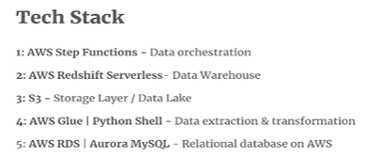
3 layers in Redshift.
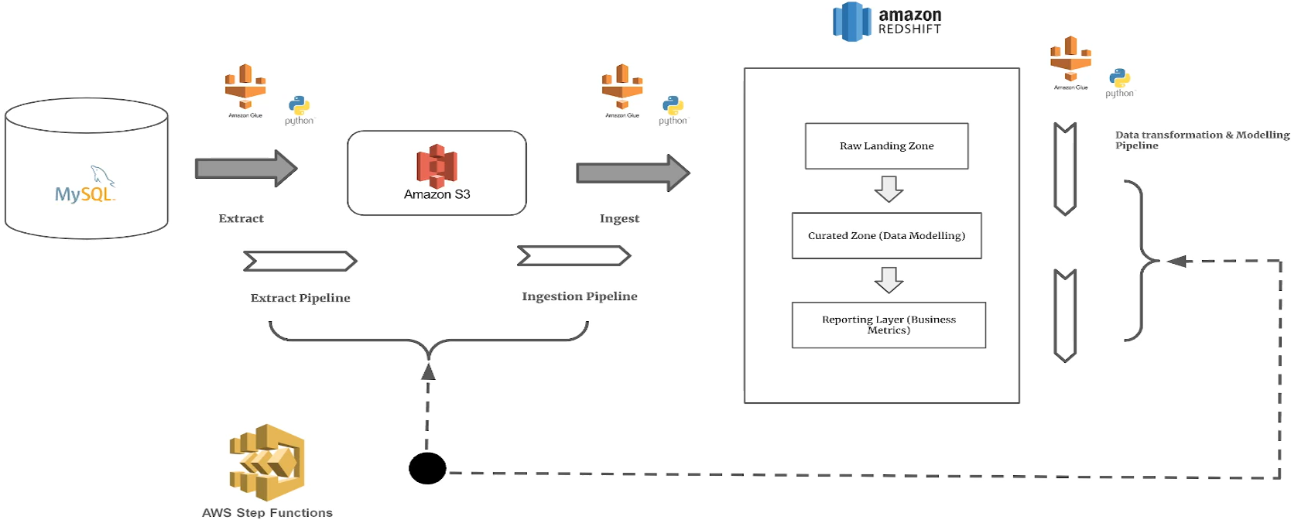
Solution: So with that in mind, let's look at our solution and what we'll be implementing in this lab.
We'll be deploying the data extraction and ingestion jobs, which right into the raw layer of redshift
using simple Python shell jobs running on AWS glue.
So overall, it's going to be two jobs where the first job will connect to the MySQL database and extract
the data to an S3 bucket. Once this is done, the second job will copy this extracted data from S3 into redshift.
Now, once the data is in the raw layer, we will have two more glue jobs one which reads the data from
raw layer to the curated layer and writes it into the curated layer. And the last one is the one which transforms the data from the curated layer to calculate the necessary business metrics, which will be used for reporting and analytics. And both these jobs will be running on glue Python shell.
Now all we are left with is the orchestration part, which is where step functions come into picture. Using step functions, we will set up the orchestration of all these four glue jobs in order to run in sequence and meet the dependency conditions.

Q. What are step functions? Tradeoffs?
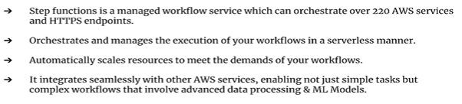
What is step functions?
It's a powerful service offered by AWS that manages workflows and automates processes.
It allows you to design and execute workflows that stitch together different AWS services such as AWS
Lambda, S3, EMR, glue pretty much any service on AWS that you can think of.
The main role of step functions is to orchestrate and manage the execution of your workflows in a serverless
manner, meaning you don't provision or manage any servers when it comes to using step functions, they
can automatically trigger each step in your workflow by making sure that they are executed in order
and as efficiently as possible.
And just like any other serverless service on cloud, step functions also scale automatically according
to the demands of the workflow.
More importantly, step functions integrate seamlessly with any other AWS service.
And this is not just for simple tasks, but also for complex workflows that involve advanced data processing
and machine learning models.
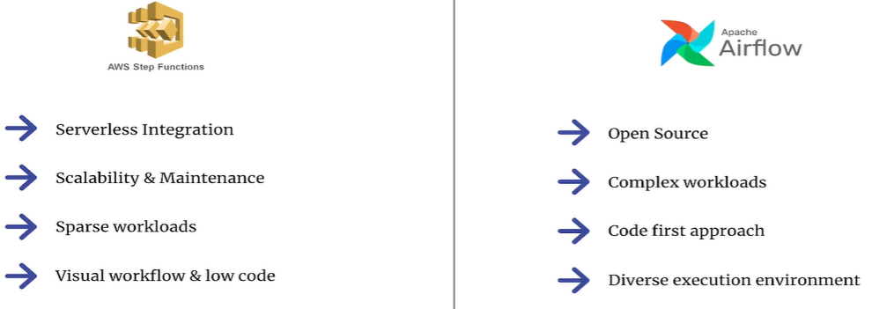
Tradeoffs: Step Functions vs Airflow: Now comes the big question when do you step functions and when to use airflow?
Because both these frameworks can pretty much do the same thing, which is their orchestration. Right now, in order to decide which one to choose between the two, it's important to understand the subtle differences and nuances when it comes to using both these frameworks.
Step function, for one, is fully serverless, meaning you just need to define your workloads either using the web console or a JSON file, which we will do soon, but there's absolutely nothing to be provisioned in terms of the underlying infrastructure.
With airflow, you need to create and set up an airflow environment with the minimum configurations,
such as the number of nodes with Vcores, the maximum number of DAGs, which means you're still going
to pay a minimum price for running the airflow environment even when you have zero pipelines or DAGs
running.
Step functions are easier to maintain because it's low code or almost no code, and you just trigger
other services inside your workflow.
With airflow, you can pretty much write the application logic, transform the data, and even install
dependency libraries to support the pipelines at runtime.
In other words, airflow is more suitable for complex workloads which require coding in Python.
Step functions are better if your workloads don't run frequently, or if they do run frequently, but
do not require complex logic in between the transitioning steps within the workflows.
Lastly, you might have already figured step functions is an almost no code framework unless you consider
JSON as code.

Q. What is AWS Aurora for MySQL?
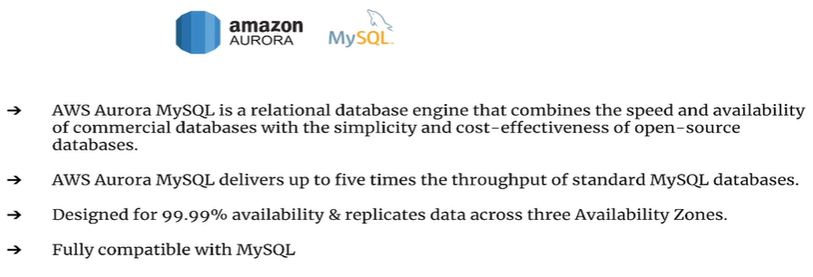
Now, Aurora MySQL is a powerful relational database engine that combines the speed and availability
of high end commercial databases with the simplicity and cost effectiveness of open source databases.
As per their documentation, Aurora can deliver up to five times the throughput of a standard MySQL
database.
Unlike the open source MySQL, Aurora with MySQL compatibility has the ability to scale up and handle
increased workloads without requiring significant changes to your application code.
It's designed for 99.99% availability and replicates the data across three availability Zones, which
ensures data durability and high availability.
Aurora is fully compatible with MySQL, which means existing applications which use MySQL as the database
can run without requiring any modifications at all if you switch to MySQL Aurora.
So all in all, for the most part, if you're using AWS Aurora, there's nothing different compared to using MySQL in terms of usage.

Q. What is ??

Lab3.1 Setup MySQL db on AWS Aurora

Lab3.2 Deploy and execute your MySQL Extraction Glue Job

Lab3.3 Deploy Redshift ingestion pipeline on AWS Glue

Lab3.4 Deploy pipeline to process curated data in Redshift on AWS Glue

Lab3.5 Deploy Step Functions to orchestrate workflow execution

Lab3.6 Setup AWS Event Bridge for workflow scheduling and automation

Lab4: Build Data Lake for Rental vehicles store using EMR, S3 and Athena

Introduction: Tech Track, Interview Questions

Q. What is?

Lab4.1

Lab5: Build Event driven pipelines for e-commerce using ECS and Step functions

Introduction: Tech Track, Interview Questions

Q. What is?

Lab5.1

Lab6: Build a lakehouse for an E-commerce store using pyspark delta tables and s3

Introduction: Tech Track, Interview Questions

Q. What is?

Lab6.1

Lab7: Event driven data processing for taxi trips using Lambda and Kinesis

Introduction: Tech Track, Interview Questions

Q. What is?

Lab7.1

Lab8: process mobile network logs in real time using pyspark & streamlit on ECS

Introduction: Tech Track, Interview Questions

Q. What is?

Lab8.1

Lab9: CI/CD for aws services using Github Actions

Introduction: Tech Track, Interview Questions

Q. What is?

Lab9.1

Lab10: real-time data ingestion of clickstreams using kinesis firehose and Redshift

Introduction: Tech Track, Interview Questions

Q. What is?

Lab10.1

Assignment 1:

Introduction: Tech Track, Interview Questions

Q. What is?

Lab10.1

Assignment 2:

Introduction: Tech Track, Interview Questions

Q. What is?

Lab10.1

Assignment 3:

Introduction: Tech Track, Interview Questions

Q. What is?

Lab10.1

Assignment 4:

Introduction: Tech Track, Interview Questions

Q. What is?

Lab10.1

Assignment 5:

Introduction: Tech Track, Interview Questions

Q. What is?

Lab10.1

