What do I know?
- Forward kinematics
- Inverse kinematics
- Jacobian
- Dynamics

Forward Kinematics
Forward kinematics is the mapping from robot joint frame to 3D cartesian coordinate. A 4-by-4 transformation matrix can represent the rotation and translation from frame to frame.
- Denavit–Hartenberg parameters
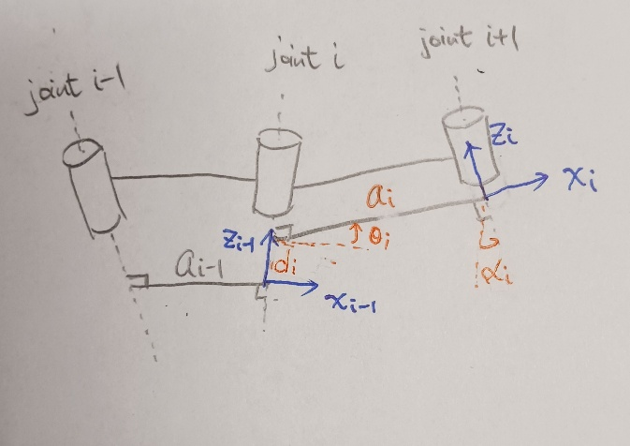
Figure 1: Denavit–Hartenberg kinematic parameters
There are 4 steps to move from the frame of joint $i-1$ to joint $i$:
- Translate along $z$-axis on joint $i$ with $d_{i}$ to the intersection of the common normal between joint $i$ and joint $i+1$.
- Revolve along $z$-axis on joint $i$ with $θ_{i}$ to match $x$-axis with the common normal.
- Translate along $x$-axis with $a_{i}$ onto joint $i+1$.
- Revolve along $x$-axis with $α_{i}$ to align $z$-axis to joint $i+1$.
The transformation matrix becomes
$${}_{i}^{i-1}T=\left[\begin{matrix}1 & 0 & 0 & 0 \\ 0 & 1 & 0 & 0 \\ 0 & 0 & 1 & d_{i} \\ 0 & 0 & 0 & 1\end{matrix}\right]\left[\begin{matrix}\cos\left(θ_{i}\right) & -\sin\left(θ_{i}\right) & 0 & 0 \\ \sin\left(θ_{i}\right) & \cos\left(θ_{i}\right) & 0 & 0 \\ 0 & 0 & 1 & 0 \\ 0 & 0 & 0 & 1\end{matrix}\right]\left[\begin{matrix}1 & 0 & 0 & a_{i} \\ 0 & 1 & 0 & 0 \\ 0 & 0 & 1 & 0 \\ 0 & 0 & 0 & 1\end{matrix}\right]\left[\begin{matrix}1 & 0 & 0 & 0 \\ 0 & \cos\left(α_{i}\right) & -\sin\left(α_{i}\right) & 0 \\ 0 & \sin\left(α_{i}\right) & \cos\left(α_{i}\right) & 0 \\ 0 & 0 & 0 & 1\end{matrix}\right] \\ \begin{aligned}=\left[\begin{matrix}\cos\left(θ_{i}\right) & -\sin\left(θ_{i}\right)\cos\left(α_{i}\right) & \sin\left(θ_{i}\right)\sin\left(α_{i}\right) & a_{i}\cos\left(θ_{i}\right) \\ \sin\left(θ_{i}\right) & \cos\left(θ_{i}\right)\cos\left(α_{i}\right) & -\cos\left(θ_{i}\right)\sin\left(α_{i}\right) & a_{i}\sin\left(θ_{i}\right) \\ 0 & \sin\left(α_{i}\right) & \cos\left(α_{i}\right) & d_{i} \\ 0 & 0 & 0 & 1\end{matrix}\right]\#\left( SEQ 方程式 \backslash * ARABIC 1\right)\end{aligned}$$
- Modified Denavit–Hartenberg parameters
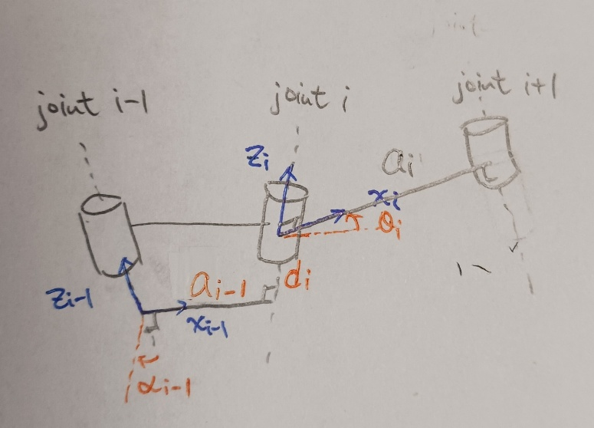
Figure 2: Modified Denavit–Hartenberg kinematic parameters
There are 4 steps to move from the frame of joint $i-1$ to joint $i$:
- Revolve along $x$-axis on joint $i-1$ with $α_{i-1}$ to align $z$-axis to joint $i$.
- Translate along $x$-axis, which is the common normal between joint $i-1$ and joint $i$, with $a_{i-1}$ onto joint $i$.
- Translate along $z$-axis on joint $i$ with $d_{i}$ to the intersection of the common normal between joint $i$ and joint $i+1$.
- Revolve along $z$-axis on joint $i$ with $θ_{i}$ to match $x$-axis with the common normal.
The transformation matrix becomes
$$\begin{aligned}{}_{i}^{i-1}T=\left[\begin{matrix}1 & 0 & 0 & 0 \\ 0 & \cos\left(α_{i-1}\right) & -\sin\left(α_{i-1}\right) & 0 \\ 0 & \sin\left(α_{i-1}\right) & \cos\left(α_{i-1}\right) & 0 \\ 0 & 0 & 0 & 1\end{matrix}\right]\left[\begin{matrix}1 & 0 & 0 & a_{i-1} \\ 0 & 1 & 0 & 0 \\ 0 & 0 & 1 & 0 \\ 0 & 0 & 0 & 1\end{matrix}\right]\left[\begin{matrix}1 & 0 & 0 & 0 \\ 0 & 1 & 0 & 0 \\ 0 & 0 & 1 & d_{i} \\ 0 & 0 & 0 & 1\end{matrix}\right]\left[\begin{matrix}\cos\left(θ_{i}\right) & -\sin\left(θ_{i}\right) & 0 & 0 \\ \sin\left(θ_{i}\right) & \cos\left(θ_{i}\right) & 0 & 0 \\ 0 & 0 & 1 & 0 \\ 0 & 0 & 0 & 1\end{matrix}\right] \\ =\left[\begin{matrix}\cos\left(θ_{i}\right) & -\sin\left(θ_{i}\right) & 0 & a_{i-1} \\ \cos\left(α_{i-1}\right)\sin\left(θ_{i}\right) & \cos\left(α_{i-1}\right)\cos\left(θ_{i}\right) & -\sin\left(α_{i-1}\right) & -d_{i}\sin\left(α_{i-1}\right) \\ \sin\left(α_{i-1}\right)\sin\left(θ_{i}\right) & \sin\left(α_{i-1}\right)\cos\left(θ_{i}\right) & \cos\left(α_{i-1}\right) & d_{i}\cos\left(α_{i-1}\right) \\ 0 & 0 & 0 & 1\end{matrix}\right]\#\left( SEQ 方程式 \backslash * ARABIC 2\right)\end{aligned}$$

Example: (PUMA 560)
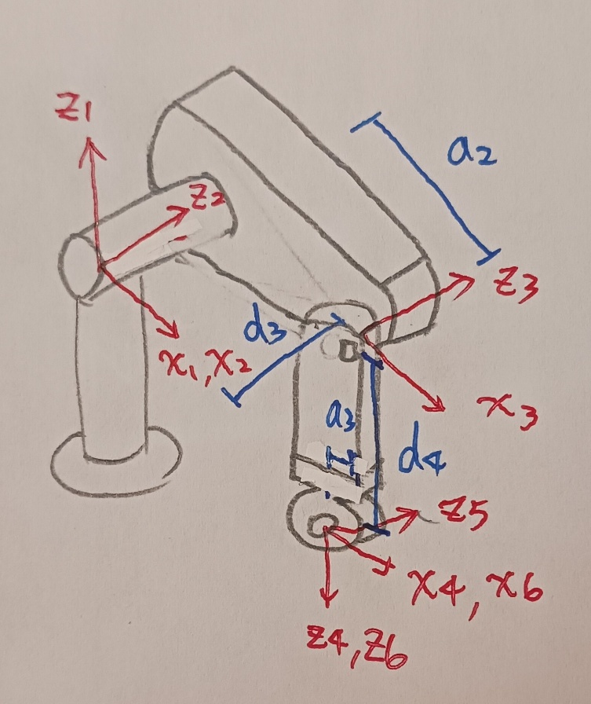
Figure 3: PUMA 560
Step 1: Define all joints on the z-axis, and define x-axis according to the robot geometry.
Step 2: Construct the DH table.
Joint | $$α_{i-1}$$ | $$a_{i-1}$$ | $$d_{i}$$ | $$θ_{i}$$
1 | $$0$$ | $$0$$ | $$0$$ | $$θ_{1}$$
2 | $$-90°$$ | $$0$$ | $$0$$ | $$θ_{2}$$
3 | $$0$$ | $$a_{2}$$ | $$d_{3}$$ | $$θ_{3}$$
4 | $$-90°$$ | $$a_{3}$$ | $$d_{4}$$ | $$θ_{4}$$
5 | $$90°$$ | $$0$$ | $$0$$ | $$θ_{5}$$
6 | $$-90°$$ | $$0$$ | $$0$$ | $$θ_{6}$$
Step 3: Calculate the transform matrix: ${}_{6}^{0}T={}_{1}^{0}T{}_{2}^{1}T{}_{3}^{2}T{}_{4}^{3}T{}_{5}^{4}T{}_{6}^{5}T$
$$\begin{aligned}{}_{6}^{0}T=\left[\begin{matrix}r_{11} & r_{12} & r_{13} & p_{x} \\ r_{21} & r_{22} & r_{23} & p_{y} \\ r_{31} & r_{32} & r_{33} & p_{z} \\ 0 & 0 & 0 & 1\end{matrix}\right]\#\left( SEQ 方程式 \backslash * ARABIC 3\right)\end{aligned}$$
$$p_{x}=c_{1}\left(a_{2}c_{2}+a_{3}c_{23}-d_{4}s_{23}\right)-d_{3}s_{1}$$
$$p_{y}=s_{1}\left(a_{2}c_{2}+a_{3}c_{23}-d_{4}s_{23}\right)+d_{3}c_{1}$$
$$p_{z}=-a_{3}s_{23}-a_{2}s_{2}-d_{4}c_{23}$$
$$c_{1}=\cos\left(θ_{1}\right), s_{1}=\sin\left(θ_{1}\right)$$

Inverse kinematics
Inverse kinematics maps the end effector position at cartesian coordinate into robot joint space. With inverse kinematics, the robot joint command can be calculated so that the end effector of the manipulator reaches our desired location.

- Geometric solution: Decompose spatial geometry into several plane.
Example: (RRR manipulator)
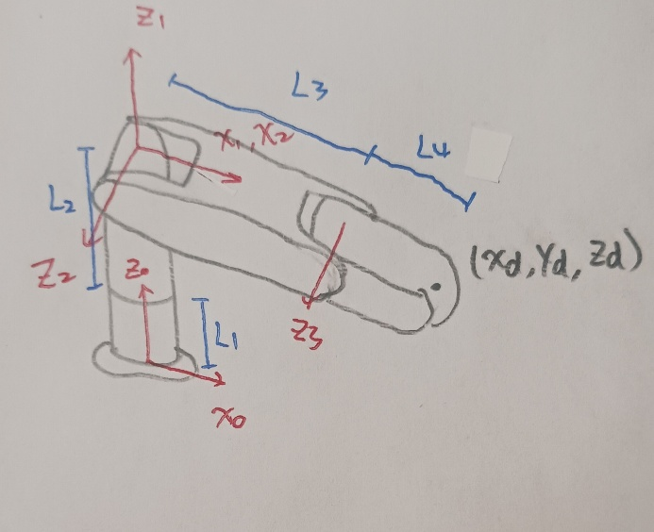
Figure 4: RRR manipulator
From top view, the joint 1 angle $θ_{1}$ can be calculated with desired position $\left(x_{d},y_{d},z_{d}\right)$:
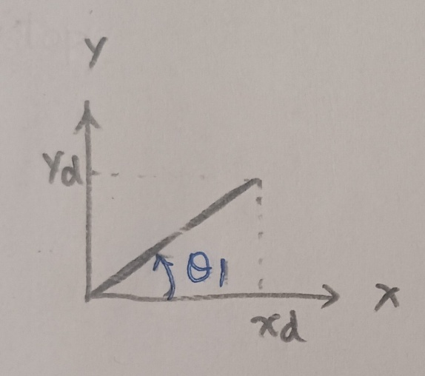
Figure 5: Top view
$$\begin{aligned}θ_{1}=atan2\left(y_{d},x_{d}\right)\#\left( SEQ 方程式 \backslash * ARABIC 4\right)\end{aligned}$$
From side view, the joint 2 and 3 angle $θ_{2}$, $θ_{3}$ can be calculated:
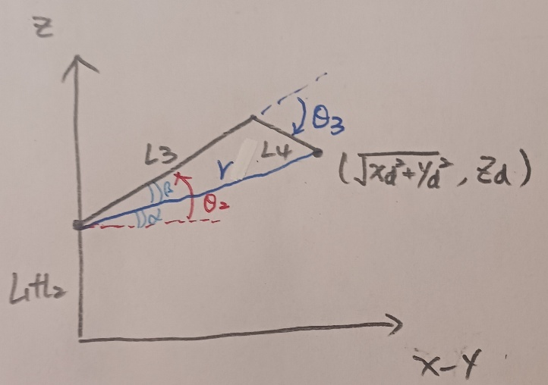
Figure 6: Side view
$$r=\sqrt{x_{d}^{2}+y_{d}^{2}+{\left(z_{d}-L_{1}-L_{2}\right)}^{2}}$$
$$\cos\left(θ_{3}\right)=\frac{r^{2}-L_{3}^{2}-L_{4}^{2}}{2L_{3}L_{4}}$$
$$\sin\left(θ_{3}\right)=±\sqrt{1-\cos^{2}\left(θ_{3}\right)}$$
$$\begin{aligned}θ_{3}=atan2\left(±\sqrt{1-\cos^{2}\left(θ_{3}\right)},\cos\left(θ_{3}\right)\right)\#\left( SEQ 方程式 \backslash * ARABIC 5\right)\end{aligned}$$
$$\cos\left(β\right)=\frac{L_{4}^{2}-r^{2}-L_{3}^{2}}{2rL_{3}}$$
$$\sin\left(β\right)=±\sqrt{1-\cos^{2}\left(β\right)}$$
$$\begin{aligned}θ_{2}=α+β=atan2\left(z_{d}-L_{1}-L_{2},\sqrt{x_{d}^{2}+y_{d}^{2}}\right)+atan2\left(±\sqrt{1-\cos^{2}\left(β\right)},\cos\left(β\right)\right)\#\left( SEQ 方程式 \backslash * ARABIC 6\right)\end{aligned}$$

- Algebraic solution (Piepers method)
Example: (PUMA 560)
Consider the forward kinematics ${}_{6}^{0}T=\left[\begin{matrix}r_{11} & r_{12} & r_{13} & p_{x} \\ r_{21} & r_{22} & r_{23} & p_{y} \\ r_{31} & r_{32} & r_{33} & p_{z} \\ 0 & 0 & 0 & 1\end{matrix}\right]$
And, the forward kinematics from joint 1 is:
$${{}_{}^{1}T}_{6}=\left[\begin{matrix}c_{1} & s_{1} & 0 & 0 \\ -s_{1} & c_{1} & 0 & 0 \\ 0 & 0 & 1 & 0 \\ 0 & 0 & 0 & 1\end{matrix}\right]\left[\begin{matrix}r_{11} & r_{12} & r_{13} & p_{x} \\ r_{21} & r_{22} & r_{23} & p_{y} \\ r_{31} & r_{32} & r_{33} & p_{z} \\ 0 & 0 & 0 & 1\end{matrix}\right] \\ \begin{aligned}=\left[\begin{matrix}* & * & * & a_{2}c_{2}+a_{3}c_{23}-d_{4}s_{23} \\ * & * & * & d_{3} \\ * & * & * & -a_{3}s_{23}-a_{2}s_{2}-d_{4}c_{23} \\ 0 & 0 & 0 & 1\end{matrix}\right]\#\left( SEQ 方程式 \backslash * ARABIC 7\right)\end{aligned}$$
From the second row of $\left(7\right)$:
$$\begin{aligned}-s_{1}p_{x}+c_{1}p_{y}=d_{3}\#\left( SEQ 方程式 \backslash * ARABIC 8\right)\end{aligned}$$
Let $ρ=\sqrt{p_{x}^{2}+p_{y}^{2}}, ϕ=atan2⁡(p_{y},p_{x})$, the above equation can be written as
$$-s_{1}c_{ϕ}+c_{1}s_{ϕ}=\frac{d_{3}}{ρ}$$
$$\sin\left(ϕ-θ_{1}\right)=\frac{d_{3}}{ρ}$$
$$\begin{aligned}θ_{1}=ϕ-atan2\left(\frac{d_{3}}{ρ},±\sqrt{1-{\left(\frac{d_{3}}{ρ}\right)}^{2}}\right)\#\left( SEQ 方程式 \backslash * ARABIC 9\right)\end{aligned}$$
Consider other two rows:
$$\begin{aligned}c_{1}p_{x}+s_{1}p_{y}=a_{2}c_{2}+a_{3}c_{23}-d_{4}s_{23}\#\left( SEQ 方程式 \backslash * ARABIC 10\right)\end{aligned}$$
$$\begin{aligned}p_{z}=-a_{3}s_{23}-a_{2}s_{2}-d_{4}c_{23}\#\left( SEQ 方程式 \backslash * ARABIC 11\right)\end{aligned}$$
${\left(9\right)}^{2}+{\left(11\right)}^{2}+{\left(12\right)}^{2}$ becomes:
$$p_{x}^{2}+p_{y}^{2}+p_{z}^{2}=a_{2}^{2}+a_{3}^{2}+d_{3}^{2}+d_{4}^{2}+2a_{2}a_{3}c_{3}-2a_{2}d_{4}s_{3}$$
$$\begin{aligned}\frac{p_{x}^{2}+p_{y}^{2}+p_{z}^{2}-\left(a_{2}^{2}+a_{3}^{2}+d_{3}^{2}+d_{4}^{2}\right)}{-2a_{2}}=d_{4}s_{3}-a_{3}c_{3}=K\#\left( SEQ 方程式 \backslash * ARABIC 12\right)\end{aligned}$$
Let $ρ=\sqrt{a_{3}^{2}+d_{4}^{2}}, ϕ=atan2⁡(a_{3},d_{4})$:
$$\sin\left(θ_{3}-ϕ\right)=\frac{K}{ρ}$$
$$\begin{aligned}θ_{3}=ϕ+atan2\left(\frac{K}{ρ},±\sqrt{1-{\left(\frac{K}{ρ}\right)}^{2}}\right)\#\left( SEQ 方程式 \backslash * ARABIC 13\right)\end{aligned}$$

The forward kinematics from joint 3 is:
$$\begin{aligned}{}_{6}^{3}T=\left[\begin{matrix}c_{1}c_{23} & s_{1}c_{23} & -s_{23} & -a_{2}c_{3} \\ -c_{1}s_{23} & -s_{1}s_{23} & -c_{23} & a_{2}s_{3} \\ -s_{1} & c_{1} & 0 & -d_{3} \\ 0 & 0 & 0 & 1\end{matrix}\right]\left[\begin{matrix}r_{11} & r_{12} & r_{13} & p_{x} \\ r_{21} & r_{22} & r_{23} & p_{y} \\ r_{31} & r_{32} & r_{33} & p_{z} \\ 0 & 0 & 0 & 1\end{matrix}\right]=\left[\begin{matrix}* & * & * & a_{3} \\ * & * & * & d_{4} \\ * & * & * & 0 \\ 0 & 0 & 0 & 1\end{matrix}\right] \#\left( SEQ 方程式 \backslash * ARABIC 14\right)\end{aligned}$$
From the first and second row of $\left(14\right)$:
$$\begin{aligned}\left\{\begin{aligned}c_{23}\left(c_{1}p_{x}+s_{1}p_{y}\right)-s_{23}p_{z}=a_{3}+a_{2}c_{3} \\ c_{23}p_{z}+s_{23}\left(c_{1}p_{x}+s_{1}p_{y}\right)=-d_{4}+a_{2}s_{3}\end{aligned}\right.\#\left( SEQ 方程式 \backslash * ARABIC 15\right)\end{aligned}$$
The solution of $(15)$ is:
$$c_{23}=\cos\left(θ_{2}+θ_{3}\right)=\frac{\left|\begin{matrix}a_{3}+a_{2}c_{3} & -p_{z} \\ -d_{4}+a_{2}s_{3} & c_{1}p_{x}+s_{1}p_{y}\end{matrix}\right|}{\left|\begin{matrix}c_{1}p_{x}+s_{1}p_{y} & -p_{z} \\ p_{z} & c_{1}p_{x}+s_{1}p_{y}\end{matrix}\right|}$$
$$s_{23}=\sin\left(θ_{2}+θ_{3}\right)=\frac{\left|\begin{matrix}c_{1}p_{x}+s_{1}p_{y} & a_{3}+a_{2}c_{3} \\ p_{z} & -d_{4}+a_{2}s_{3}\end{matrix}\right|}{\left|\begin{matrix}c_{1}p_{x}+s_{1}p_{y} & -p_{z} \\ p_{z} & c_{1}p_{x}+s_{1}p_{y}\end{matrix}\right|}$$
$$\begin{aligned}θ_{2}=atan2\left(\begin{aligned}\left(c_{1}p_{x}+s_{1}p_{y}\right)\left(-d_{4}+a_{2}s_{3}\right)-p_{z}\left(a_{3}+a_{2}c_{3}\right), \\ \left(a_{3}+a_{2}c_{3}\right)\left(c_{1}p_{x}+s_{1}p_{y}\right)+p_{z}\left(-d_{4}+a_{2}s_{3}\right)\end{aligned}\right)-θ_{3} \#\left( SEQ 方程式 \backslash * ARABIC 16\right)\end{aligned}$$

We can start solving the rotation matrix, the forward kinematics from joint 3 is:
$$\begin{aligned}{}_{6}^{3}T=\left[\begin{matrix}c_{1}c_{23} & s_{1}c_{23} & -s_{23} & -a_{2}c_{3} \\ -c_{1}s_{23} & -s_{1}s_{23} & -c_{23} & a_{2}s_{3} \\ -s_{1} & c_{1} & 0 & -d_{3} \\ 0 & 0 & 0 & 1\end{matrix}\right]\left[\begin{matrix}r_{11} & r_{12} & r_{13} & p_{x} \\ r_{21} & r_{22} & r_{23} & p_{y} \\ r_{31} & r_{32} & r_{33} & p_{z} \\ 0 & 0 & 0 & 1\end{matrix}\right] \\ =\left[\begin{matrix}c_{4}c_{5}c_{6}-s_{4}s_{6} & -c_{4}c_{5}s_{6}-s_{4}c_{6} & -c_{4}s_{5} & * \\ s_{5}c_{6} & -s_{5}s_{6} & -c_{5} & * \\ -s_{4}c_{5}c_{6}-c_{4}s_{6} & s_{4}c_{5}s_{6}-c_{4}c_{6} & s_{4}s_{5} & * \\ 0 & 0 & 0 & 1\end{matrix}\right] \#\left( SEQ 方程式 \backslash * ARABIC 17\right)\end{aligned}$$
Consider (1,3) and (3,3) elements:
$$c_{1}c_{23}r_{13}+s_{1}c_{23}r_{23}-s_{23}r_{33}=-c_{4}s_{5}$$
$$-s_{1}r_{13}+c_{1}r_{23}=s_{4}s_{5}$$
When $s_{5}≠0$,
$$\begin{aligned}θ_{4}=atan2\left(-s_{1}r_{13}+c_{1}r_{23},-c_{1}c_{23}r_{13}-s_{1}c_{23}r_{23}+s_{23}r_{33}\right)\#\left( SEQ 方程式 \backslash * ARABIC 18\right)\end{aligned}$$

The forward kinematics from joint 4 is:
$$\begin{aligned}{}_{6}^{4}T=\left[\begin{matrix}c_{1}c_{23}c_{4}+s_{1}s_{4} & s_{1}c_{23}c_{4}-c_{1}s_{4} & -s_{23}c_{4} & * \\ -c_{1}c_{23}s_{4}+s_{1}c_{4} & -s_{1}c_{23}s_{4}-c_{1}c_{4} & s_{23}s_{4} & * \\ -c_{1}s_{23} & -s_{1}s_{23} & -c_{23} & * \\ 0 & 0 & 0 & 1\end{matrix}\right]\left[\begin{matrix}r_{11} & r_{12} & r_{13} & p_{x} \\ r_{21} & r_{22} & r_{23} & p_{y} \\ r_{31} & r_{32} & r_{33} & p_{z} \\ 0 & 0 & 0 & 1\end{matrix}\right] \\ =\left[\begin{matrix}c_{5}c_{6} & -c_{5}s_{6} & -s_{5} & * \\ s_{6} & c_{6} & 0 & * \\ s_{5}c_{6} & -s_{5}s_{6} & c_{5} & * \\ 0 & 0 & 0 & 1\end{matrix}\right]\#\left( SEQ 方程式 \backslash * ARABIC 19\right)\end{aligned}$$
Consider (1,3) and (3,3) elements:
$$-r_{13}\left(c_{1}c_{23}c_{4}+s_{1}s_{4}\right)-r_{23}\left(s_{1}c_{23}c_{4}-c_{1}s_{4}\right)+r_{33}s_{23}c_{4}=s_{5}$$
$$-r_{13}c_{1}s_{23}-r_{23}s_{1}s_{23}-r_{33}c_{23}=c_{5}$$
$$\begin{aligned}θ_{5}=atan2\left(\begin{aligned}-r_{13}\left(c_{1}c_{23}c_{4}+s_{1}s_{4}\right)-r_{23}\left(s_{1}c_{23}c_{4}-c_{1}s_{4}\right)+r_{33}s_{23}c_{4}, \\ -c_{1}c_{23}r_{13}-s_{1}c_{23}r_{23}+s_{23}r_{33}\end{aligned}\right)\#\left( SEQ 方程式 \backslash * ARABIC 20\right)\end{aligned}$$

The forward kinematics from joint 5 is:
$${}_{6}^{5}T=\left[\begin{matrix}c_{1}c_{23}c_{4}c_{5}+s_{1}s_{4}c_{5}-s_{1}c_{23}c_{4}s_{5}+c_{1}s_{4}s_{5} & s_{23}c_{4} & c_{1}c_{23}c_{4}s_{5}+s_{1}s_{4}s_{5}+s_{1}c_{23}c_{4}s_{5}-c_{1}s_{4}c_{5} & * \\ -c_{1}c_{23}s_{4}c_{5}+s_{1}c_{4}c_{5}+s_{1}c_{23}s_{4}s_{5}+c_{1}c_{4}s_{5} & -s_{23}s_{4} & -c_{1}c_{23}s_{4}s_{5}+s_{1}c_{4}s_{5}-s_{1}c_{23}s_{4}c_{5}-c_{1}c_{4}c_{5} & * \\ -c_{1}s_{23}c_{5}+s_{1}s_{23}s_{5} & -c_{23} & -c_{1}s_{23}s_{5}-s_{1}s_{23}c_{5} & * \\ 0 & 0 & 0 & 1\end{matrix}\right]\left[\begin{matrix}r_{11} & r_{12} & r_{13} & p_{x} \\ r_{21} & r_{22} & r_{23} & p_{y} \\ r_{31} & r_{32} & r_{33} & p_{z} \\ 0 & 0 & 0 & 1\end{matrix}\right]=\left[\begin{matrix}c_{6} & -s_{6} & 0 & * \\ 0 & 0 & 1 & * \\ -s_{6} & -c_{6} & 0 & * \\ 0 & 0 & 0 & 1\end{matrix}\right]$$
Consider (1,1) and (1,3) elements:
$$r_{11}\left(c_{1}c_{23}c_{4}c_{5}+s_{1}s_{4}c_{5}-s_{1}c_{23}c_{4}s_{5}+c_{1}s_{4}s_{5}\right)+r_{21}s_{23}c_{4}+r_{31}\left(c_{1}c_{23}c_{4}s_{5}+s_{1}s_{4}s_{5}+s_{1}c_{23}c_{4}s_{5}-c_{1}s_{4}c_{5}\right)=c_{6}$$
$$r_{11}\left(c_{1}s_{23}c_{5}-s_{1}s_{23}s_{5}\right)+r_{21}c_{23}+r_{31}\left(c_{1}s_{23}s_{5}+s_{1}s_{23}c_{5}\right)=s_{6}$$
$$\begin{aligned}θ_{6}=atan2\left(s_{6},c_{6}\right)\#\left( SEQ 方程式 \backslash * ARABIC 21\right)\end{aligned}$$

Jacobian
Jacobian represents the mapping from joint velocity to linear and angular velocity.
$$\dot{x}=J(q)\dot{q}$$
Where $\dot{x}∈R^{6×1}$ are linear and angular velocity in 3-D space, and $\dot{q}∈R^{n×1}$ are the velocity of $n$ joints.
- Kinematics
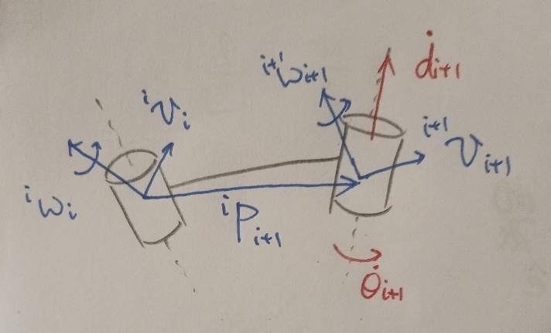
Figure 7: Kinematics
- Rotational joint
Angular velocity:
$$\begin{aligned}{}_{}^{i+1}{ω_{i+1}}={}_{i}^{i+1}R{}_{}^{i}{ω_{i}}+{\dot{θ}}_{i+1}{}_{}^{i+1}{{\hat{z}}_{i+1}}\#\left( SEQ 方程式 \backslash * ARABIC 22\right)\end{aligned}$$
Linear velocity:
$$\begin{aligned}{}_{}^{i+1}{v_{i+1}}={}_{i}^{i+1}R\left({}_{}^{i}{v_{i}}+{}_{}^{i}{ω_{i}}×{}_{}^{i}{P_{i+1}}\right)\#\left( SEQ 方程式 \backslash * ARABIC 23\right)\end{aligned}$$
- Prismatic joint
Angular velocity:
$$\begin{aligned}{}_{}^{i+1}{ω_{i+1}}={}_{i}^{i+1}R{}_{}^{i}{ω_{i}}\#\left( SEQ 方程式 \backslash * ARABIC 24\right)\end{aligned}$$
Linear velocity:
$$\begin{aligned}{}_{}^{i+1}{v_{i+1}}={}_{i}^{i+1}R\left({}_{}^{i}{v_{i}}+{}_{}^{i}{ω_{i}}×{}_{}^{i}{P_{i+1}}\right)+{\dot{d}}_{i+1}{}_{}^{i+1}{{\hat{z}}_{i+1}}\#\left( SEQ 方程式 \backslash * ARABIC 25\right)\end{aligned}$$
Example: (Planer RR manipulator)
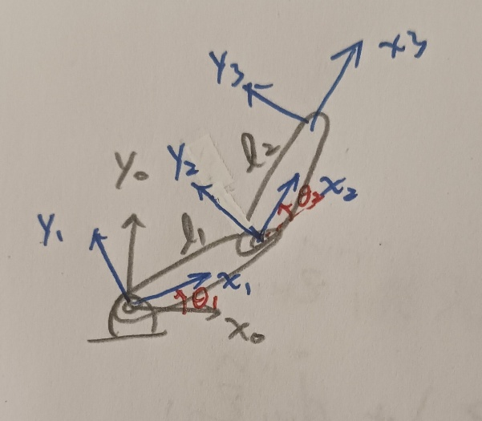
Figure 8: Planer RR manipulator
$$\begin{aligned}{}_{1}^{0}T=\left[\begin{matrix}c_{1} & -s_{1} & 0 & 0 \\ s_{1} & c_{1} & 0 & 0 \\ 0 & 0 & 1 & 0 \\ 0 & 0 & 0 & 1\end{matrix}\right],{}_{2}^{1}T=\left[\begin{matrix}c_{2} & -s_{2} & 0 & l_{1} \\ s_{2} & c_{2} & 0 & 0 \\ 0 & 0 & 1 & 0 \\ 0 & 0 & 0 & 1\end{matrix}\right],{}_{3}^{2}T=\left[\begin{matrix}1 & 0 & 0 & l_{2} \\ 0 & 1 & 0 & 0 \\ 0 & 0 & 1 & 0 \\ 0 & 0 & 0 & 1\end{matrix}\right]\#\left( SEQ 方程式 \backslash * ARABIC 26\right)\end{aligned}$$
$${}_{}^{1}{ω_{1}}={}_{0}^{1}R{}_{}^{0}{ω_{0}}+{\dot{θ}}_{1}{}_{}^{1}{{\hat{z}}_{1}}={}_{0}^{1}R\left[\begin{matrix}0 \\ 0 \\ 0\end{matrix}\right]+{\dot{θ}}_{1}\left[\begin{matrix}0 \\ 0 \\ 1\end{matrix}\right]=\left[\begin{matrix}0 \\ 0 \\ {\dot{θ}}_{1}\end{matrix}\right]$$
$${}_{}^{1}{v_{1}}={}_{0}^{1}R\left({}_{}^{0}{v_{0}}+{}_{}^{0}{ω_{0}}×{}_{}^{0}{P_{1}}\right)={}_{0}^{1}R\left(\left[\begin{matrix}0 \\ 0 \\ 0\end{matrix}\right]+\left[\begin{matrix}0 \\ 0 \\ 0\end{matrix}\right]×{}_{}^{0}{P_{1}}\right)=\left[\begin{matrix}0 \\ 0 \\ 0\end{matrix}\right]$$
$${}_{}^{2}{ω_{2}}={}_{1}^{2}R{}_{}^{1}{ω_{1}}+{\dot{θ}}_{2}{}_{}^{2}{{\hat{z}}_{2}}=\left[\begin{matrix}c_{2} & s_{2} & 0 \\ -s_{2} & c_{2} & 0 \\ 0 & 0 & 1\end{matrix}\right]\left[\begin{matrix}0 \\ 0 \\ {\dot{θ}}_{1}\end{matrix}\right]+{\dot{θ}}_{2}\left[\begin{matrix}0 \\ 0 \\ 1\end{matrix}\right]=\left[\begin{matrix}0 \\ 0 \\ {\dot{θ}}_{1}+{\dot{θ}}_{2}\end{matrix}\right]$$
$${}_{}^{2}{v_{2}}={}_{1}^{2}R\left({}_{}^{1}{v_{1}}+{}_{}^{1}{ω_{1}}×{}_{}^{1}{P_{2}}\right)=\left[\begin{matrix}c_{2} & s_{2} & 0 \\ -s_{2} & c_{2} & 0 \\ 0 & 0 & 1\end{matrix}\right]\left(\left[\begin{matrix}0 \\ 0 \\ 0\end{matrix}\right]+\left[\begin{matrix}0 \\ 0 \\ {\dot{θ}}_{1}\end{matrix}\right]×\left[\begin{matrix}l_{1} \\ 0 \\ 0\end{matrix}\right]\right)=\left[\begin{matrix}s_{2}l_{1}{\dot{θ}}_{1} \\ c_{2}l_{1}{\dot{θ}}_{1} \\ 0\end{matrix}\right]$$
$$\begin{aligned}{}_{}^{3}{ω_{3}}=\left[\begin{matrix}0 \\ 0 \\ {\dot{θ}}_{1}+{\dot{θ}}_{2}\end{matrix}\right]\#\left( SEQ 方程式 \backslash * ARABIC 27\right)\end{aligned}$$
$$\begin{aligned}{}_{}^{3}{v_{3}}={}_{2}^{3}R\left({}_{}^{2}{v_{2}}+{}_{}^{2}{ω_{2}}×{}_{}^{2}{P_{3}}\right)=\left[\begin{matrix}1 & 0 & 0 \\ 0 & 1 & 0 \\ 0 & 0 & 1\end{matrix}\right]\left(\left[\begin{matrix}s_{2}l_{1}{\dot{θ}}_{1} \\ c_{2}l_{1}{\dot{θ}}_{1} \\ 0\end{matrix}\right]+\left[\begin{matrix}0 \\ 0 \\ {\dot{θ}}_{1}+{\dot{θ}}_{2}\end{matrix}\right]×\left[\begin{matrix}l_{2} \\ 0 \\ 0\end{matrix}\right]\right) \\ =\left[\begin{matrix}s_{2}l_{1}{\dot{θ}}_{1} \\ c_{2}l_{1}{\dot{θ}}_{1}+l_{2}\left({\dot{θ}}_{1}+{\dot{θ}}_{2}\right) \\ 0\end{matrix}\right]\#\left( SEQ 方程式 \backslash * ARABIC 28\right)\end{aligned}$$
Summarize $(27)$ and $(28)$:
$$\begin{aligned}\left[\begin{matrix}{}_{}^{3}{v_{3}} \\ {}_{}^{3}{ω_{3}}\end{matrix}\right]=\left[\begin{matrix}s_{2}l_{1} & 0 \\ c_{2}l_{1}+l_{2} & l_{2} \\ 0 & 0 \\ 0 & 0 \\ 0 & 0 \\ 1 & 1\end{matrix}\right]\left[\begin{matrix}{\dot{θ}}_{1} \\ {\dot{θ}}_{2}\end{matrix}\right]\#\left( SEQ 方程式 \backslash * ARABIC 29\right)\end{aligned}$$
Jacobian can be calculated by transferring $(29)$ to the world frame.
$$\begin{aligned}\left[\begin{matrix}{}_{}^{0}{v_{3}} \\ {}_{}^{0}{ω_{3}}\end{matrix}\right]=\left[\begin{matrix}{}_{3}^{0}R & 0 \\ 0 & {}_{3}^{0}R\end{matrix}\right]\left[\begin{matrix}s_{2}l_{1} & 0 \\ c_{2}l_{1}+l_{2} & l_{2} \\ 0 & 0 \\ 0 & 0 \\ 0 & 0 \\ 1 & 1\end{matrix}\right]\left[\begin{matrix}{\dot{θ}}_{1} \\ {\dot{θ}}_{2}\end{matrix}\right]=\left[\begin{matrix}-s_{1}l_{1}-s_{12}l_{2} & -s_{12}l_{2} \\ c_{1}l_{1}+c_{12}l_{2} & c_{12}l_{2} \\ 0 & 0 \\ 0 & 0 \\ 0 & 0 \\ 1 & 1\end{matrix}\right]\left[\begin{matrix}{\dot{θ}}_{1} \\ {\dot{θ}}_{2}\end{matrix}\right]\#\left( SEQ 方程式 \backslash * ARABIC 30\right)\end{aligned}$$

- Explicit form
$$\begin{aligned}J\left(q\right)=\left[\begin{matrix}J_{v} \\ J_{ω}\end{matrix}\right]=\left\{\begin{aligned}\left[\begin{matrix}⋯ & {}_{i}^{0}z & ⋯ \\ ⋯ & 0 & ⋯\end{matrix}\right] if joint i is prismatic \\ \left[\begin{matrix}⋯ & {}_{i}^{0}z×\left({}_{}^{0}{P_{n}}-{}_{}^{0}{P_{i}}\right) & ⋯ \\ ⋯ & {}_{i}^{0}z & ⋯\end{matrix}\right] if joint i is revolute\end{aligned}\right.\#\left( SEQ 方程式 \backslash * ARABIC 31\right)\end{aligned}$$
$${}_{i}^{0}T=\left[\begin{matrix}* & * & {}_{i}^{0}z & {}_{}^{0}{P_{i}} \\ 0 & 0 & 0 & 1\end{matrix}\right]$$
Example: (Planer RR manipulator)
$${}_{1}^{0}T=\left[\begin{matrix}c_{1} & -s_{1} & 0 & 0 \\ s_{1} & c_{1} & 0 & 0 \\ 0 & 0 & 1 & 0 \\ 0 & 0 & 0 & 1\end{matrix}\right],{}_{2}^{0}T=\left[\begin{matrix}c_{12} & -s_{12} & 0 & l_{1}c_{1} \\ s_{12} & c_{12} & 0 & l_{1}s_{1} \\ 0 & 0 & 1 & 0 \\ 0 & 0 & 0 & 1\end{matrix}\right]$$
$${}_{3}^{0}T=\left[\begin{matrix}c_{12} & -s_{12} & 0 & l_{1}c_{1}+l_{2}c_{12} \\ s_{12} & c_{12} & 0 & l_{1}s_{1}+l_{2}s_{12} \\ 0 & 0 & 1 & 0 \\ 0 & 0 & 0 & 1\end{matrix}\right]$$
$$\begin{aligned}J\left(q\right)=\left[\begin{matrix}{}_{1}^{0}z×\left({}_{}^{0}{P_{3}}-{}_{}^{0}{P_{1}}\right) & {}_{2}^{0}z×\left({}_{}^{0}{P_{3}}-{}_{}^{0}{P_{2}}\right) \\ {}_{1}^{0}z & {}_{2}^{0}z\end{matrix}\right] \\ =\left[\begin{matrix}\left[\begin{matrix}0 \\ 0 \\ 1\end{matrix}\right]×\left(\left[\begin{matrix}l_{1}c_{1}+l_{2}c_{12} \\ l_{1}s_{1}+l_{2}s_{12} \\ 0\end{matrix}\right]-\left[\begin{matrix}0 \\ 0 \\ 0\end{matrix}\right]\right) & \left[\begin{matrix}0 \\ 0 \\ 1\end{matrix}\right]×\left(\left[\begin{matrix}l_{1}c_{1}+l_{2}c_{12} \\ l_{1}s_{1}+l_{2}s_{12} \\ 0\end{matrix}\right]-\left[\begin{matrix}l_{1}c_{1} \\ l_{1}s_{1} \\ 0\end{matrix}\right]\right) \\ \left[\begin{matrix}0 \\ 0 \\ 1\end{matrix}\right] & \left[\begin{matrix}0 \\ 0 \\ 1\end{matrix}\right]\end{matrix}\right] \\ =\left[\begin{matrix}\left[\begin{matrix}-l_{1}s_{1}-l_{2}s_{12} \\ l_{1}c_{1}+l_{2}c_{12} \\ 0\end{matrix}\right] & \left[\begin{matrix}-l_{2}s_{12} \\ l_{2}c_{12} \\ 0\end{matrix}\right] \\ \left[\begin{matrix}0 \\ 0 \\ 1\end{matrix}\right] & \left[\begin{matrix}0 \\ 0 \\ 1\end{matrix}\right]\end{matrix}\right]\#\left( SEQ 方程式 \backslash * ARABIC 32\right)\end{aligned}$$

Dynamics
- Newton-Euler dynamic formulation
- Rotational joint
Angular acceleration:
$$\begin{aligned}{}_{}^{i+1}{{\dot{ω}}_{i+1}}={}_{i}^{i+1}R{}_{}^{i}{{\dot{ω}}_{i}}+{}_{i}^{i+1}R{}_{}^{i}{ω_{i}}×{\dot{θ}}_{i+1}{}_{}^{i+1}{{\hat{z}}_{i+1}}+{\ddot{θ}}_{i+1}{}_{}^{i+1}{{\hat{z}}_{i+1}}\#\left( SEQ 方程式 \backslash * ARABIC 33\right)\end{aligned}$$
Linear acceleration:
$$\begin{aligned}{}_{}^{i+1}{a_{i+1}}={}_{i}^{i+1}R\left({}_{}^{i}{a_{i}}+{}_{}^{i}{{\dot{ω}}_{i}}×{}_{}^{i}{P_{i+1}}+{}_{}^{i}{ω_{i}}×\left({}_{}^{i}{ω_{i}}×{}_{}^{i}{P_{i+1}}\right)\right)\#\left( SEQ 方程式 \backslash * ARABIC 34\right)\end{aligned}$$
- Prismatic joint
Angular acceleration:
$$\begin{aligned}{}_{}^{i+1}{{\dot{ω}}_{i+1}}={}_{i}^{i+1}R{}_{}^{i}{{\dot{ω}}_{i}}\#\left( SEQ 方程式 \backslash * ARABIC 35\right)\end{aligned}$$
Linear acceleration:
$$\begin{aligned}{}_{}^{i+1}{a_{i+1}}= \\ {}_{i}^{i+1}R\left({}_{}^{i}{a_{i}}+{}_{}^{i}{{\dot{ω}}_{i}}×{}_{}^{i}{P_{i+1}}+{}_{}^{i}{ω_{i}}×\left({}_{}^{i}{ω_{i}}×{}_{}^{i}{P_{i+1}}\right)\right)+2{}_{i}^{i+1}R{}_{}^{i}{ω_{i}}×{\dot{d}}_{i+1}{}_{}^{i+1}{{\hat{z}}_{i+1}}+{\ddot{d}}_{i+1}{}_{}^{i+1}{{\hat{z}}_{i+1}}\#\left( SEQ 方程式 \backslash * ARABIC 36\right)\end{aligned}$$
Linear acceleration on center of mass (COM):
$$\begin{aligned}{}_{}^{i}{a_{c_{i}}}={}_{}^{i}{a_{i}}+{}_{}^{i}{{\dot{ω}}_{i}}×{}_{}^{i}{P_{c_{i}}}+{}_{}^{i}{ω_{i}}×\left({}_{}^{i}{ω_{i}}×{}_{}^{i}{P_{c_{i}}}\right)\#\left( SEQ 方程式 \backslash * ARABIC 37\right)\end{aligned}$$
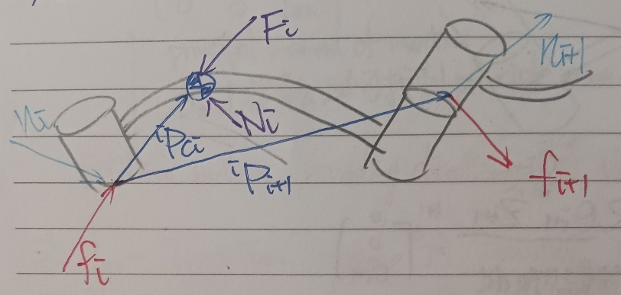
Figure 9: Newton-Euler dynamic
- The force and torque on COM to generate motion
$${}_{}^{i}{F_{i}}=m_{i}{}_{}^{i}{a_{c_{i}}}$$
$${}_{}^{i}{N_{i}}={}_{}^{c_{i}}I{}_{}^{i}{{\dot{ω}}_{i}}+{}_{}^{i}{ω_{i}}×{}_{}^{c_{i}}I{}_{}^{i}{ω_{i}}$$
Where $m_{i}$ is the mass of link $i$, and ${}_{}^{c_{i}}I$ is inertia of link $i$.
- The force and torque provided by each joint
$${}_{}^{i}{f_{i}}={}_{i+1}^{i}R{}_{}^{i+1}{f_{i+1}}+{}_{}^{i}{F_{i}}$$
$${}_{}^{i}{n_{i}}={}_{i+1}^{i}R{}_{}^{i+1}{n_{i+1}}+{}_{}^{i}{N_{i}}+{}_{}^{i}{P_{i+1}}×{}_{i+1}^{i}R{}_{}^{i+1}{f_{i+1}}+{}_{}^{i}{P_{c_{i}}}×{}_{}^{i}{F_{i}}$$
Example: (Planer RR manipulator)
- Calculate angular and linear velocity of each joint starting from the first joint.
$${}_{}^{1}{{\dot{ω}}_{1}}={}_{0}^{1}R{}_{}^{i}{{\dot{ω}}_{i}}+{}_{0}^{1}R{}_{}^{0}{ω_{0}}×{\dot{θ}}_{1}{}_{}^{1}{{\hat{z}}_{1}}+{\ddot{θ}}_{1}{}_{}^{1}{{\hat{z}}_{1}}=\left[\begin{matrix}0 \\ 0 \\ {\ddot{θ}}_{1}\end{matrix}\right]$$
$${}_{}^{1}{a_{1}}={}_{0}^{1}R\left({}_{}^{0}{a_{0}}+{}_{}^{0}{{\dot{ω}}_{0}}×{}_{}^{0}{P_{1}}+{}_{}^{0}{ω_{0}}×\left({}_{}^{0}{ω_{0}}×{}_{}^{0}{P_{1}}\right)\right) \\ =\left[\begin{matrix}c_{1} & s_{1} & 0 \\ -s_{1} & c_{1} & 0 \\ 0 & 0 & 1\end{matrix}\right]\left[\begin{matrix}0 \\ g \\ 0\end{matrix}\right]=\left[\begin{matrix}s_{1}g \\ c_{1}g \\ 0\end{matrix}\right]$$
$${}_{}^{1}{a_{c_{1}}}={}_{}^{1}{a_{1}}+{}_{}^{1}{{\dot{ω}}_{1}}×{}_{}^{1}{P_{c_{1}}}+{}_{}^{1}{ω_{1}}×\left({}_{}^{1}{ω_{1}}×{}_{}^{1}{P_{c_{1}}}\right) \\ =\left[\begin{matrix}s_{1}g \\ c_{1}g \\ 0\end{matrix}\right]+\left[\begin{matrix}0 \\ 0 \\ {\ddot{θ}}_{1}\end{matrix}\right]×\left[\begin{matrix}a_{1}l_{1} \\ 0 \\ 0\end{matrix}\right]+\left[\begin{matrix}0 \\ 0 \\ {\dot{θ}}_{1}\end{matrix}\right]×\left[\begin{matrix}0 \\ 0 \\ {\dot{θ}}_{1}\end{matrix}\right]×\left[\begin{matrix}a_{1}l_{1} \\ 0 \\ 0\end{matrix}\right]=\left[\begin{matrix}-a_{1}l_{1}{\dot{θ}}_{1}^{2}+s_{1}g \\ a_{1}l_{1}{\ddot{θ}}_{1}+c_{1}g \\ 0\end{matrix}\right]$$
$${}_{}^{2}{{\dot{ω}}_{2}}={}_{1}^{2}R{}_{}^{1}{{\dot{ω}}_{1}}+{}_{1}^{2}R{}_{}^{1}{ω_{1}}×{\dot{θ}}_{2}{}_{}^{2}{{\hat{z}}_{2}}+{\ddot{θ}}_{2}{}_{}^{2}{{\hat{z}}_{2}}=\left[\begin{matrix}0 \\ 0 \\ {\ddot{θ}}_{1}+{\ddot{θ}}_{2}\end{matrix}\right]$$
$${}_{}^{2}{a_{2}}={}_{1}^{2}R\left({}_{}^{1}{a_{1}}+{}_{}^{1}{{\dot{ω}}_{1}}×{}_{}^{1}{P_{2}}+{}_{}^{1}{ω_{1}}×\left({}_{}^{1}{ω_{1}}×{}_{}^{1}{P_{2}}\right)\right)=\left[\begin{matrix}c_{2} & s_{2} & 0 \\ -s_{2} & c_{2} & 0 \\ 0 & 0 & 1\end{matrix}\right]\left(\left[\begin{matrix}s_{1}g \\ c_{1}g \\ 0\end{matrix}\right]+\left[\begin{matrix}0 \\ 0 \\ {\ddot{θ}}_{1}\end{matrix}\right]×\left[\begin{matrix}l_{1} \\ 0 \\ 0\end{matrix}\right]++\left[\begin{matrix}0 \\ 0 \\ {\dot{θ}}_{1}\end{matrix}\right]×\left[\begin{matrix}0 \\ 0 \\ {\dot{θ}}_{1}\end{matrix}\right]×\left[\begin{matrix}l_{1} \\ 0 \\ 0\end{matrix}\right]\right)=\left[\begin{matrix}-l_{1}{\dot{θ}}_{1}^{2}c_{2}+l_{1}{\ddot{θ}}_{1}s_{2}+s_{12}g \\ l_{1}{\dot{θ}}_{1}^{2}s_{2}+l_{1}{\ddot{θ}}_{1}c_{2}+c_{12}g \\ 0\end{matrix}\right]$$
$${}_{}^{2}{a_{c_{2}}}={}_{}^{2}{a_{2}}+{}_{}^{2}{{\dot{ω}}_{2}}×{}_{}^{2}{P_{c_{2}}}+{}_{}^{2}{ω_{2}}×\left({}_{}^{2}{ω_{2}}×{}_{}^{2}{P_{c_{2}}}\right)=\left[\begin{matrix}-l_{1}{\dot{θ}}_{1}^{2}c_{2}+l_{1}{\ddot{θ}}_{1}s_{2}+s_{12}g \\ l_{1}{\dot{θ}}_{1}^{2}s_{2}+l_{1}{\ddot{θ}}_{1}c_{2}+c_{12}g \\ 0\end{matrix}\right]+\left[\begin{matrix}0 \\ 0 \\ {\ddot{θ}}_{1}+{\ddot{θ}}_{2}\end{matrix}\right]×\left[\begin{matrix}a_{2}l_{2} \\ 0 \\ 0\end{matrix}\right]+\left[\begin{matrix}0 \\ 0 \\ {\dot{θ}}_{1}+{\dot{θ}}_{2}\end{matrix}\right]×\left[\begin{matrix}0 \\ 0 \\ {\dot{θ}}_{1}+{\dot{θ}}_{2}\end{matrix}\right]×\left[\begin{matrix}a_{2}l_{2} \\ 0 \\ 0\end{matrix}\right]=\left[\begin{matrix}-l_{1}{\dot{θ}}_{1}^{2}c_{2}+l_{1}{\ddot{θ}}_{1}s_{2}+s_{12}g-a_{2}l_{2}{\left({\dot{θ}}_{1}+{\dot{θ}}_{2}\right)}^{2} \\ l_{1}{\dot{θ}}_{1}^{2}s_{2}+l_{1}{\ddot{θ}}_{1}c_{2}+c_{12}g+a_{2}l_{2}\left({\ddot{θ}}_{1}+{\ddot{θ}}_{2}\right) \\ 0\end{matrix}\right]$$
- Calculate force and torque of each joint starting from the final joint.
$${}_{}^{2}{F_{2}}=m_{2}{}_{}^{2}{a_{c_{2}}}=m_{2}\left[\begin{matrix}-l_{1}{\dot{θ}}_{1}^{2}c_{2}+l_{1}{\ddot{θ}}_{1}s_{2}+s_{12}g-a_{2}l_{2}{\left({\dot{θ}}_{1}+{\dot{θ}}_{2}\right)}^{2} \\ l_{1}{\dot{θ}}_{1}^{2}s_{2}+l_{1}{\ddot{θ}}_{1}c_{2}+c_{12}g+a_{2}l_{2}\left({\ddot{θ}}_{1}+{\ddot{θ}}_{2}\right) \\ 0\end{matrix}\right]$$
$${}_{}^{2}{N_{2}}={}_{}^{c_{2}}I{}_{}^{2}{{\dot{ω}}_{2}}+{}_{}^{2}{ω_{2}}×{}_{}^{c_{2}}I{}_{}^{2}{ω_{2}}=\left[\begin{matrix}0 \\ 0 \\ I_{zz2}\left({\ddot{θ}}_{1}+{\ddot{θ}}_{2}\right)\end{matrix}\right]$$
$${}_{}^{2}{f_{2}}={}_{3}^{2}R{}_{}^{3}{f_{3}}+{}_{}^{2}{F_{2}}=m_{2}\left[\begin{matrix}-l_{1}{\dot{θ}}_{1}^{2}c_{2}+l_{1}{\ddot{θ}}_{1}s_{2}+s_{12}g-a_{2}l_{2}{\left({\dot{θ}}_{1}+{\dot{θ}}_{2}\right)}^{2} \\ l_{1}{\dot{θ}}_{1}^{2}s_{2}+l_{1}{\ddot{θ}}_{1}c_{2}+c_{12}g+a_{2}l_{2}\left({\ddot{θ}}_{1}+{\ddot{θ}}_{2}\right) \\ 0\end{matrix}\right]$$
$${}_{}^{2}{n_{2}}={}_{3}^{2}R{}_{}^{3}{n_{3}}+{}_{}^{2}{N_{2}}+{}_{}^{2}{P_{3}}×{}_{3}^{2}R{}_{}^{3}{f_{3}}+{}_{}^{2}{P_{c_{2}}}×{}_{}^{2}{F_{2}}=\left[\begin{matrix}0 \\ 0 \\ I_{zz2}\left({\ddot{θ}}_{1}+{\ddot{θ}}_{2}\right)\end{matrix}\right]+\left[\begin{matrix}a_{2}l_{2} \\ 0 \\ 0\end{matrix}\right]×m_{2}\left[\begin{matrix}-l_{1}{\dot{θ}}_{1}^{2}c_{2}+l_{1}{\ddot{θ}}_{1}s_{2}+s_{12}g-a_{2}l_{2}{\left({\dot{θ}}_{1}+{\dot{θ}}_{2}\right)}^{2} \\ l_{1}{\dot{θ}}_{1}^{2}s_{2}+l_{1}{\ddot{θ}}_{1}c_{2}+c_{12}g+a_{2}l_{2}\left({\ddot{θ}}_{1}+{\ddot{θ}}_{2}\right) \\ 0\end{matrix}\right]=\left[\begin{matrix}0 \\ 0 \\ I_{zz2}\left({\ddot{θ}}_{1}+{\ddot{θ}}_{2}\right)\end{matrix}\right]+m_{2}\left[\begin{matrix}0 \\ 0 \\ a_{2}l_{1}l_{2}{\dot{θ}}_{1}^{2}s_{2}+a_{2}l_{1}l_{2}{\ddot{θ}}_{1}c_{2}+a_{2}l_{2}c_{12}g+a_{2}^{2}l_{2}^{2}\left({\ddot{θ}}_{1}+{\ddot{θ}}_{2}\right)\end{matrix}\right]$$
$${}_{}^{1}{F_{1}}=m_{1}{}_{}^{1}{a_{c_{1}}}=m_{1}\left[\begin{matrix}-a_{1}l_{1}{\dot{θ}}_{1}^{2}+s_{1}g \\ a_{1}l_{1}{\ddot{θ}}_{1}+c_{1}g \\ 0\end{matrix}\right]$$
$${}_{}^{1}{N_{1}}={}_{}^{c_{1}}I{}_{}^{1}{{\dot{ω}}_{1}}+{}_{}^{1}{ω_{1}}×{}_{}^{c_{1}}I{}_{}^{1}{ω_{1}}=\left[\begin{matrix}0 \\ 0 \\ I_{zz1}{\ddot{θ}}_{1}\end{matrix}\right]$$
$${}_{}^{1}{f_{1}}={}_{2}^{1}R{}_{}^{2}{f_{2}}+{}_{}^{1}{F_{1}}=\left[\begin{matrix}c_{2} & -s_{2} & 0 \\ s_{2} & c_{2} & 0 \\ 0 & 0 & 1\end{matrix}\right]m_{2}\left[\begin{matrix}-l_{1}{\dot{θ}}_{1}^{2}c_{2}+l_{1}{\ddot{θ}}_{1}s_{2}+s_{12}g-a_{2}l_{2}{\left({\dot{θ}}_{1}+{\dot{θ}}_{2}\right)}^{2} \\ l_{1}{\dot{θ}}_{1}^{2}s_{2}+l_{1}{\ddot{θ}}_{1}c_{2}+c_{12}g+a_{2}l_{2}\left({\ddot{θ}}_{1}+{\ddot{θ}}_{2}\right) \\ 0\end{matrix}\right]+m_{1}\left[\begin{matrix}-a_{1}l_{1}{\dot{θ}}_{1}^{2}+s_{1}g \\ a_{1}l_{1}{\ddot{θ}}_{1}+c_{1}g \\ 0\end{matrix}\right]=\left[\begin{matrix}-m_{2}l_{1}{\dot{θ}}_{1}^{2}+m_{2}s_{1}g-m_{2}a_{2}l_{2}{\left({\dot{θ}}_{1}+{\dot{θ}}_{2}\right)}^{2}c_{2}-m_{2}a_{2}l_{2}\left({\ddot{θ}}_{1}+{\ddot{θ}}_{2}\right)s_{2}-m_{1}a_{1}l_{1}{\dot{θ}}_{1}^{2}+m_{1}s_{1}g \\ m_{2}l_{1}{\ddot{θ}}_{1}+m_{2}c_{1}g-m_{2}a_{2}l_{2}{\left({\dot{θ}}_{1}+{\dot{θ}}_{2}\right)}^{2}s_{2}+m_{2}a_{2}l_{2}\left({\ddot{θ}}_{1}+{\ddot{θ}}_{2}\right)c_{2}+m_{1}a_{1}l_{1}{\ddot{θ}}_{1}+m_{1}c_{1}g \\ 0\end{matrix}\right]$$
$${}_{}^{1}{n_{1}}={}_{2}^{1}R{}_{}^{2}{n_{2}}+{}_{}^{1}{N_{1}}+{}_{}^{1}{P_{2}}×{}_{2}^{1}R{}_{}^{2}{f_{2}}+{}_{}^{1}{P_{c_{1}}}×{}_{}^{1}{F_{1}}=\left[\begin{matrix}0 \\ 0 \\ I_{zz2}\left({\ddot{θ}}_{1}+{\ddot{θ}}_{2}\right)\end{matrix}\right]+m_{2}\left[\begin{matrix}0 \\ 0 \\ a_{2}l_{1}l_{2}{\dot{θ}}_{1}^{2}s_{2}+a_{2}l_{1}l_{2}{\ddot{θ}}_{1}c_{2}+a_{2}l_{2}c_{12}g+a_{2}^{2}l_{2}^{2}\left({\ddot{θ}}_{1}+{\ddot{θ}}_{2}\right)\end{matrix}\right]+\left[\begin{matrix}0 \\ 0 \\ I_{zz1}{\ddot{θ}}_{1}\end{matrix}\right]+\left[\begin{matrix}l_{1} \\ 0 \\ 0\end{matrix}\right]×\left[\begin{matrix}-m_{2}l_{1}{\dot{θ}}_{1}^{2}+m_{2}s_{1}g-m_{2}a_{2}l_{2}{\left({\dot{θ}}_{1}+{\dot{θ}}_{2}\right)}^{2}c_{2}-m_{2}a_{2}l_{2}\left({\ddot{θ}}_{1}+{\ddot{θ}}_{2}\right)s_{2} \\ m_{2}l_{1}{\ddot{θ}}_{1}+m_{2}c_{1}g-m_{2}a_{2}l_{2}{\left({\dot{θ}}_{1}+{\dot{θ}}_{2}\right)}^{2}s_{2}+m_{2}a_{2}l_{2}\left({\ddot{θ}}_{1}+{\ddot{θ}}_{2}\right)c_{2} \\ 0\end{matrix}\right]+\left[\begin{matrix}a_{1}l_{1} \\ 0 \\ 0\end{matrix}\right]×m_{1}\left[\begin{matrix}-a_{1}l_{1}{\dot{θ}}_{1}^{2}+s_{1}g \\ a_{1}l_{1}{\ddot{θ}}_{1}+c_{1}g \\ 0\end{matrix}\right]$$
- Arrange the result into inertia, Coriolis-centripetal and gravitational matrices. (Let $a_{1}=a_{2}=1$)
$$\begin{aligned}M\left(q\right)\ddot{q}+C\left(q,\dot{q}\right)+G\left(q\right)=τ\#\left( SEQ 方程式 \backslash * ARABIC 38\right)\end{aligned}$$
$$M\left(q\right)=\left[\begin{matrix}I_{zz1}+I_{zz2}+m_{2}l_{2}^{2}+2m_{2}l_{1}l_{2}c_{2}+\left(m_{1}+m_{2}\right)l_{1}^{2} & I_{zz2}+m_{2}l_{2}^{2}+m_{2}l_{1}l_{2}c_{2} \\ I_{zz2}+m_{2}l_{2}^{2}+m_{2}l_{1}l_{2}c_{2} & I_{zz2}+m_{2}l_{2}^{2}\end{matrix}\right]$$
$$C\left(q,\dot{q}\right)=\left[\begin{matrix}-m_{2}l_{1}l_{2}s_{2}{\dot{θ}}_{2}^{2}-2m_{2}l_{1}l_{2}s_{2}{\dot{θ}}_{1}{\dot{θ}}_{2} \\ m_{2}l_{1}l_{2}s_{2}{\dot{θ}}_{1}^{2}\end{matrix}\right]$$
$$G\left(q\right)=\left[\begin{matrix}m_{2}l_{2}c_{12}g+\left(m_{1}+m_{2}\right)l_{1}c_{1}g \\ m_{2}l_{2}c_{12}g\end{matrix}\right]$$

- Lagrangian dynamic formulation
$$\begin{aligned}\frac{d}{dt}\frac{∂K\left(q,\dot{q}\right)}{∂\dot{q}}-\frac{∂K\left(q,\dot{q}\right)}{∂q}+\frac{∂U\left(q\right)}{∂q}=τ\#\left( SEQ 方程式 \backslash * ARABIC 39\right)\end{aligned}$$
Where $K(q,\dot{q})$ is kinematic energy, and $U\left(q\right)$ is potential energy.
Example: (Planer RR manipulator)
- Calculate kinematic and potential energy.
$${}_{}^{0}{P_{c_{1}}}=\left[\begin{matrix}a_{1}l_{1}c_{1} \\ a_{1}l_{1}s_{1} \\ 0\end{matrix}\right]$$
$${}_{}^{0}{P_{c_{2}}}=\left[\begin{matrix}l_{1}c_{1}+a_{2}l_{2}c_{12} \\ l_{1}s_{1}+a_{2}l_{2}s_{12} \\ 0\end{matrix}\right]$$
$${}_{}^{0}{v_{c_{1}}}={}_{}^{0}{{\dot{P}}_{c_{1}}}=\left[\begin{matrix}-a_{1}l_{1}s_{1}{\dot{θ}}_{1} \\ a_{1}l_{1}c_{1}{\dot{θ}}_{1} \\ 0\end{matrix}\right]$$
$${}_{}^{0}{v_{c_{2}}}={}_{}^{0}{{\dot{P}}_{c_{2}}}=\left[\begin{matrix}-l_{1}s_{1}{\dot{θ}}_{1}-a_{2}l_{2}s_{12}\left({\dot{θ}}_{1}+{\dot{θ}}_{2}\right) \\ l_{1}c_{1}{\dot{θ}}_{1}+a_{2}l_{2}c_{12}\left({\dot{θ}}_{1}+{\dot{θ}}_{2}\right) \\ 0\end{matrix}\right]$$
$$K\left(q,\dot{q}\right)=\frac{1}{2}m_{1}{\left\|{}_{}^{0}{v_{c_{1}}}\right\|}_{2}^{2}+\frac{1}{2}m_{2}{\left\|{}_{}^{0}{v_{c_{2}}}\right\|}_{2}^{2}+\frac{1}{2}I_{zz1}{\dot{θ}}_{1}^{2}+\frac{1}{2}I_{zz2}{\left({\dot{θ}}_{1}+{\dot{θ}}_{2}\right)}^{2}=\frac{1}{2}I_{zz1}{\dot{θ}}_{1}^{2}+\frac{1}{2}I_{zz2}{\left({\dot{θ}}_{1}+{\dot{θ}}_{2}\right)}^{2}+\frac{1}{2}m_{1}a_{1}^{2}l_{1}^{2}{\dot{θ}}_{1}^{2}+\frac{1}{2}m_{2}l_{1}^{2}{\dot{θ}}_{1}^{2}+\frac{1}{2}m_{2}a_{2}^{2}l_{2}^{2}{\left({\dot{θ}}_{1}+{\dot{θ}}_{2}\right)}^{2}+m_{2}a_{2}l_{1}l_{2}c_{2}{\dot{θ}}_{1}\left({\dot{θ}}_{1}+{\dot{θ}}_{2}\right)$$
$$U\left(q\right)=m_{1}a_{1}l_{1}s_{1}g+m_{2}l_{1}s_{1}g+m_{2}a_{2}l_{2}s_{12}g$$
- Calculate Lagrangian.
$$\frac{∂K\left(q,\dot{q}\right)}{∂\dot{q}}=\left[\begin{matrix}{\dot{θ}}_{1}\left(I_{zz1}+I_{zz2}+m_{1}a_{1}^{2}l_{1}^{2}+m_{2}l_{1}^{2}+m_{2}a_{2}^{2}l_{2}^{2}+2m_{2}a_{2}l_{1}l_{2}c_{2}\right)+{\dot{θ}}_{2}\left(I_{zz2}+m_{2}a_{2}^{2}l_{2}^{2}+m_{2}a_{2}l_{1}l_{2}c_{2}\right) \\ {\dot{θ}}_{1}\left(I_{zz2}+m_{2}a_{2}^{2}l_{2}^{2}+m_{2}a_{2}l_{1}l_{2}c_{2}\right)+{\dot{θ}}_{2}\left(I_{zz2}+m_{2}a_{2}^{2}l_{2}^{2}\right)\end{matrix}\right]$$
$$\frac{d}{dt}\frac{∂K\left(q,\dot{q}\right)}{∂\dot{q}}=\left[\begin{matrix}{\ddot{θ}}_{1}\left(*\right)+{\ddot{θ}}_{2}\left(*\right)-2m_{2}a_{2}l_{1}l_{2}s_{2}{\dot{θ}}_{1}{\dot{θ}}_{2}-m_{2}a_{2}l_{1}l_{2}s_{2}{\dot{θ}}_{2}^{2} \\ {\ddot{θ}}_{1}\left(*\right)+{\ddot{θ}}_{2}\left(*\right)-m_{2}a_{2}l_{1}l_{2}s_{2}{\dot{θ}}_{1}{\dot{θ}}_{2}\end{matrix}\right]$$
$$-\frac{∂K\left(q,\dot{q}\right)}{∂q}=\left[\begin{matrix}0 \\ m_{2}a_{2}l_{1}l_{2}s_{2}{\dot{θ}}_{1}\left({\dot{θ}}_{1}+{\dot{θ}}_{2}\right)\end{matrix}\right]$$
$$\frac{∂U\left(q\right)}{∂q}=\left[\begin{matrix}m_{1}a_{1}l_{1}c_{1}g+m_{2}l_{1}c_{1}g+m_{2}a_{2}l_{2}c_{12}g \\ m_{2}a_{2}l_{2}c_{12}g\end{matrix}\right]$$
- Arrange the result into inertia, Coriolis-centripetal and gravitational matrices.
$$M\left(q\right)=\left[\begin{matrix}I_{zz1}+I_{zz2}+m_{1}a_{1}^{2}l_{1}^{2}+m_{2}l_{1}^{2}+m_{2}a_{2}^{2}l_{2}^{2}+2m_{2}a_{2}l_{1}l_{2}c_{2} & I_{zz2}+m_{2}a_{2}^{2}l_{2}^{2}+m_{2}a_{2}l_{1}l_{2}c_{2} \\ I_{zz2}+m_{2}a_{2}^{2}l_{2}^{2}+m_{2}a_{2}l_{1}l_{2}c_{2} & I_{zz2}+m_{2}a_{2}^{2}l_{2}^{2}\end{matrix}\right]$$
$$C\left(q,\dot{q}\right)=\left[\begin{matrix}-2m_{2}a_{2}l_{1}l_{2}s_{2}{\dot{θ}}_{1}{\dot{θ}}_{2}-m_{2}a_{2}l_{1}l_{2}s_{2}{\dot{θ}}_{2}^{2} \\ m_{2}a_{2}l_{1}l_{2}s_{2}{\dot{θ}}_{1}^{2}\end{matrix}\right]$$
$$G\left(q\right)=\left[\begin{matrix}m_{1}a_{1}l_{1}c_{1}g+m_{2}l_{1}c_{1}g+m_{2}a_{2}l_{2}c_{12}g \\ m_{2}a_{2}l_{2}c_{12}g\end{matrix}\right]$$

