This app is a simple example of using Bridge Pattern.

The UML of the app is as below:

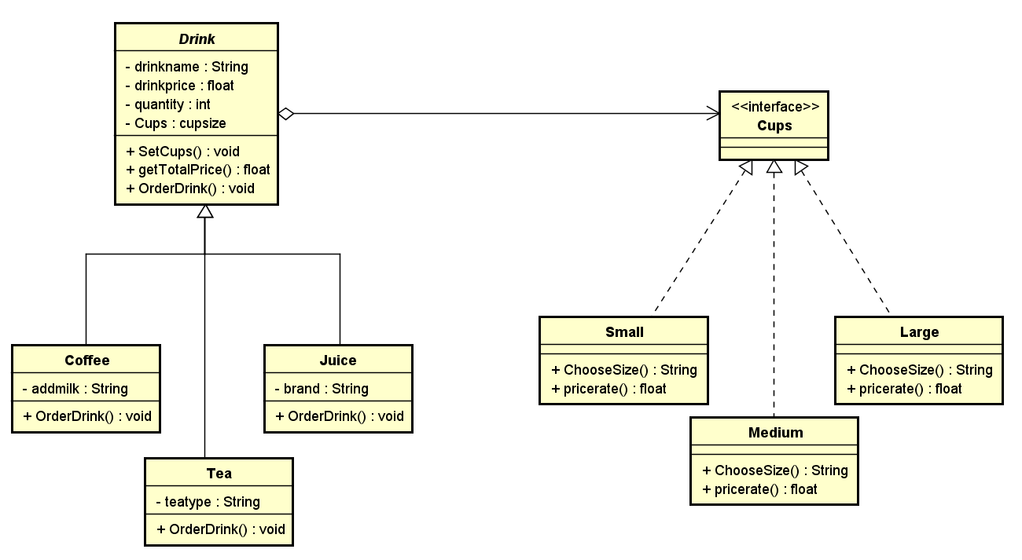

This app is an online Drink Store which sells different kind of drinks with different sizes of cups. We use a bridge pattern to “decouple an abstraction from its implementation so that the two can vary independently”. Here Drink is the abstraction and Cups is the implementer. When it is necessary to add another kind of drink, like Milk, we only add a Milk class to inherit the abstract class Drink, don’t need to change other part of the code. The same to Drink, if we need to add another kind of Cups, like a HolidayTheme cup, just add a class to implement the interface Cups.

Below is the result of running this app:

