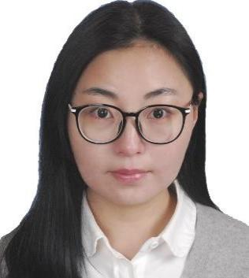

Name：Ting He

Tel: +86 15201920322

Email: [995903723@qq.com](mailto:995903723@qq.com)

Birthday: 1990-08-10

# Work Experience

## Shanghai Yitu Network Technology Co., Ltd.

**2020.2-now Team leader of Quality and Efficiency Test Group 1 of R&D Center**

* Manage a team which has 10 testers, daily job contains function (API test using python & UI test using playwright) and performance test (contain robustness, security and stability test), CICD and Jenkins job development and maintenance, cross-function team communication
* During the past year, drive test framework transfer from Polita to Pandora, build up different CI job for TXWL and JF (product name)for different test scenario which increase the test coverage of API test
* Make test plan for robustness(using chaosmesh) and stability test for TXWL, and finally integrate all the cases into CI, make upgrade test from manual test to automation
* Expand test data set to bicycle and car which cover more test scenario
* As a quality assure team, product release is also part of my daily job which contains requirement study, progress following and driving, bug triage, risk analysis, product release and online customer acceptance verification,during last year, I followed two KP（Key Point）program and continuously increase verification standards and efficiency

## Ericsson (China) Communications Co., Ltd.

**2019.7-2020.2 Senior verification engineer/Test coordinator**

* Responsible for product verification life cycle which include test plan, customer requirement & test analysis, which include maintain existing CI automation, FT & ST & test environment, new test cases design and product release test. During this period, integrate all the characteristic and stability test in CI.
* As a test coordinator，study the traffic of Vodafone UK and TIM Italy, improve user360 capacity test witch adding customer traffic model in test cases, good test strategy and plan help me to win the Spot Award in programs

**2017.5-2019.6 Verification engineer**

* Led team to participate in the bidding of CMCC-NBIoT project, actively connected with UPG customers and other nodes, completed the demand analysis, function realization, products integration and Lab test together with the team, and successfully completed the Demo
* User360 ST Improvement: Break through the existing hardware bottleneck, provide the test solution which divide full function to module and implemented the cases with Python which help to increase test capacity to 16 times. At the same time, actively study customer traffic model which improve the reliability of Lab test data
* User360 CLI FT Automation: Found the shortcomings of existing automated and functional tests, took the initiative to undertake the development of test cases and integrate them into the existing automated test system which improves the coverage of automated tests and product quality. These experience helps me to get Program Recognition Award during this time

**2016.5-2017.5 Assistant verification engineer**

* Focus on Node System test and performance. Develop automation tools which help team to set up test environment. Win Program recognition Award in UPG All Employee Meeting as a quick learner
* Efficiently and actively solved customer issues during this time which helps me win Program Recognition Award as a quick trouble-shooter

# Education

2013.9-2016.4 Master of Communication & Information System in Shanghai University

2009.9-2013.6 Bachelor of Communication engineering in Shanghai Normal University

# Self-Evaluation

Familiar with software development & testing & release process, Python &CICD, and have about 5 years' experience in Linux terminal function (interface &UI) and performance (including stability and robustness) testing which including about 2 years' experience in team management & project release