Exploring Religious Differences in Online vs. In-Person Worship Attendance During COVID-19
Author: Tingji Tao, Kamron, Jizhou
Course: MSSP Consulting Project
Client: Tyler Fuller (Department of Religion)
Date: 2025/11/28

Abstract
This study investigates how U.S. Catholics and Protestants differed in their worship attendance patterns—online, in-person, or both—during the COVID-19 pandemic, specifically before vaccines became widely available. Using the Pew Research Center’s American Trends Panel (ATP), we analyze survey responses collected in July 2020 (Wave 70) and March 2021 (Wave 84). Exploratory data analysis summarizes denominational, demographic, and attitudinal differences. Multinomial logistic regression models are developed to identify predictors of online versus in-person attendance, including demographic and Health Belief Model–related variables.
(results will be inserted here later)

1. Introduction
The COVID-19 pandemic forced many religious congregations across the United States to suspend or modify traditional in-person services. This created a natural experiment for understanding how religious groups adapt their worship behavior in response to health risks and public restrictions.
This project focuses on comparing Catholics and Protestants, two of the largest Christian groups in the U.S., analyzing differences in:
Online religious service attendance
In-person worship participation
Hybrid (both online and in-person) behavior
The goal is to understand whether denominational affiliation shapes worship decisions under public health constraints, and which demographic or belief-related factors predict online worship.

2. Background and Project Description
The project has three major components: project goals, data source, and experiment design.

2.1 Project Goals
Determine online vs. in-person religious attendance rates among U.S. Catholics and Protestants.
Identify predictors of online worship participation.
Compare denominational differences at two time points:
Wave 70 (July 2020)—early pandemic
Wave 84 (March 2021)—during vaccine rollout
Provide insights to inform public health communication strategies during future crises.

2.2 Data Source
Survey collected through Pew Research Center’s American Trends Panel (ATP).
Nationally representative, probability-based sample (~10,000 panelists).
Conducted via telephone interviews.
Uses standard Pew methodology for weighting and design.

2.3 Relevant Concepts
Health Belief Model (HBM): explains behavior based on perceived risk, benefit, barriers, and cues to action.
ATP: a multimode panel providing high-quality U.S. public opinion data.
Additional factors such as religious importance, pastor communication, and perceived COVID threat may act as behavioral triggers.

3. Data Description
This dataset includes approximately 6,000 Catholic and Protestant respondents across Waves 70 and 84. Variables available include:

3.1 Demographic Variables
-Age
-Gender
-Race/Ethnicity
-Education
-Income
-Region & Metro Area
-Political ideology

3.2 Religion & Worship Variables
Religious tradition (Catholic / Protestant)
Self-reported attendance frequency
Online service participation
In-person service participation
Congregation streaming availability

3.3 Health Belief Model Variables
Perceived COVID threat
COVID confidence
Social cues (religious importance, communication frequency)

3.4 Data Cleaning Steps (to be filled by you later)
You will summarize:
How missing values were handled
How the attendance outcome (“Both”, “In-person only”, “Online only”) was constructed
How the religion variable was cleaned and filtered
How the two waves were combined or analyzed separately
(Leave space for your description.)

4. Exploratory Data Analysis (EDA)

Part 1: Overall Attendance Distribution
Insert barplots or summary tables comparing:
% Online
% In-person
% Both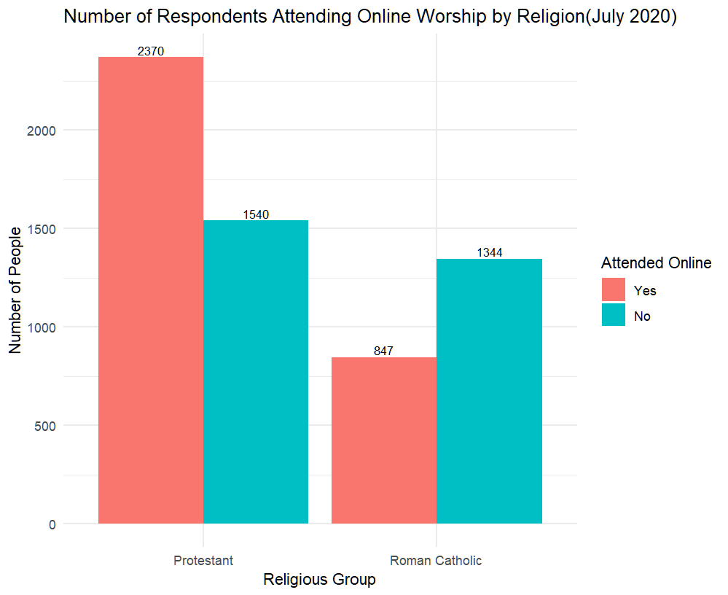
# R code for attendance distribution plots

Part 2: Comparison by Religion
Include:
Boxplots / barplots
Wave 70 vs Wave 84 comparison
# R code for Catholic vs Protestant comparisons

Part 3: Demographic Patterns
Tables summarizing demographic characteristics by religion and attendance type.
(Leave blank)
# demographic summary table code

Part 4: HBM Variables
Plots for:
Perceived threat

Confidence

Congregation streaming

(Leave blank)
# HBM-related EDA

5. Modeling

5.1 Model Specification
Outcome variable:

attend ∈ {inperson, online, both}

Main predictor:

religion ∈ {Catholic, Protestant}

Controls may include:

age, gender, education, political ideology

COVID beliefs (perceived threat, confidence)

streaming availability

internet access

Model form (to be inserted after you choose):
model <- multinom(attend ~ religion + age + gender + ..., data = ...)

5.2 Model Versions
Model 1 — Religion only
(code placeholder)
Model 2 — Add demographics
(code placeholder)
Model 3 — Add HBM variables
(code placeholder)
Model Comparison Table
(leave blank)
Model | Predictors | AIC | Pseudo-R2 | Notes
1 | Religion only | ___ | ___ | ___
2 | + Demographics | ___ | ___ | ___
3 | + HBM variables | ___ | ___ | chosen

6. Results

6.1 Model Output
Paste your summary(modelX) output here later:
# summary(model3)

6.2 Interpretation
Leave space for interpretation of key coefficients:

Religion effect

Age effect

HBM predictors

Wave comparison

(You will fill these once the results are known.)

7. Discussion
To be filled after results:

Did Catholics attend online more than Protestants?

Did Protestants return in person faster?

Which demographic factors mattered most?

How do HBM variables influence attendance decisions?

(Leave blank)

8. Conclusion
Summarize:

Main denominational differences

Implications for public health communication

Future analysis directions (Bayesian models, random effects)

(Leave blank)

9. Appendix
Include:

Diagnostic plots

R code

Full tables
(Leave space.)

