Django 第一天作业
- 让Django的小火箭起飞(WIN调试,Linux运行)
重点1: 运行不能报错
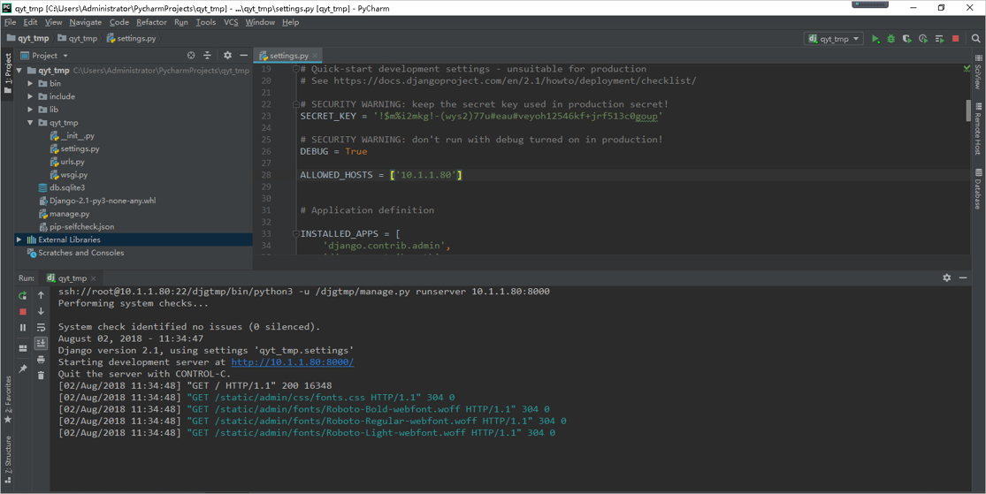
重点2: 看到小火箭起飞的图
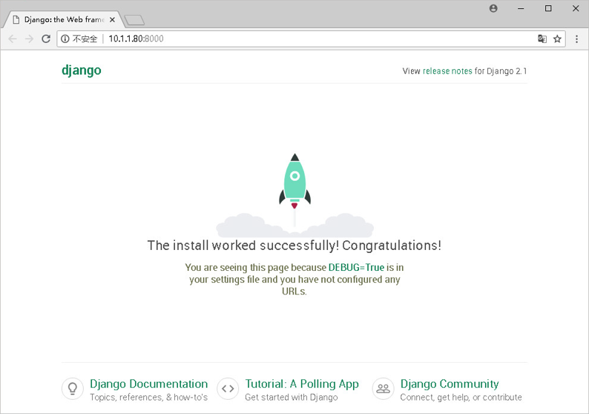
作业标准:
- 提供完整的代码(Windows 或 Linux)
- 对打印结果进行截图

作业内如如下:
代码是django-admin startproject mysite . 自动产生的
目录结构如下
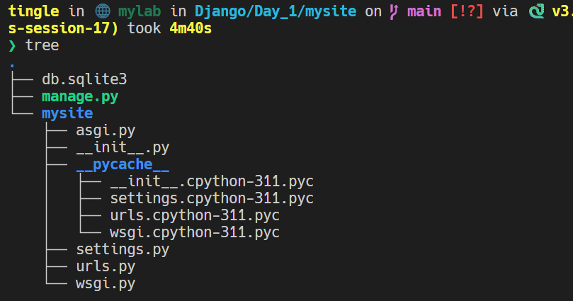

launch.json文件
{
// Use IntelliSense to learn about possible attributes.
// Hover to view descriptions of existing attributes.
// For more information, visit: https://go.microsoft.com/fwlink/?linkid=830387
"version": "0.2.0",
"configurations": [
{
"name": "Run Django with Gunicorn",
"type": "debugpy",
"request": "launch",
"program": "${workspaceFolder}/.venv/bin/gunicorn",
"args": [
"--bind", "0.0.0.0:8000",
"mysite.wsgi:application",
"--worker-class", "gthread",
"--workers", "3",
"--log-level", "debug",
"--access-logfile", "-"
],
"console": "integratedTerminal",
"justMyCode": false,
"cwd": "${workspaceFolder}/homework/Django/Day_1/mysite"
},
{
"name": "Python Debugger: Django",
"type": "debugpy",
"request": "launch",
"args": [
"runserver"
],
"django": true,
"autoStartBrowser": false,
"autoReload": {"enable": true},
"program": "${workspaceFolder}/homework/Django/Day_1/mysite/manage.py"
}
]
}

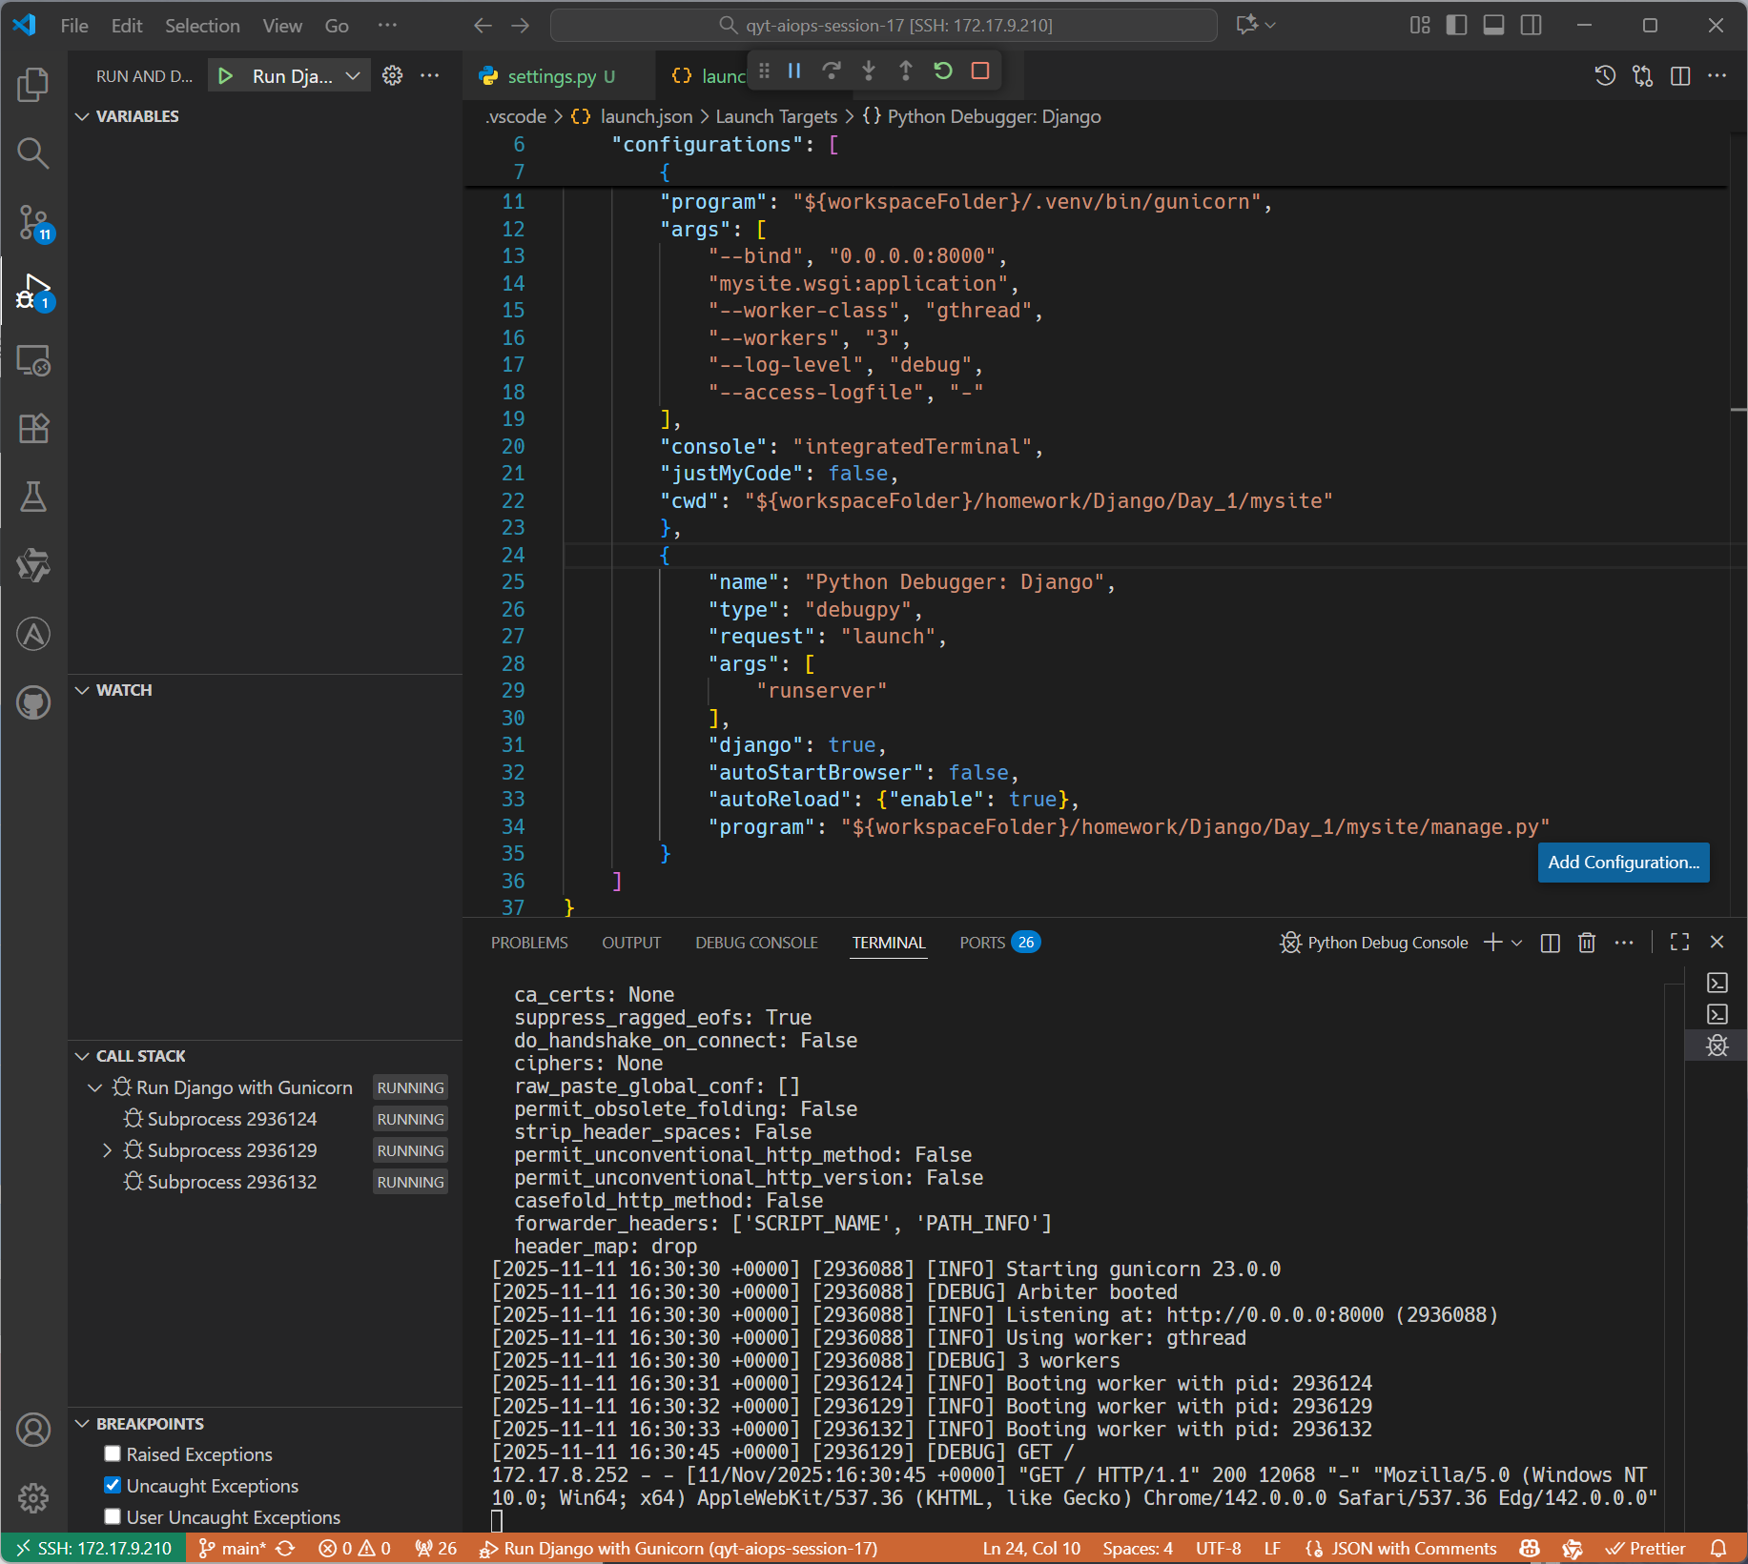
访问服务器地址能够看到小火箭
