Django 第五天作业
- 查看和删除网络设备
效果图如下:
下拉菜单与超链接:
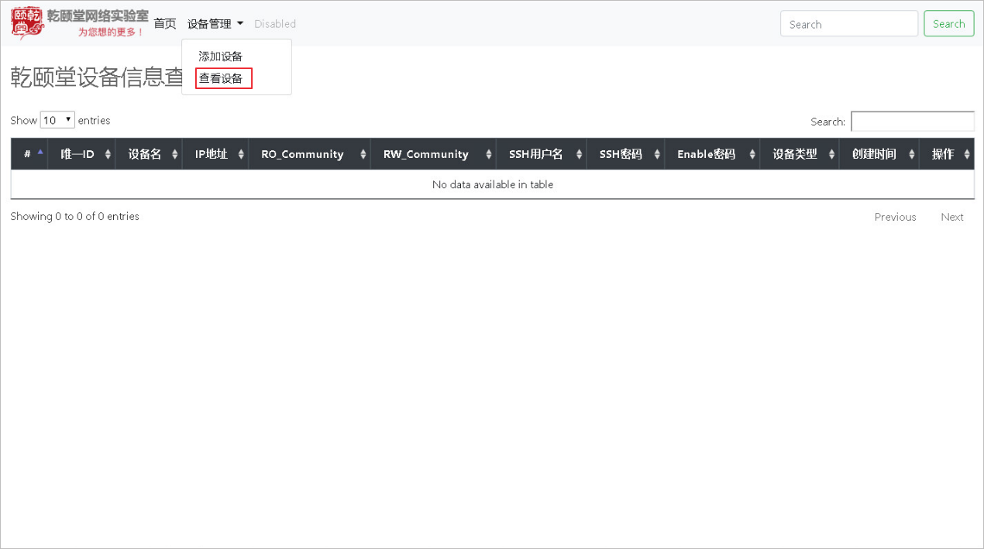
查看网络设备(注意:DataTables的JS要被正常加载,能搜索能排序):
使用filter(过滤器)格式化设备名称(大写)和时间:
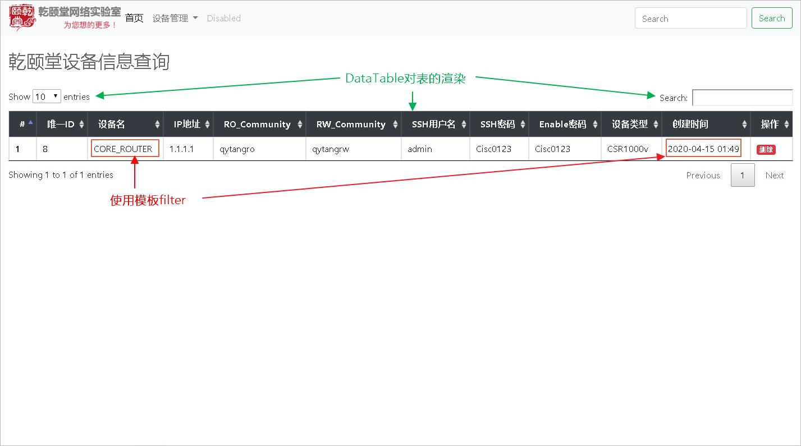
删除网络设备(有删除提醒, 删除确认):
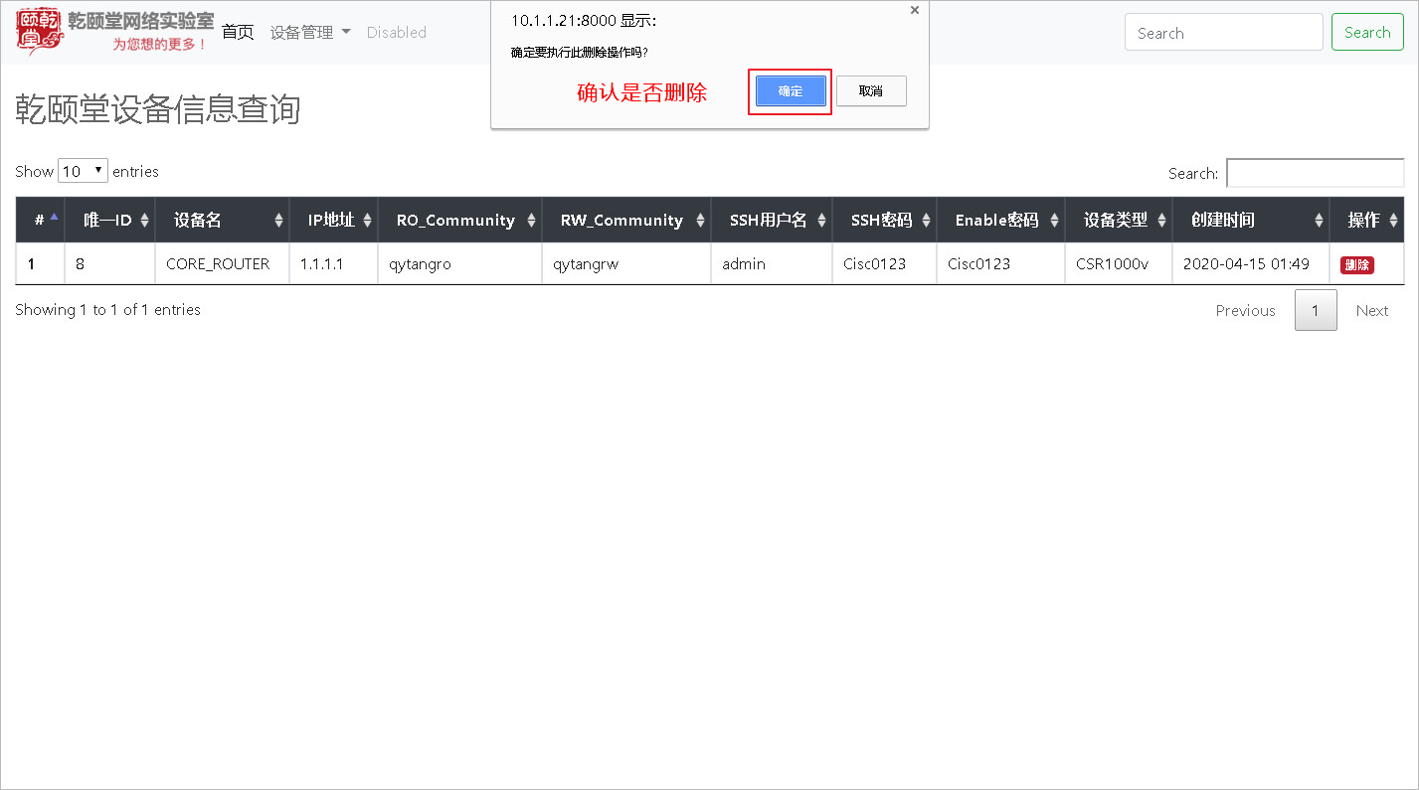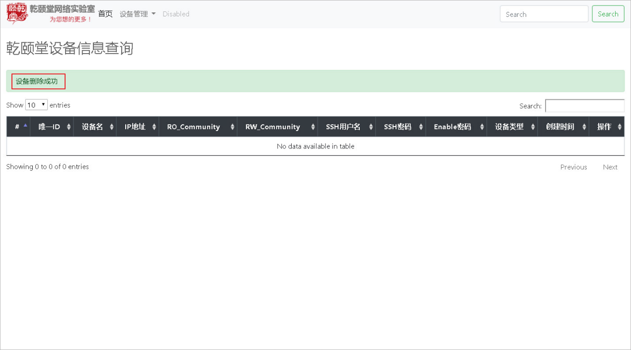
作业标准:
- 提供html, view代码
- 提供查看设备和删除设备后截图
- 代码可以参考:CodeCommit Django作业
- 就算是全部都是贴的标准配置,也要把效果做出来感受一下

作业内容如下：
做了设备列表的选项可以展示添加了的设备
将hostname全部转为了大写显示，并且格式化了时间的显示
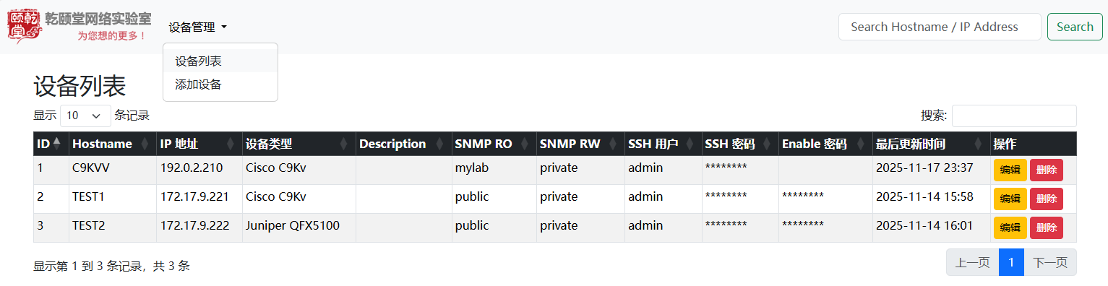
排序功能测试
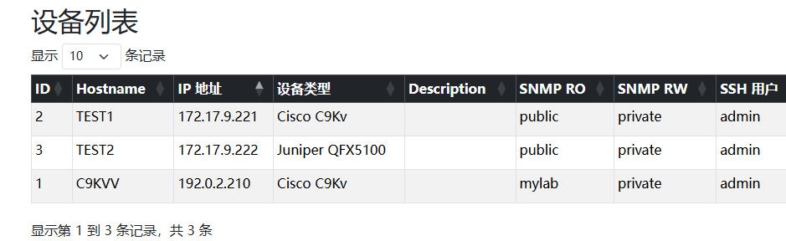
搜索功能测试
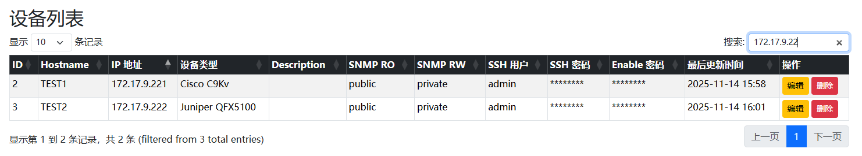
删除设备的功能
删除会弹出确认项
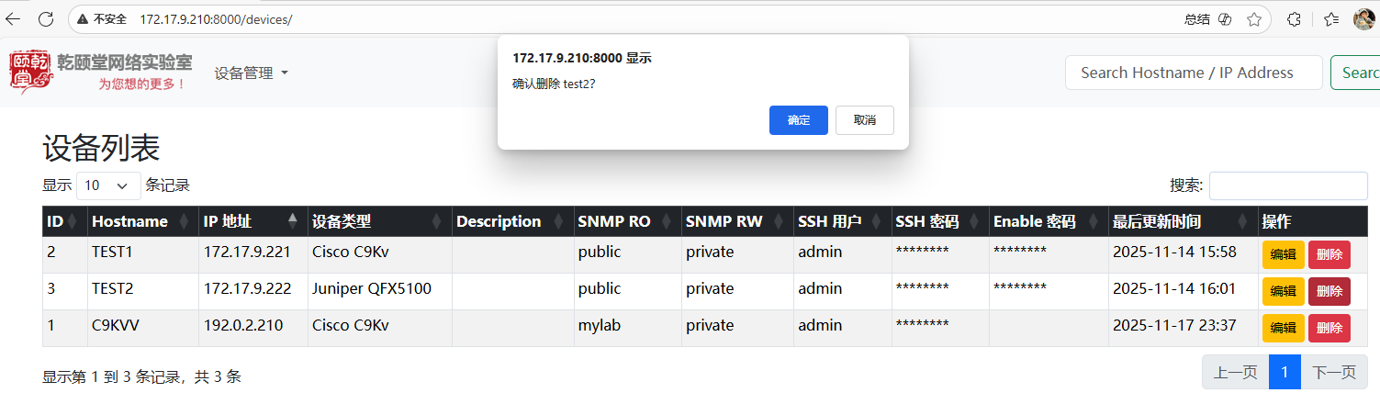

删除成功后回显剩下的设备并且会有气泡通知条提示删除成功
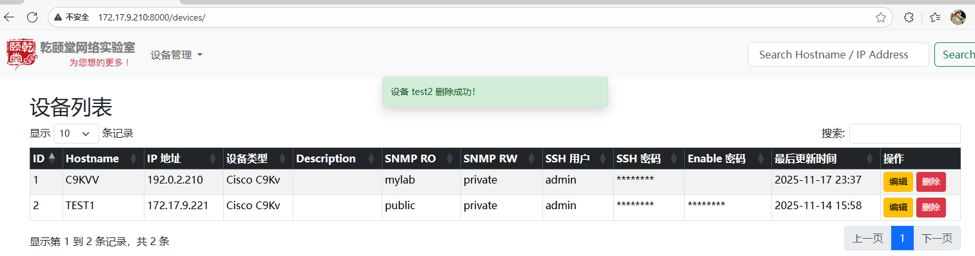
代码如下
代码仓库连接 https://github.com/tinglemmx/qyt-aiops-session-17/tree/main/homework/Django
homework/Django/mysite/templates/devices/list.html
{% extends "base.html" %}
{% block list_extra_css %}
<style>
.custom-toast {
background-color: #d4edda; /* 淡绿色 */
color: #155724; /* 深绿色文字 */
border: 1px solid #c3e6cb;
border-radius: 0.25rem;
opacity: 0;
transition: opacity 0.6s ease-in-out;
}

.custom-toast.show {
opacity: 1;
}
</style>
{% endblock list_extra_css %}
{% load tz %}
{% block title %}设备列表{% endblock %}

{% block content %}
<div class="container-fluid mt-4 px-5">
{% if messages %}
<div aria-live="polite" aria-atomic="true" class="position-relative">
<div class="position-fixed top-5 start-50 translate-middle p-3" style="z-index: 1050;">
{% for message in messages %}
<div class="toast custom-toast mb-2" role="alert" aria-live="assertive" aria-atomic="true">
<div class="toast-body">
{{ message }}
</div>
</div>
{% endfor %}
</div>
</div>
{% endif %}
<h2>设备列表</h2>

<table id="deviceTable" class="table table-striped table-bordered table-sm">
<thead class="table-dark">
<tr>
<th>ID</th>
<th>Hostname</th>
<th>IP 地址</th>
<th>设备类型</th>
<th>Description</th>
<th>SNMP RO</th>
<th>SNMP RW</th>
<th>SSH 用户</th>
<th>SSH 密码</th>
<th>Enable 密码</th>
<th>最后更新时间</th>
<th>操作</th>
</tr>
</thead>
<tbody>
{% for device in devices %}
<tr>
<td>{{ device.id }}</td>
<td>{{ device.hostname |upper }}</td>
<td>{{ device.ip_address }}</td>
<td>{{ device.dev_type }}</td>
<td>{{ device.description }}</td>
<td>{{ device.snmp_ro_community }}</td>
<td>{{ device.snmp_rw_community }}</td>
<td>{{ device.ssh_username }}</td>
<td>{% if device.ssh_password %}********{% endif %}</td>
<td>{% if device.enable_password %}********{% endif %}</td>
<td>{{ device.last_update|timezone:"Asia/Shanghai"|date:"Y-m-d H:i"}}</td>
<td>
<a href="{% url 'edit_device' device.id %}" class="btn btn-sm btn-warning">编辑</a>
<form action="{% url 'delete_device' device.id %}" method="post" style="display:inline-block;"
onsubmit="return confirm('确认删除 {{ device.hostname }}？');">
{% csrf_token %}
<button type="submit" class="btn btn-sm btn-danger">删除</button>
</form>
</td>
</tr>
{% empty %}
<tr>
<td colspan="12" class="text-center">暂无设备</td>
</tr>
{% endfor %}
</tbody>
</table>
</div>
{% endblock %}

{% block extra_js %}

</style>
<!-- jQuery -->
<script src="https://cdnjs.cloudflare.com/ajax/libs/jquery/3.6.4/jquery.min.js"></script>

<!-- DataTables CSS -->
<link rel="stylesheet" href="https://cdnjs.cloudflare.com/ajax/libs/datatables.net-bs5/1.13.6/dataTables.bootstrap5.min.css">

<!-- DataTables JS -->
<script src="https://cdnjs.cloudflare.com/ajax/libs/datatables.net/1.13.6/jquery.dataTables.min.js"></script>
<script src="https://cdnjs.cloudflare.com/ajax/libs/datatables.net-bs5/1.13.6/dataTables.bootstrap5.min.js"></script>

<!-- Bootstrap Icons（也换掉 jsDelivr） -->
<link rel="stylesheet" href="https://cdnjs.cloudflare.com/ajax/libs/bootstrap-icons/1.11.3/font/bootstrap-icons.min.css">
<script>
$(document).ready(function() {
$('#deviceTable').DataTable({
"paging": true,
"lengthChange": true,
"searching": true,
"ordering": true,
"info": true,
"autoWidth": false,
"columnDefs": [
{ "orderable": false, "targets": 11 } // 操作列不能排序
],
"language": {
"search": "搜索:",
"lengthMenu": "显示 _MENU_ 条记录",
"info": "显示第 _START_ 到 _END_ 条记录，共 _TOTAL_ 条",
"paginate": {
"first": "首页",
"last": "末页",
"next": "下一页",
"previous": "上一页"
},
"emptyTable": "暂无数据"
}
});
});
</script>
<script>
document.addEventListener('DOMContentLoaded', function () {
var toastElList = [].slice.call(document.querySelectorAll('.toast'))
toastElList.forEach(function (toastEl) {
var toast = new bootstrap.Toast(toastEl, { delay: 3000 }) // 显示3秒
toast.show()
})
})
</script>
{% endblock %}

homework/Django/mysite/devices/views.py
from django.shortcuts import render, get_object_or_404,redirect
from .models import DeviceDB, DeviceMetric
from scripts.snmp_collector import collect_snmp_for_device
from .forms import DeviceForm
from django.db.models import Q
from django.contrib import messages

def collect_once(request):
devices = DeviceDB.objects.all()
metrics = []

if request.method == 'POST':
device_id = request.POST.get('device_id')
device = get_object_or_404(DeviceDB, id=device_id)
collect_snmp_for_device(device)
metrics = DeviceMetric.objects.filter(device=device).order_by('-timestamp')

return render(request, 'devices/collect.html', {'devices': devices, 'metrics': metrics})

def add_device(request):
if request.method == "POST":
form = DeviceForm(request.POST)
if form.is_valid():
ip = form.cleaned_data["ip_address"]
duplicate = DeviceDB.objects.filter(ip_address=ip).exists()
if duplicate and request.POST.get("confirm_duplicate") != "1":
# IP 重复，先显示模板，触发 JS 弹窗
return render(request, "devices/add_device.html", {
"form": form,
"duplicate_ip": ip,
"show_duplicate_confirm": True # 新增标记

})
form.save()
return redirect("device_list") # 保存后跳回列表页
else:
form = DeviceForm()
return render(request, "devices/device_form.html",{"form": form, "mode":"add"})

def device_list(request):
q = request.GET.get("q", "").strip()
sort = request.GET.get("sort", "id") # 默认按 id
direction = request.GET.get("dir", "asc") # 默认升序

# 组合排序字段
sort_field = f"-{sort}" if direction == "desc" else sort

devices = DeviceDB.objects.all()

# 搜索
if q:
devices = devices.filter(
Q(hostname__icontains=q) |
Q(ip_address__icontains=q)
)

# 排序
devices = devices.order_by(sort_field)

return render(request, "devices/list.html", {
"devices": devices,
"q": q,
"current_sort": sort,
"current_dir": direction,
})

def edit_device(request, device_id):
device = get_object_or_404(DeviceDB, pk=device_id)

if request.method == "POST":
form = DeviceForm(request.POST, instance=device)
if form.is_valid():
form.save()
return redirect("device_list")
else:
form = DeviceForm(instance=device)

return render(request, "devices/device_form.html", {"form": form, "device": device,"mode":"edit"})

def delete_device(request, pk):
device = get_object_or_404(DeviceDB, pk=pk)
device.delete()
messages.success(request, f"设备 {device.hostname} 删除成功！")
return redirect("device_list")

