NetDevOps 第七天作业
  - [APIFOX, RESTCONF采集CPU利用率并配置SYSLOG]
- APIFOX, RESTCONF采集CPU利用率并配置SYSLOG
任务一:安装APIFOX, 加载下面链接教主提供的项目文件(当然有能力自己做更好):
链接: https://pan.baidu.com/s/1-KrfjyJMZk9rt-JOJ4C9jA 提取码: c5ir
任务二:使用APIFOX获取最近5秒CPU利用率, 测试截图如下! 请你转换到Python3代码,做成函数让代码更具通用性(def monitor_cpu(device_ip, username, password, monitor_type='5s'):)
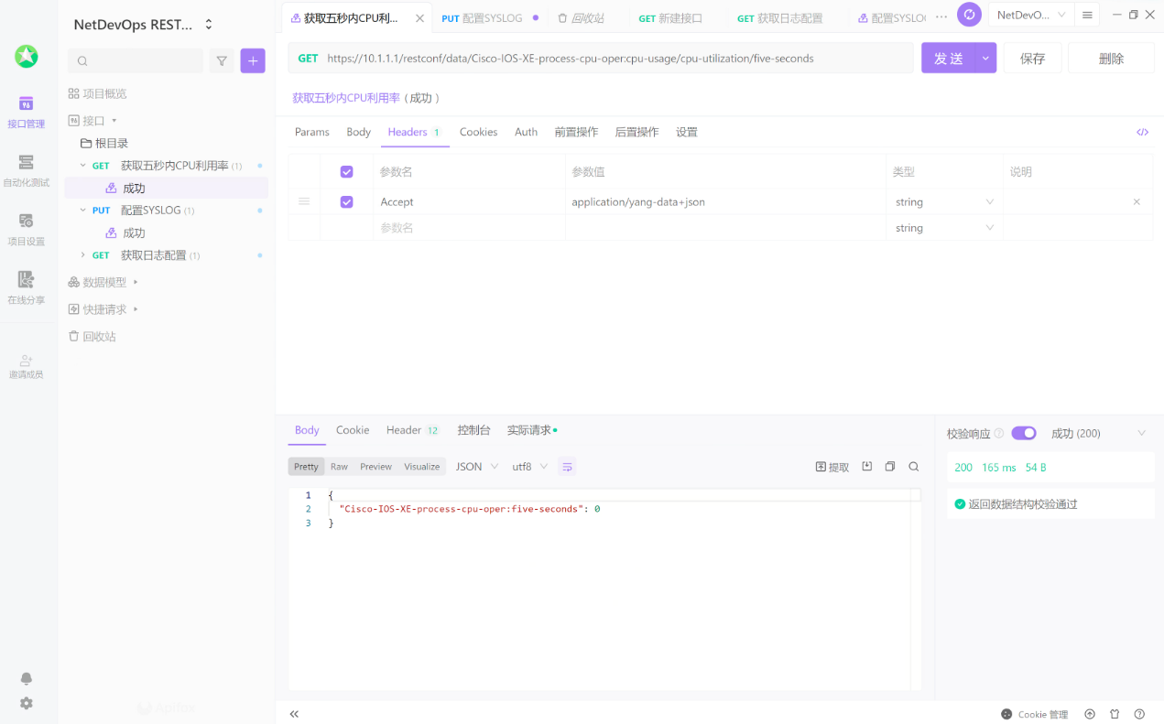
任务三:使用APIFOX配置SYSLOG(host与trap level), 测试截图如下! 请你转换到Python3代码,做成函数让代码更具通用性(def conf_syslog(device_ip, username, password, severity, hostip):)
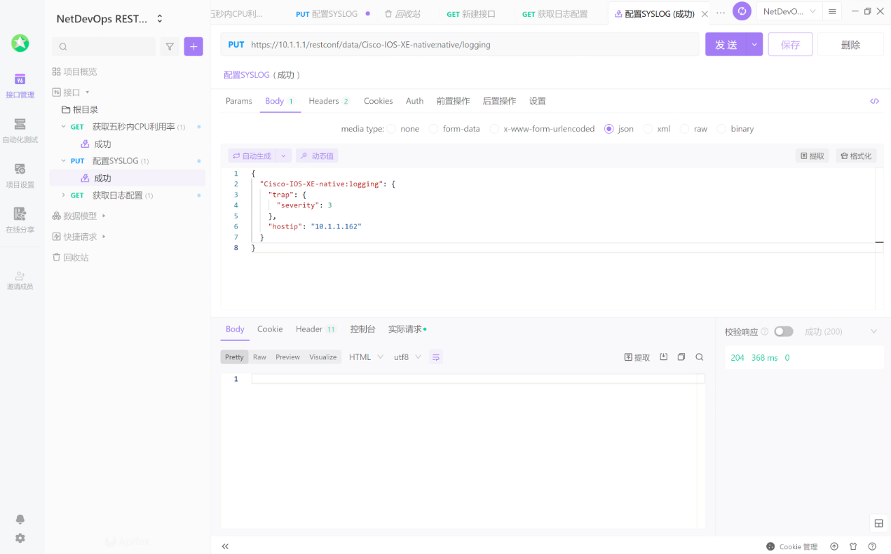
作业标准:
- 提供完整的代码（Windows 或 Linux）
- 对打印结果进行截图

作业内容如下
任务一：安装APIFOX
安装APIFOX 并导入了 CPU 和logging的部分API数据
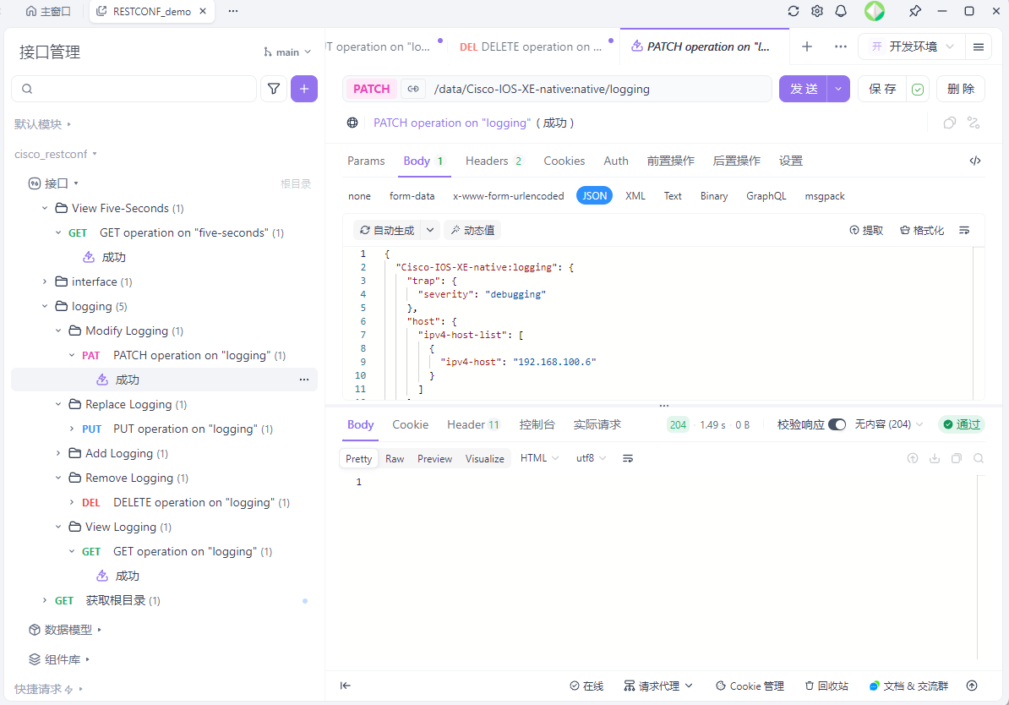

任务二:使用APIFOX获取最近5秒CPU利用率
用APIFOX获取
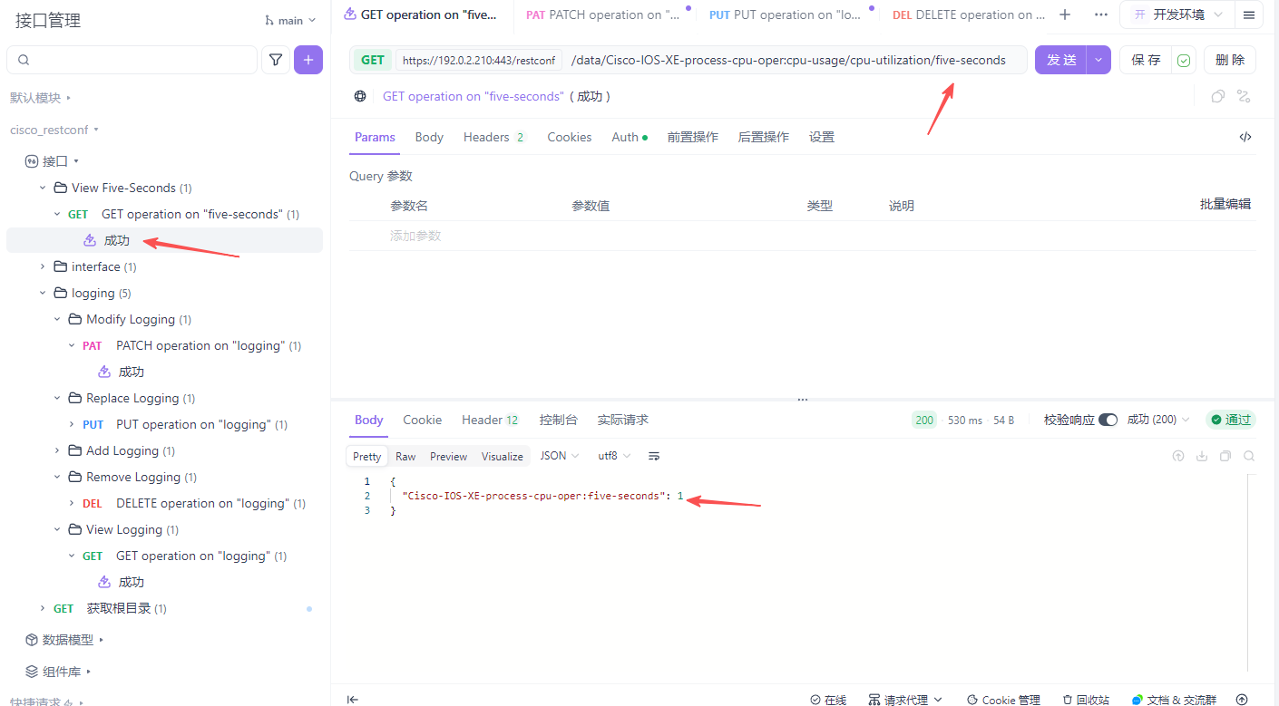
用python获取
python代码如下
import requests
from requests.auth import HTTPBasicAuth
import urllib3

# 禁用 HTTPS 证书告警（实验环境常用）
urllib3.disable_warnings(urllib3.exceptions.InsecureRequestWarning)

# === RESTCONF 访问配置 ===
url = "https://192.0.2.210:443/restconf/data/Cisco-IOS-XE-process-cpu-oper:cpu-usage/cpu-utilization/five-seconds"
username = "admin"
password = "cisco123"

# === RESTCONF Header ===
headers = {
"Accept": "application/yang-data+json",
"Content-Type": "application/yang-data+json"
}

# === 发送 GET 请求 ===
response = requests.get(
url,
auth=HTTPBasicAuth(username, password),
headers=headers,
verify=False # 实验设备一般使用自签名证书
)

# === 解析返回 ===
if response.status_code == 200:
print("请求成功")
print(response.json())
else:
print(f"请求失败，状态码: {response.status_code}")
print(response.text)

任务三:使用APIFOX配置SYSLOG
用APIFOX配置SYSLOG
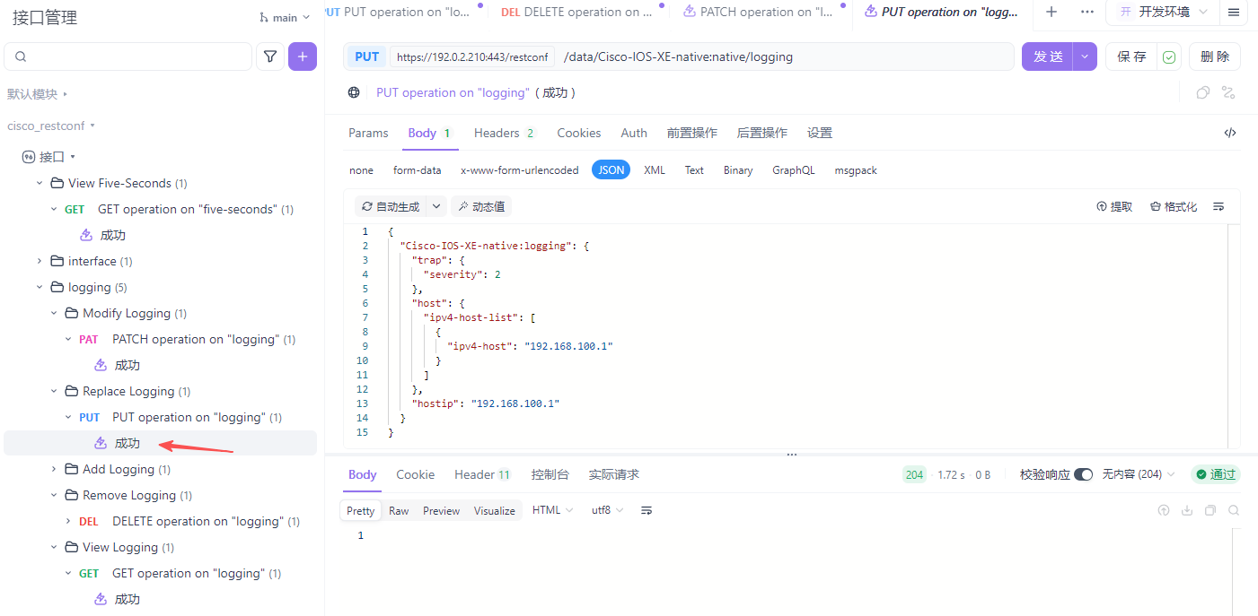
检查设备配置APIFOX请求生效
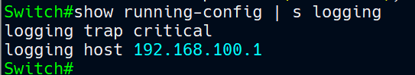

用python put另一套配置
检查设备配置python请求生效
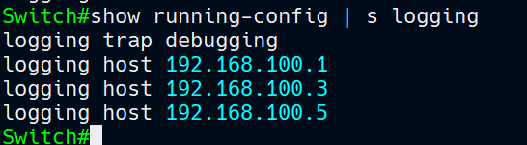
python代码如下
import requests
from requests.auth import HTTPBasicAuth
import urllib3
import json

# 禁用 HTTPS 证书告警（实验环境常用）
urllib3.disable_warnings(urllib3.exceptions.InsecureRequestWarning)

url = "https://192.0.2.210:443/restconf/data/Cisco-IOS-XE-native:native/logging"
username = "admin"
password = "cisco123"

headers = {
"Accept": "application/yang-data+json",
"Content-Type": "application/yang-data+json"
}

data = {
"Cisco-IOS-XE-native:logging": {
"trap": {"severity": "debugging"},
"host": {
"ipv4-host-list": [
{"ipv4-host": "192.168.100.1"},
{"ipv4-host": "192.168.100.5"},
{"ipv4-host": "192.168.100.3"}
]
},
"hostip": "192.168.100.1"
}
}

resp = requests.put(
url,
headers=headers,
data=json.dumps(data),
auth=HTTPBasicAuth(username, password),
verify=False
)

print(resp.status_code, resp.text)

