Document History
Date | Author | Summary of Change | Note
7/04/06 | Augmentum | Initial version.

Webtop Plugin Install and Configuration Guide

1. Deploy Webtop Plugin
1.1 Make sure that DCTM webtop is installed. Generally, it is installed at: "C:\Program Files\Apache Software Foundation\Tomcat 5.0\webapps\webtop"
1.2 Copy “custom” folder from the unzipped folder “.\custom” over to webtop “custom” folder “CATALINA_HOME\Tomcat 5.0\webapps\webtop\custom”.
1.3 Copy following jar files from the unzipped folder ".\lib" to webtop lib directory "CATALINA_HOME\Tomcat 5.0\webapps\webtop\WEB-INF\lib"
activation.jar axis.jar dfc.jar
ambassador.jar collaboration.jar saaj.jar
documentum-adapter.jar jsp-api.jar
commons-discovery.jar subscription.jar jaxrpc.jar
servlet-api.jar workflow.jar wsdl4j.jar
1.4. Configure the properties file under the unzipped folder ".\classes\properties" and then copy it to webtop's directory ".\Tomcat 5.0\webapps\webtop\WEB-INF\classes\properties".
DocumentumAdapter.properties

Following configuration is about the Ambassador server which provides the Web Services for the Plugin.
amb_hostname=<Ambassodr_hostname>
amb_http_port=7001
amb_https_port=7001
amb_username=<Ambassador_User> //Must be PM or admin user
amb_password=<Password>

Docbase and super user is also configured in this property file.
dctm_repository=<Docbase>
dctm_username=<Super_User>
dctm_password=<Password>

1.5. Modify "web.xml" in your webtop location: "Tomcat 5.0\webapps\webtop\WEB-INF".
FROM:
<context-param>
<param-name>AppFolderName</param-name>
<param-value>custom</param-value>
</context-param>
TO:
<context-param>
<param-name>AppFolderName</param-name>
<param-value>custom/ambassador</param-value>
</context-param>

2. Configuration
2.1 Run the DQL script for Documentum server to create types and objects which the Plugin needs.
In file “webtop_plugin.zip”, there is a script named “initAmbssador.dql”.
a. Login Documentum with idql32.exe which is located at <Documentum_Install_Folder>\product\5.3\bin
e.g.
cd c:\Documentum\product\5.3\bin
C:\Documentum\product\5.3\bin> idql32.exe
Input the docbase and user/password to login like the following screen shot.
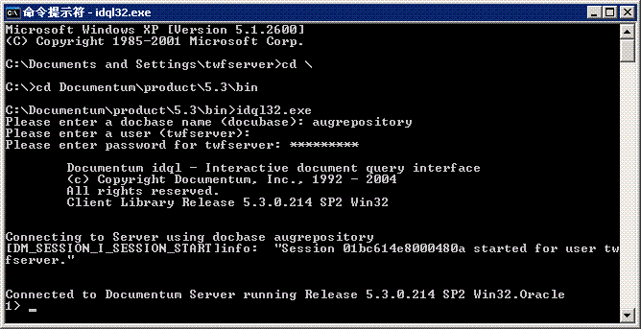
b. Run the script.
1>@<Your_Path>\initAmbssador.dql

The following is the content of the script file:
#create table ref_country_list
CREATE TYPE "ref_country_list" ("locale" char(16), "country_language" char(32)) with supertype NULL
go

#create table ref_translation_preselect
CREATE TYPE "ref_translation_preselect" ("locale_set_code" char(32), "locales" char(16) repeating) WITH SUPERTYPE NULL
go

#create table cfg_translation_attr
CREATE TYPE "cfg_translation_attr" ("doctype" char(64), "location" char(255), "attributes" char(64) repeating) WITH SUPERTYPE NULL
go

#create type ambassador_document
#Here the “ambassador_document” is configurable. You can change it to “pmi_document” for example. Also you can create multi types.
CREATE TYPE "ambassador_document" ("target_languages" char(64), "r_translation_job" char(16), "r_translation_ids" char(255), "r_translation_state" char(32)) WITH SUPERTYPE "dm_document"
go

#create ref_country_list objects
#Here you can add more as required. For example “
CREATE "ref_country_list" OBJECT SET "locale" = 'en_US', SET "country_language" = 'American English'
go
CREATE "ref_country_list" OBJECT SET "locale" = 'fr_FR', SET "country_language"='French'
go
CREATE "ref_country_list" OBJECT SET "locale" = 'it_IT', SET "country_language"='Italian'
go
CREATE "ref_country_list" OBJECT SET "locale" = 'es_ES', SET "country_language"='Spanish'
go
CREATE "ref_country_list" OBJECT SET "locale" = 'en_AU', SET "country_language"='English(Australia)'
go
CREATE "ref_country_list" OBJECT SET "locale" = 'fi_FI', SET "country_language"='Finnish(Finland)'
go
CREATE "ref_country_list" OBJECT SET "locale" = 'ko_KR', SET "country_language"='Korean(South Korea)'
go
CREATE "ref_country_list" OBJECT SET "locale" = 'ru_RU', SET "country_language"='Russian(Russia)'
go
CREATE "ref_country_list" OBJECT SET "locale" = 'zh_CN', SET "country_language"='Chinese'
go
CREATE "ref_country_list" OBJECT SET "locale" = 'zh_TW', SET "country_language"='Chinese(TaiWan)'
go
CREATE "ref_country_list" OBJECT SET "locale" = 'de_DE', SET "country_language"='Germany'
go

#create ref_translation_preselect objects
#You can add more predefined languages here.
CREATE "ref_translation_preselect" OBJECT SET "locale_set_code" = 'G01', SET locales[0] = 'en_US', SET locales[1] = 'zh_CN', SET locales[2] = 'fr_FR', SET locales[3] = 'it_IT',SET locales[4] = 'es_ES',SET locales[5] = 'en_AU',SET locales[6] = 'fi_FI',SET locales[7] = 'ko_KR', SET locales[8]='ru_RU', SET locales[9]='zh_TW'
go
CREATE "ref_translation_preselect" OBJECT SET "locale_set_code" = 'G07', SET locales[0] = 'en_US', SET locales[1] = 'zh_CN', SET locales[2] = 'fr_FR', SET locales[3] = 'it_IT', SET locales[4]='de_DE'
go
CREATE "ref_translation_preselect" OBJECT SET "locale_set_code" = 'G27', SET locales[0] = 'en_US', SET locales[1] = 'zh_CN', SET locales[2] = 'fr_FR', SET locales[3] = 'it_IT'
go

#create cfg_translation_attr objects
#Please make sure that doctype and location is correct. For example, if you renamed it to “pmi_document” when you create the doctype above, then here it must be “pmi_document”.
CREATE "cfg_translation_attr" OBJECT SET doctype = 'ambassador_document', SET location = 'augrepository/Silver/Home/Translation', SET attributes[0] = 'title', SET attributes[1] = 'subject'
go
CREATE "cfg_translation_attr" OBJECT SET doctype = 'pmi_document', SET location = 'augrepository/Brent/HTMLFolder', SET attributes[0] = 'title', SET attributes[1] = 'subject', SET attributes[2]='keywords'

quit

Note: you also can run these DQL statements one by one with idql32.exe or Documentum Administrator.

3.Brief instructions to use Documentum Adapter
3.1 Precondition:
- Make sure Ambassador is running.
- Prepare fileprofiles which will be used in webtop.
- Make sure Doucmentum docbase service and broker service are running.
- Start Tomcat by running:
“C:\Program Files\Documentum\tomcat\5.0.28\bin\startup.bat”

3.2 Webtop plug-in user guide:
- Access the webtop:
http://<Webtop_host>:<port>/webtop
- Login using the account: <DocumentumServerInstaller>/<password>.
- In classic view, create a new folder, for example “Translatable”.
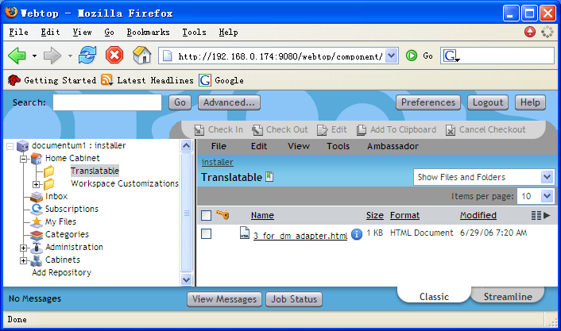
- Import one file into this folder.
- Select user defined doctype during the configuration, for example “Document(ambassador_document)”, as the type for this file. Since this type name is configurable in script files mentioned above, if you have changed it, you should select the proper one.
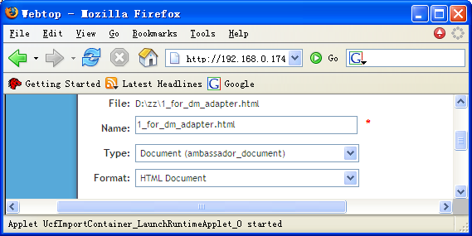
- Modify attributes of this Documentum object(the imported file).
Change the value of attribute “target languages” to the predefined value for example G07.
[The “G07” is a predefined value for a set of target locales]
The attributes need to be translated can also be predefined. Please refer to the script mentioned in section Configuration.
- Select this Documentum object, click on menu “ambassador --> Translate” to create translation job for this document. Then the following page will pop up.
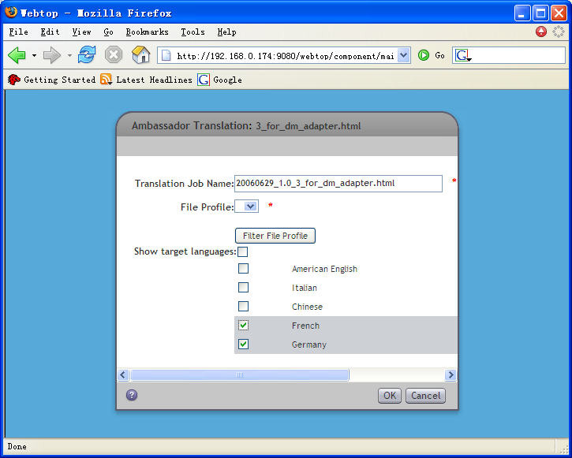
- Choose target languages and click “Filter File Profile” to get all available fileprofiles. Select one fileprofile and click “OK” button to create an Ambassador job. The file profile search criteria is the target locales and the suffix of the file name. If there is no match file profile found, user then could not proceed with creating translation job.
If you select multi objects, the “OK” button should be shown as “Finish” button.
- Go to Ambassador to check the job. If the job is created, finish one workflow of this job.
- Go to Webtop to check the attributes of this object. Following attributes should be changed:
a) r_object_id b) r_translation_ids
c) r_translation_job d) r_translation_state
- Check the file translated by Ambassador in the same folder of Webtop, its file name is like the original one, but added the target locale. For example, the original file name is “dctmToAmb.html” and target language to be translated is “Chinese(zh_cn)”, so the translated file name is “dctmToAmb_zh_cn.html”.
- Check the translated attributes of the translated file.
- Import a new file and create a new Ambassador job. Click on menu “ambassador -->Cancel Translation” to cancel current job.

2. Configure Ambassador translation scope in Webtop Plugin
Note: Part one and part two about how to create a role and how to add a user as a role's member. You can read webtop administration guide for more help, or read more documentum help document to know the role concept in webtop. Part three is to do change in xml file.

Part one – create ambassador translation role.
precondition: you must login with administration privilege.

- Login webtop.
- From the treeview, Go to Administration—User Management – Roles.
- From file menu, click New—Role,
- In this page you can create role for ambassador translation scope.
- We will use “ambassador_translation_role” as example.
- In the name field you should input “ambassador_translation_role”
- Note that you should use the same name to configure scope in the component xml.
- For other configure parameters you can refer to webtop administration guide.

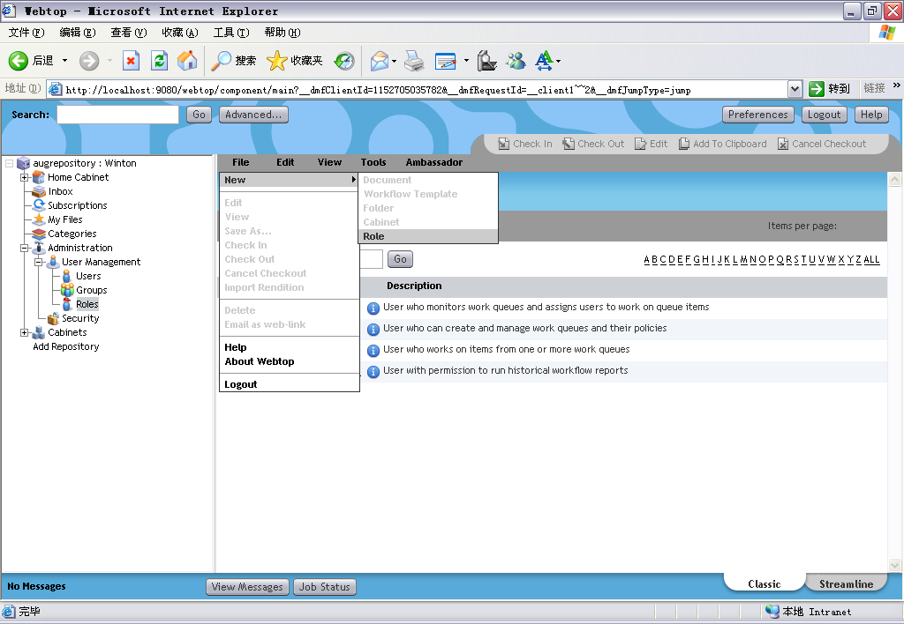

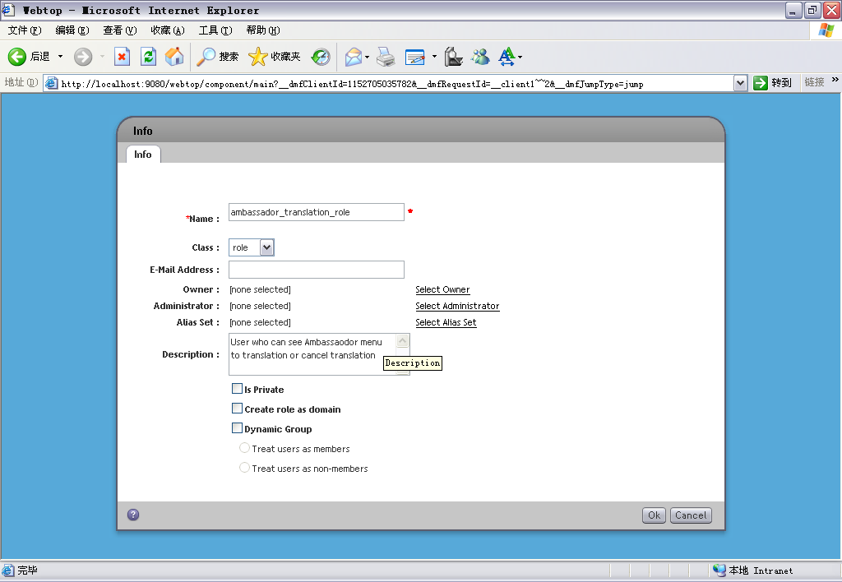

Part two --- add a user as ambassador translation role's member

- Click “ambassador_translation_role” to the page which you can add user as a member.
- From file menu. Click Add member(s) to the page than you can add this role to a user.
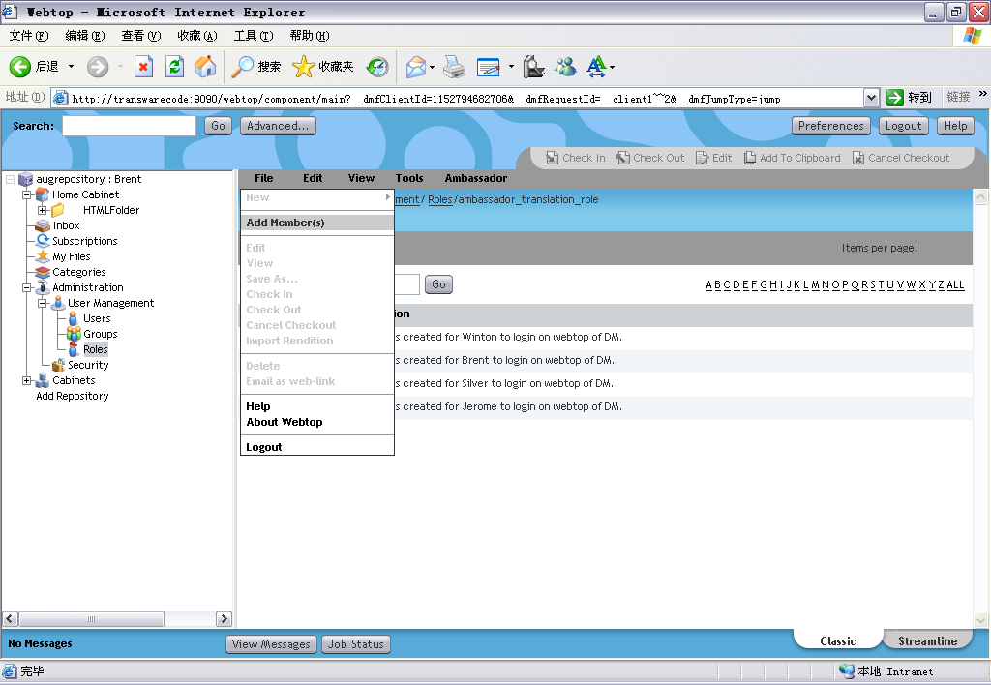

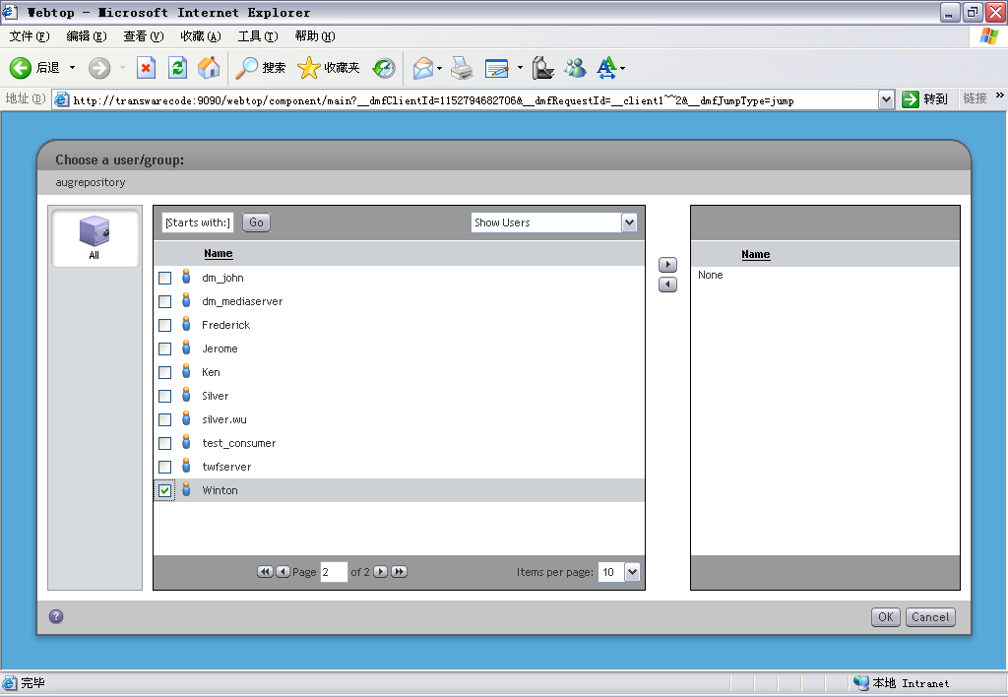

Part three --- configure ambassador translation scope in component xml file.

- Open these files:
- webtop\custom\ambassador\config\actions\dm_sysobject_actions.xml
- webtop\custom\ambassador\config\homecabinet_streamline_component.xml
- webtop\custom\ambassador\config\menubar_component.xml

- change <scope> to <scope role="ambassador_translation_role">
- Now you can start webtop(if you webtop is running, you need to stop it first) to check if ths scope setting successful.
- Or, refresh the configuration files in memory by navigating to /wdk/refresh.jsp, and then observe the new tab

