Software Requirements Specification
For Diplomat 1.0

Version 1.3

Revision History
Date | Version | Description | Author
6/4/2000 | 1.0 | Initial revision | Franco Finstad
6/15/2000 | 1.1 | Incorporated changes from the first review. | Franco Finstad
9/11/2000 | 1.2 | Added details worked out in the design sessions. This will make it possible for QA to write test plans based on this document. This document functions as the spec. | Franco Finstad
9/27/2000 | 1.3 | Added HTML and JavaScript extraction specs. Also added Diplomat DTD and Diplomat Format Specification in the Appendix. | Franco Finstad
10/02/2000 | 1.4 | Added CSS extraction spec. Updated TeamSite section. | Franco Finstad
10/31/00 | 1.5 | Added Java properties, PlainText, Pseudo Tag and Offline sections. | Bill Brotherton
11/05/00 | 1.6 | Added XML extractor section (content provided by Shigemichi). Added Offline translation section (content provided by Jim, Bill, Nils, Shigemichi) | Bill Brotherton

Table of Contents
1. Introduction 5
Purpose 5
Scope 5
Definitions, Acronyms and Abbreviations 5
References 5
Overview 5
2. Overall Description 5
3. Specific Requirements 5
Diplomat Configuration 5
Processing Data from text files 32
Processing data from database-driven web sites 32
Changes to Ambassador 32
Offline Download / Upload 42
PSO interfaces for extensibility 51
Supported character sets 51
4. HTML Extraction Specification 52
Switching rules 52
Extraction 53
Translatable Attributes 56
Localizable Attributes 56
5. JavaScript Extraction Specification 57
Switching rules 57
Extraction 58
Limitations 59
Future direction 60
6. CSS Extraction Specification 60
Switching rules 60
Extraction 60
CSS @ Rules 61
Style Properties 62
Limitations 65
7. Java Properties Extraction Specification 66
Switching rules 66
Extraction 66
Limitations 67
Future direction 67
8. Plain Text Extraction Specification 69
Switching rules 69
Extraction 69
Limitations 71
Future direction 71
9. XML Extractor 72
The Default rule 72
Rule file specification 72
10. Appendix 75
Diplomat DTD 75
Diplomat Format Specification 76
Table of Contents 76
1. Overview 76
2. Specification 77
3. Usage 80

Software Requirements Specification

Introduction

Purpose
This SRS describes the external behavior of the Diplomat 1.0. It describes functional and nonfunctional requirements, design constraints and other factors necessary to provide a complete and comprehensive description of the requirements for the software.

Scope
The main purpose of this product is to provide a flexible and modular method of integrating with external (customer) data sources.

Definitions, Acronyms and Abbreviations

Importing
Registering the data source with the Ambassador system and entering the data in to Ambassador database.

Parsing
Examining data line by line to determine the translatable or localizable content.

Extracting
The process of applying rules to parsed data, such as segmentation, word count, and TM leveraging.

References
Product Marketing MRD dated 5/12/2000.

Overview
This SRS is divided into four main sections:
1. Introduction
2. Overall Description
3. Specific Requirements;
4. Supporting Information
The Introduction section describes the purpose and scope of this SRS. It provides a list of definitions, acronyms and abbreviations used in this document and it lists reference documents.
The Overall Description section contains the use cases that pertain to Ambassador Release 3.0.
The Specific Requirements section contains the functional and non-functional requirements listed in order of use case and any supplementary requirements. Error messages anticipated for this release are also contained in this section.

Overall Description
Release 1.0 of GlobalSight Diplomat provides a bi-directional integration framework and also provides data transfer between multiple data sources and GlobalSight Ambassador 2.4. This product addresses critical needs to integrate and transfer a variety of different data types into the Ambassador products.

Specific Requirements

Diplomat Configuration

General Description
Diplomat configuration consists of a set of screens where the user (an Ambassador Administrator) enters data that Diplomat will later use when it receives an import or export request from 1) Ambassador or 2) Customer database triggers. All configuration data is stored in the Diplomat database tables. If the data source is a database, Diplomat configuration also includes the placing of triggers on the customer database.

The Diplomat Configuration screen (see Figure 1 Diplomat Configuration) shall provide access to the following utilities:

Database Source Profile GUI

File System Source Profile GUI

Localization Profile GUI

Database Connection GUI

Preview URL GUI

XML Rule GUI

TeamSite GUI
Figure 1 Diplomat Configuration
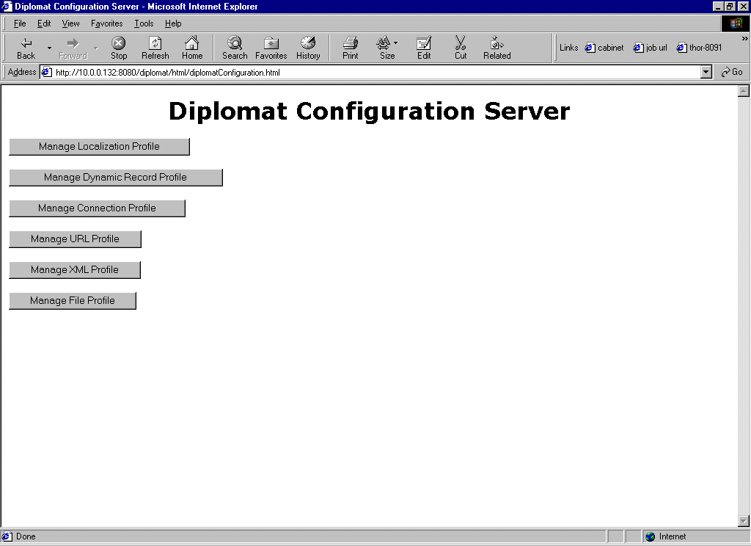

Diplomat shall allow users of group Administrator to access Diplomat Configuration GUIs.

Database Source Profile

General Description
The Database Source Profile stores information about a set of data in the customer database. The Database Source Profile is the equivalent of a “Task” in the previous versions of Ambassador. The “set of data” that the Database Source Profile describes can be a table, a column, a set of columns in a single table or across many tables, or a set of rows in a single table. The Database Source Profile is primarily defined by the Acquisition SQL, which tells Diplomat where and how to get the data.

The user shall be able to add a Database Source Profile.

The user shall be able to modify a Database Source Profile.

The user shall be able to delete a Database Source Profile.

Profile Name

General Description
The Profile Name will be used to uniquely identify the database source profile in the Diplomat GUI. Internally, the database source profile ID will be the unique identifier.

The user shall be able to enter the Profile Name.

The user shall be able to modify the Profile Name

Acquisition SQL

General Description
Acquisition SQL is SQL written by PSO that retrieves the translatable data from the customer database.

The user shall be able to enter the Acquisition SQL.

The user shall be able to modify the Acquisition SQL

Acquisition Context SQL

General Description
Acquisition Context SQL is SQL written by PSO that retrieves the context for the translatable data from the customer database.

The user shall be able to enter the Acquisition Context SQL.

The user shall be able to modify the Acquisition Context SQL

Preview Insert SQL

General Description
Preview Insert SQL is SQL written by PSO that is executed when the user, in the Ambassador Editor, uses the Instant Preview feature. When the user clicks on the Instant Preview button (see Preview URL below) for a newly translated segment, the Preview Insert SQL inserts the newly translated data into the customer database. This newly inserted data is then displayed in context by the customer application to the user via the Preview URL (see Preview URL below). This data will be inserted into a staging database (as opposed to the Final Insert SQL, below) and not the product database since it has not been fully reviewed.

The user shall be able to enter the Preview Insert SQL.

The user shall be able to modify the Preview Insert SQL.

Preview Update SQL.

General Description
Preview Update SQL is the same as Preview Insert SQL, except that it corresponds to segments that were triggered by updates, instead of inserts, on the customer database.

The user shall be able to enter the Preview Update SQL

The user shall be able to modify the Preview Update SQL

Final Insert SQL

General Description
Final Insert SQL is SQL written by PSO that is executed when the data is fully translated and ready to be exported back to the customer database.

The user shall be able to enter the Final Insert SQL

The user shall be able to modify the Final Insert SQL

Final Update SQL.

General Description
Final Update SQL is the same as Final Insert SQL, except that it corresponds to segments that were triggered by updates, instead of inserts, on the customer database.

The user shall be able to enter the Final Update SQL

The user shall be able to modify the Final Update SQL

Database Connection Settings

General Description
Multiple Database Connection settings are needed to enable Diplomat to connect to different databases (staging, production) in the customer environment. In addition to connecting to staging or production databases, each target language may reside in a different database. For example, The Preview SQL Database Connection String might connect to a staging database. The Final SQL Database Connection String might connect to a production database. The Database Connection strings are entered in the Database Connection section below.

The user shall be able to select the Database Connection Strings for:

Acquisition SQL

Preview SQL

Final SQL

General Description
The Preview URL is the URL that corresponds to the Instant Preview feature for a segment. Each segment generated from a given Database Source Profile will have a Preview URL that, when clicked on, will display the corresponding segment in the context of the customer application.

The user shall be able to enter the Preview URL

The user shall be able to modify the Preview URL

Manual Job Creation

General Description
If Manual Job Creation is chosen, any data corresponding to the given Database Source Profile will be queued in the TaskQue table. The data will only be imported and added to a job when an Ambassador user chooses to “Create a Database Job” on the Jobs screen in Ambassador

The user shall be able to choose Manual Job Creation.

Automatic Job Creation.

General Description
If Automatic Job Creation is chosen, any data corresponding to the given Database Source Profile will be added to the TaskQue table, then automatically imported and added to a job that corresponds to the chosen Localization Profile

The user shall be able to choose Automatic Job Creation.

Column Profile

General Description
The column profile information is necessary so that Diplomat will know how to parse the data stored in each column. Each column can store any one of Diplomat’s supported formats (Text, HTML, XML, JavaScript, Java Properties, CSS).

The user shall be able to enter the Column Profile information:

Column name

Table name

Data format.
The data format can be any one of Diplomat’s supported formats: Text, HTML, XML, JavaScript, Java Properties, CSS

Rule data if the data in the column is XML.
See XML Rules below.
Figure 2 Database Source Profile
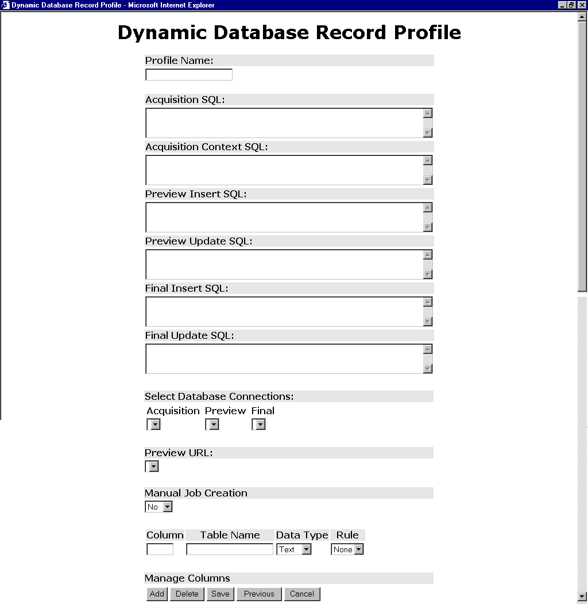

Customer Database Triggers

General Description
If the data source is a database, the user (PSO) shall place triggers on the customer database that will populate the TaskQue table in the customer database. The TaskQue table is the equivalent of the TranJobs table in previous versions of Ambassador.

The user shall create a TaskQue table in the customer database with the following structure. [TaskQue spec goes here].

The trigger shall be executed when data in the table is inserted.

The trigger shall be executed when data in the table is updated.

The trigger shall populate the TaskQue table in the customer database.

Sample trigger

File System Source Profile

General Description
The File System Source Profile (see Figure 3 File System Source Profile) stores information about customer files. Once a File System Source Profile is defined, it will later be assigned to customer files using a file system browser interface.

The user shall be able to add a File System Source Profile.

The user shall be able to modify a File System Source Profile.

The user shall be able to delete a File System Source Profile.
Figure 3 File System Source Profile
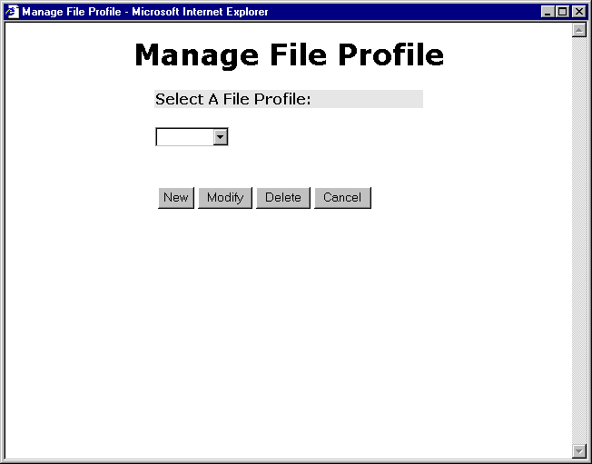

The user shall be able to enter the profile name.
See Figure 4 Add/Modify File System Source Profile.

The user shall be able to select the data format.
The data form can be any one of Diplomat’s supported formats: Text, HTML, XML, JavaScript, Java Properties, CSS

The user shall be able to select the Rule file if the data format is XML.
See XML Rule GUI below.
Figure 4 Add/Modify File System Source Profile
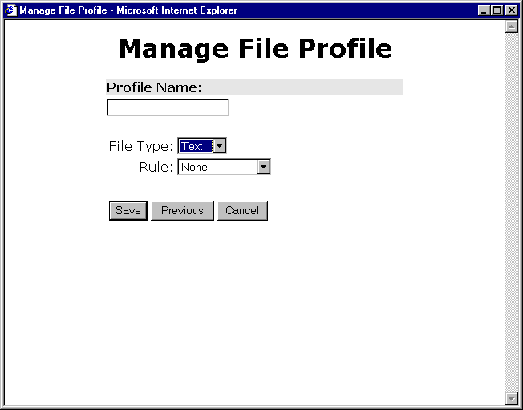

Localization Profile

General Description
The Localization Profile (see Figure 5 Localization Profile) stores information that allows for the automatic creation of jobs. It stores all the information that Ambassador will need to create a job and route it through the system.

The user shall be able to add a Localization Profile.

The user shall be able to modify a Localization Profile.

The user shall be able to delete a Localization Profile.
Figure 5 Localization Profile
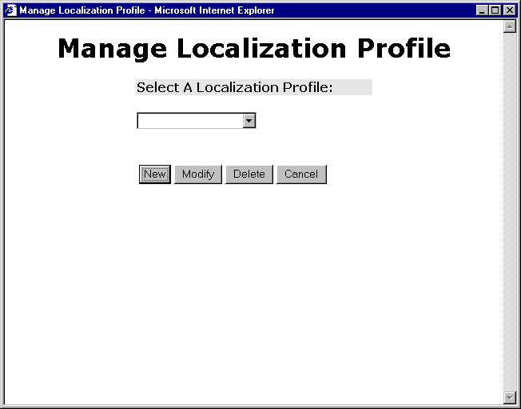

The user shall be able to enter a name for the Localization Profile (see Figure 6 Step 1 of Defining a Localization Profile).

The user shall be able to select the source language of Localization Profile.

The user shall be able to select the target languages of the Localization Profile.
Figure 6 Step 1 of Defining a Localization Profile
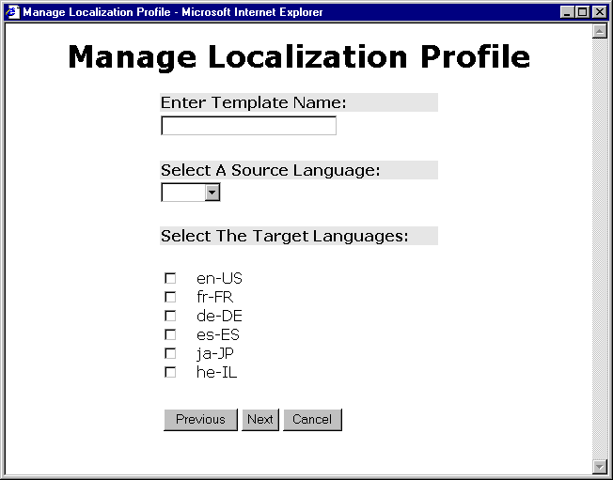

The user shall be able to select the order of the stages of the Localization Profile. See Figure 7 Step 2 of Defining a Localization Profile.

The user shall be able to select the users for each stage of the Localization Profile.

The user shall be able to enter the duration (in calendar days, not work days) of each stage in the Localization Profile.

The user shall be able to select to leverage Translation Memory for the Localization Profile.

The user shall be able to select Page TM for the Localization Profile.
Figure 7 Step 2 of Defining a Localization Profile
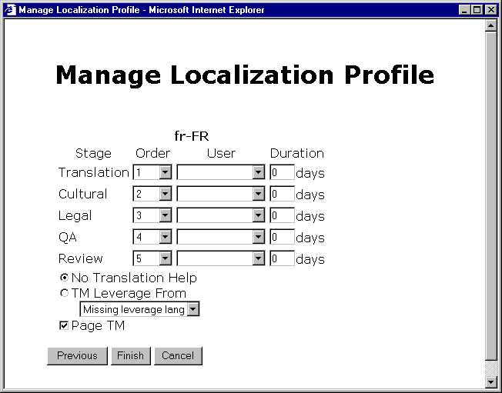

XML Rules

General Description
The XML Rule GUI (see Figure 8 XML Rule GUI) stores information that allows Diplomat to properly parse XML data. Since each flavor of XML has different tags and structure, Diplomat requires an XML rule to know what segments are translatable (text), localizable (links), viewable (images), etc.

The user shall be able to add an XML Rule.

The user shall be able to modify an XML Rule.

The user shall be able to delete an XML Rule.
Figure 8 XML Rule GUI
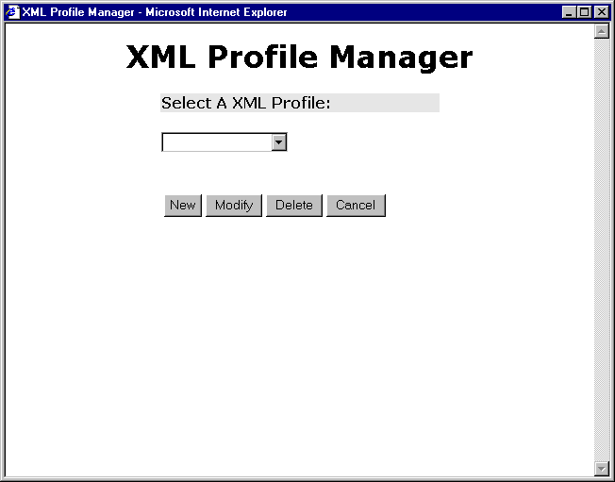

The user shall be able to enter the name of the XML Rule.
See Figure 9 Entering XML Rule Data.

The user shall be able to enter the XML rule data.
Figure 9 Entering XML Rule Data
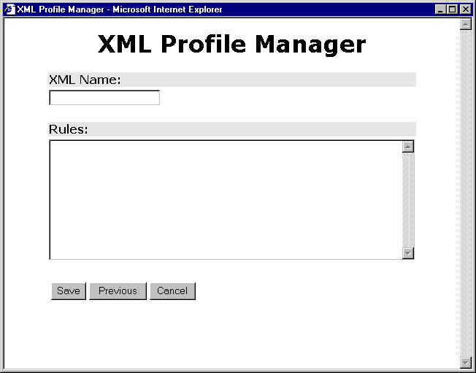

Preview URL

General Description
The Preview URL GUI (see Figure 10 Preview URL GUI) stores the URL that is used by the Instant Preview feature. In the editor, when the user wants to preview the database segment in the context of the customer web-database application, she will click on a Preview URL that will save the segment to the customer database and then display the segment in context to the user.

The user shall be able to add a Preview URL.

The user shall be able to modify a Preview URL.

The user shall be able to delete a Preview URL.
Figure 10 Preview URL GUI
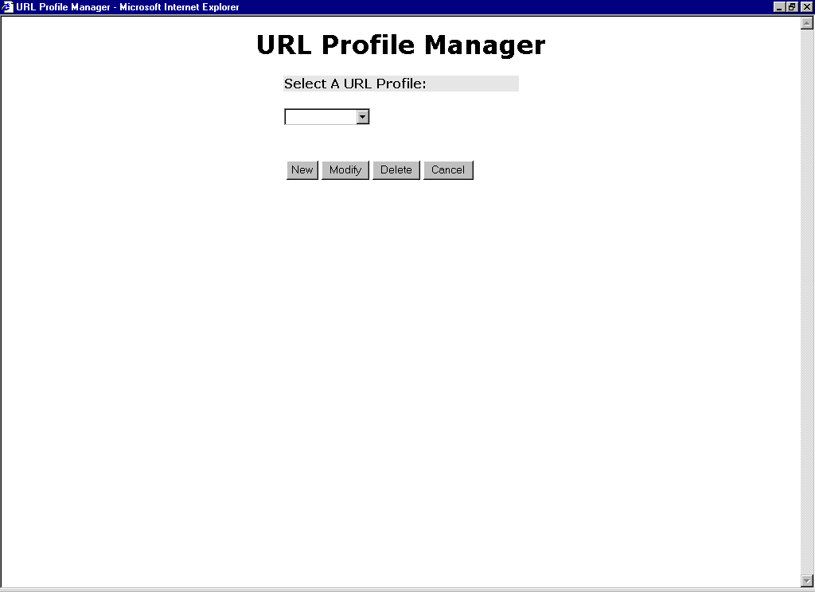

The user shall be able to enter the name of the Preview URL.
See Figure 11 Entering Preview URL Data.

The user shall be able to enter the Preview URL.
Figure 11 Entering Preview URL Data
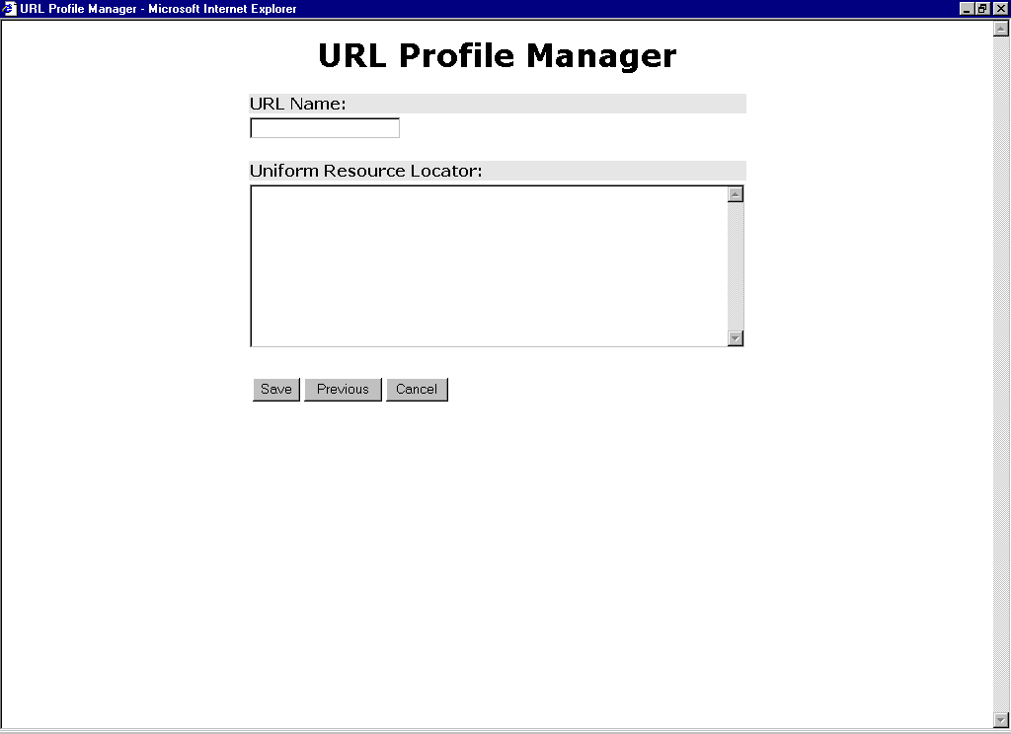

Database Connections

General Description
The Database Connection GUI (see Figure 12 Database Connection GUI) stores database connect strings that will be used by other parts of Diplomat to connect to the customer database(s).

The user shall be able to add a Database Connection setting.

The user shall be able to modify a Database Connection setting.

The user shall be able to delete a Database Connection setting.
Figure 12 Database Connection GUI
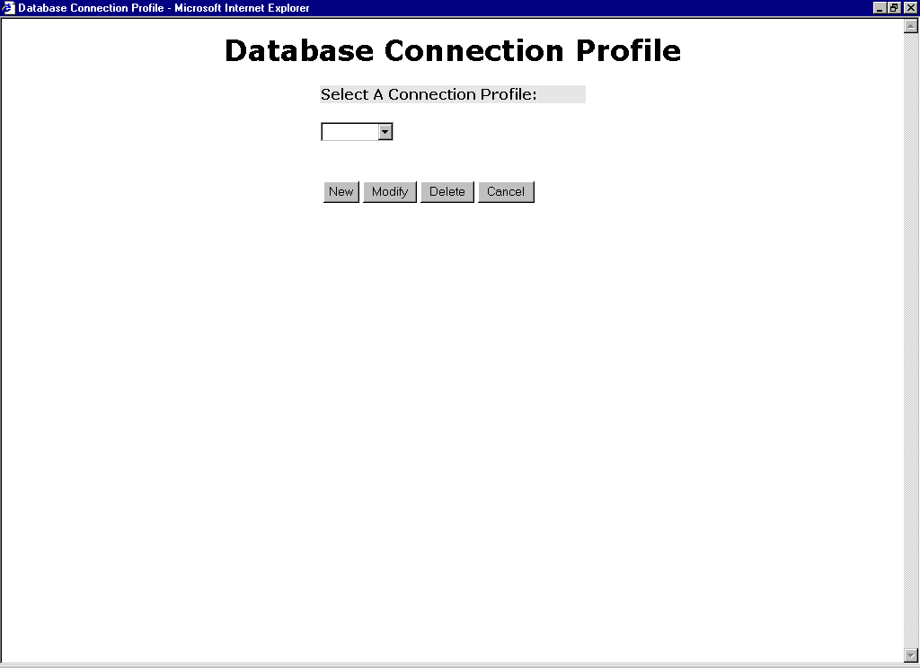

The user shall be able to enter Database Connection name.
See Figure 13 Entering Database Connection Data.

The user shall be able to enter the machine that the database server is running on (i.e., Jupiter).

The user shall be able to enter the port number of the database server (i.e., for Oracle it’s 1521 by default).

The user shall be able to enter the database name (i.e., all Oracle installs at GlobalSight have the name GSOR).

The user shall be able to enter the service that Diplomat will use to connect to the database

The user shall be able to enter the user name that Diplomat will use to connect to the database.

The user shall be able to enter the password that Diplomat will use to connect to the database.
Figure 13 Entering Database Connection Data
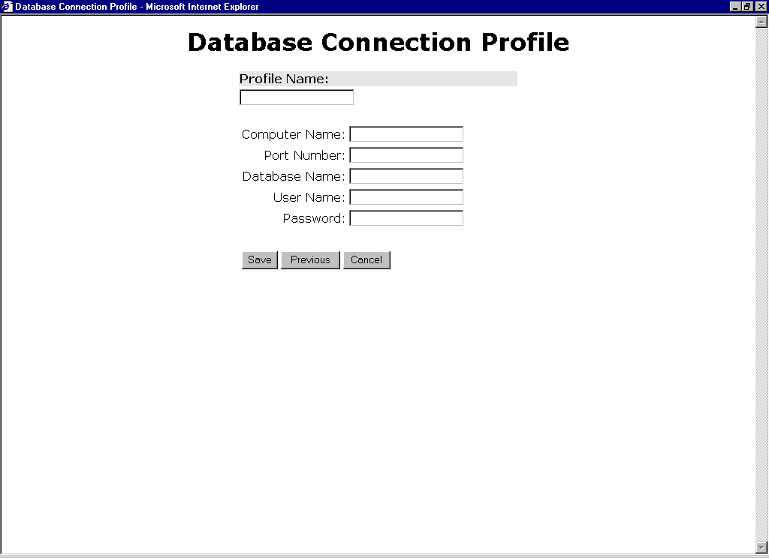

TeamSite Configuration

General Description
In keeping with the goal of Diplomat, which is the decoupling of the data sources with Ambassador, most of the functions in the TeamSite pull-down menu have been moved to the Diplomat Configuration GUI. These functions are:
- Create Job Template – Now covered in Localization Profile
- Manage Job Template -- Now covered in Localization Profile
- Select Language Branches – Now on the TeamSite Configuration screen
- View Language Branches – Now on the TeamSite Configuration screen
- View Job Status
All of the data related to the above utilities must be entered before you can start a TeamSite job.
The TeamSite pull-down menu now only contains the “Translate Files” menu item. See Figure 16 TeamSite GUI.

Select TeamSite Branches

The user shall be able to select a TeamSite branch for a source language.

The user shall be able to select a TeamSite branch for a target language.
Figure 14 Select TeamSite Branches
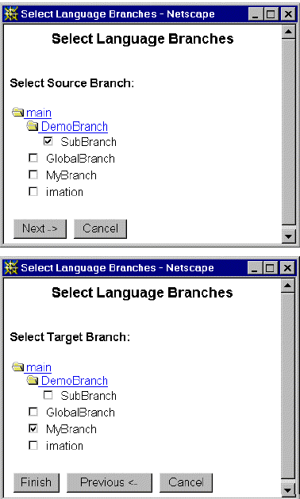

View TeamSite Branches

The user shall be able to view branch associations for each source-target language pair.

The user shall be able to delete branch associations for each source-target language pair.
Figure 15 View TeamSite Branches
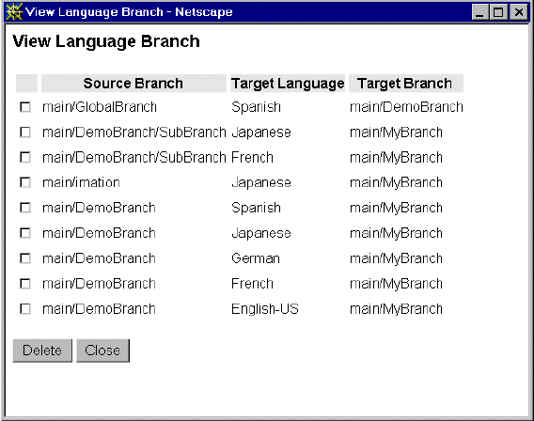

Translate File
This function is available on the TeamSite pull-down menu.

The user shall be able to choose files in TeamSite and select the Translate option it the TeamSite File pull-down menu. See Figure 16 TeamSite GUI.
Figure 16 TeamSite GUI
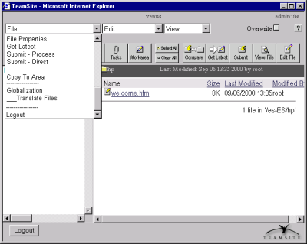

Diplomat will validate the user access privileges, and verify that the selected files are not already part of an on-going translation Job.

Diplomat will return a new page where the user will be asked to choose a Job Description and to pick a Job Template and a Data Source Profile to be associated to the selected files. See Figure 17 TeamSite Translate Files Screen

Figure 17 TeamSite Translate Files Screen
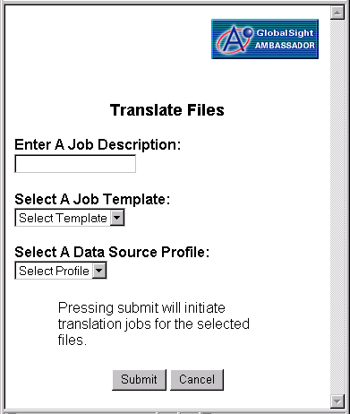

After all the files have been successfully published, Diplomat will acknowledge the completion of the operation to the user. See Figure 18 Translate Files Confirmation.

Figure 18 Translate Files Confirmation
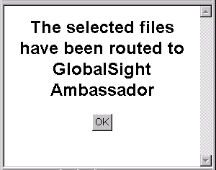

View Job Status

The user shall be able to view the status of TeamSite jobs by accessing the Jobs screen in Ambassador. See Figure 19 View Job Status.

The user shall be able to manually export files to TeamSite by checking the “Select” checkbox on the View Job Status screen and pressing the Export button. Figure 19 View Job Status.
Figure 19 View Job Status
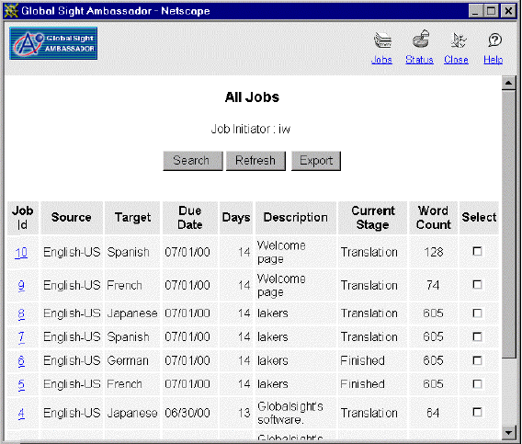

Processing Data from text files

Diplomat shall be capable of importing local files or sym-linked files that reside in the Ambassador docs directory.

Diplomat shall be able to import, parse, extract, and export plain text files (e.g., .txt).

Diplomat shall be able to import, parse, extract, and export HTML (HTML 4.0) files (e.g., .html, .htm, .shtml). See HTML Extraction Specification in section 4.

Diplomat shall be able to import, parse, extract, and export Cascading Style Sheet (CSS Level 1) files (e.g., .css).

Diplomat shall be able to import, parse, extract, and export Cascading Style Sheet definitions that occur in HTML files (in-line styles).

Diplomat shall be able to import, parse, extract, and export JavaScript (1.1 through 1.5) files (e.g., .js). See JavaScript Extraction Specification in section 5.

Diplomat shall be able to import, parse, extract, and export JavaScript code that occurs within <SCRIPT> tags in HTML files. See JavaScript Extraction Specification in section 5.

Diplomat shall be able to import, parse, extract, and export Java Property files (e.g., .properties).

Diplomat shall be able to import, parse, extract, and export XML files (e.g., .xml).

Diplomat shall be able to import, parse, extract, and export Interwoven TeamSite files.

Processing data from database-driven web sites

Diplomat shall be capable of importing, parsing, and extracting data from any database with a JDBC driver.
Note: Diplomat shall be tested with Oracle and SQL Server only.

Diplomat shall be able to export translated data to any database with a JDBC driver.
Note: Diplomat shall be tested with Oracle and SQL Server only.

Changes to Ambassador

General Description
This section describes the new or changed features in Ambassador required by the addition of the Diplomat product.
Changes to Ambassador are required for it to:
- Interface with Diplomat
- Process and display Diplomat XML and the new data formats that Diplomat XML encodes.

Interface with Diplomat
Ambassador interfaces with Diplomat during:
- Import – Ambassador tells Diplomat to get the data.
- Export – Ambassador tells Diplomat to put the data back.
- Instant Preview – Ambassador tells Diplomat to export a segment to the customer database and then display the segment in context. Instant Preview only applies to database content.
Processing new data types
Diplomat sends Ambassador Diplomat XML, which encodes the 6 data formats that we support in this release (Text, HTML, XML, CSS, JavaScript, Java Properties). Therefore, all areas where Ambassador displays data must change in order to convert Diplomat XML and the format it encodes to a displayable format. These areas are:
- Page preview in the Editor – Ambassador must decode Diplomat XML to get the data, and then display the data in HTML as a “page”. Only the data format HTML will have HTML formatting that Ambassador can use for display.
- Segment editing in the Editor (pseudo tags) – Some formats have tags that do not have a visual representation. Therefore, Ambassador must display the tags to the user during editing so they can manipulate them appropriately. Ambassador will do this in a user friendly way called “pseudo tags”.
- Segment editing in the download file (pseudo tags) – Pseudo tags, instead of raw HTML, will appear in the download file.

Import

The user shall be able to import files with formats listed in Section 3.2 Processing Data from text files.

The user shall be able to import in the background.

The user shall receive an email when the import process in complete.

The user shall receive an email if the import process fails for one or more files.

The import failure email shall list the files that failed to be imported.

Export

The user shall be able to export files with formats listed in Section 3.2 Processing Data from text files.

The user shall be able to export in the background.

The user shall receive an export when the import process in complete.

The user shall receive an export if the import process fails for one or more files.

The import failure email shall list the files that failed to be exported.

Instant Preview

General Description
Instant Preview allows the user to preview any database segment in the context of the customer application. For every segment in a database job there will one or more Preview URLs that, when clicked on, will pop a new window that displays the segment served by the customer application.

The user shall be able to click on a Preview URL for every segment in a database job.

The user shall be able to preview a segment in the context of the customer application by clicking on the associated Preview URL.

Figure 20 Instant Preview
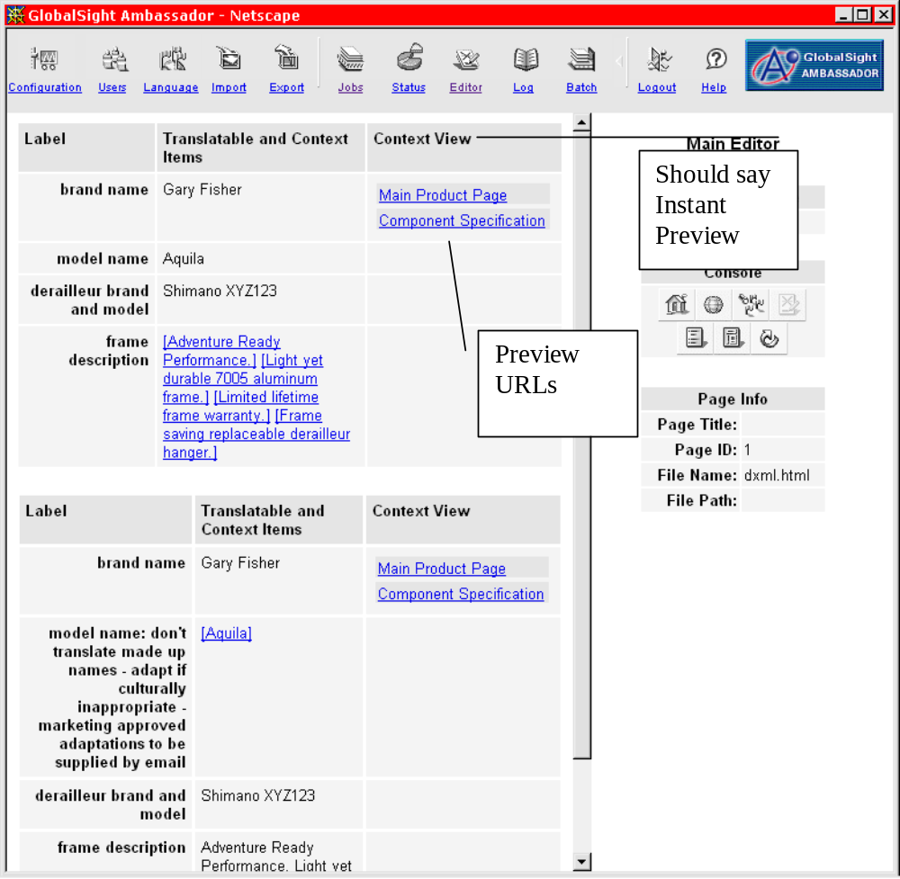

Page preview in the Editor

General Description
Now that Ambassador supports non-HTML file formats, page preview in the Editor will be different depending on the format of the file being previewed. The preview for most formats will be equivalent to detail mode.

The user shall be able to preview Text files in standard mode.

The user shall be able to preview HTML files in standard mode.

The user shall be able to preview HTML files in detail mode.

The user shall be able to preview XML files in standard mode.

The user shall be able to preview XML files in detail mode.

The user shall be able to preview JavaScript files in detail mode.

The user shall be able to preview Java Properties files in detail mode.

The user shall be able to preview CSS files in detail mode.

Pseudo Tags

General Description
Supporting multiple file formats requires that Ambassador display various native markup tags within a segment in the edit box. To alleviate this problem we will use Pseudo Tags (see Figure 21 Pseudo Tags) also referred to as PTags or simply Placeholders. The purpose of Pseudo tags is to hide the complexities of the underlying segment format. Here’s the justification:
No Visual Representation
Most tags in non-HTML formats (and some in HTML) do not have a visual representation, so the translator has no way of seeing where the tag is. For example, in HTML the <SPAN>, <DIV> tags have no visual representation so the translator has no way to manipulate and preserve them unless we expose them in the edit box.
In XML, almost all tags have no visual representation -- they're all for structure of the document. The XML character entity, for example, is very common, has no visual representation, but needs to be preserved.
Multiple Links in a Segment
If there are several links in a segment, the translator will never be able to know which link goes where because the link displays are identical. This is currently a problem in the Ambassador Editor. Pseudo tags have ids and we'll have a legend to keep track of which link corresponds to which pseudo tag (see attached screen shot).
Pseudo Tags Definition
So, instead of displaying the actual tag, which is ugly, we display a “pseudo tag”, which is a simpler representation of the actual tag.
For example:
Actual Tag | Pseudo Tag
<A HREF=…>Hello</A> | [link1]Hello[/link1]
<IMG SRC=…>Hello | [image1]Hello
<B>Hello</B> | [bold]Hello[/bold]

User Addable tags
For each document format (e.g. HTML, XML, JavaScript, plain text) we support a set of addable tags that can arbitrarily be added and deleted by the user. For this release, we only allow these tags in HTML. And, the addable tags for HTML are Bold, Underline and Italic. These tags can only be added when the segment is in HTML format. If the segment comes from JavaScript “within” HTML, these tags are disabled since JavaScript is an entirely different format and we currently do not define any addable tags for JavaScript.

For this release, ALL addable tags are unnumbered.

Addable tags are enabled/disabled on a segment-by-segment basis. The segment format attribute is read form the diplomat XML and passed along to the PTag module whenever a segment is submitted. The format parameter instructs the PTag module when to enable/disable addables and selects the proper native content to be injected. In this first release, we will only allow addable tags in HTML (bold, underline and italic). Each addable tag has a predefined TMX string that will be inserted when the string is converted from Pseudo to TMX.
For example: An added Open-bold will be inserted in TMX as:
<bpt type=”bold” erasable=”1” movable=”yes’ i=”1” >&lt;B&gt;</bpt>
With the content defined in HTML as <B>.

NOTE: In this release, where the clients files use <strong> we may inadvertently modify this to <B>. This is because the content defined for an addable is reused for all tags of that given type (including existing tags in the source). Ideally, <strong> should be defined in GXML as type=”strong” instead of type=”bold”.

Addable tags can be added anywhere and are always erasable and movable.
a) The same rule applies for existing tags of the same type.
b) This means that addable tags can overlap other tag boundaries.
c) Right now we are assuming the only format that allows addable tags is HTML and only for Bold, Underline and Italic.

The “i” attribute on the resulting diplomat XML returned from the editor must be unique. However, it does not have to be in consecutive order in regards to adjacent pairs. A post process, will uniquely renumber the “i” attribute for all paired addable types just before returning the segment in diplomat form. The renumbering will begin one above the highest index found in the original source. This guarantees that we do not step on the IDs for other non-addable pairs in the original source. So, the indexes will be uniquely paired but there may be gaps in the numbering.

Pseudo tag – name generation
Since the PTag module has no knowledge about the format it is dealing with, it relies on the Diplomat XML layer to help generate a name for a given chunk of native formatting. To accomplish this, the PTag module uses the Diplomat-“type” attribute to generate a unique name. For example:

For this Diplomat input:
Hello <bpt type="bold" i="1">&lt;b&gt;</bpt>world<ept i="1"> &lt;/b&gt;</ept>

We get the following output for verbose mode:
Hello [bold]world[/bold]

And this for compact mode:
Hello [b]world[/ b]

The diplomat type attribute is left to the discretion of the extractor. However, our extractors do follow the recommended mappings in the TMX specification for general types. In the absence of the type attribute, generic names such as "x" and “g” are used. The extractor only has to provide a meaningful name; the PTag generator will take care of its uniqueness by adding a suffix to the name if necessary (e.g. "[link1]","[link2]"). The uniqueness is necessary since the PTag generator keeps a mapping of the simplified tags and their diplomat equivalent so that we can return to the native format.

In general, PTag names originate in the extractor and are further refined by the PTag module. The following general rules are applied:

By default, all pseudo tags are numbered.

In special cases, some pseudo tags are unnumbered. An unnumbered tag is an indicator that it is a generic addable tag (addable and /or deletable by the user).

If the Diplomat type attribute is missing, we default to “x” and “g”. (g means group or paired)

If the PTag module comes across an addable tag in the diplomat input who’s attributes differ from those already found, the PTag module will make that instance of the tag unique by numbering it so that it can be distinguished from the other tags of that type. Example: [Bold2] as opposed to [Bold]. [Bold2] means that this particular bold has different attributes than the other bolds and therefore cannot share attributes. This should really never happen while the PTag module is used with our parsers.

Both the compact and verbose forms of an addable tag are acceptable in either display mode. However, all other tags must be entered in the same form as they are shown on screen in the source.

Addable tags may be entered in mixed case.

A paired set of addables must use the same form (compact or verbose).

Due to the fact that diplomat <it> tags are paired across segment boundaries, they cannot be checked for errors. Therefore, as a safety measure, all <it> tags are converted to unique non-erasable “x” tags regardless of there original attributes.

Error Checking Overview
There are two levels of error checking enabled in this release;

ValidateTagNames
The lowest level test which will validate that all non-erasable tags in the source also appear somewhere in the target and that any additional tags that are not found in the source are of the addable type.

This is the lowest level test that is performed first. Basically, this test will:

Validate that all the mandatory (non-erasable) tags in the source also appear in the target exactly one time each.

Any additional tags that do not appear in the source must be one of the addable tags allowed for that format. Otherwise it is an error.

Return one combined error, which reports all missing and illegal tags.
This test will produce errors messages something like this:
The following mandatory tags are missing from the source:
[link1] , [/span5]
The following tags cannot be added:
[link9] , [/span9]
For source tags that are non-erasable and unnumbered, we map the first matching name in the target to the first non-erasable occurrence of the tag in the source. This method insures that we map to all non-erasable tags in the source first. Any additional identical tags will then map to the corresponding erasable versions (if any) in the source. Finally, when all occurrences of the tag in the source have been used, we check to see if the tag is of the “addable” type
Well Formed
A simple test to assure the segment is well formed. Paired tags are balance, ect..

The close of a pair cannot come before an open. Example [/b] [b]

There are balanced sets of numbered begins and ends.

This test will produce errors messages something like this:
The following tags are unbalanced:
[bold] , [/italic]

Meaning, bold does not close and italic does not open.

Escaping the brackets
In some cases the source segment may have literal text between literal brackets. In this case the leading bracket must be escaped with an additional open bracket so that it is not mistaken for a Pseudo tag.

Example:
“Globalsight P-tags look like this [tag_name]” // incorrect

“Globalsight P-tags look like this [[tag_name]” // Correct

An escape encoder/decoder will handle the automatic insertion and removal of the escape bracket for existing input text. In fact, it would handle the case above on input. However, if the user wants to insert new open brackets in the target text while they are editing, they must use the double open-bracket.

The requirements for escaping literal braces are forgiving. If the user enters a single open bracket preceding a P-tag and does not escape it, the P-tag parser is smart enough to know that an open bracket cannot exists within a P-Tag and assumes the previous open bracket (the one the user entered) was text. If the user’s new open bracket does not precede any P-tags, and the end of line is reached, an end-of-tag will be assumed and the text between the open bracket and the end-of-line will be recognized as a tag. This action allows the error checker to catch the error where the closing brace on the last P-tag was accidentally deleted.

The only time a user absolutely MUST escape an OPEN bracket is when there is also a user defined CLOSE brace BEFORE the next P-tag or it is not followed by any other P-tags before reaching the end-of-line.

Segment editing in the Editor (pseudo tags)

All markup that occurs within a segment shall be represented with pseudo tags in the edit box, source preview pane, and the target preview pane.

All content of an attribute of a tag shall be represented in a subflow pseudo tag that will be displayed directly after the parent tag in the edit box.

Pseudo tags shall map to actual tags according to the following table:
<B>Hello</B> | [bold]Hello[/bold]
<U>Hello</U> | [underline]Hello[/underline]
<I>Hello</I> | [italic]Hello[/italic]
<A HREF=”www.yahoo.com”>Hello</A> | [link1]Hello[/link1][subflow1]www.yahoo.com[/subflow1]
<IMG SRC=”myimage.gif”>Hello | [image1][subflow1]myimage.gif[/subflow2]
<MYTAG>Hello</MYTAG> | [paired1]Hello[/paired1]

The user shall be able to edit (copy, paste) pseudo tags in the edit box.

The user shall receive a warning if pseudo tags other that bold, italic, underline were added or subtracted from the segment.

The user shall be able to view a Tag Table that displays the mapping between the pseudo tag and the actual tag. See Figure 21 Pseudo Tags.

Segment editing in the download file (pseudo tags)

The user shall be able to edit (copy, paste) pseudo tags in the download file.

The user shall receive a warning if pseudo tags other than bold, italic, underline were added or deleted.

Error checking in the download file.
Error checking takes place on the server. The user will upload a page which will then be scanned for errors. All segment related tag errors are actually the exact same messages the user would receive on-line (see the sections above regarding error messages). The main difference for off-line is that error messages will be returned in a web page. Also, since the entire page is checked at one time rather than one segment at a time (as in the case of on-line), error messages for all segments will be returned in one pass.

Limitations

- Currently, we do not detect the illegal “movement” of tags inside or outside of parent tags (if any).
This missing level of error checking can eventually lead to merge problems if the user misplaces tags. This had to be dropped for this release due to time constraints.

- We do not enforce mandatory leading or trailing space (as should be the case with some formats like java properties).

Future direction

- Add detection for the illegal movement of tags.

- Optionally enforce leading and trailing space on a per format basis.
Figure 21 Pseudo Tags
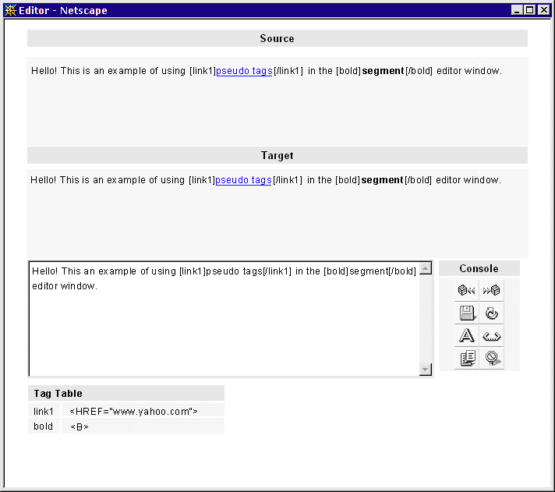

Offline Translation

Download

The user will be able to choose individual files for download using the “Select A File” check boxes. To the selected files, there will be a “Download selected files” button. After clicking the Download selected files button, the Job Download page should appear. If Download selected files is pressed without any files selected, the user should receive an error.

The user will be able to download an entire job using the “Download whole job” button. If the user made any single files selections, they should be ignored (selection information is not used). After clicking the Download whole job button, the Job Download page should appear.
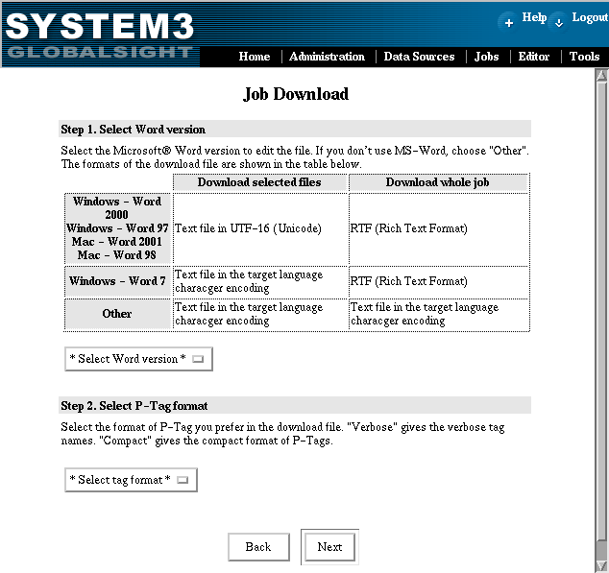

The users will need to select the MS-Word version they are using. The file format they will receive varies according to the combination of the Word version and whether you are downloading individual files or the entire job. The matrix will be shown on the Job download page.

L The use will be able to select the P-Tag format they prefer. They will be able to select either “Verbose” or “Compact”. Failure to select either Word version or P-Tag format should result in an error message.

When the “Next” button is pressed, the system should go to a second Job Download page where the user will see instructions for how to get the files This hasn’t changed from Ambassador 2.3).

The resource package
With a single download file, the source segments are quickly lost as the translator overwrites them. Even if the translators save a copy, the file may already be partially leveraged. Without the source segments the translators have no way to see the placement of the original formatting. Retaining the original source is also useful for reviewing source language terms and double-checking translations.

In order to address the above issue it was decided that translators would be sent a “resource package”. This resource package is zipped up with the original download files and contains:

- The p-tagged files to be translated (with optional RTF layer).
- HTML reference for each download page.

Note: The translator still has the option to download individual TEXT files, but this is discouraged.

The zipped files will be organized around jobs. The name of the zip file is composed of the job id and current workflow stage id. For example, job number 33 in stage 3 would generate: “job33_3.zip”. All the pages to be translated for the current job are found inside the “inbox” directory. Translators are encouraged to save their work in the “outbox”.

Once the download file is unzipped the translator should be presented with the following directory structure:
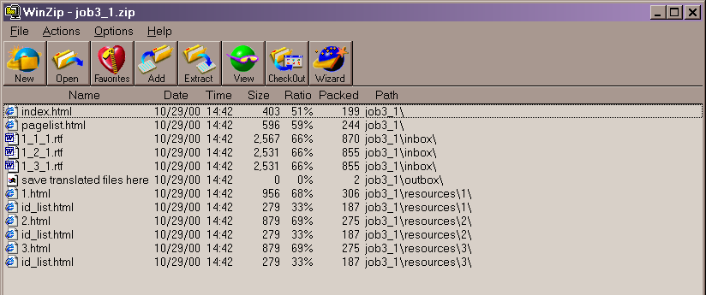

Double-clicking on “index.html” should launch the default browser and load the following three frames:
- Pages Frame – Lists all the pages in the download package (names and ids) and optional page preview links.
- Segment Identifiers Frame – Lists all the segments in the current page.
- Source Segments Frame – Lists the original source segments and P-tag to native mapping table. The p-tags are highlighted in red, just as they are in the RTF files.

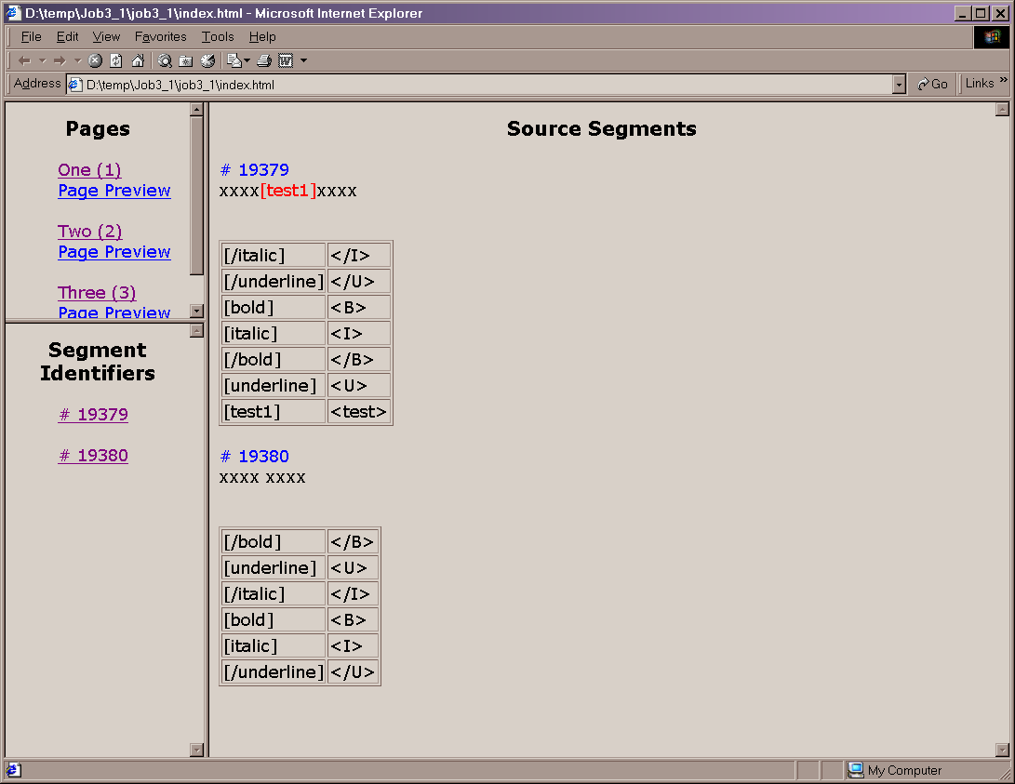

Clicking on a page name or page id should refresh the segment identifier frame.

Clicking on a segment id should bring up the corresponding source segment page. Note that this behavior should probably be considered a bug. When clicking the page name, both segment identifier and source segment frames should update.

The optional “page preview” links should point to WYSIWYG versions of the source pages. This will provide needed context to the translators. But, these preview pages will only be available if the original format was HTML.

The RTF files (text versions are also a download option) should be named as in Ambassador 2.3.x (jobid_pageid_stageid.xxx, where xxx = rtf or txt).

Conversion of GXML to PTag
All files selected for download should have their tag presentation converted from GXML to generic Ptags. This is a transparent internal conversion. The necessary information required to return to GXML is stored in a separate companion file on the server. One separate companion file is required to be present for each uploaded file (see upload section for more information). Since GXML is being converted to Ptags at this stage, no error checking is performed at this time.

Files downloaded in RTF format.
The official RTF 1.6 specification can be found at http://msdn.microsoft.com/library/default.asp?URL=/library/specs/rtfspec.htm.

An RTF version of a PTag file uses RTF styles and colors to mark up sections that are editable or read-only.

The document styles shall be compatible with TRADOS Translator's Workbench, so RTF download files can be translated using the Workbench WordBasic macros (in tw4win.dot), and optionally with a TRADOS TM.

When the TRADOS WordBasic macros are loaded (via the TRADOS document template), "tag protection" should enforced and non-translatable text cannot be modified. Without the macros, all text is modifiable. This behavior is by design.
RTF Styles
The styles defined and used by the RTFWriter are character styles, not paragraph styles.
- tw4winInternal: marks a stretch of text inside translatable text as non-translatable. In TRADOS parlance, these stretches are segment-internal tags.

All PTags inside a segment should be marked up as tw4winInternal. Style properties: font Arial, font size 12pt, language en_US, color red.
- tw4winExternal: marks a stretch of visible text in the document that is not translatable. In TRADOS parlance, these stretches are segment-external tags, and as such not part of segments.

All PTag segment identifiers (# num) and header lines are marked up as tw4winExternal. Properties: font Arial, font size 10pt, language en_US, color light grey.
Other styles that are defined for compatibility with Translator's Workbench:
- tw4winMark: style to mark up the source and target segment brackets during translation with Workbench: "{0> source segment <} match_value {> target segment <0}".
- tw4winPopup: specifies popup text in RTF help files
- tw4winJump: specifies a link in RTF help files
- tw4winError: marks up an error in the document (I think)
- tw4winTerm: in a source or target segment, marks up terms retrieved from the terminology database during pre-translation. This style is used to embed terms inside segments for offline translation without Workbench and Multiterm, and the terms can be manipulated using Word Macros and toolbar buttons.
- DO_NOT_TRANSLATE: a hook for users to manually mark up text that should be excluded from text detection and segmentation.

A sample PTag-in-RTF-file looks schematically like this:

{\rtf1\ansi{\fonttbl…}{\colortbl…}{\stylesheet…}
{\tw4winExternal # Ambassador Download File - Do not modify this line.}¶
{\tw4winExternal # Encoding: utf-8}¶
{\tw4winExternal # Original Format: HTML}¶
{\tw4winExternal # Source Locale: en-US}¶
{\tw4winExternal # Target Locale: ja}¶
{\tw4winExternal # Page ID: 1}¶
{\tw4winExternal # Job ID: 2}¶
{\tw4winExternal # Current Stage ID: 3}¶
{\tw4winExternal \par}¶
{\tw4winExternal # 123}¶
Morgan Stanley Dean Witter¶
{\tw4winExternal \par}¶
{\tw4winExternal # 306}¶
Learn more about our presence at {\tw4winInternal [link1]} WestFest! {\tw4winInternal [/link1][x2]}¶
{\tw4winExternal \par}¶
{\tw4winExternal # 306}¶
Company News¶
{\tw4winExternal \par}¶
{\tw4winExternal # END Ambassador Download File - Do not modify this line.}¶
}

Unicode, ANSI RTF and non-Western Languages
RTF was created way back when and is primarily a text-format containing all characters encoded in ASCII. Some versions and readers of RTF know how to handle ANSI characters with 128 ≤ char ≤ 255 and interpretation of the code is guided by a code page. The latest, Unicode-enabled RTF readers understand Unicode characters encoded as \uDDDDD. They also have Unicode fonts at their disposal and map character codes to the correct glyphs.

In general, any text in RTF files must be marked up with its language (\lang1033), a paragraph or character style (\csNUM), and a font (\fNUM) that itself has the character set specified in its declaration (\fcharsetNUM in the header's \fonttbl). When all this is done properly, the text's characters are mapped correctly to the font's glyphs.

The current implementation shall produce a font table containing the default font for the source language, and outputs source characters encoded according to the chosen target RTF reader:
Unicode Readers: found in Word 2000 (Office 9) and Word 97 (Office 8).
The source text font \f0 is Arial Unicode MS, and characters are output as their Unicode code in decimal: \u12345.

ANSI Readers: found in pre-Office 8 versions of Word and Word-J(apanese).
The source text font \f0 and codeset \fcharsetNUM is the default font of Word for the source language, e.g. MS Mincho for Japanese, and the font's encoding, e.g. \fcharset128 for Shift JIS. Characters are output by converting them from Unicode to an encoded string, and then converting each byte to a hexadecimal character representation: \'HH.

Unicode RTF should be read and displayed correctly by the various Word versions.

ANSI RTF should be read and displayed correctly by the various Word versions.

Verify that RTF is correctly interpreted by TRADOS Translator's Workbench.

The font definitions and conversion specifications are contained in Java property files in the jar file under /com/globalsight/ling/tw/offline/rtf. The files shall be named UnicodeRTF.properties and AnsiRTF.properties.

The file UnicodeRTF.properties is not expected to require changes (see below).

The file AnsiRTF.properties, however, requires additional font and encoding specifications for each source language that System 3 wants to support (see the next section).

Adding RTF download support for a new source language.

We should be able to add support for a new source language (L), by following these steps:
- Find a version of Word that has been localized to L.
- Create a new document, type a few lines making sure they are in language L
- Save the document as RTF, in Word 6 compatibility mode if necessary
- Open the RTF file in Notepad and search for the default font specification "\deff"; remember the number after it, say N
- Find the font table "\fonttbl" and look for the font with number N: "{\fN … }"
- Copy the entire font definition between the braces to a new "RTFDefaultFont.XX" property in AnsiRTF.properties
- !!! Change the number N after "\f" to zero: "{\f0 …}"
- !!! Double each and every backslash between the braces: "\f0" must become \\f0 and so on
- Find the font's encoding id "\fcharsetN" and match it with the list of known encodings (see the comments in the properties file or the official RTF documentation) to find the font's IANA encoding. The RTFWriter will internally map IANA encoding names to Java encoding names.
- Add the encoding as a "RTFFontEncoding.XX" property
- Test it, test it and test it.

ANSI RTF should be created correctly for all supported source languages (see the language support section above).

Upload

On the Job Detail page, there will be an “Upload” button. Clicking the button should bring the user to the File Upload page. In this release, files can only be uploaded one at a time. During upload, each files is checked for segment errors.

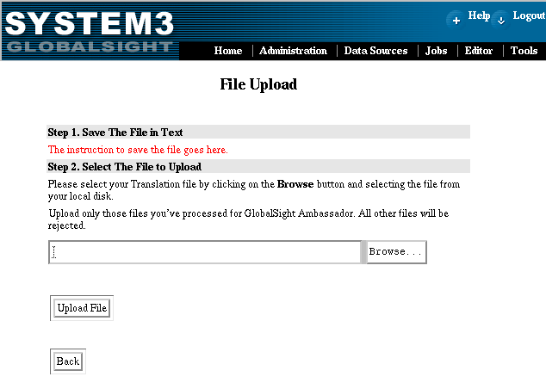

The format of the upload file must be text. The user must convert the RTF file they received to a text file in MS-Word. Step 1 in the upload page should explain how to save an RTF file as a text file in all the supported MS-Word (not yet implemented). The encoding of the upload file must be the same as stated in the “# Encoding:” line of the header of the file.
Encoding Name | Explanation
UTF-16BE | 16-bit Unicode big endian
UTF-16LE | 16-bit Unicode little endian
Other | Legacy encoding (e.g. Shift_JIS)

The user should be able to click a “Browse…” button to select a file for upload. Then click an “Upload” button to begin the upload and automatic Ptag error detection. If the upload succeeds, the Browse To New Location: page should appear.
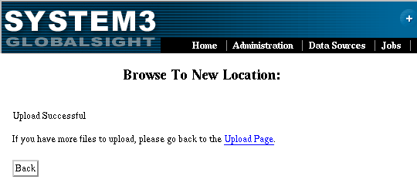

If there are Ptag errors in the file, the user should receive an error page, similar to the one below, explaining what to correct. (NOTE: At the segment level, this is the same error code and algorithms that are called upon in on-line mode). When the user gets an error, they will need to correct the errors and repeat the upload.

For off-line mode, the entire file should be checked for errors in one pass and all the errors for that one page accumulated into one error report. The error report should be returned as an HTML web page to the user.
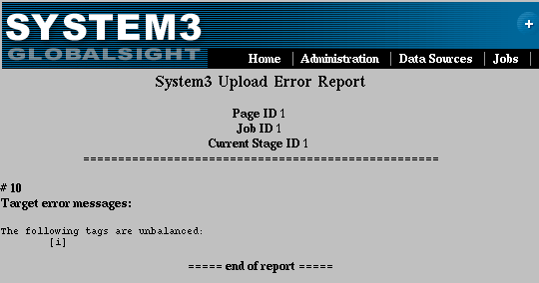

Explanation of file extensions
While downloading and uploading, some internal and external files are created. The following is the list of files. The file names are formed using the jobid, pageid and stageid. These ids are substituted for the actual ids in the actual file names (e.g. {jobid}_{pageid}_{stageid}.f1 -> 1_1_1.f1).
{jobid}_{pageid}_{stageid}.f1 | Format one file (internal), one for each page
{jobid}_{pageid}_{stageid}.f2 | Format two file (internal), one for each page
{jobid}_{pageid}_{stageid}.txt | Text file. It will be downloaded by the user. It will be created only when the user choose to download the individual files.
Job{jobid}_{stageid}.zip | Download package. It will be created when the user choose to download a whole job.
These files are placed in ${Ambassador_root}/lib/AS_docs/job_data. Especially, .f1 files shouldn’t be removed from the directory while the upload is not complete. Once the upload is complete, all the files are moved to /tmp/GSA/.

RTF post processing
If files were downloaded in RTF, the end-users is “required” to use the “SaveAs” feature in their editor to save the file as plain text before uploading it to the server. This is required since in this release we do not have an RTF parser in place to retrieve just the text after upload.

Upon receiving the file, a small subroutine will try to determine the proper codset to load the file from disk into memory. The routine first looks for the Unicode Byte Order Mark (the BOM, for either Little Endian or Big Endian ). If a BOM is found, the file is in Unicode. If a BOM is not found, the routine sniffs further into the file to try and locate the header encoding information and retrieves the codeset form there. If this routine fails, the following general error message should appear to the users. The message is somewhat general because it could also be the result of a more general I/O error.
File error:
"There was problem reading the file into memory on the server.
Please contact you support representative for help."

The Zip job-package
The zip file is a one-way container used to download files. It is never uploaded. The user should save it in case they need to look at the original download files again.

Other Upload error messages
In addition to segment level error messages, the following additional system or file related messages might be received during upload:

File error:
“The upload file itself has no errors. However, the system was unable to save the file to disk.
Please protect your file by making a backup copy and then contact your support representative for help.”
This is a general IO error that might occur after a file has successfully cleared the error checking process.

File error:
"There was problem reading the file into memory on the server.
Please contact you support representative for help."
This is a general I/O error that might occur on upload as a result of improper code set detection or general failure to read the file from the server’s disk.

File error:
“There was an error loading the file. The most likely cause is an invalid file format. Please check the following
- Compare the file header against the original file you received.
The header may be missing some information.
- Be sure that the first and last lines of the file have not been altered.
- Check each segment for missing segment IDs."
This error will occur if the format of the download file is invalid.

File error:
"There was an error loading the companion-file on the server.
The most likely cause is missing or incorrect header information that is required to locate the file.
Please check the values for JobID, PageID and StageID listed in the header of your file. These IDs should never be changed.”
This error will occur if the companion file cannot be found on the server. The companion file holds all the information used for error checking and the conversion of PTags to GXML. To locate the companion file, the upload API tries to build the companion filename from the header information in the upload file. The name is generated in this way so that changes to the download file name do not affect the error checking. If however, the header information is changed, we may be unable to locate the companion file.

PSO interfaces for extensibility

Diplomat shall provide a platform that will allow the development of parsers by third parties for formats not provided in the standard distribution.

Diplomat shall provide a platform that will allow the development extractors by third parties for formats not provided in the standard distribution.

Supported character sets
Note: This data is from the convrtrs.txt file in Ambassador 2.4 ICU (version 1.2.2) data directory.

Character set | Comments
Big-5
dobe-Latin1-Encoding
dobe-Standard-Encoding
ebcdic-us
EUC-JP | Japanese EUC
EUC-KR | Korean EUC
EUC-TW | Chinese Traditional
GB2312 | Simplified Chinese GBK
ISO-8859-1
ISO-8859-3 | Maltese Esperanto
ISO-8859-4
ISO-8859-5
ISO-8859-6 | Arabic
ISO-8859-7
ISO-8859-8 | Hebrew [bertrand test for sbcs]
ISO-8859-8i
ISO-8859-9 | Turkish
KOI8-R | Russian UNIX
ksc | KSC-5601-1992, Korean
Latin-1
MacCentralEurope | Apple Central Europe
MacCyrillic | Apple Cyrillic
MacGreek | Apple Greek
MacRoman | Apple latin 1
MacTurkish | Apple Turkish
uni-han
UTF16 | BigEndian
UTF16LE | LittleEndian
UTF-8
Windows-1250
Windows-1251
Windows-1252
Windows-1253
Windows-1255
windows-1256 | Arabic
X-SJIS | Japanese.

HTML Extraction Specification
This chapter describes when the HTML extractor is called, which rules it uses and the limitations of the extractor. This document should be used as a reference. If the code does not behave as described here, a bug is to be assumed and needs to be reported!

Switching rules

From the Framework
Files with a *.htm or *.html extension usually contain HTML. The framework should directly call the HTML Extractor on such files.

From the JavaScript Extractor
The JavaScript Extractor calls the HTM Extractor on strings that presumably contain HTML fragments. If the HTML Extractor cannot successfully parse the fragment, it throws an exception, which the JavaScript Extractor catches. No error is raised to the user.

To the JavaScript Extractor
JavaScript is most commonly used embedded in HTML. There are six ways to embed JavaScript in HTML. Currently, three of them are supported:

- Between a pair of <SCRIPT> and </SCRIPT> tags. The language attribute of the tag should be "JavaScript", "JavaScript1.1", "JavaScript1.2", “ECMAScript”, or nothing.
Example: <script language="JavaScript1.2">alert("hello world!")</script>
- In an event handler. The script is specified as the value of an HTML attribute.
- In URLs. Used with the "javascript:" protocol (<a href="javascript:alert('hello world!')">Text</a>). It is used when no event handler is available.

The following methods are not supported because they only work in Navigator and won't probably make it to a standard, so they should occur only rarely.

- JavaScript Style Sheets: Aimed at replacing standard style sheets.
- Conditional comments: Script that is defined if and only if a condition is satisfied. E.g:
<!--&{navigator.platform=="win95"}
<SCRIPT>
…
</SCRIPT>
-->
- JavaScript entities: appear as values of HTML tags and have the form &{statement };.. Example:
<body bgcolor="&{favorite_color();};">

To the CSS Extractor
- Between a pair of <STYLE> and </STYLE> tags. The style sheet can be protected from the HTML parser by an HTML comment (<!-- … -->), but not by a CDATA section.
- Embedded STYLE attribute. CSS styles can be associated with every HTML element by using the STYLE attribute with a list of style properties. Example:
<DIV STYLE=”color: red; font: Verdana”>.
When the element is part of the skeleton, the standalone CSS Extractor is called. When the element is inside translatable text, the embedded CSS Extractor is called, which outputs localizable styles as <sub locType=”localizable”>…</sub>.

Extraction
Two types of information are extracted from an HTML file:
- TRANSLATABLE: all text that is shown to a user and that needs to be translated, whether it occurs inside a text element (<P>subscribe today!<P>) or as value of an attribute (<IMG ALT=”Sales figures of last year”>)
- LOCALIZABLE: everything that influences how information is displayed to the user and what actions she can perform on a localized web site. This includes display styles like fonts, colors, indents and margins, writing directions, URLs to navigate to localized content, images with text or symbols, and so on.

The tags <listing> and <pre> enforce the preservation of white space and line breaks. Text inside of these tags must not be subject to white space normalization

Any text is considered a candidate for translation and extracted as <translatable>. Tags that appear around or inside text are categorized as follows:
- Breaking Tags: also called “external”. These tags break the text flow and define the structure, or skeleton, of an HTML document. Examples: <head>, <body>, <script>, <ol>, <table>.
- Non-breaking Tags: also called “internal”. These are formatting tags that influence the displaying of text they embed, or linking tags that highlight a stretch of text and add additional information. Examples of the former: <B>, <I>, <CODE>, example of the latter: <A> (which is used for index markers, footnotes, and other cross-references found in traditional word processors).

Breaking Tags
These tags are considered breaking:

ADDRESS, APPLET, AREA, BASE, BASEFONT, BGSOUND, BLOCKQUOTE, BODY, CAPTION, CENTER, COL, COLGROUP, COMMENT, DD, DIR, DIV, DL, DT, EMBED, FIELDSET, H1-H6, HEAD, HTML, IFRAME, LEGEND, LINK, LISTING, MAP, MARQUEE, MENU, META, NOFRAMES, NOSCRIPT, OBJECT, OL, P, PRE, SCRIPT, STYLE, TABLE, TBODY, TD, TFOOT, TH, THEAD, TITLE, TR, UL, XML.

Non-breaking Tags
The following tags are considered non-breaking. The type attribute defaults to “x-elementname” if not specified otherwise.

Element | Description | Diplomat XML type | Note
A | Anchor | url
ABBR | Abbreviation
ACRONYM | Acronym
B | Bold text | bold
BASEFONT | Base font change | css-font
BDO | BiDi override
BIG | Large text
BLINK | Blinking text |  | Deprecated, unimplemented
BR | Line break |  | Considered non-breaking
CITE | Citation
CODE | Computer code
DFN | Defined term
EM | Emphasis
FONT | Font change | css-font
I | Italic text | italic
IMG | Inline image
INPUT | Form input |  | Considered breaking
KBD | Text to be input
NOBR | Don’t break
LABEL | Form field label |  | Considered breaking
Q | Short quotation
S | Strike-through text
SAMP | Sample output
SELECT | Option selector |  | Considered breaking
SMALL | Small text
SPAN | Generic inline container
STRIKE | Strike-through text | Strike
STRONG | Strong emphasis
SUB | Subscript | subscript
SUP | Superscript | superscript
TEXTAREA | Multi-line text input |  | Considered breaking
TT | Teletype text
U | Underlined text | underline
VAR | Variable
WBR | Soft break |  | Inside <NOBR>

In addition to those tags, the HTML comments <!-- comments here --> are also considered non breaking and are surrounded in the extracted segment with tags of type comment.

Example:
HTML:
<p><a href="http://www.globalsight.com>Globalsight</a></p>
Diplomat XML output:
<skeleton>&lt;p&gt;</skeleton>
<translatable blockId=”1”><bpt type="link" i="1">&lt;a href=&quot;<sub locType=”localizable”> http://www.globalsight.com </sub>&quot;&gt;</bpt>Globalsight<ept i="1">&lt;/a&gt;</ept></translatable>
<skeleton>&lt;/p&gt;</skeleton>

Note: non-breaking tags are considered part of a segment, so they start a translatable section. This is to allow the translator to move the tags if necessary. E.g., <b>today</b> big sale! could be translated in French as Solde monstre <b>aujourd'hui</b>. If the extractor finds out later that the section is empty, it is flushed to the skeleton.

Paired Tags, Placeholders and Isolated Tags
- Internal tags that appear in pairs within a segment are output using <bpt> and <ept>.
- Internal tags that open in one segment and close in another are output as isolated tags <it pos=”begin|end”> with an x attribute to match them.
- Internal tags that don’t have a closing tag and don’t require one are output as placeholders <ph>.
- Closing tags that were never opened or opening tags that require a closing tag but do not have it in the document are output as isolated tags <it x=”-1”> with an unmatchable x attribute of “-1”. Authoring mistakes are not repaired. They are flagged, however, and subsequent processing can notify the author.
- Isolated end tags at the beginning of a segment are moved to the skeleton.
- Isolated font start tags at the beginning of a segment are also moved to the skeleton, because their closing tag is most likely also part of the skeleton.

The following table lists which inline tags require or don’t require closing tags.

Elements | Description | Requires closing tag | Note
A | Anchor | Yes
ABBR | Abbreviation | Yes
ACRONYM | Acronym | Yes
B | Bold text | Yes
BASEFONT | Base font change | Yes
BDO | BiDi override | Yes
BIG | Large text | Yes
BLINK | Blinking text | Yes
BR | Line break | No | Considered non-breaking
CITE | Citation | Yes
CODE | Computer code | Yes
DFN | Defined term | Yes
EM | Emphasis | Yes
FONT | Font change | Yes
I | Italic text | Yes
IMG | Inline image | No
INPUT | Form input | No | Considered breaking
KBD | Text to be input | Yes
NOBR | Don’t break | Yes
LABEL | Form field label | Yes | Considered breaking
Q | Short quotation | Yes
S | Strike-through text | Yes
SAMP | Sample output | Yes
SELECT | Option selector | Yes | Considered breaking
SMALL | Small text | Yes
SPAN | Generic inline container | Yes
STRIKE | Strike-through text | Yes
STRONG | Strong emphasis | Yes
SUB | Subscript | Yes
SUP | Superscript | Yes
TEXTAREA | Multi-line text input | Yes | Considered breaking
TT | Teletype text | Yes
U | Underlined text | Yes
VAR | Variable | Yes
WBR | Soft break | No | Inside <NOBR>

The Meta Element
The <meta> tag’s attributes can be translated or localized depending on the values found in the name or http-equiv attribute. The rules are:

- name is never translatable nor localizable because it is a standardized keyword or a custom tag from, e.g., a content management system. We do not interfere with these systems (although we might allow a configuration mechanism).
- http-equiv is never translatable nor localizable because the values are predefined keywords.
- content is not translatable if the name attribute is present and its value is one of expires, generator, progid, robots, template.
- content is translatable in all other cases.
- Exception: for HTTP-EQUIV=”Content-Type”, the charset value in the content attribute is extracted as localizable.

Examples:

HTTP-EQUIV="Content-Type" content="text/html; charset=ISO-8859-1" | only the charset is localizable
HTTP-EQUIV="Keywords" content="key,key" | content is translatable
NAME="Keywords" content="key,key" | content is translatable
NAME="EXPIRES" content="Fri Sep 01 00:25:01 2000" | content is not translatable
NAME="ROBOTS" content="INDEX,FOLLOW,ALL" | content is not translatable

Translatable Attributes
Here is the list of which attributes are recognized as translatable:

Attribute | Element | Description | Note
ABBR | TD, TH | abbreviation for header cell | Netscape specific?
ACCESKEY | BUTTON, LABEL, LEGEND, TEXTAREA | shortcut key
ALT | APPLET, AREA, IMG, INPUT | alternate text
CHAR | COL, TBODY, COLGROUP, TD, TFOOT, THEAD, TR | alignment character for cells | Netscape specific?
LABEL | OPTGROUP, OPTION | group label
PROMPT | ISINDEX
STANDBY | OBJECT | message to show while loading
SUMMARY | TABLE | Purpose of the table
TITLE | All | Title | Used in ToolTip
VALUE | INPUT, OPTION, BUTTON, PARAM | Value of an input control | Not translatable for <option> and <button>

Localizable Attributes
These attributes are recognized as localizable:

Attribute | Element | Diplomat XML type | Note
ACTION | FORM
FACE | BASEFONT, FONT | css-font
HREF | A, AREA, BASE, LINK | url, url-style
SRC | ANIMATION, AUDIO, APPLET, BGSOUND, EMBED, FRAME, IMG, INPUT, MEDIA, SCRIPT, STYLE, VIDEO, XML
ALINK | BODY
BGCOLOR | BODY, COL, COLGROUP, MARQUEE, TABLE, TBODY, TD, TFOOT, TH, THEAD, TR
LINK | BODY
TEXT | BODY
VLINK | BODY
BACKGROUND | BODY, TABLE, TD, TH

Attribute Extraction:
There are two ways to extract attributes:
- If the tag is not contained in a segment, then it is left in the skeleton and only the attribute is extracted as <translatable> or <localizable>.
HTML:
<TD ABBR="Solde">
Diplomat XML:
<skeleton>&lt;TD ABBR="</skeleton>
<translatable>Solde</translatable>
<skeleton>"&lt;</skeleton>
- If the tag is inside a segment, it will be output between <bpt>/<ept> and the attribute inside a <sub>.
HTML:
<p><a href="http://www.globalsight.com>Globalsight</a></p>
Diplomat XML output:
<skeleton>&lt;p&gt;</skeleton>
<translatable blockId=”1”>
<bpt type="link" i="1">&lt;a href=&quot;
<sub locType=”localizable” type=”url”> http://www.globalsight.com </sub>
&quot;&gt;</bpt>
Globalsight
<ept i="1">&lt;/a&gt;</ept>
</translatable>
<skeleton>&lt;/p&gt;</skeleton>

Optimizations
- Segments that contain no digits and letters only white space are not extracted.
- Strings that are part of standard HTML text are normalized (i.e. multiple spaces and new lines are replaced by a single space).

JavaScript Extraction Specification
This chapter describes when the JavaScript extractor is called, which rules it uses and the limitations of the extractor. This document should be used as a reference. If the code doesn’t behave as described here, a bug is to be assumed and needs to be reported!

Switching rules

From the Framework
Files with the *.js extension usually contain JavaScript only. The framework should directly call the JavaScript extractor on such files. JavaScript files are referenced from HTML by the SRC attribute of the SCRIPT tag (eg. <script src="../myScript.js"></script>).

From the HTML extractor
If JavaScript is not contained in a separate file, it appears embedded in HTML. There are six ways to embed JavaScript in HTML, and currently three of them are supported:

- Between a pair of <SCRIPT> and </SCRIPT> tags. The language attribute of the tag must be one of "JavaScript", "JavaScript1.1", "JavaScript1.2", “ECMAScript”, or nothing.
Example: <script language="JavaScript">alert("hello world!")</script>)
- In an event handler. The script is specified as the value of an html attribute.
Example: <body onClick=”>…</body>.
- In URLs. Used with the "javascript:" protocol (<a href="javascript:alert('hello world!')">Text</a>). Used when no event handler is available or special actions are required.

The following methods are not supported because they are rarely used, superceded by different methods, or only work in Netscape Navigator.

- JavaScript Style Sheet: Aimed at replacing standard style sheets.
- Conditional comment: Script that is defined if and only if a condition is satisfied. Example:
<!--&{navigator.platform=="win95"}
<SCRIPT>
…
</SCRIPT>
-->
- JavaScript entity: appears as value of HTML tags and has the form “&{statement};”
Example: <body bgcolor="&{favorite_color();};">

To the HTML extractor
JavaScript can write HTML directly into the current document or construct new pages dynamically to be displayed in new windows.
- Every string that may contain HTML tags is sent to the HTML extractor. These strings are recognized by the pattern “<…>”. Examples:
//HTML extractor called with <B>Hello World!</B>
message = "<B>Hello World!</B>";
//HTML extractor called with <BR>
Document.write(message, "<BR>");
//String directly extracted
message = "Hello Colorado!";
If the string contains incomplete HTML (fragments, or the often used escaped end tag “</SCRIP” + “T>”) and the HTML extractor throws an exception, the string is output in its entirety as TRANSLATABLE.

Extraction
Despite the fact that very few function calls result in text being displayed (document.write(), document.writeln(), alert, prompt, status, confirm) it is virtually impossible to automatically reverse engineer the code and find out the origin of the string used without addition of tags and/or human intervention. Since it is better to over-extract than to under-extract, in this version we assume that all simple quoted and double quoted strings are potentially translatable strings. That may seem overkill but it is the only way to guarantee that all translatable strings are extracted.

Extract:
- All single or double quoted strings that do not belong to the exception list

Exceptions:
- Strings in comments. Comments in JavaScript are identical to the one used in C++. See the following code sample:
// "this text is not extracted"
/*
'Neither is this one'
*/
- Associative arrays. In JavaScript, object can be referenced as associative array. We need to ignore all the strings used to reference an object property since translating them would usually break the JavaScript code. As a rule, we are not extracting strings that are contained within square brackets when it follows a name. See code sample:
// "width" is not getting extracted
MyRectangle["width"]=3
// standard array the strings are extracted
Fruit = ["banana","orange","apple"]

>> Not implemented yet

Embedded vs. Standalone Extraction
Depending on the context in which JavaScript is extracted, the Extractor must output different TMX codes.
- Standalone: .js files and <SCRIPT> content produce <SKELETON> and <TRANSLATABLE> tags, just like all other extractors.
- Embedded: when JavaScript appears in event handlers (<div onClick=”…”>) and URLs (<a href="javascript:alert('hello world!')">Text</a>) that are embedded inside translatable text, the HTML extractor has already output a <TRANSLATABLE><BPT> context and embedded translatable text must be surrounded by <sub locType=”translatable”>…</sub>.

Limitations
- JavaScript current limited code set support. Currently, the Netscape 4 Browser’s JavaScript only supports the Latin1 code set.
// This shouldn't be a problem since JS does not interpret it and passes it to the browser as is
document.write("some text in Japanese")
// This is likely to display garbage
alert("some in text in Japanese")

Action item: Do some testing on various browsers to see the exact behavior. Provide guidelines and workarounds (Java applet? HTML file in separate window?).

Action item: Test current browsers to see if this is still a limitation.

- Standard I18N issues. It is possible and easy to write in JavaScript code that will not support to be localized. The clients needs to be aware that some code needs to be rewritten, again we should provide guidelines for the most common problem and consult our clients.
- Context promotion. The context of an extractor (embedded, standalone) must be passed on to all extractors called by it to ensure the validity of the generated Diplomat XML. Currently, only the JavaScript Extractor can be called on embedded text, but the HTML Extractor cannot. Instead, the JavaScript Extractor outputs all embedded text as is.
- HTML Comments. Web Browsers allow scripts to be escaped by HTML comments (<script><!-- … --></script>). Everything between the <script> tags is sent to the JavaScript parser as is. The parser then is supposed to handle its input gracefully. The behavior of the JavaScript Extractor follows the standard implementations and treats everything after the opening comment until the end of the line as a JavaScript comment. So this code is valid:
<SCRIPT>
<!-- hide from old browsers
var color = “red”;
// --></SCRIPT>
Whereas here the first line of JavaScript code is ignored:
<SCRIPT><!-- var color = “red”;
// --></SCRIPT>
Also note that the closing HTML comment needs to be protected from JavaScript by its own comment syntax. Another authoring error is the omission of “//” before “-->”, which will result in a parse error:
<SCRIPT>
<!--
var color = “red”;
--></SCRIPT>
- URL syntax. One known authoring error is the duplication of the javascript: protocol specifier, as in the following example:
<SCRIPT type=text/javascript>
javascript:if(x) {do_something())
</SCRIPT>
This being invalid code, it is not handled gracefully by the Extractor and a parse error exception is thrown.

Future direction
- Extracting all the strings and locking them later may not be an efficient solution in all cases. For this parser, it is best if the programmer added some tags to the code to specify what should and should not be translated. That is an extra but necessary step to provide high quality extraction. We will then have two JavaScript parsers, one for untagged code that over-extract, one for tagged code that requires some work upfront.
- Unlike C or Java, JavaScript doesn't use placeholders such as %1 to specify the position of variable strings in a text. Fragmentation has to be used. This makes translation harder:
alert("There were " + nbMistakes + " spelling mistakes in the file " + filename + ".")
It would be better if we could extract the entire sentence and mark the position and name of the variable with proper TMX tags. That would allow the translator to reorder the elements without having to go directly in the JS code.

Action item: Try to put together some guidelines for a good markup solution. We can try to get inspiration from GNU Gettext.

CSS Extraction Specification
This chapter describes when the CSS extractor is called, which rules it uses and the limitations of the extractor. This document should be used as a reference. If the code doesn’t behave as described here, a bug is to be assumed and needs to be reported!

Switching rules

From the Framework
Files with the *.css extension usually contain cascaded style sheets. The framework should directly call the CSS Extractor on such files. External style sheets are referenced from HTML by the STYLE tag (eg. <style src="../myStyle.css"></style>).

From the HTML extractor
If a style sheet is not contained in a separate file, it appears embedded in HTML. There are two ways to embed CSS in HTML:

- Between a pair of <STYLE> and </STYLE> tags. The type attribute of the tag must be “text/css”. Other style sheet types are not yet supported (e.g., “text/xsl(t)”).
Example: <style type="text/css"> div.xml-example { color: maroon }</style>)
- In a style attribute. Style properties are specified as the value of the style attribute.
Example: <div style=”color: red;”>…</div>.

Extraction
Style properties specify how text is displayed in the Browser. In a translated web site, the styles have to be localized to accommodate different fonts, font sizes, color schemas, indentations, margins, writing direction and so on.

Extract:
- All style properties that are locale- or culture dependent

The list of recognized style properties that need to be localized is given below.

Embedded vs. Standalone Extraction
Depending on the context in which styles are extracted, the Extractor must output different Diplomat XML codes.
- Standalone: produces <skeleton> and <localizable> tags. Used for:
- .css files
- style sheets within <STYLE>
- style attribute of non-translatable tags (that go into the skeleton)
- Embedded: produces <sub locType=”localizable”>…</sub>. Used for:
- style attribute of translatable tags, for which the HTML Extractor has already output a <translatable><bpt> context that requires sub-flows (<sub>).

To handle these different cases, two versions of the Extractor are implemented:
- CssExtractor: a standalone extractor for complete style sheets (files and <style>).
- StyleExtractor: an extractor for style properties only (inside the style attribute). It can be called as both standalone or embedded extractor.

Examples
CSS file:
STRONG { font-weight: bolder }
Diplomat XML:
<skeleton>STRONG { font-weight: </skeleton>
<localizable blockId="1" type="css-font-weight">bolder</localizable>

Attribute inside translatable section:
<P><SPAN style="font-weight: bolder">Attention:</SPAN> Beware the dog</P>
Diplomat XML:
<skeleton>&lt;P&gt;</skeleton>
<translatable blockId="84">
<bpt type="x-span" i="1">&lt;SPAN style=&quot;font-weight:
<sub locType="localizable" type="css-font-weight">bolder</sub>
&quot;&gt;</bpt>
Attention:
<ept type="x-span" i="1">&lt;/SPAN&gt;</ept>
Beware the dog
</translatable>
<skeleton>&lt;/P&gt;

CSS @ Rules
CSS uses @ rules to specify meta information:
- @charset: specifies the character encoding of the .css file. Example: @charset "ISO-8859-1";
- @font-face: defines additional fonts that can be used in subsequent styles. Example:
@font-face {
font-family: "Robson Celtic";
src: url("http://site/fonts/rob-celt")
}
H1 { font-family: "Robson Celtic", serif }
- @import: this is the method to include other style sheets and to optionally restrict their usage to specific media types. Examples:
@import url("fineprint.css") print;
@import url("bluish.css") projection, tv;
- @media: specifies a media type for which the following style properties apply. Media types include visual (screen, projection, tv), aural, and tactile (braille, emboss). Examples:
@media print {
BODY { font-size: 10pt }
}
@media screen {
BODY { font-size: 12pt }
}
@media screen, print {
BODY { line-height: 1.2 }
}

All @ rules are recognized and their localizable values are extracted when necessary. This includes @charset, @import and all font properties.

Note that @ rules are considered a mechanism to include future extensions (CSS3), or user extensions. CSS – already in its version 1 – defines a general grammar for the rules. This grammar is fully implemented by the extractors and they accept all valid input. However, since extended @ rules have not yet been standardized, nor has their semantics been well-defined, the extractors do not claim to make any sense of them.
Here’s a (scary) example of what valid style rules can look like:

.one { mirror-image: ( run-around [ color: blue ] ); }
.two { mirror-image: @say hello { {@why url(error.html)} @not } @fine; }
.three { mirror-image: [ nothing ( much [ goes ( here ) ] but ) symbols ]; }

Style Properties
Action Item: find real-world examples and gather input from authors and translators about which styles need to be localized, and which not.

In general, the Diplomat XML type attribute is “css-propertyname”.

CSS 1 Styles:

Style Property | Is Localizable? | Diplomat XML type
Background
background-attachment
background-color
background-image | true
background-position
background-repeat
Border
border-bottom
border-bottom-width
border-color
border-left
border-left-width
border-right
border-right-width
border-style
border-top
border-top-width
border-width
clear
color
display
float
font | true
font-family | true
font-size | true
font-style | true
font-variant | true
font-weight | true
height
letter-spacing | true
line-height
list-style
list-style-image
list-style-position
list-style-type
margin | true
margin-bottom | true
margin-left | true
margin-right | true
margin-top | true
padding | true
padding-bottom | true
padding-left | true
padding-right | true
padding-top | true
text-align | true
text-decoration | true
text-indent | true
text-transform | true
vertical-align
white-space
width
word-spacing | true

CSS 2 Styles:

Style Property | Is Localizable? | Diplomat XML type
azimuth
border-bottom-color
border-bottom-style
border-bottom-width
border-collapse
border-left-color
border-left-style
border-left-width
border-right-color
border-right-style
border-right-width
border-top-color
border-top-style
border-top-width
caption-side
clip
content | true
counter-increment | true
counter-reset | true
cue | true
cue-after | true
cue-before | true
cursor | true
direction | true
elevation
empty-cells
font-size-adjust | true
font-stretch | true
left
marks
max-height
max-width
min-height
min-width
orphans | true
outline | true
outline-color | true
outline-style | true
outline-width | true
overflow | true
page-break-after | true
page-break-before | true
page-break-inside | true
pause | true
pause-after | true
pause-before | true
pitch | true
pitch-range | true
play-during
position
quotes | true
richness | true
right
size
speak | true
speak-date | true
speak-header | true
speak-punctuation | true
speak-time | true
speech-rate | true
stress | true
table-layout
text-shadow
top
unicode-bidi | true
visibility
voice-family | true
volume | true
widows | true
word-spacing | true
z-index

Internet Explorer Extensions:

Style Property | Is Localizable? | Diplomat XML type
behavior | true
filter | true
ime-mode | true
layout-grid
layout-grid-char
layout-grid-char-spacing
layout-grid-line
layout-grid-mode
layout-grid-type
overflow-x | true
overflow-y | true
ruby-align | true
ruby-overhang | true
ruby-position | true
text-autospace | true
text-justify | true
word-break | true

Limitations
- The list of styles that are localizable cannot be configured.

Java Properties Extraction Specification
This chapter describes the Java Properties extractor and the limitations of the extractor. This document should be used as a reference. If the code doesn’t behave as described here, a bug is to be assumed and needs to be reported!

Switching rules

From the Framework
Files with the *.properties extension usually contain some amount of text to be translated. The framework should directly call the Java Properties extractor on such files.

From other extractors
Other extractors do not call this extractor.

To other extractors
This extractor does not call other extractors.

Extraction
By default, all property values are considered fair game. No attempt is made to determine if a segment has translatable text or some other programmatic content. Since it is better to over-extract than to under-extract, in this version we assume that property values contain potentially translatable strings. Again, that may seem overkill but it is the only way to guarantee that all translatable strings are extracted.

Extract:
All property values following a valid key. ( See the java documentation included below.)

Exceptions:
Commented lines. A pound sign or exclamation point precedes comments in Java property files. See the following code sample:

# Key = this text is not extracted
! Key = this text is not extracted

Conditional extraction: Several of our parsers employ a generic conditional extraction language, which can be used to instruct the extractor to exclude text that would otherwise be extracted. Using special markup inside file comments, the user can help guide the extractor. Please see the separate document regarding the syntax and capabilities of this markup.

From Java docs:
Every property occupies one line of the input stream. Each line is terminated by a line terminator (\n or \r or \r\n).

A line that contains only whitespace or whose first non-whitespace character is an ASCII # or ! is ignored (thus, # or ! indicate comment lines).

Every line other than a blank line or a comment line describes one property to be added to the table (except that if a line ends with \, then the following line, if it exists, is treated as a continuation line, as described below). The key consists of all the characters in the line starting with the first non-whitespace character and up to, but not including, the first ASCII =, :, or whitespace character. All of the key termination characters may be included in the key by preceding them with a \. Any whitespace after the key is skipped; if the first non-whitespace character after the key is = or :, then it is ignored and any whitespace characters after it are also skipped. All remaining characters on the line become part of the associated element string. Within the element string, the ASCII escape sequences \t, \n, \r, \\, \", \', \ (a backslash and a space), and \\uxxxx are recognized and converted to single characters. Moreover, if the last character on the line is \, then the next line is treated as a continuation of the current line; the \ and line terminator are simply discarded, and any leading whitespace characters on the continuation line are also discarded and are not part of the element string.

As an example, each of the following four lines specifies the key "Truth" and the associated element value "Beauty":
Truth = Beauty
Truth:Beauty
Truth :Beauty

As another example, the following three lines specify a single property:
fruits apple, banana, pear, \
cantaloupe, watermelon, \
kiwi, mango

The key is "fruits" and the associated element is:
"apple, banana, pear, cantaloupe, watermelon,kiwi, mango"

Note that a space appears before each \ so that a space will appear after each comma in the final result; the \, line terminator, and leading whitespace on the continuation line are merely discarded and are not replaced by one or more other characters.

As a third example, the line:
cheeses

specifies that the key is "cheeses" and the associated element is the empty string.

Limitations

Conditional extraction:
The conditional extraction works fine. However, property values that use line the continuation sequence to
break an entry onto more than one line are "always" normalized (to a single line) regardless of the conditional extraction tags. This means that something that would NOT be extracted, like this:

# GS_BEGIN_EXCLUDE
key1 = see jane \
run.
# GS_END_EXCLUDE

will look like this in the merged file:

key1 = see jane run.

The condition was upheld but the format of the original string is changed.
This will have no affect on the way the string is displayed or used and is consider a minor bug.

Future direction
The javaprop extractor has some internal configuration options that can be used to control which tags are erasable and whether or not leading spaces are marked with diplomat tags. Often, leading spaces are important to software strings so this second option allows leading spaces to be wrapped in diplomat and marked as erasable/non-erasable.

The configuration is currently hard-coded. If necessary, we could export the configuration to a file which could then be modified outside of the extractor. The following behavior could be customized:

The Tmx.setErasable() method can be set to one of the following:

ALL_TMX_NON_ERASABLE // encoded formatting cannot be erased
ALL_TMX_ERASABLE // encoded formatting can be erased
LEADING_TMX_NON_ERASABLE // only leading formatting can be erased

The Tmx.enableTmxOnLeadingSpaces() method can be set to TRUE or FALSE.

true - leading spaces will be wrapped in TMX
false - leading spaces will NOT be wrapped in TMX

Note: This flag only affects leading spaces.

Plain Text Extraction Specification
This chapter describes the plain text extractor. This document should be used as a reference. If the code doesn’t behave as described here, a bug is to be assumed and needs to be reported!

Switching rules

From the Framework
Files with the *.txt extension usually contain some amount of text to be translated. The framework should directly call the Java Properties extractor on such files.

From other extractors
Other extractors do not call this extractor.

To other extractors
This extractor does not call other extractors.

Extraction
All text within a given text file is considered to be translatable text.

A separate tag controller object - referred to as the TmxController, handles the conversion of certain format related characters into diplomat tags. The controller has static internal rules that govern the creation of certain diplomat tags. Editing the internal flags in the TmxController class changes the rules.

Extract:
All text is extracted.

Segmentation:
An internal flag, m_bBreakOnSingleCR, controls the “chunk” or paragraph level segmentation of the file. When true, this flag triggers "chunk level" segmenting on a single carriage return (end-of-line). When false, segmenting is triggered on the double carriage return. The default is False –or double carriage return. Perhaps best referred to as paragraph mode.

Embedded carriage returns:
An internal flag, m_bKeepEmbeddedCR, controls what happens to embedded carriage returns (carriage returns within a chunk or paragraph). When this flag is true, carriage returns are maintained. When set to false, each carriage return is converted to a single space. The default is true – to keep embedded carriage returns.

Hard-coded configuration of Ptags:
For a given character such as a space or a tab, the following behavior can be defined:

Leading characters
- If the character leads the segment, we can instruct the extractor to either wrap the character in a Ptag or leave it alone. This allows us to highlight important leading white-space.
- If the leading character is marked with a ptag, we can also control whether it is erasable or non-erasable at this location.

Embedded characters
- If the character is “inside” the segment, we can instruct the extractor to either wrap the character in a Ptag or leave it alone. This allows us to highlight important embedded white-space.
- If the embedded character is marked with a ptag, we can also control whether it is erasable or non-erasable at this location.

Trailing characters
- If the character appears at the end of the segment, we can instruct the extractor to either wrap the character in a Ptag or leave it alone. This allows us to highlight important trailing white-space.
- If the embedded character is marked with a ptag, we can also control whether it is erasable or non-erasable at this location.

The following characters have been defined. The actions described below can be changed at any time.

Char | OnLead  Convert | OnLead  Erasable | OnMid  Convert | OnMid  Erasable | OnTail  Convert | OnTail  Erasable
FORMFEED | true | true | true | true | true | true
LINEBREAK | true | false | true | false | true | false
TAB | true | true | true | false | true | true
NBSPACE | true | true | true | true | true | true

Exceptions:
None.
Also, since there is no syntax for comments in a text file, there is also no support for conditional extraction.

Limitations
None know.

Future direction
A mentioned above, the plain text parser has some internal configuration options that can be used to control which characters are tagged and whether or not they are erasable. The configuration is currently hard-coded. If necessary, we could export the configuration to a file, which could then be modified outside of the extractor.

XML Extractor
XML extractor extracts XML files according to rules defined in rule files associated with the documents. If no rule file is specified for the document, the default rule is applied.

The Default rule
If an XML document is not associated with a rule file, the following default rule shall be applied to extract text from the document.

- Contents of all the elements are extracted as translatable.
- All of the element tags break a segment. In other words, all the tags go into skeleton and no tag is included in an extracted translatable segment.
- No attributes are extracted.

Rule file specification
The rule file for the XML extractor is an XML document itself. A single rule file can include rules for multiple document types. Each rule for a document type defines which elements and attributes are extracted or not extracted and how they are extracted. If the rule does not define some of elements or attributes, they will be extracted according to the default rule. A rule file consists of four kinds of elements.

<schemarules> element
This is a document root element. It contains one or more <ruleset> elements.

<ruleset> element
<ruleset> element contains one or more <translate> and <dont-translate> attributes. <ruleset> defines rules for a document type. A <ruleset> applies to a document type. Since more than one <ruleset> can be included in a rule file, one rule file can be used to define the rules for more than one document type.
Attribute | Description | Required
schema | A name of the document type. This is a name of the document root element. Note that the name is case sensitive. | Yes

<translate> element
<translate> element specifies elements or attributes that are to be extracted for the translation.
Attribute | Description | Required
path | XPath expression to address the elements and attributes that are to be extracted for the translation. | Yes
loctype | Localization type. It specifies the extracted data are whether translatable or localizable. The possible value is “translatable” or “localizable”. The default value is “translatable”. | Optional
datatype | Format of the data. If the extracted data need the further extraction, the data format should be specified in this attribute. The typical use case is that a HTML snippet is stored in an XML element. When the datatype attribute has a value “html”, the XML extractor extracts the content of the element and call the HTML extractor passing the extracted content. | Optional
type | Type of the data. This attribute is used when the type of the extracted data needs to be explicitly specified. The example of the types are link, bold, underline and etc. | Optional
inline | This attribute specifies if the elements specified by path attribute break a segment. If an element breaks a segment, the element tag is not included in the extracted data. If an element doesn’t break a segment (if the tag is in-line), the element tag is included in the extracted data. The possible value for the attribute is “yes” or “no”. “yes” means the tag doesn’t break segments. “no” means the tag breaks segments. The default value is “no”. | Optional
<dont-translate> element
<dont-translate> element specifies elements or attributes that are not to be extracted.
Attribute | Description | Required
path | XPath expression to address the elements and attributes that are not to be extracted. | Yes

XPath
“path” attribute in <translate> and <dont-translate> element uses XPath expression. XPath is a language for addressing parts of an XML document. It is a W3C Recommendation. This document doesn’t discuss the spec of the language other than showing a couple of examples. The W3C Recommendation can be found at http://www.w3.org/TR/xpath.html. A digestible tutorial is available on the web at http://www.arbortext.com/think%5Ftank/norm%5Fs%5Fcolumn/issue%5Fone/body%5Fissue%5Fone.html. Note that this is written before the Recommendation is published. Also there is a web page that lists examples of XPath expression at http://www.zvon.org/HTMLonly/XPathTutorial/General/examples.html.

Character encoding
As with any XML document, a character encoding used in the rule file must be listed in the XML declaration unless the file is encoded in UTF-8.

Example:
<?xml version=”1.0” encoding=”Shift_JIS”?>

Example
<?xml version="1.0"?>
<schemarules>
<ruleset schema="sample">
<!-- name element under sample is not extracted -->
<dont-translate path="/sample/name">

<!-- any element that has xlate attribute and the value of it is “no” is not extracted -->
<dont-translate path=’//*[@xlate=”no”]’>

<!-- Everything under snippet3 is not extracted -->
<dont-translate path="/sample/snippet3">
<dont-translate path="/sample/snippet3//*">

<!-- All attributes in snippet4 is extracted -->
<translate path="/sample/snippet4/@*">

<!-- snippet4 tag itself is extracted -->
<translate path="/sample/snippet4" inline="yes">

</ruleset>
</schemarules>

DTD
<!-- schemarules.dtd created on Aug 31, 2000 version 1.0 -->

<!-- Document root -->
<!ELEMENT schemarules (ruleset)+>

<!-- One ruleset element for each document type. There can be multiple ruleset elements -->
<!ELEMENT ruleset (translate|dont-translate)+>
<!ATTLIST ruleset
schema CDATA #REQUIRED>

<!-- Specify an element that is to be translated -->
<!ELEMENT translate EMPTY>
<!ATTLIST translate
path CDATA #REQUIRED
loctype (translatable|localizable) "translatable"
datatype CDATA #IMPLIED
type CDATA #IMPLIED
inline (yes|no) "no">

<!-- Specify an element that is not to be translated -->
<!ELEMENT dont-translate EMPTY>
<!ATTLIST dont-translate
path CDATA #REQUIRED>

XML extractor shall support GSA snippet extraction. GSA snippet should be specified as XML comments.

XML extractor does not support conditional extraction. The same functionality can be obtained by writing a rule file.

Appendix

Diplomat DTD
The following is the current Diplomat DTD as of 9/27/2000. Please refer to ClearCase for the most current Diplomat DTD.

**************************************************************
<!-- diplomat.dtd created on May 15, 2000 -->
<!-- version 1.0 -->
<!-- by Shigemichi Yazawa, GlobalSight Corp. -->

<!ELEMENT diplomat (translatable|localizable|skeleton|gsa)*>
<!ATTLIST diplomat
version CDATA #REQUIRED
locale CDATA #REQUIRED
datatype CDATA #REQUIRED
targetEncoding CDATA #IMPLIED
wordcount CDATA #IMPLIED>

<!-- !ELEMENT translatable ((segment+)|(#PCDATA|bpt|ept|it|ph|ut|localizable)*)> -->
<!ELEMENT translatable (segment)+>
<!ATTLIST translatable
blockId CDATA #REQUIRED
datatype CDATA #IMPLIED
type CDATA "TEXT"
wordcount CDATA #IMPLIED>

<!ELEMENT localizable (#PCDATA|bpt|ept|it|ph|ut)*>
<!ATTLIST localizable
blockId CDATA #REQUIRED
datatype CDATA #IMPLIED
type CDATA #IMPLIED
wordcount CDATA #IMPLIED>

<!ELEMENT segment (#PCDATA|bpt|ept|it|ph|ut|localizable)*>
<!ATTLIST segment
segmentId CDATA #REQUIRED
wordcount CDATA #IMPLIED>

<!ELEMENT gsa (translatable|localizable|skeleton|presentation|gsa)*>
<!ATTLIST gsa
extract CDATA #IMPLIED
add CDATA #IMPLIED
delete CDATA #IMPLIED
added CDATA #IMPLIED
deleted CDATA #IMPLIED>

<!ELEMENT skeleton (#PCDATA)>

<!ELEMENT bpt (#PCDATA|sub)*>
<!ATTLIST bpt
i CDATA #REQUIRED
x CDATA #IMPLIED
type CDATA #IMPLIED>

<!ELEMENT ept (#PCDATA|sub)*>
<!ATTLIST ept
i CDATA #REQUIRED>

<!ELEMENT sub (#PCDATA|bpt|ept|it|ph|ut|localizable|translatable)*>
<!ATTLIST sub
datatype CDATA #IMPLIED
type CDATA #IMPLIED>

<!ELEMENT it (#PCDATA|sub)*>
<!ATTLIST it
pos (begin|end) #REQUIRED
x CDATA #IMPLIED
type CDATA #IMPLIED>

<!ELEMENT ph (#PCDATA|sub)*>
<!ATTLIST ph
assoc (p|f|b) #IMPLIED
x CDATA #IMPLIED
type CDATA #IMPLIED>

<!ELEMENT ut (#PCDATA)>
<!ATTLIST ut
x CDATA #IMPLIED>

**************************************************************

Diplomat Format Specification
The following is the current Diplomat Format Specification as of 9/27/2000. Please refer to ClearCase for the most current Diplomat Format Specification.

Table of Contents
1. Overview
2. Specification
2.1 Encoding
2.2 Element Definitions
2.3 Attribute Definitions
3. Usage
3.1 TMX elements
3.2 Example

1. Overview
The purpose of DIPLOMAT format is to provide a well defined interface when GlobalSight Diplomat and GlobalSight Ambassador interact each other. DIPLOMAT, which is a XML compliant file format, defines a data structure that is being translated in Ambassador. Using DIPLOMAT format enables to extract the translatable and localizable text from the original data source without loosing the structure of the original data.

2. Specification

2.1. Encoding
DIPLOMAT files must be written in UTF-8. The encoding declaration in XML declaration will be ignored. The DIPLOMAT processor assumes that the files are always in UTF-8 and process them accordingly.

2.2. Element Definitions
The following table lists the different elements of a DIPLOMAT document:
<diplomat> | The <diplomat> element is the document root. It contains zero, one or more <translatable> element, zero, one or more <localizable> element, zero, one or more <skeleton> element and zero, one or more <gsa> element.  Mandatory attribute: version, locale and datatype.  Optional attributes: wordcount and targetEncoding.
<translatable> | The <translatable> element is used to identify its content as a translatable text. It contains one or more <segment> elements.  Mandatory attributes: blockId.  Optional attributes: datatype, type and wordcount.
<segment> | The <segment> element is used to identify the boundary of the segment in the <translatable> element. It contains zero, one or more <bpt> elements; the same number of corresponding <ept> elements; zero, one or more <it> elements; zero, one or more <ph> elements; zero, one or more <ut> elements; and zero, one or more <localizable> elements. If no <segment> element is present in <translatable> element, that means the <translatable> element is not segmented yet so the linguistic processor has the privilege to perform the segmentation on it.  Mandatory attributes: segmentId.  Optional attributes: wordcount.
<localizable> | The <localizable> element is used to identify its content as a localizable string. It contains zero, one or more <bpt> elements, the same number of corresponding <ept> elements, zero, one or more <it> elements, zero, one or more <ph> elements and zero, one or more <ut> elements.  Mandatory attribute: blockId.  Optional attributes: datatype, type and wordcount.
<skeleton> | The <skeleton> element is used to identify its content as skeleton (presentational or structural codes) of the document. It contains no other elements.  Mandatory attribute: none.  Optional attributes: none.
<gsa> | The <gsa> element is used to identify the mark-up of the add/delete functionality. It contains zero, one or more <translatable> element, zero, one or more <localizable> element, zero, one or more <skeleton> element and zero, one or more <gsa> element.  Mandatory attribute: none.  Optional attributes: extract, add, delete, added, deleted.
The following table lists the different elements of a TMX document used in <translatable> element:
<bpt> | The <bpt> (Begin paired tag) element contains zero, one or more <sub> elements. It is used to delimit the beginning of a paired sequence of native codes. Each <bpt> has a corresponding <ept> element within the segment.  Mandatory attributes: i.  Optional attributes: type and x.
<ept> | The <ept> (End paired tag) element contains zero, one or more <sub> elements. It is used to delimit the end of a paired sequence of native codes. Each <ept> element has a corresponding<bpt> element within the segment.  Mandatory attributes: i.  Optional attribute: none.
<sub> | The <sub> (Sub-flow) element contains zero, one or more <bpt> elements; the same number of <ept> elements; zero, one or more <it> elements; zero, one or more <ut> elements; zero, one or more <localizable> elements; zero, one or more <translatable> elements; and zero, one or more <ph> elements. It is used to delimit sub-flow text inside a sequence of native code, for example: the definition of a footnote or the text of a title in a HTML anchor element.  Mandatory attributes: none.  Optional attributes: datatype and type.
<it> | The <it> (Isolated tag) element contains zero, one or more <sub> elements. It is used to delimit a beginning/ending sequence of native codes that does not have its corresponding ending/beginning within the segment.  Mandatory attribute: pos.  Optional attributes: type and x.
<ph> | The <ph> (Place holder) element contains zero, one or more <sub> elements. It is used to delimit a sequence of native stand-alone codes in the segment.  Mandatory attributes: none.  Optional attributes: type, x and assoc.
<ut> | The <ut> (Unknown tag) element contains no other elements. It is used to delimit a sequence of native codes, about which the exporter has no information.  Mandatory attributes: none.  Optional attribute: x.

2.3. Attribute Definitions
The following table lists the different attributes used in the elements of a DIPLOMAT document. The same attribute may be used with multiple elements, but will be either mandatory or optional depending on the specific occurrence.
version | The version attribute is used in the <diplomat> element. It indicates the version of the DIPLOMAT format to which the document conforms.
locale | The locale attribute is used in the <diplomat> element to specify the language for the document. Its value is a combination of ISO Language Code and ISO Country Code with a dash between them (e.g. en-US). More information about ISO Language Code and ISO Country Code can be obtained in the java.util.locale API reference in the JAVA SDK Documentation.
datatype | The datatype attribute is used in the <diplomat>, <translatable>, <localizable> and <sub> elements. If it is used in the <diplomat> element, it specifies the type of data contained in the document. If it is used in the <translatable>, <localizable> or <sub> elements, it overrides the data type used in these elements. Its default value is "unknown".
targetEncoding | The targetEncoding attribute is used in the <diplomat> element. It specifies the character encoding to be used when the document is exported to the original format. The name of encoding must be supported in JAVA.
assoc | The assoc attribute (Association) is used to define whether an <ph> element is associated with the previous or the following text. Its value must be "p" (previous), "f" (following), or "b" (both).
i | The i attribute (Internal matching) is used in the content markup to pair the <bpt> elements with <ept> elements. This mechanism provides TMX with support to markup a possibly overlapping range of codes, such as: "<B>Bold <I>Bold+Italic</B> Italics</I>".
pos | The pos attribute (Position) specifies that an <it> element is actually the beginning or the end part of a paired code that has no correspondence in the segment. Its value must be an empty string, "begin" or "end".
type | The type attribute specifies the kind of data a <bpt>, <ph>, <it> or <sub> element represents. i.e. bold, italic, underline, etc.
x | The x attribute (External matching) is used in the content markup to match <bpt>, <ph>, <it> and <ut> elements between each <translatable> element. This mechanism facilitates the pairing of allied codes in source and target text, even if the order of code occurrence differs between the two.
blockId | The blockId attribute specifies an identifier of the <translatable> and <localizable> elements. Each blockId must be unique in a file.
segmentId | The segmentId attribute specifies an identifier of the <segment> elements in a <translatable> element. Each segmentId must be unique in a <translatable> element.
wordcount | The wordcount attribute specifies the number of words in the <diplomat>, <segment>, <translatable> and <localizable> elements.
extract | The value of the extract attribute is the unique name of the snippet to create from the text between the tags.
add | The value of the add attribute is the name of the type of snippet that can be added at that location.
delete | If the delete attribute is present and set to 1, it will mean that the item can be deleted.
added | The added attribute will be added to the tag of an item that was added in the editor and whose value will the name of the language for which it was added.
deleted | The deleted attribute will be added to the tag of a deleted item after a delete takes place in the editor and whose value will be a comma separated list of languages from which the item has been deleted.

3. Usage

3.1. TMX elements
A piece of a translatable text (segment) often has native codes of the original document in it. <B> or <I> tags in HTML document are the examples. TMX (Translation Memory Exchange) format has been developed by OSCAR group of LISA to provide a standard method to describe translation memory data. DIPLOMAT uses TMX elements to delimit the native codes of various data formats in a universal way. Abstracting the data format with TMX allows a data processor to treat any data format in the same way.
For more information of TMX, see http://www.lisa.org/tmx/tmx.htm#content.

3.2 Example
<HTML>
<HEAD></HEAD>
<BODY>
<P>Hello, <A HREF="world.html">world.</A></P>
</BODY>
</HTML>
The above HTML will be transformed to a Diplomat format as follows.
<?xml version="1.0"?>

<diplomat version="1.0" locale="en-US" datatype="HTML">

<skeleton>&lt;HTML&gt;
&lt;HEAD&gt;&lt;/HEAD&gt;
&lt;BODY&gt;
&lt;P&gt;</skeleton>
<translatable blockId="1">
<segment segmentId="1">Hello, <bpt i="1" type="HREF">&lt;A HREF=&quot;<sub><localizable blockId="2">world.html</localizable></sub>&quot;&gt;</bpt>world.<ept i="1">&lt;/A&gt;</ept></segment>
</translatable>
<skeleton>&lt;/P&gt;
&lt;/BODY&gt;
&lt;/HTML&gt;</skeleton>
</diplomat>

