Diplomat 1.0:

Processing of Translatable Content from Databases

Overview
One of the objectives of the Diplomat/Ambassador system is to enable the recognition of changes in database tables that cause triggering of job-creation events, which in turn result in the translation of client records in a timely manner after the records have been added or updated. This is a process that requires close collaboration with the client, for a few different reasons:
- the database structure at the client site is not generally known
- triggers which create translation tasks must be written by someone familiar with the client database structure – either the client or a collaborator (consultant/contractor such as PSO)
- there must be one trigger per translatable table (i.e. a table containing translatable content)
- translation tasks themselves involve a lot of steps, including the execution of client SQL commands which insert or update records in a “staging” database.
This document describes the requirements for database translation and proposes a basic design for meeting those requirements.

Database Structures
Database structures at client sites vary considerably and can be arbitrarily complex. The Diplomat objective is to enable the timely translation of “translatable content” without knowing too much about the details of the client’s database structure.
We have identified several database models that seem to be common to most client installations.
- One Table Containing BOTH Source & Target Language
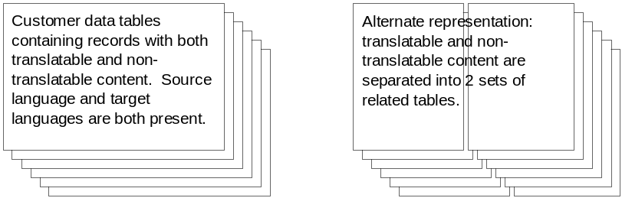
In this model, each client table that contains translatable content includes a column indicating the record’s language/locale. In addition, there may be one extra column that identifies whether the record is in a source language or a target language.
A variation of this model would put the translatable content into one sub-table, and the non-translatable content into a different sub-table.
Considerations/Issues
  - This model has the simplest database structure, which may be easier to maintain.
  - An advantage of this model is that it makes it possible to support an environment where the source language changes frequently, even to the granularity of a single record, which may have a different source language each time it is modified. However, the downside of this flexibility is that there must be some kind of status table present that knows the source language at the time the record was written.
  - When a trigger is written for a table in this model, it will fire whenever a record is updated or inserted, irrespective of the source language. If the “source language” indicator is present in the table, the trigger can be modified to disregard updates/inserts on “target” records. Otherwise, the trigger must be modified to check a separate status table before proceeding.
- One Table for Source Language / One Table for ALL Target Languages
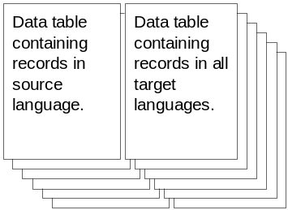
In this model, all of the client’s data is stored in a single set of tables in a pre-selected designated “source” language. A second set of tables is constructed to hold translated replicas of the source records. Each table in the “target” space contains a column to identify the language/locale of the record in the row.
A variation of this model would put the translatable content into one sub-table, and the non-translatable content into a different sub-table.
Considerations/Issues
  - This model has at most twice as many tables as needed for the source language table. This total can be reduced to some degree if the translatable and non-translatable content are kept in separate but related tables, in which case there are only twice as many “translatable” tables.
  - The maintenance of triggers is quite a bit simpler, because triggers are only placed on translatable tables in the source domain. Because of this, when a trigger fires, it simply creates a task entry and specifies the identity of the localization profile (which in turn contains details of the target language(s)). There is no need for a trigger to exist on any of the tables in the target domain.
  - Adding new locales to the system does not affect the number of tables in the database. This simplifies table management.
- One Table for Source Language / One Table for EACH Target Languages
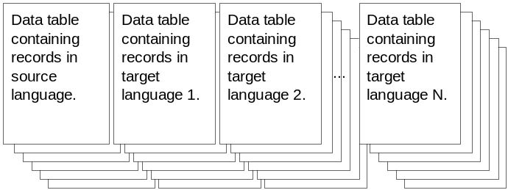
In this model, all of the client’s data is stored in a single set of tables in a pre-selected designated “source” language. For each “target” language, there is a set of tables that parallels the structure of the source language, and each target table bears a name that indicates the target language.
A variation of this model would put the translatable content into one sub-table, and the non-translatable content into a different sub-table.
Considerations/Issues
  - This model has at most N times as many tables as needed for the source language table (one for each language being supported by the database). This total can be reduced to some degree if the translatable and non-translatable content are kept in separate but related tables, in which case there are only twice as many “translatable” tables.
  - There is a minor naming problem in this model, because each target table must have the same schema as its source counterpart, but the name must be different. This can complicate maintenance quite a bit.
  - The maintenance of triggers is simple here too – at least no more complicated than the “One Source / One Target” model; once again, triggers are only placed on translatable tables in the source domain. Because of this, when a trigger fires, it simply creates a task entry and specifies the identity of the localization profile (which in turn contains details of the target language(s)). There is no need for a trigger to exist on any of the tables in the target domain.
Preferred Structure
Our intention is to support all three of these database models. Any customer model that doesn’t conform may be supportable through SQL statements that the customer writes. If this cannot be done, then the customer should transform the non-conforming tables into temporary staging tables that do conform to one of these models.
In the case where a customer does not yet have a database model in place, we recommend the use of model #2.

Terminology
The following descriptions are included to help clarify the meaning of some terms which are used elsewhere in this document.

- PaginatedResultSetXml (formerly “DynamicXml”)
  - Describes the data taken from the database, a collection of records representing the outcome of a query
  - Created by the DbSourceAdapter
- DiplomatXml
  - Describes structure and content of the original document being translated, with items identified as “translatable”, “viewable”, or “skeleton”.
  - Created by the ExtractorAgent
- EventFlowXml (formerly “diplomat data”)
  - Arbitrary scratch pad data used by Diplomat components
  - Describes additional details about the source document, such as file path info
  - Includes names of events that will be executed after translation (pre-merge event, post-merge event)
  - Locale, charset, translator name, database connect string
  - Contains information about the page count and the current page number (this enables result sets resul sets to be split into chunks and reassembled later)
  - Context information for viewing translatable content
  - Created by the DbSourceAdapter
- Data Source Profile
  - Two types currently identified
    - FilesystemSourceProfile
    - DatabaseSourceProfile
  - DatabaseSourceProfile describes column, rule, table name, whether translatable; contains SQL for acquisition, staging insert, staging update, final insert, final update
  - Created by a Diplomat administrator using a GUI associated with a Data Source Adapter
- Localization Profile
  - Describes characteristics of the translation process for a particular kind of data
  - Includes source language and target language
  - Workflow stages
  - Translator per stage
  - Duration per stage based on translator capabilities
  - Flag whether to use page translation memory
  - Created by a Diplomat administrator using a Localization GUI

Steps in the Flow
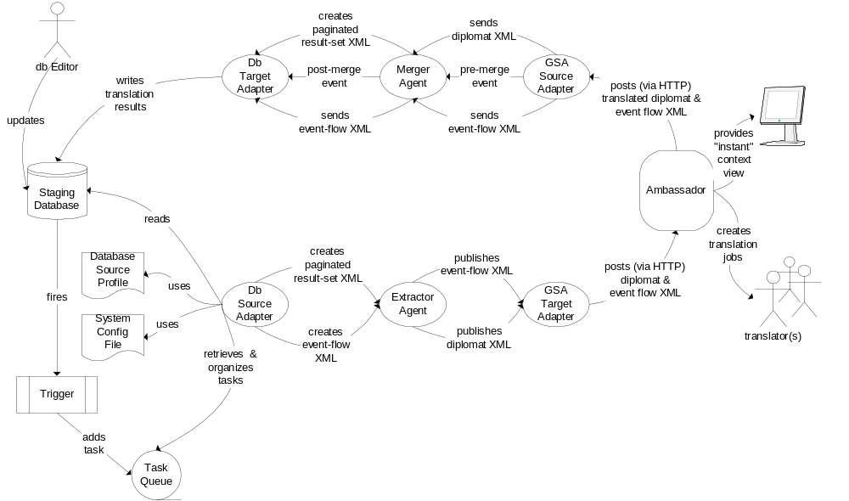Diplomat is responsible for detecting when a change occurs in the client’s database. Changes result in translation tasks being added to a task queue. When enough are present, Diplomat sets the translation process in motion. This process consists of three phases: a read phase, a translation phase, and a write phase. The translation phase is handled entirely by Ambassador; Diplomat is responsible for everything else. Sequentially, the flow of tasks appears as follows:

- The database editor changes the database by inserting or updating a record containing some translatable content.
- A trigger fires. Depending on the which columns in the source table were modified, the trigger may generate an entry in the Task Queue. Trigger construction (by the customer or by PSO) is based upon knowledge of a particular localization profile; therefore, the trigger can determine certain details of how the translation task should be performed.
- When there are “enough” tasks in the Task Queue, the DbSourceAdapter retrieves tasks from the queue, organized according to information from the localization profile. The DbSourceAdapter uses the Source Profile to obtain the SQL required to read records from the database.
- The DbSourceAdapter partitions tasks into pages based on information stored in its internal Active configuration. Each page is converted into PaginatedResultSetXml.
- The DbSourceAdapter publishes one page at a time, along with corresponding EventFlowXml that is used by other Diplomat components.
- The ExtractorAgent transforms PaginatedResultSetXml into DiplomatXml.
- The ExtractorAgent publishes the DiplomatXml, along with the possibly unchanged EventFlowXml, to the GsaTargetAdapter.
- GsaTargetAdapter uploads the both the DiplomatXml and the EventFlowXml via a single HTTP POST to Ambassador.
- Ambassador uses EventFlowXml information and accumulates DiplomatXml to create jobs.
- Ambassador calls upon one or more translators to perform the actual translation of each segment of translatable content. Ambassador uses context information (a live URL or an HTML display template) provided by Diplomat in the EventFlowXml to allow translators to view their changes in relation to a full or partial rendering of real data.
- Once the translation is complete, Ambassador send translated DiplomatXml and EventFlowXml to the GsaSourceAdapter via a single HTTP POST request.
- The GsaSourceAdapter publishes a pre-merge event that is read from the EventFlowXml. This event is picked up by the appropriate MergerAgent.
- The MergerAgent performs the steps necessary to merge the translated DiplomatXml and create PaginatedResultSetXml which can be used for writing records into the database.
- The MergerAgent publishes the post-merge event that is read from the EventFlowXml.
- The DbTargetAdapter decomposes the PaginatedResultSetXml and writes data back to the database according to the SQL “restore” instructions previously obtained from the Database Source Profile.

Automatic vs. Manual Record Selection
This release of Diplomat will support Automatic Record selection only; that is, there will be no explicit GUI for the manual selection of records. However, there is a known workaround: the user must define and execute an SQL statement that will select the desired records from the appropriate source tables and put the results in the correct format into the Task Queue directly. Once the records are in the Task Queue, they will be automatically picked up by the DbSourceAdapter and passed on for translation and re-insertion into the database.

Automatic vs. Manual Job Dispatch
This release of Diplomat will support both automatic and manual job dispatch.

How the Translation Process Works
The client writes a trigger program for each translatable table that inserts information about the updated records into the “Task_Queue” table. Each record in the “Task_Queue” table specifies manual or automatic job creation based on the record profile ID. For automatic job creation the records are organized into pages. Multiple pages with the same localization profile constitute a job. For manual job creation, each page has only one record. A job consists of multiple selected pages with the same source language. The process flow is the same for manual or automatic mode except for automatic job creation. In manual mode the designated user can view, and assign new localization profile for each record before job creation.
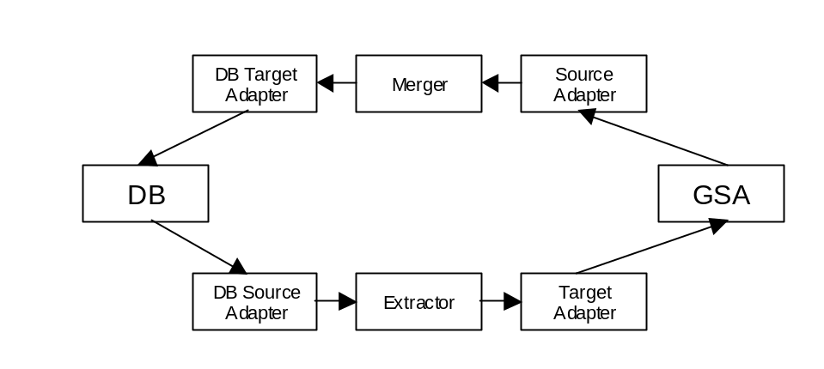
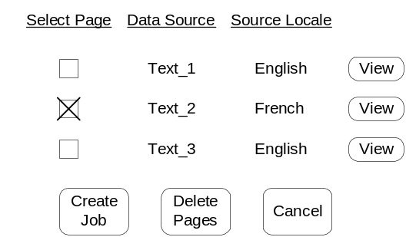
What the designated user sees in Ambassador is a list of temporary filenames with checkboxes along the left side. The list can be sorted by data source or source locale. There is a button to permit job creation, another to enable the deletion of selected pages from the job, and a third for canceling. Clicking on “Create Job” results in the manual initiation of a job containing the selected pages. Clicking on “Delete Pages” initiates the deletion of the selected pages from further consideration; this task must be completed by following with a separate confirmation. Clicking on any “View” button creates a new pop-up window that displays the contents of the selected record in context using Ambassador’s default display template mechanism.

Record Management Process Flow
A trigger program for a translatable table inserts records into the task queue table for each new or updated record in the translatable table. Translated records are reinserted into the same tables with target locales. Below is an example trigger program for a watched table and its associated sibling.
The Watched Table
CREATE TABLE COMMENT_LOG(
COMMENT_LOG_ID NUMBER(10,0) NOT NULL,
COMMENT_TEXT VARCHAR2(2000) NOT NULL,
FROM_WHOM VARCHAR2(127) NOT NULL,
TO_WHOM VARCHAR2(127) NOT NULL,
COMMENT_DATE DATE NOT NULL,
LOCALE VARCHAR2(10) NOT NULL
);

Sibling
CREATE TABLE COMMENT_PLUS(
COMMENT_LOG_ID NUMBER(10,0) NOT NULL,
COMMENT_ADDITIONAL VARCHAR2(2000) NOT NULL,
LOCALE VARCHAR2(10) NOT NULL
);

The Trigger Program
For simplicity the recursion algorithm is omitted. Also, all columns data are converted into string representation.

CREATE TRIGGER COMMENT_TRIGGER AFTER UPDATE OR INSERT ON COMMENT_LOG
FOR EACH ROW
DECLARE
SEPARATOR VARCHAR2(4):= '||||';
PARAMETER VARCHAR2(100);
ID NUMBER(10,0);

BEGIN
PARAMETER := TO_CHAR(:new.COMMENT_LOG_ID) || SEPARATOR || :new.LOCALE;
SELECT INCREMENT_TASK_ID.NEXTVAL INTO ID FROM DUAL;
INSERT INTO TASK_QUEUE VALUES(ID, 1, 1, PARAMETER);
END;

Primary Table Schemas
- Task Queue Table
Table Name: Task_Queue Table

Column Name | Data Type | Comment
Task_Queue_ID | Number(10,0) | Primary key
Record_Profile_ID | Number(10,0) | Foreign key
Localization_Profile_ID | Number(10,0) | Foreign key
Parameter | Varchar2(2000) | For SQL statements

Data Source Profile Tables
Table Name: Record_Profile Table

Column Name | Data Type | Comment
Record_Profile_ID | Number(10,0) | Primary key
Name | Varchar2(127)
Acquisition_SQL | Varchar2(2000)
Acquisition_Connect_ID | Number(10,0) | Foreign key
Preview_Insert_SQL | Varchar2(2000)
Preview_Update_SQL | Varchar2(2000)
Preview_Connect_ID | Number(10,0) | Foreign key
Final_Insert_SQL | Varchar2(2000)
Final_Update_SQL | Varchar2(2000)
Final_Connect_ID | Number(10,0) | Foreign key
Preview_URL | Varchar2(2000)
Manual_Mode | Number(1,0) | True or False

Table Name: Column_Profile Table

Column Name | Data Type | Comment
Record_Profile_ID | Number(10,0) | Foreign key
Column_Number | Number(4,0)
Table_Name | Varchar2(127)
Data_Type | Varchar2(127) | Html, xml, text, etc ..
Rule | Number(10,0) | Foreign key
Attribute | Number(1,0) | Translatable, Contextual, Invisible
Column_Label | Varchar2(127) | For display template

The database source adapter retrieves records from the “Task_Queue” table. For each record the adapter knows the acquisition, insert, and update SQL or PL/SQL statements from the ”Record_Profile_ID.” A simple string substitution algorithm replaces variable names with the actual parameters from the “Task_Queue” table record and the retrieved result set translation. All SQL statements are case insensitive. Here’s a list of predefined variables and sample SQL and PL/SQL statements.

Predefined Formats

%%some_number%% => references parameter value at location “some_number”
%%tableName.columnName%% => the translated value at this location
%%sourceLanguage%% => source language at this location
%%targetLanguage%% => target language at this location

Acquisition SQL
SELECT TO_CHAR(a.comment_log_id), a.comment_text, a.from_whom, a.to_whom, TO_CHAR(a.comment_date, 'MM/DD/YYYY - hh24:mi:ss'), a.locale, b.comment_additional FROM comment_log a, comment_plus b WHERE a.comment_log_id = TO_NUMBER(‘%%1%%’) and b.comment_log_id = TO_NUMBER(‘%%1%%’) and a.locale='%%2%%' and b.locale='%%2%%'

Insert SQL
BEGIN
INSERT INTO COMMENT_LOG VALUES (TO_NUMBER('%%comment_log.comment_log.id%%'), '%%comment_log.comment_text%%', '%%comment_log.from_whom%%', '%%comment_log.to_whom%%’, TO_DATE('%%comment_log.comment_date%%', 'MM/DD/YYYY - hh24:mi:ss'), '%%comment_log.comment_text.targetLanguage%%');

INSERT INTO COMMENT_PLUS VALUES(TO_NUMBER('%%comment_log.comment_log_id%%'), '%%comment_plus.comment_additional%%', '%%comment_log.comment_text.targetLanguage%%');
END;

Update SQL

BEGIN
UPDATE comment_log SET comment_text='%%comment_log.comment.text%%' WHERE comment_log_id = TO_NUMBER('%%comment_log.comment_log_id%%') AND locale='%%comment_log.comment_text.targetLanguage%%';

UPDATE comment_plus SET comment_additional='%%comment_plus.comment_additional%%' WHERE comment_log_id = TO_NUMBER('%%comment_log.comment_log_id%%') AND locale='%%comment_log.comment_text.targetLanguage%%';
END;

Additional Table Schemas
- JDBC Thin Client Connection
Table Name: Connection_Profile Table

Column Name | Data Type | Comment
Connection_Profile_ID | Number(10,0) | Primary key
Name | Varchar2(127)
Computer_Name | Varchar2(127)
Port_Number | Varchar2(127)
Database_Name | Varchar2(127)
User_Name | Varchar2(127)
Password | Varchar2(127)

- Localization Profile Tables
Table Name: Job_Template

Column Name | Data Type | Comment
Job_Template_ID | Number(5,0) not null | Primary key
Name | NVarchar2(127) not null | Name of L10N profile
Source_Language | Number(2,0) not null | References GSA language

Table Name: Job_Template_Target

Column Name | Data Type | Comment
Job_Template_ID | Number(5,0) not null | Foreign key
Job_Template_Target_ID | Number(5,0) not null | Primary key
Target_Language | Number(2,0) not null | References GSA language
TM_Language | Number(2,0)
Page_TM | Number(1,0)

Table Name: Job_Template_Routing

Column Name | Data Type | Comment
Job_Template_Target_ID | Number(5,0) not null | Foreign key
Stage | Number(2,0) not null
Seq_uence | Number(2,0)
User | Number(5,0) | References GSA Users
Duration | Number(5,0) | Working days per stage

Providing Context During Translation
Context is required when translating content that sits in database tables because, in order to fully understand how to translate properly, the translator needs to see the translatable content in the context of related details. For example, in order for a translator to properly translate the description of a bicycle from English into French, he/she might need information about the parts that make up the bike, even though there would not necessarily be any simultaneous translation of the parts themselves.
Full Context View refers to being able to view a set of translatable items in context with associated information so that a translator can see the result of his/her translation the way a normal user of the system would. This is accomplished by directing the user to the real system – e.g. a web server – that renders the page presentation.
In order to translate pages properly, however, the translator may not need to actually access the end system to see how the pages are presented. A Partial Context View solution could provide translators with enough context to be able to translate without directing the user to the real web application for presentation.
Questions:
  - Is there a real need for this in the field? Most of the translators working on HP’s web pages do not even use Ambassador to view the static HTML in the WYSIWYG environment because they prefer to download to Trados and work offline. How necessary is context?
- Full Context View
In order to provide a view of the translated segments in full context, Ambassador must either render the presentation by interfacing with whatever third party systems actually create the rendering, or Ambassador must redirect the translator to view the pages generated by whatever third party system is involved. Redirecting the user to a URL that accesses a third party web application is a more tractable solution.
Assumptions:
  - Every query of database content can be related to at least one URL where a Servlet, CGI script, JSP, or ASP accesses the database for the just-translated items. This page provides the needed context.
  - Every such URL can be fully described as either an HTTP GET with arguments or an HTTP POST with arguments.
  - For database content, this set of context-view URLs can be stored in the Database Source Profile such that every source-target language pair contains a set of source and target URLs. These URLs can be parameterized with data from the query result set.
Possible Implementation:
The AmbassadorSourceServlet can send on the translated content to be committed to the database and then create an HTML page containing links to the context-view pages. The translator can then click these links to see all the associated URLs for the context. If there is only one associated URL, then the AmbassadorSourceServlet can just show that URL to the user.
Furthermore, if each Acquisition SQL statement is associated with a set of URLs corresponding to the source language and the target language, then we can display one browser window with two frames, one for the source web page and one for the target web page so the translator can compare the two context views.
The Database Source Profile will apply to whatever target language the customer is currently translating to. This means that the URL information for all target languages will need to be stored in the Database Source Profile. For example, this can be stored in a “ContextUrl” column in the Database Source Profile table. The value can be an XML string containing the source and target URLs for each source-target language pair. For example:
<srcLocale id=”en_US”>
<tgtLocale id=”fr_Fr”>
<urlPair>
<srcUrl>http://foo/blah.asp</srcUrl>
<tgtUrl>http://foo/fr/blah.asp</tgtUrl>
</urlPair>
</tgtLocale>
<tgtLocale id=”es_Mx”>
<urlPair>
<srcUrl>http://foo/blah.asp</srcUrl>
<tgrUrl>http://foo/mx/blah.asp</tgtUrl>
</urlPair>
<urlPair>
<srcUrl>http://foo/blah2.asp&productId=$pid</srcUrl>
<tgtUrl>http://foo/mx/blah2.asp&productId=$pid_t</tgtUrl>
</urlPair>
</tgtLocale>
</srcLocale>

In the above example, the English to Spanish(Mexico) translations require two URL pairs for context view. The urlPair tag can futher be defined to include POST or GET arguments and some mechanism to substitute values.
The AmbassadorSourceServlet can retrieve the XML describing these URLs and make the value substitutions when the context view (instant preview) button is hit. The substitutions can be based on the values passed into the acquisition SQL by the trigger. When the trigger passed in the key values, it can also pass in name information. For example “pid=1424” for a situation where the primary key (“pid”) has the value 1424. When the AmbassadorSourceServlet sees the string $pid in the URL, it can substitute in the value 1424. If this value has been translated, then the translated value can be flagged with “_t”. So if bookname is the primary key, then bookname_t will be the translated value that should be substituted into the URL.
Issues:
  - The current publish/subscribe model may need to be changed to incorporate the use of acknowledgements so the AmbassadorSourceServlet can know when the data has been committed and the URLs can be presented to the user.
  - We will need some means of substituting in arguments for the URL. This might not just be the column names and values. This gets complicated because the values we might want to substitute may have nothing to do with items in the result set.
  - We will need at least one URL per source-target pair per acquisition SQL. This will require a lot of work on the part of PSO to set this up in addition to all the customization of the SQL statements that are required. And furthermore, no such URL may already exist at the customer site. Then the expectation is that PSO has to create such a servlet. That is a heavy task.
- Partial Context Via Static Display Templates
In order to provide a view of the translated segments with some context, Ambassador must render an HTML approximation of the original context. This can be set up in advance through the use of display templates.
Assumptions:
  - Every query of database content can be related to at least one HTML display template. This page provides the needed context.
  - PSO or the customer can create these display templates. The association of display template to query can be stored in the Database Source Profile.
  - One row of data in the query’s result set contains the entire context needed. Therefore the display template can be instantiated by filling in values from one row of the result set content.
Possible Implementation:
The Database Source Profile stores a reference to an HTML display template that corresponds to each SQL query. This HTML display template shows how to display the translatable and non-translatable columns that come from the query result set. This template may contain frames so that if a column contains XML or HTML data, it can be displayed in a separate frame in the same page.
Issues:
  - This approach requires the customer (with the help of PSO or some other consulting group) to build the static templates. Since there must be one template for each context in which the client would like to see the translatable content, this implies a lot of work.
  - Template maintenance would become a major additional task unto itself.
- Partial Context Via Dynamic Display Templates
The 2.3 Ambassador editor has a display page in the editor which provides a means for viewing HTML pages in context and for accessing each individual item for editing. Items which are editable are links which pull up the segment editor for that item and all other content is presented for context. This is achieved for DB content by using HTML templates into which translatable items and their context are substituted. Templates provide additional context from that which can be gathered from the database itself in the form of text, positioning and possibly style. Each template represented a database record containing one translatable item and its context.
In 2.4 the job is made more complex by the need to bundle multiple records into a single page and by the fact that we are now dealing with formats other than HTML and the database may contain items which contain formatting information and an unknown number of translatable strings. If we linguistically segment every database cell, then we have an unknown number of translatable items in every record.
The job is also made simpler because we have Instant Preview (called Full Context View in this document) which will allow the user a true context generated from the customer database and page generation environment. This allows the editor display to be much simpler because the translator can use context view for context that is not available there.
The simpler solution described here is a companion to Full Context View view, not a fallback for it. It does not use templates, it does not use formatting information in database items, and it does not gather multiple child rows from the database for context. Text labels are the only means to provide additional context. The success of context view is assumed. If we did not have context view we would need a solution that at least allows multiple child rows for context and at worst uses templates. We should avoid a solution that uses templates because the maintenance and creation of templates involves a lot of work for the customer and/or PSO. Using format information from individual database items should not be considered in either case.
Assumptions:
  - Database content that needs to be translated is associated with other content from the database that is supplied for context purposes only.
  - Database content is not just text; it may also be fragments of any other format that we deal with, and these fragments have to be parsed for translatable or context content.
  - This content is grouped into pages that need to be displayed by Ambassador in the editor.
  - A context view or instant preview which shows the user an example wysiwyg page containing what they have translated will also be available.
Possible Implementation:
Labels
In the table in the Database Source Profile which describes each column in the result set, there is a column which is for an optional text label describing the database content or even giving instructions to the translator. Labels are in the source language and supplied by the customer. This works because there is only one Database Source Profile for each source language for any result set. They involve some maintenance, but much less than templates.
PaginatedResultSetXml will gain a tag to associate the label with the column. This could also be an attribute of the column. If it is a tag, its only attribute is the corresponding column name. In either case, the content probably will need to be escaped, though it won’t be in the examples below.
<table name="bicycle">
<column name="brand" translate="false">Gary Fisher</column>
<label name="name">brand name</label>
<column name="model" translate="true">Aquila</column>
<label name="model">model name: don’t translate made up
names – adapt if culturally inappropriate – marketing
approved adaptations to be supplied by email</label>
<column name="derailleur" translate="false">Shimano
XYZ123</column>
<label name="derailleur">derailleur name and model</label>
</table>
Display Appearance
Ambassador will make use of translatable, context and label strings to create a page of editable items and their contexts. We may choose to limit pages to records with the same Database Source Profile, but the image below is based on the assumption that we can combine them. You can see that the label for the model name changes depending on whether it is the translatable item or whether it is there only for context. Notice that the paragraph about the frame is from one database column, but it is linguistically segmented and therefore contains several Ambassador items. The following screen shot does not address how context view is accessed. The Page Info table in all screen shots is invalid.
Note that there will also be buttons to access the context view somewhere in these pages.
Formatted Database Content
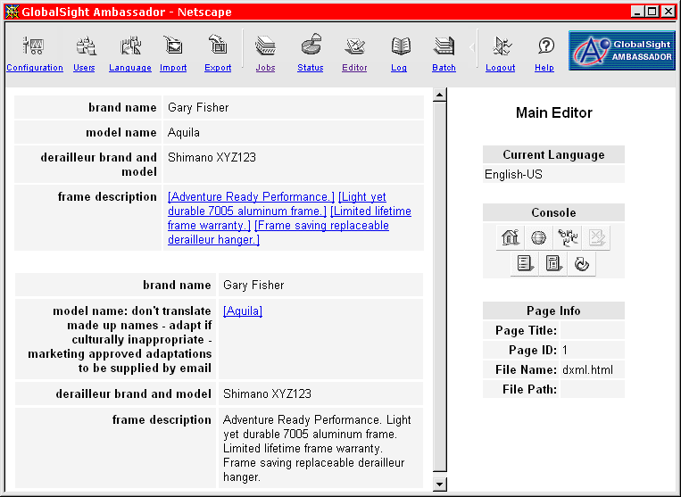
Formatted database content needs to be parsed for translatable content or context content. The ExtractorAgent that transforms PaginatedResultSetXml into DiplomatXml uses the format attribute for the column and parses the content. The resulting translatable or context segments become Ambassador items. Ambassador returns the DiplomatXml with the translatable items replaced by their translations and when the MergerAgent restores the DiplomatXML, the formatting information in the skeleton is again part of the column content. If we start with this content
<tr>
<td>A sentence. Another sentence.</td>
<td>BLAH BLAH</td>
</tr>
we get this PaginatedResultSetXml
<column name=”table row” format="HTML" translate="true">
<tr>
<td>A sentence. Another sentence.</td>
<td>BLAH BLAH</td>
</tr>
</column>
and approximately this DiplomatXml
<skeleton>
&lt;column name=&quot;table row&quot; format=&quot;HTML&quot;
translate=&quot;true&quot;&gt;&lt;tr&gt;&lt;td&gt;
<translatable table=1 column=1 id=1>
<segment id=1>A sentence.</segment>
<segment id=2>Another sentence.</segment>
</translatable>
&lt;/td&gt;&lt;td&gt;
<translatable table=1 column=1 id=2>BLAH BLAH</translatable>
&lt;/td&gt;&lt;/tr&gt;&lt;/column&gt;
</skeleton>
which Ambassador will make into a template with placeholders for individual items, leaving behind the formatting and never knowing the association between the items.
<skeleton>
&lt;column name=&quot;table row&quot; format=&quot;HTML&quot;
translate=&quot;true&quot;&gt;&lt;tr&gt;&lt;td&gt;
<translatable table=1 column=1 id=1>
<segment id=1>[%%100]</segment>
<segment id=2>[%%101]</segment>
</translatable>
&lt;/td&gt;&lt;td&gt;
<translatable table=1 column=1 id=2>[%%102]</translatable>
&lt;/td&gt;&lt;/tr&gt;&lt;/column&gt;
</skeleton>

The table and column attributes (or equivalent functionality) for translatable and localizable tags need to be added to the DiplomatXml specification in order to tell Ambassador the groupings of items in the same record and column so that they end up in the correct place in the editor display. The above items will be together in the same table cell to show the user that they come from the same database cell.
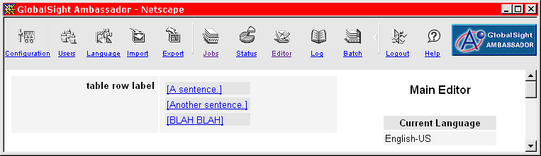
Changes to DiplomatXml
The columns described by the Database Source Profile are either translatable or for context. Diplomat determines whether translatable items are translatable or localizable, so we do not need to make the distinction in the profile. We do need some way to tell Ambassador whether translatable or localizable items are present only for context or are editable. The translatable and localizable tags need a context attribute with values “label” and “viewable”. If the attribute is not present, the item is editable. The Extractor for PaginatedResultSetXml needs to know about label elements as well as column elements.
Another option is to have a context and label elements in DiplomatXml with the same attributes as translatable elements.
Integration with Full Context View
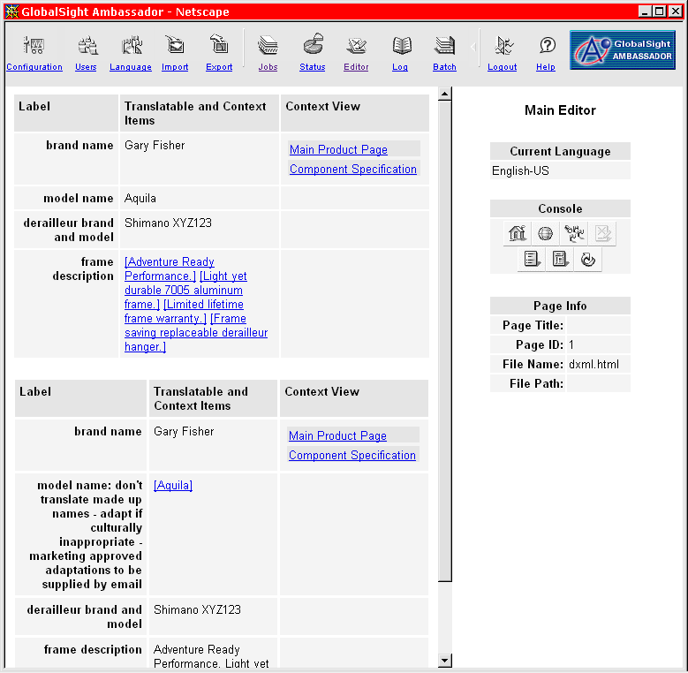
The previous section describes a servlet that would present a list of urls for context to the user. An alternative to having a context view button to open a window with links, the links to the various urls associated with the record can be right in the display table. The links can either be the name of the url or labels in the source language to give the translator some sort of idea about what context can be viewed there. A label can be associated with a single url or a source/target url pair and bring up separate windows as described in the Context View section. Because we don’t want Ambassador to have to know about urls, we need to give it only the minimum information to associate a link or button with the correct record in the page. If we add the label and a parameter to the servlet to indicate which label was clicked to that information, we can still use a servlet and not introduce asymmetry by having Ambassador modify urls or go to the Data Source Profile for urls.
Import, Export and Maintenance of DB Items in Ambassador
We have the choice of importing label and context strings as Ambassador items and restoring them to the final template unchanged. This would require new categories for the items in the table and some way to tell Ambassador how to group them. Because there is no need to change the display during the life of the job, we have the option to leave these pieces unextracted in the DiplomatXml template for export, but to use them to build a temporary template with labels and context and placeholders for translatable and localizable items in their appropriate table cells. This allows Ambassador to make use of the grouping and context information in the DiplomatXml without having to store it.
Export would use the templatized DiplomatXml and the temporary template would be deleted when the job is completed.
Note that Ambassador can use a similar plan for all formats with one difference; when Add/Delete is used on files, the DiplomatXml skeleton would be modified and the temporary template would be regenerated. This saves building the display from the DiplomatXml template every time the file is brought into the editor, though this is a more feasible possibility with file formats.
Issues:
  - We might want to make use of HTML or XML format information in a cell. To actually make use of it would require the use of templates. Since what is in the cell can be anything, templates will be needed to insure that it is displayed properly. For example, if the content is an HTML table row, the template would need <TABLE> tags to surround it. In general templates would need to be more complex and Diplomat would need to own the task of repopulating the format with the translated content as if it were a template.
  - Localizable in the sense mentioned above is something like an image path. It needs to be edited by a human being, but it isn’t really a translation task. Do we also need to address the issue of fields with prices or dates that need to be adapted for locale or converted in some way? Can we let the SQL that restores the fields take care of that based on locale and relying on built-in database conversions? Most of this sort of information will be in the category of invisible columns.

