Diplomat 1.0 Design
File Content 2
Diagram Steps 2
Diagram Steps 3
Messages 3
Database Content 5
Diagram Steps 5
Diagram Steps 6
Messages 6
Interwoven TeamSite 8
Diagram Steps 8
Diagram Steps 9
Messages 9
Object Model 12
File System Import 12
File System Export 17
Diplomat Database Translation Schema 21
Trigger 21
Dynamic Jobs Summary with Instant Preview 24

File Content

Java Properties Merge Agent
Java Properties P&E Agent
JavaScript Merge Agent
JavaScript P&E Agent
XML Merge Agent
XML P&E Agent
CSS Merge Agent
CSS P&E Agent
Text Merge Agent
Text P&E Agent
HTML Merge Agent
HTML P&E Agent
Import
File1
File2
File3
Diplomat XML
(HTTP socket)
Filename, locale, charset, format

cust_tmpl templates
(In Diplomat XML)
Ambassador DB
HTML
Text
CSS
XML
JavaScript
Java Prop
Text File
Target Adapter

Ambassador 2.4

Diplomat
Extractor.pm
(XML::Parser)

Export

Java

Perl
Ling Processing
(segmentation, word count)
1
3
5
6
Ambassador Import List
Broker Client
Diplomat XML

2
4
7
8
10
11
9
Translation, Workflow

Ambassador
Target Adapter
HTML
Text
CSS
XML
JavaScript
Java Prop

B

C

A

D

E

F

G

H

Text File
Source Adapter
Ambassador
Source Adapter

Diagram Steps
- Select the files to by imported from the Ambassador Import screen.
- Send list to Diplomat via perl system() call to Ambassador Import List Adapter, which is actually just an Active broker client.
- Text File Source Adapter gets file list and reads in files.
- File data is sent to appropriate P&E (Parse & Extract) agent for parsing, extracting, segmentation, word count. The agent sends back Diplomat XML.
- The Ambassador Target Adapter sends Diplomat XML to Ambassador via HTTP.
- Ambassador uses XML::Parser to create skeleton file (in Diplomat XML) and enter data into database.
- The file is translated in Ambassador.
- Ambassador sends the translated Diplomat XML file to the Ambassador Source Adapter using perl system() call.
- The appropriate Merge agent merges the file (converts the Diplomat XML into the original format).
- The Text File Target Adapter writes the file out to the correct language directory.

Messages
- Message: Ambassador Import CGI script → Import List Adapter
Protocol: perl system() call
Values Sent: filenames, paths, code set, locale
Values Returned: none
- Message: Import List Adapter → Text File Source Adapter
Protocol: Active
Values Sent: filenames, paths, code set, locale
Values Returned: none
- Message: Text File Source Adapter → P&E Agent
Protocol: Active
Values Sent: filenames, paths, code set, locale, file data, (format is determined by file extension plus config file mapping table)
Values Returned: none
- Message: P&E Agent → Ambassador Target Adapter
Protocol: Active
Values Sent: filenames, paths, code set, locale, file data in Diplomat XML
Values Returned: none
- Message: Ambassador Target Adapter → Ambassador Import Script
Protocol: HTTP Socket
Values Sent: filenames, paths, code set, locale, file data in Diplomat XML
Values Returned: none
- Message: Ambassador Export Script → Ambassador Source Adapter
Protocol: HTTP Socket
Values Sent: Target filenames, paths, export code set, translated files in Diplomat XML
Values Returned: none
- Message: Ambassador Source Adapter → Merge Agent
Protocol: Active
Values Sent: Target filenames, paths, translated files in Diplomat XML
Values Returned: none
- Message: Merge Agent → Text File Target Adapter
Protocol: Active
Values Sent: Target filenames, paths, translated files in native format
Values Returned: none

Database Content
Dynamic XML P&E Agent
Dynamic XML Merge Agent
Merge Agents
(See File Diagram)
P&E Agents
(See File Diagram)

Diplomat XML
(HTTP socket)

Diplomat

Java
Ambassador Target Adapter
Customer DB
Oracle
Source Adapter
(Polling TRANJOBS)
Ambassador Source Adapter
1
7
8
10
Page Composer
Agent
Dynamic XML
Merge
(Dip XML → Dyn XML)
cust_tmpl templates
(In Diplomat XML)
Ambassador DB

Ambassador 2.4
Extractor.pm
(XML::Parser)

Perl
Diplomat XML

6
3
4
5
Ambassador DB
Jobs Tables
Translation Workflow

Ling Processing
(segmentation, word count)

A

B

C

D

E

F

G

Oracle
Target Adapter

Page Decomposer
Agent

H

Export
9
2

Diagram Steps
- A trigger in the customer database populates the TRANJOBS table. The Oracle Adapter polls TRANJOBS and imports data based on settings specified in a Task file (see Jon’s Dynamic Jobs document). This is where accumulation happens.
- Records are sent to the Page Composer Agent that wraps them in Dynamic XML (this is a GSA format) so they can be sent through the system as a “page”.
- The Dynamic XML File data is sent to the Dynamic XML P&E (Parse & Extract) agent for parsing, extracting, segmentation, word count. The Dynamic XML P&E agent uses the other P&E agent depending on the format of the individule record. The Dynamic XML P&E agent sends back Diplomat XML.
- The Ambassador Target Adapter sends Diplomat XML to Ambassador.
- Ambassador uses XML::Parser to create skeleton file (in Diplomat XML) and enter data into database.
- The file is translated in Ambassador.
- Ambassador sends the translated Diplomat XML file to the Ambassador Source Adapter using a perl system() call.
- The appropriate Dynamic XML Merge agent merges the file (converts the Diplomat XML into Dynamic XML). For merging, the Dynamic XML agent uses the other P&E agents depending on the format of the individual record.
- The Page Decomposer Agent converts the file from Dynamic XML into individual records.
- The Oracle Target Adapter updates the customer database with the translated data.

Messages
- Message: Oracle Source Adapter → Page Composer Agent
Protocol: Active
Values Sent: task ID, record data
Values Returned: none
- Message: Page Composer Agent → Dynamic XML P&E Agent
Protocol: Active
Values Sent: task ID, multiple records in Dynamic XML
Values Returned: none
- Message: Dynamic XML P&E Agent → Ambassador Target Adapter
Protocol: Active
Values Sent: Task ID, code set, locale, file data in Diplomat XML
Values Returned: none
- Message: Ambassador Target Adapter → Ambassador Import Script
Protocol: HTTP Socket
Values Sent: Task ID, code set, locale, file data in Diplomat XML
Values Returned: none
- Message: Ambassador Export Script → Ambassador Source Adapter
Protocol: HTTP Socket
Values Sent: Task ID, export code set, translated files in Diplomat XML
Values Returned: none
- Message: Ambassador Source Adapter → Merge Agent
Protocol: Active
Values Sent: Target filenames, paths, translated files in Diplomat XML
Values Returned: none
- Message: Merge Agent → Page Decomposer Agent
Protocol: Active
Values Sent: Target filenames, paths, translated records in Dynamic XML
Values Returned: none

- Message: Merge Agent → Oracle Target Adapter
Protocol: Active
Values Sent: Target filenames, paths, individual translated records
Values Returned: none

Interwoven TeamSite
Merge Agents
(See File Diagram)
P&E Agents
(See File Diagram)

TeamSite

Perl

Java

Diplomat
Click “Translate”
IW CGI
script
IW Import List Adapter
Diplomat XML
(HTTP socket)
cust_tmpl templates
(In Diplomat XML)
Ambassador DB
Extractor.pm
(XML::Parser)

Export
1
6
Diplomat XML

7
8

Ambassador 2.4

File System
3
4
5
10
2
Translation Workflow

A

B

E

F

G

D

I

Ambassador
Source Adapter
IW Source Adapter
Ling Processing
(segmentation, word count)

C

H

IW Target Adapter
Ambassador
Target Adapter
9
HTML
Text
CSS
XML
JavaScript
Java Prop
HTML
Text
CSS
XML
JavaScript
Java Prop

Diagram Steps
- Choose the “Translate” option on the TeamSite pulldown menu for selected files.
- IW CGI script makes perl system() call to IW Import List Adapter.
- The IW Source Adapter gets file list, reads in files.
- File data is sent to appropriate P&E (Parse & Extract) agent for parsing, extracting, segmentation, word count. The agent sends back Diplomat XML.
- The Ambassador Target Adapter sends Diplomat XML to Ambassador.
- Ambassador uses XML::Parser to create skeleton file (in Diplomat XML) and enter data into database.
- The file is translated in Ambassador.
- Ambassador sends the translated Diplomat XML file to the Ambassador Source Adapter.
- The HTML Merge agent merges the file (converts the Diplomat XML into the original format).
- The IW Target Adapter writes the file out to the correct language directory and branch.

Messages
- Message: TeamSite “Translate” menu item → TeamSite CGI (perl) script
Protocol: HTTP (CGI)
Values Sent: filenames, paths, TeamSite user, TeamSite branch
Values Returned: none
- Message: TeamSite CGI (perl) script → IW Import List Adapter
Protocol: HTTP Socket
Values Sent: filenames, paths, TeamSite user, TeamSite branch
Values Returned: none
- Message: IW Import List Adapter → IW Source Adapter
Protocol: Active
Values Sent: filenames, paths, TeamSite user, TeamSite branch
Values Returned: filenames, paths, TeamSite user, TeamSite branch, byte array containing file
- Message: IW Source Adapter → HTML P&E Agent
Protocol: Active
Values Sent: filenames, paths, TeamSite user, TeamSite branch, byte array containing file
Values Returned: none
- Message: HTML P&E Agent → Ambassador Target Adapter
Protocol: Active
Values Sent: filenames, paths, TeamSite user, TeamSite branch, byte array processed Diplomat XML
Values Returned: none
- Message: Ambassador Target Adapter → Ambassador Import Script
Protocol: HTTP Socket
Values Sent: filenames, paths, code set, locale, file data in Diplomat XML
Values Returned: none
- Message: Ambassador Export Script → Ambassador Source Adapter
Protocol: HTTP Socket
Values Sent: Target filenames, paths, export code set, translated files in Diplomat XML
Values Returned: none
- Message: Ambassador Source Adapter → Merge Agent
Protocol: Active
Values Sent: Target filenames, paths, translated files in Diplomat XML
Values Returned: none
- Message: Merge Agent → IW Target Adapter
Protocol: Active
Values Sent: Target filenames, paths, translated files in native format
Values Returned: none

Object Model
Dhananjay Ragade

The Diplomat 1.0 design is based on an Active framework using the ActiveWorks broker as the central point for message management. Diplomat components will fall into two main categories: Adapters and Agents. Functionally, there are minor differences between the two. Adapters are objects that serve as the bridge between some data source or system and the Active Broker. Agents are objects that only subscribe to events from and publish events to the Active Broker.

All of the following cases will involve the same sets of objects:
- Source and Target Adapters – These adapters are responsible for the input from and output to a data source or system that needs to be integrated with GSA.
- Parse/Extract Agents – These agents are responsible for subscribing to un-translated content, parsing it, and then publishing it back to the broker as Diplomat XML.
- Merge Agents – These agents are responsible for subscribing to translated Diplomat XML, and then producing translated content in the original format such as HTML or Javascript.
- Ambassador-specific Broker Clients – small Java programs used by GSA 2.4 to publish events to the Active Broker from within GSA’s perl scripts.

Each adapter, agent, or broker client shown is a run in a separate java process. Adapters and Agents can be run as daemons on the server. In this manner, new data sources and formats can be incorporated into Diplomat by creating the necessary source and target adapters, parsers, and mergers, and running them separately from the working parts of Diplomat.

File System Import
This section describes the Diplomat scenario of importing new or updated web content from the file system and exporting translated content to the file system. This section also describes the objects and events necessary to handle File System content.

Events
When content is imported from the File System into Ambassador, the following events are used:

Ambassador Import

AmbassadorImport {
String Filename /*name of file to import*/;
String Path /*full path to directory where file sits*/;
String Locale /*locale of the content*/;
String Charset /*character set of the content*/;
}

This event is generated by the AmbassadorImport broker client. This is a small Java program run by Ambassador executed from a perl script once the user in GSA 2.4 selects what content he want to import. The Diplomat Flat File Adapter subscribes to these events and upon receipt reads in the appropriate file from the local file system and then publishes the binary contents of the file as HTMLContent, XMLContent, JSPContent, etc.

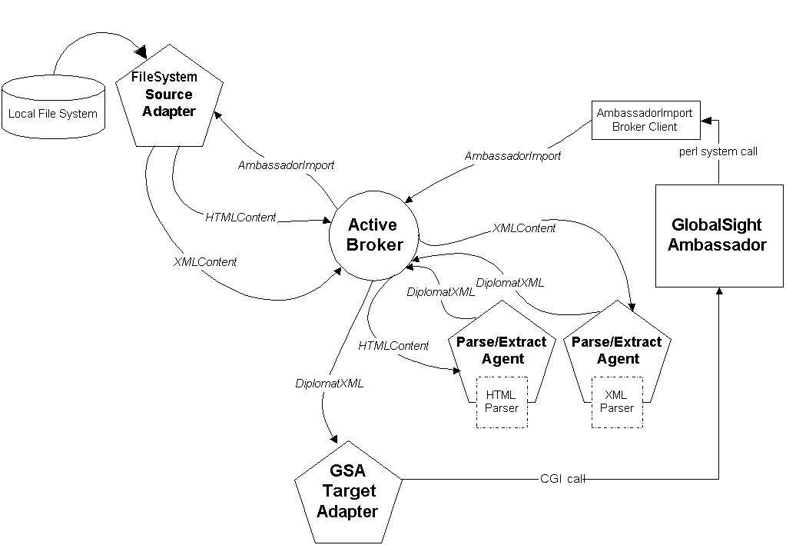
Figure 1: Import from File System to GSA
- <type>Content
There are many different content events that differ only in the name of the event itself. This allows different Parse/Extract agents to operate on the events based on the name of the event since particular Parse/Extract agents will subscribe only to certain content events. These events can be named HTMLContent, XMLContent, JSPContent, etc. One example of a content event is:

HTMLContent {
String MetaData; /*Data source Metadata in XML*/;
Byte[] Data /*the actual content data in binary*/;
}

These events contain the content to be translated as well as the XML meta data about the data source from where the content came.

- DiplomatXML
DiplomatXML {
String MetaData; /*Data source Metadata in XML*/;
String Data /*the actual content data converted to Diplomat XML*/;
}
When content is sent from the Parse/Extract agents to the GSA Target Adapter, it is sent as Diplomat XML. This event is generated by the Parser agents and contains the translatable content in DiplomatXML as well as the XML metadata about the original data source.

Objects
The objects involved in the file import scenario include:

- AmbassadorImportBrokerClient
This simple object is used by GSA (launched from a perl system() call) to send an AmbassadorImport event to the Broker. It expects command line arguments for: Filename, Path, Locale, and Charset.

- FileSystemSourceAdapter
The FileSystemSourceAdapter is a simple class that extends the Active Intelligent Adapter class. It is associated with one operation class called ImportFileOperation where all the meaningful activity regarding input from the file system is managed.

- ImportFileOperation
In Active, each operation that an intelligent adapter can perform is implemented through the scriptInvoke() method of an operation class known to the adapter. The ImportFileOperation is responsible for accepting an AmbassadorImport event, reading in the named file, and publishing its contents in an appropriate <type>Content event. The ImportFileOperation also fills in the data source related metadata in XML.

The data source related metadata includes information about the locale, character set, content type, filename, and path.

3. ContentMap
The ImportFileOperation class makes the determination of what <type>Content event to send through the help of a ContentMap object. The ContentMap reads in a configuration file (specified at instantiation time) that maps filename extensions to the names of <type>Content Extract events. An example of this configuration file is:

#File System Adapter ImportFileOperation configuration file
#Extension | Content Type | Extract Event | Merge Event
.html | HTML | Diplomat::HTMLContent | Diplomat::TrHTMLContent
.xml | XML | Diplomat::XMLContent | Diplomat::TrXMLContent
.css | CSS | Diplomat::CSSContent | Diplomat::TrCSSContent
.htm | HTML | Diplomat::HTMLContent | Diplomat::TrHTMLContent
.jsp | JSP | Diplomat::JSPContent | Diplomat::TrJSPContent

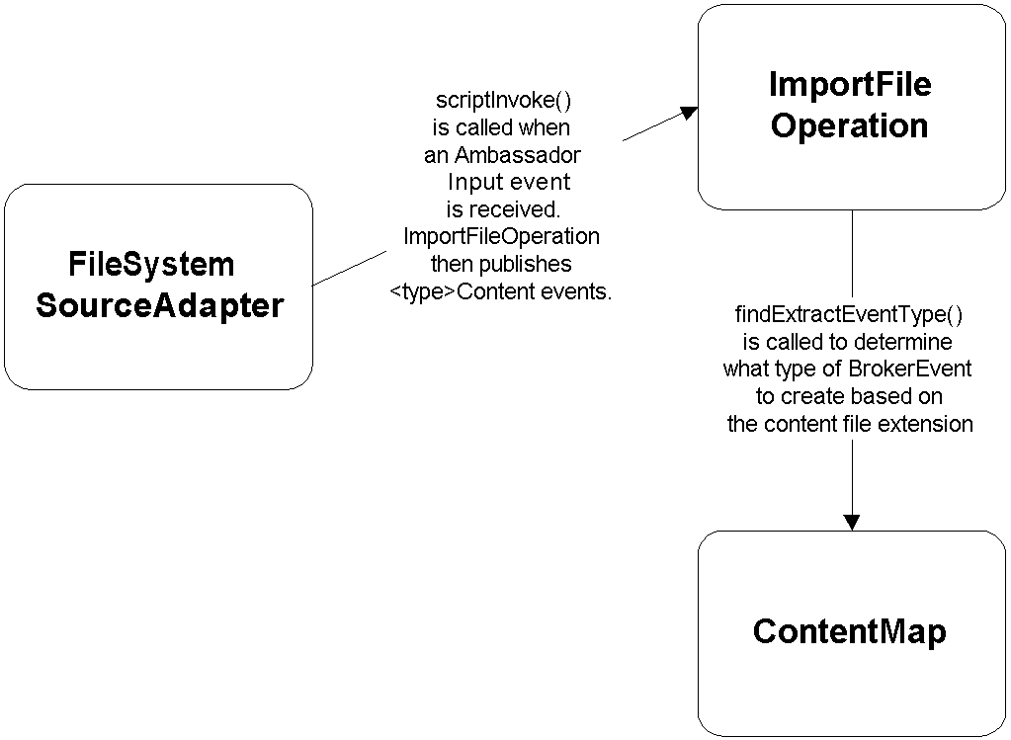
Figure 2: The FileSystemSourceAdapter imports a file.

- ParseExtractAgent
The ParseExtractAgent subscribes to particular <type>Content events (specified through ActiveWorks Configuration) and upon receiving a content event invokes the operation class SimpleParseOperation.

- SimpleParseOperation
The scriptInvoke() method of this class calls its configured Parser. Each instantiation of an ParseExtractAgent’s SimpleParseOperation class will be configured to invoke one particular parser for the type of content it is configured to accept. The Parser will create the DiplomatXML version of the original content.

- <type>Parser
The <type>Parser class (for example HTMLParser) implements the Parser interface.

The Parse/Extract Agents invoke a Parser object that implements the Parser interface. This allows new Parsers to be plugged into the Parse/Extract Agents.

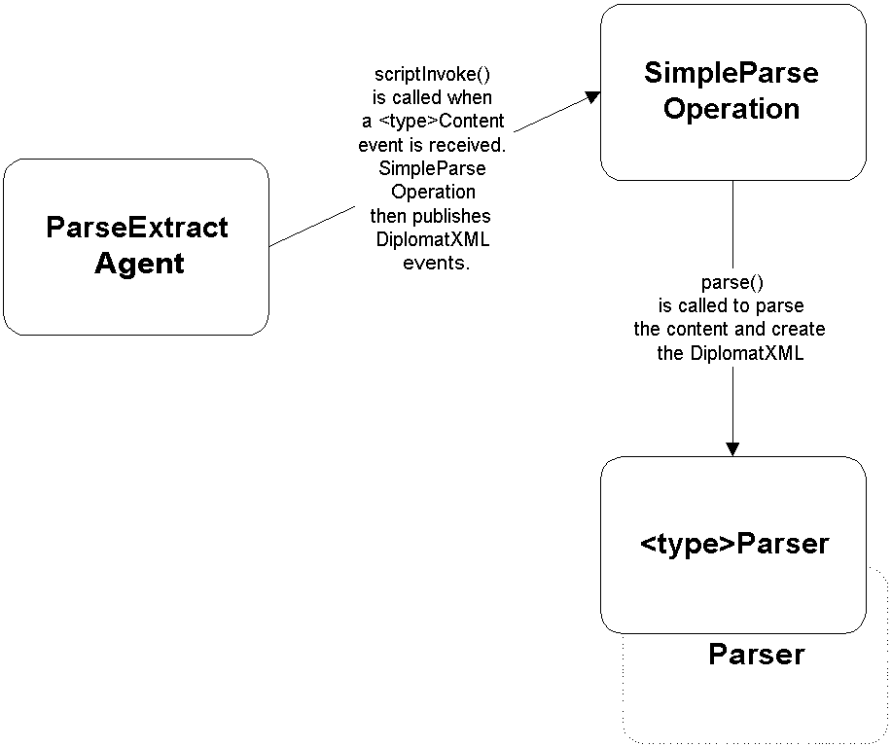
Figure 3: A ParseExtract Agent parses a content event.
- GSATargetAdapter
The GSATargetAdapter is a simple class that extends the Active Intelligent Adapter class. It is associated with one operation class called GSAExportOperation where all the meaningful activity regarding sending DiplomatXML to GSA is handled. When DiplomatXML events arrive, the adapter executes GSAExportOperation.scriptInvoke().

- GSAExportOperation
The scriptInvoke() method of this class invokes a GSA CGI script through a Java URL object so that DiplomatXML can be uploaded to GlobalSight Ambassador.

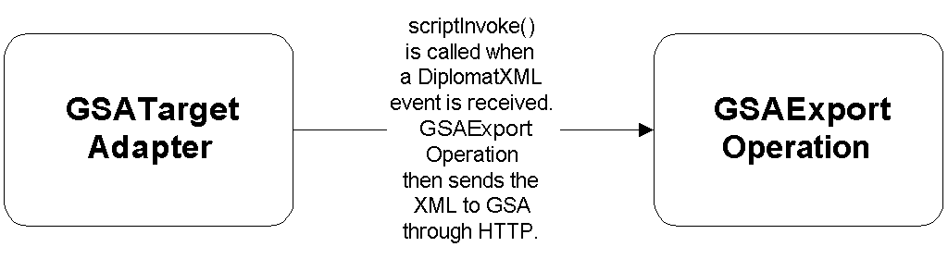
Figure 4: The GSATargetAdapter sends DiplomatXML to GSA through HTTP.

File System Export

Events
When content is exported from Ambassador to the File System, the following events are used:

TrDiplomatXML
DiplomatXML {
String MetaData; /*Data source Metadata in XML*/;
String Data /*the actual content data converted to Diplomat XML*/;
}
When content is sent from the GSA to Diplomat, it is sent as Diplomat XML. This event is generated by the AmbassadorExport broker client. This is a small Java program run by Ambassador executed from a perl script once the user in GSA 2.4 selects what content he want to export. The GSASourceAgent subscribes to these events. The name indicates that this event contains DiplomatXML for content that has already been translated through GSA.

- Tr<type>Content
There are many different content events that differ only in the name of the event itself. This allows different Merge agents to operate on the events based on the name of the event since particular Merge agents will subscribe only to certain content events. These events can be named TrHTMLContent, TrXMLContent, TrJSPContent, etc. One example of a content event is:

TrHTMLContent {
String MetaData; /*Data source Metadata in XML*/;
String Data /*the translated content in Diplomat XML*/;
}

These events contain the translated content as well as the XML metadata about the data source from where the content came.

- FSExport
FSExport {
String MetaData; /*Data source Metadata in XML*/;
Byte[] Data /*the actual translated content data*/;
}
Once a merger has merged the translated content with the skeletons in the Diplomat XML file, it examines the MetaData and determines which event to create so that the appropriate Data Source Target Adapter will pick up the event. FSExport is the export event that gets used in the File System scenario. Other <system>Export events can be defined to indicate other Target Adapters.

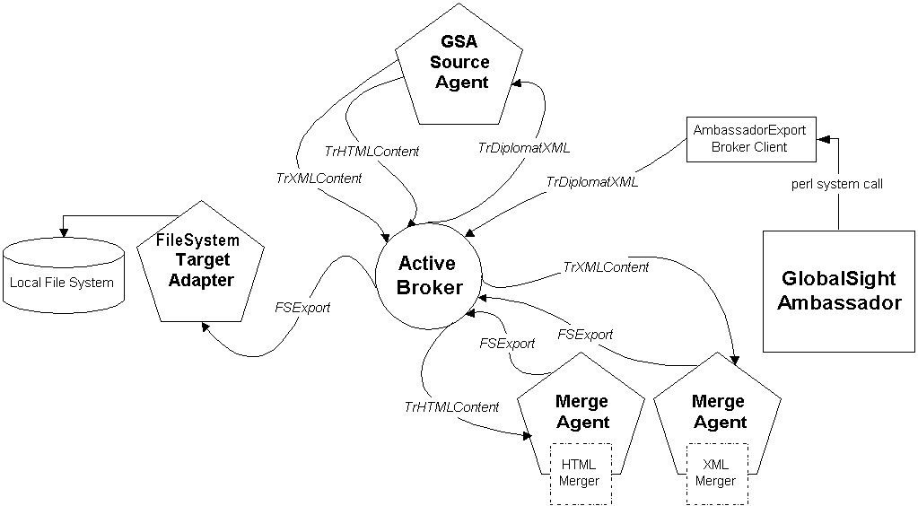
Figure 5: The FileSystemTargetAdapter exports a file.

Objects
The objects involved in the file import scenario include:

- AmbassadorExportBrokerClient
This simple object is used by GSA (launched from a perl system() call) to send a TrDiplomatXML event to the Broker. It expects the name of the translated DiplomatXML file as a command line argument.

- GSASourceAgent
The GSASourceAgent is a simple class that extends the Active Intelligent Adapter class. It is associated with one operation class called MapDiplomatXMLOperation where all the meaningful activity regarding input from the file system is managed.

- MapDiplomatXMLOperation
The MapDiplomatXMLOperation is responsible for accepting a TrDiplomatXML event, and creating the appropriate Tr<type>Content event so that the appropriate Merger Agent can pick up the event.

3. ContentMap
The MapDiplomatXMLOperation class makes the determination of what Tr<type>Content event to send through the help of a ContentMap object. The ContentMap reads in a configuration file (specified at instantiation time) that maps content types to the names of Tr<type>Content Merge events. An example of this file is:

#File System Adapter ImportFileOperation configuration file
#Extension | Content Type | Extract Event | Merge Event
.html | HTML | Diplomat::HTMLContent | Diplomat::TrHTMLContent
.xml | XML | Diplomat::XMLContent | Diplomat::TrXMLContent
.css | CSS | Diplomat::CSSContent | Diplomat::TrCSSContent
.htm | HTML | Diplomat::HTMLContent | Diplomat::TrHTMLContent
.jsp | JSP | Diplomat::JSPContent | Diplomat::TrJSPContent

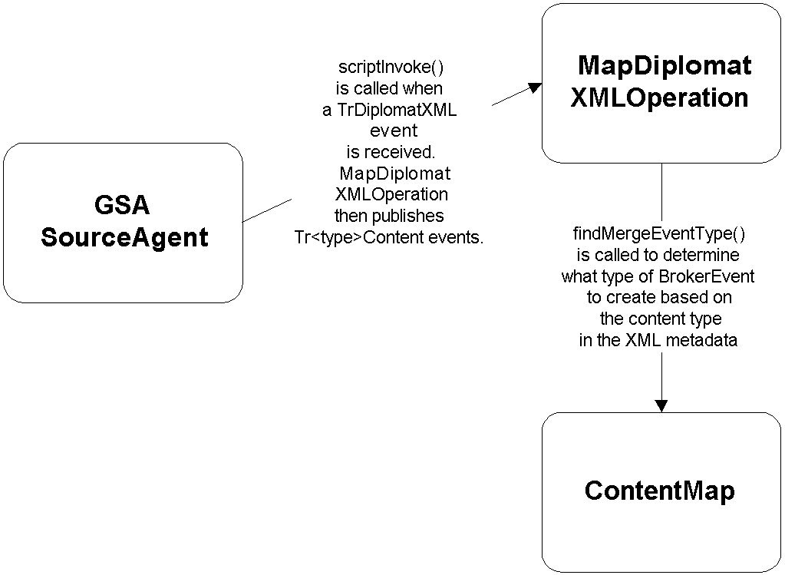
Figure 6: The GSASourceAgent converts a TrDiplomatXML event to the right Tr<type>Content event for merging.

- MergeAgent
The MergeAgent subscribes to particular Tr<type>Content events (specified through ActiveWorks Configuration) and upon receiving a content event invokes the operation class SimpleMergeOperation.

- SimpleMergeOperation
The scriptInvoke() method of this class calls its configured Merger. Each instantiation of a MergeAgent’s SimpleMergeOperation class will be configured to invoke one particular merger for the type of content it is configured to accept. The Merger will create the translated version of the original content from the translated DiplomatXML by combining the skeletons and translatable elements in the Diplomat XML.

- <type>Merger
The <type>Merger class (for example HTMLMerger) implements the Merger interface.

The Merge Agents invoke a Merger object that implements the Merger interface. This allows new Mergers to be plugged into the Merge Agents.

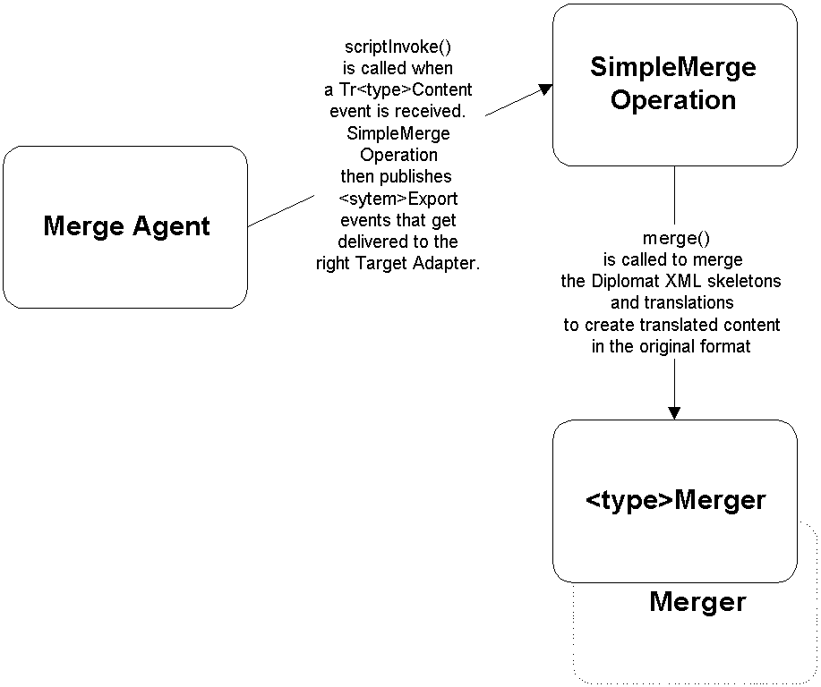
Figure 7: The Merge Agent merges Diplomat XML to translated file content.
- FileSystemTargetAdapter
The FileSystemTargetAdapter is a simple class that extends the Active Intelligent Adapter class. It is associated with one operation class called ExportFileOperation where all the meaningful activity regarding output to the file system is managed.

- ExportFileOperation
The ExportFileOperation is responsible for accepting an FSExport event, and then creating a file in the file system according to the data source metadata and the content contained in the FSExport event (for example, creating the “welcome.html” file in the “es-ES” directory).

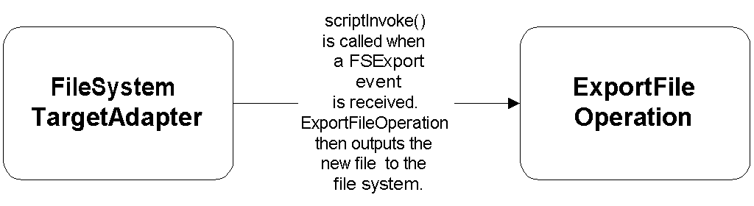
Figure 8: The FileSystemTargetAdapter exports the translated file to the file system.

Diplomat Database Translation Schema
by Scott Phan

Trigger

Table Name: Trigger

Column Name | Data Type | Comment
Trigger_ID | Number(5,0) not null | Primary key
Name | NVarchar2(127) not null | Name of the trigger
Table_Name | NVarchar2(127) not null | Customer’s table
Column_Name | NVarchar2(127) not null | Customer’s column
Primary_Key | NVarchar2(127) not null | Primary key column name
Event | Varchar2(127) not null | Both, Insert, or Update
Record_Type | Varchar2(127) not null | Xml, html, txt, etc …

Association

Table Name: Association

Column Name | Data Type | Comment
Association_ID | Number(5,0) not null | Primary key
Name | NVarchar2(127) not null | Name of association
Trigger_ID | Number(5,0) not null | Foreign key
Job_Template_ID | Number(5,0) not null | Foreign key
Target_Table_Name | NVarchar2(127) not null | New table name
Target_Column_Name | NVarchar2(127) not null | New column name
Record_Limit | Number(5,0) not null | Max records in a xml file
Time_Limit | Number | In seconds

Localization Profile

Table Name: Job_Template

Column Name | Data Type | Comment
Job_Template_ID | Number(5,0) not null | Primary key
Name | NVarchar2(127) not null | Name of L10N profile
Source_Language | Number(2,0) not null | References GSA language

Table Name: Job_Template_Target

Column Name | Data Type | Comment
Job_Template_ID | Number(5,0) not null | Foreign key
Job_Template_Target_ID | Number(5,0) not null | Primary key
Target_Language | Number(2,0) not null | References GSA language
TM_Language | Number(2,0)
Page_TM | Number(1,0)

Table Name: Job_Template_Routing

Column Name | Data Type | Comment
Job_Template_Target_ID | Number(5,0) not null | Foreign key
Stage | Number(2,0) not null
Seq_uence | Number(2,0)
User | Number(5,0) | References GSA Users
Duration | Number(5,0) | Working days per stage

Relationships
Job_Template_Routing
Job_Template
Job_Template_Target
Job_Template_Target
Trigger
Job_Template
Association
Job_Template_Routing
Job_Template_Routing
Job_Template_Routing

Translation Queue

Table Name: Translation_Queue

Column Name | Data Type | Comment
Translation_Queue_ID | Number(10,0) not null | Primary key
Primary_Key | Number(10,0) not null | Customer table’s primary key
Table_Name | NVarchar2(127) not null
Column_Name | NVarchar2(127) not null
Content | NCLOB | The data being translated

Architecture

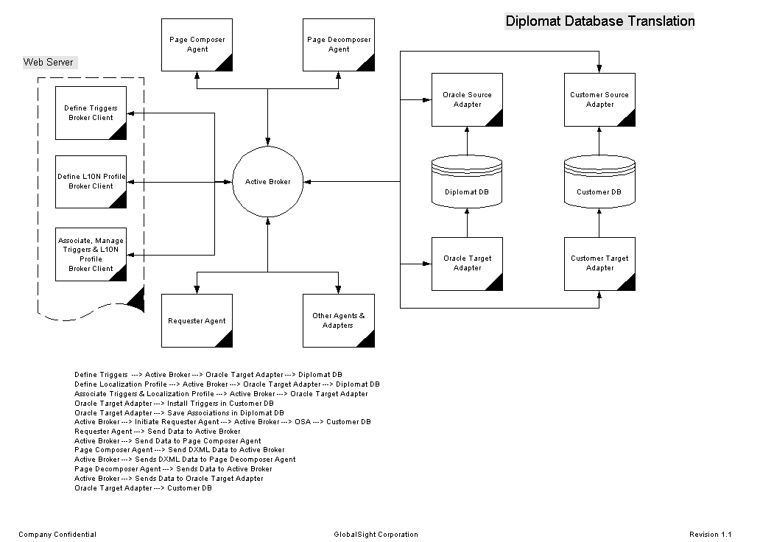

Dynamic Jobs Summary with Instant Preview

- The trigger populates the translation queue table with the following data:
  - Select sql for retrieving the data
  - Insert sql or pl/sql for adding new data records
  - Update sql or pl/sql for updating records
  - Data types for each column – some ID number to another table
  - Localization Profile
  - Database connect string
  - URL for previewing – This URL will allow us to query the web application and build a page to view the segment in context.
  - Table name for each column – some ID number to another table
- The requester agent composes the records into pages and sends the data to the extractor
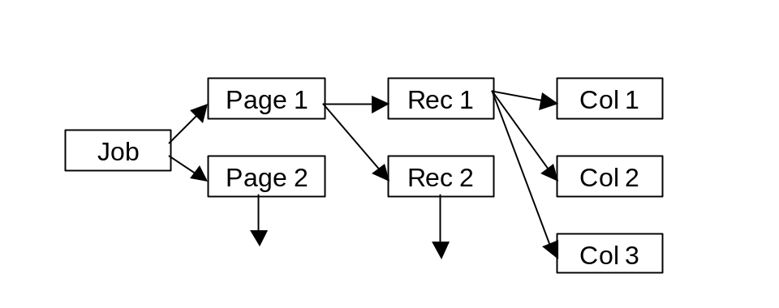
- The extractor converts the pages into Diplomat XML and sends it to Ambassador
- Ambassador creates a job for these pages
- The translation workstation displays the pages grouping columns belonging to the same records together.
[MyBikeName]
[My bike description.]
[MyBikeName]
[My bike description.]
[MyBikeName]
[My bike description.]
Row 1
Row 2
Row 3
Preview
Preview
Preview

- The following transaction takes place when a user clicks on the preview button
  - A new window is created sending the data to a servlet running in Diplomat.
  - The merge agent converts the data from Diplomat XML to its original form
  - A preview component writes the data into the customer database
  - A URL (defined in the trigger) that will provide record (segment) context is passed to the new window.
- Eventually the job is finished and a similar process occurs

Assumptions and Concerns

- PSO has to write very complex triggers
- All columns in the translation queue are translatable
- Items are view as list of segments not in context
- There’s an unknown lag time after the user clicks on the preview button
- Cannot preview a single column, only the record the column belongs to
- We need to distinguish between dynamic pages (preview) and static pages
- A staging database is required or else workflow is irrelevant
- Can we send snippet Diplomat XML back to the merger in step (6b)
- Diplomat retrieves and writes to the same DB

