Dynamic Jobs Summary with Instant Preview

- The trigger populates the translation queue table with the following data:
  - Select sql for retrieving the data
  - Insert sql or pl/sql for adding new data records
  - Update sql or pl/sql for updating records
  - Data types for each column – some ID number to another table
  - Localization Profile
  - Database connect string
  - URL for previewing – This URL will allow us to query the web application and build a page to view the segment in context.
  - Table name for each column – some ID number to another table
- The requester agent composes the records into pages and sends the data to the extractor
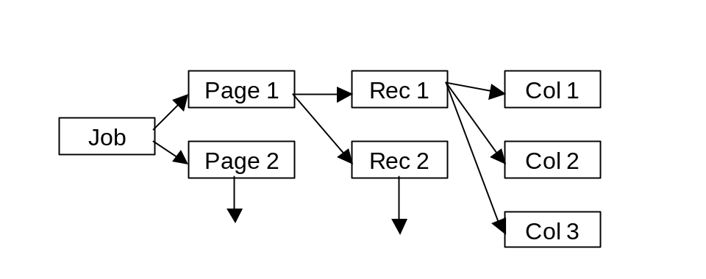
- The extractor converts the pages into Diplomat XML and sends it to Ambassador
- Ambassador creates a job for these pages
- The translation workstation displays the pages grouping columns belonging to the same records together.
[MyBikeName]
[My bike description.]
[MyBikeName]
[My bike description.]
[MyBikeName]
[My bike description.]
Row 1
Row 2
Row 3
Preview
Preview
Preview

- The following transaction takes place when a user clicks on the preview button
  - A new window is created sending the data to a servlet running in Diplomat.
  - The merge agent converts the data from Diplomat XML to its original form
  - A preview component writes the data into the customer database
  - A URL (defined in the trigger) that will provide record (segment) context is passed to the new window.
- Eventually the job is finished and a similar process occurs

Assumptions and Concerns

- PSO has to write very complex triggers
- All columns in the translation queue are translatable
- Items are view as list of segments not in context
- There’s an unknown lag time after the user clicks on the preview button
- Cannot preview a single column, only the record the column belongs to
- We need to distinguish between dynamic pages (preview) and static pages
- A staging database is required or else workflow is irrelevant
- Can we send snippet Diplomat XML back to the merger in step (6b)
- Diplomat retrieves and writes to the same DB

