Illustrator Adapter Installation Guide

TABLE OF CONTENTS

Part I: Install Illustrator Converter as Windows Service 2
Addition Software For Converters 2
Install Illustrator Converter Service 2
Uninstall Illustrator Converter Service 9
Part II: Install Illustrator Adapter In Ambassador 11
Install Ambassador 11
Configure Illustrator Adapter in Ambassador 13

Part I: Install Illustrator Converter as Windows Service

Addition Software For Converters
- Microsoft DotNet Framework v2.0.50727
(download form: http://www.microsoft.com/downloads/details.aspx?FamilyID=0856eacb-4362-4b0d-8edd-aab15c5e04f5&DisplayLang=en)
- Adobe Illustrator CS2

Install Illustrator Converter Service
1. Extract “conv_Illustrator.zip” to get two installing files: “IllustratorConverterSetup.msi” and “setup.exe”.
2. Double click the file “setup.exe”, and the install wizard will pop up.

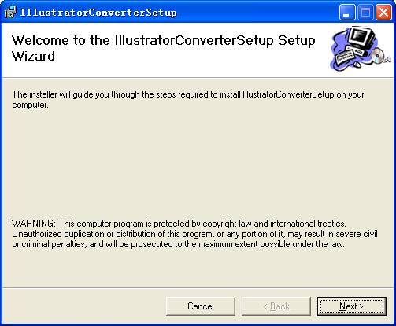
3. Click “Next” to select installation folder.

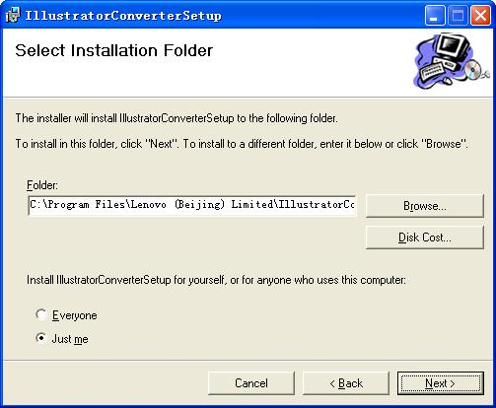

4. Click “Next” to confirm the installation.

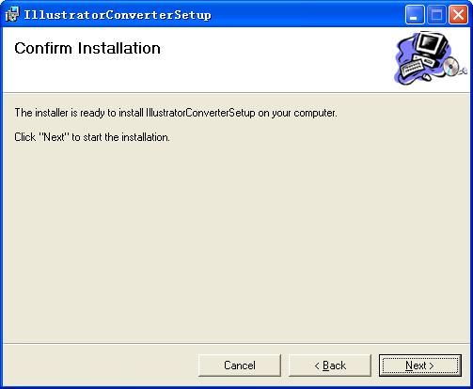

5. Click “Next” to start the installation.

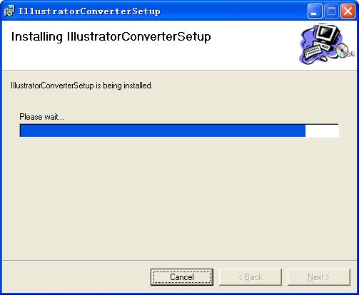

6. Click “Close” to finish the installation.

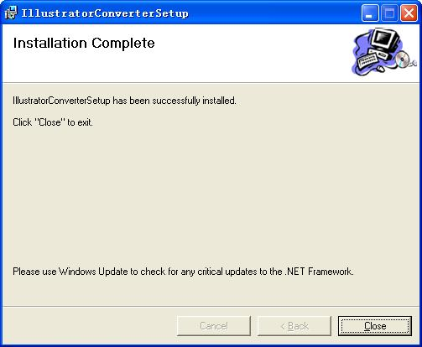

7. Go to desktop, and click “start” ---- > “All programs” --- > “GlobalSight Illustrator Converter” --- > “Install Service” to register the Illustrator converter as a Windows Service.

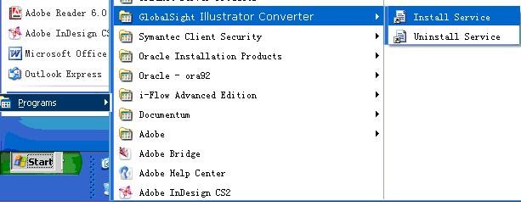

8. A command window will pop up to show that the installation is fininshed successfully.

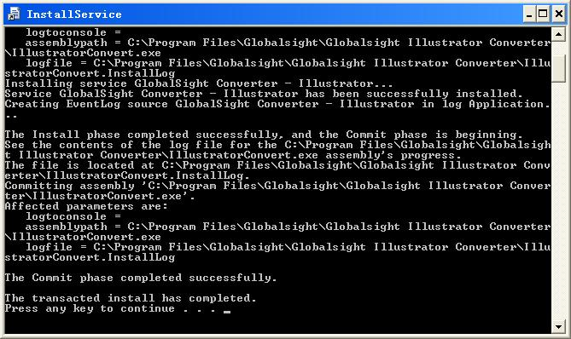

9. Open Windows Service to find the “GlobalSight Illustrator Converter”. Select the service “Globalsight Converter --- Illustrator” and right click on it.

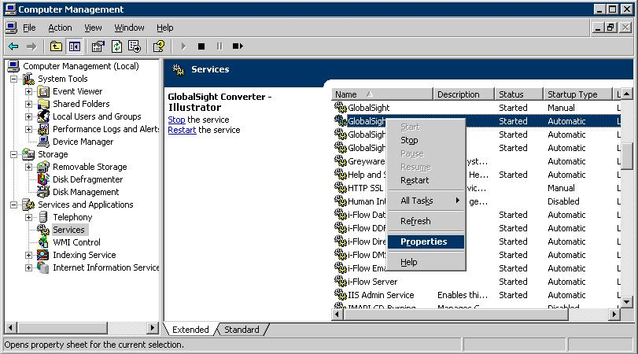

10. Select “properties” to pop up the window. Click the “Log on” page.
Note：Be sure to check the checkbox “Allow service to interact with desktop”, or Illustrator Converter will not work.
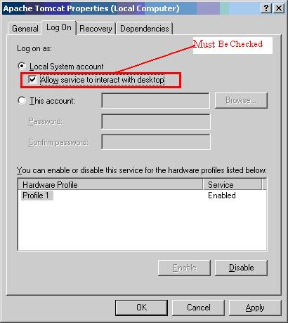

11. Close Adobe Illustrator CS2 application if it was opened by someone else.
12. Start the service.

Uninstall Illustrator Converter Service
- Stop the service.
- Go to desktop, and click “start” ---- > “All programs” --- > “GlobalSight Illustrator Converter” --- > “Uninstall Service” to remove the Illustrator converter Service.
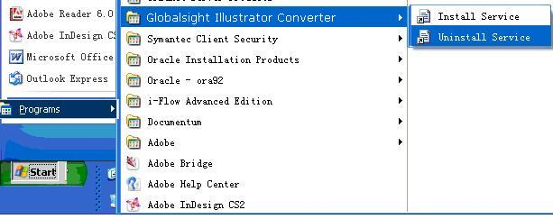

- Open the “Control Panel” to select the “Add or remove program” item. Then select “GlobalSight Illustrator Converter” to remove it.

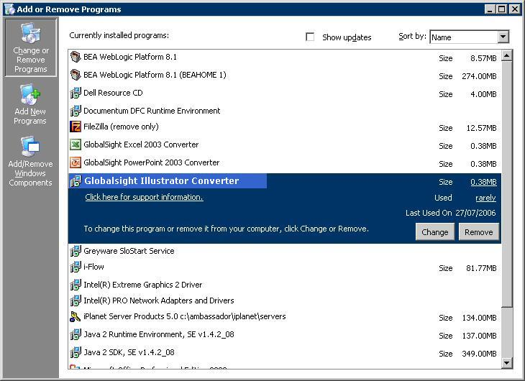

Part II: Install Illustrator Adapter In Ambassador

Install Ambassador
When installing Ambassador, following two items need to be paid more attention:

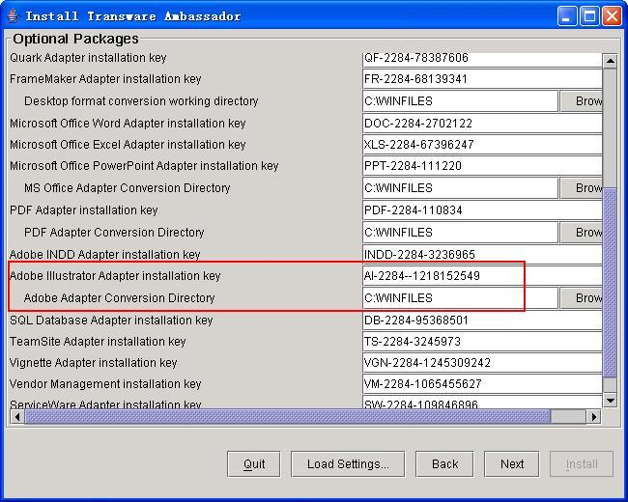

Illustrator Adapter Installation Key should be: “AI-2284--1218152549” and the character is case sensitive.
Adobe Adapter Conversion Directory, this directory is used to store the temporary files which will be converted by Adobe Converters such as INDD Adapter and Illustrator Adapter. The default path is “C:\WINFILES”. If this path is changed, for example, it was changed to “D:\ADOBE_CONV_DIR”, the corresponding value in “window regedit” also needs to be changed from “C:\WINFILES” to “D:\ADOBE_CONV_DIR”, or the Converter can not work. The regedit key is: “My Computer\HKEY_LOCAL_MACHINE\SOFTWARE\Globalsight”. Take IllustratorConvDir as an example.

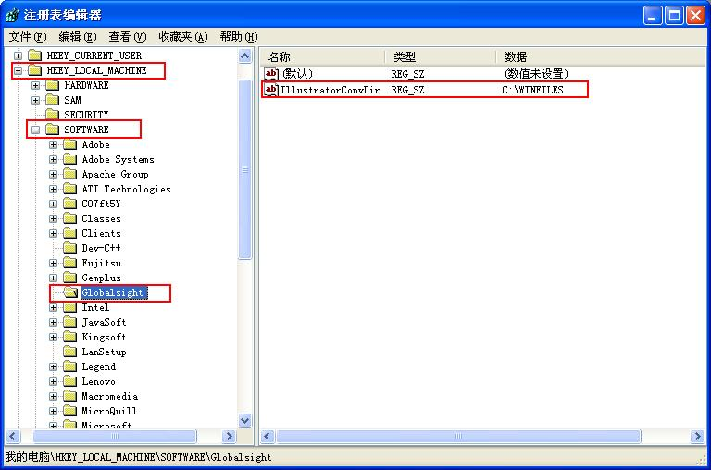

Configure Illustrator Adapter in Ambassador
1. Max Waiting Time
This parameter can be configured in following file:
<Ambassador_home>\deployment\ambassador.ear\lib\classes\properties\AdobeAdapter.properties. This parameter means the max time that Ambassador will wait for the Adobe Converter to convert from adobe format file to xml file or vice versa. The default value of this parameter is “60” minutes, that is to say, if the Adobe Converter can not convert from an adobe format file to an xml file successfully in an hour ( 60 minutes), Ambassador will not wait for the conversion any more, but think the conversion has failed.

2. Prepare to run Ambassador.
2.1) Edit the updateDB.bat. Modify the username, password and sid_host to those of the oracle
instance you are using.
2.2) Double click updateDB.bat to run the script.

3. Create the Illustrator file extension “ai” in Ambassador
3.1) Log in Ambassador as the company admin
3.2) Go to “Data Souces” -> “File Extensions”. Click “New” button, input ai in the text filed and click “Save” button.

