High Level Design for
GlobalSight Automatic Action for Crowdsight

Permission Groups:

Add Automatic Action in Permissions.
Enable it by default for Administrator permission group

If the permission is enabled, it will show:

Automatic Actions Setup:

Allow "Remove", "Edit", "New" function. Also, Select All, Clear All.

"New" and "Edit" will show
Automatic Action Name:
Email Address:
Description:

"Cancel" "Save"

Automatic action name, email address, description
ie Crowdsight_SFO, annie.lin@welocalize.com, CS_SFO Admin

Work to do:
Add permissions for “Automatic Action” like below:
Setup
Automatic Action
Remove
Edit
New

Add one table in db to save action info.
ID
AUTOMATIC_ACTION_NAME
EMAIL_ADDRESS
DESCRIPTION

Implementation: jsp files, handlers, hibernate xml, DAO etc.

Estimated Time: 3 days
Activity Type:

Add Type selection for "Automatic Action" for all Activity Types
- Translate
- Review (Editable)
- Review Only
- Automatic Action
(Can only pick one)

If Automatic Action is selected, they will be selection to ask user to pick which Automatic action (from Automatic Action Setup) to use

Note: It is recommended to create new Activity Type for "Automatic Action" type instead of modifying existing Activity Type.

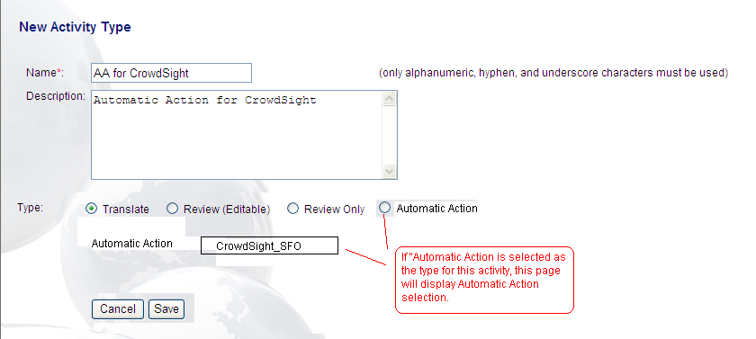

Work to do:
Jsp UI changes.
Add one column “AUTOMATIC_ACTION_ID” to save automatic action info if this activity’s type is specified as “Automatic Action” type.
Estimated Time: 2 days

Workflow:

When creating workflow, if the "Activity" selected is set for Automatic Action, the "Participant(s)" selection will also listed the name of the Automatic Action name ie Crowdsight_SFO

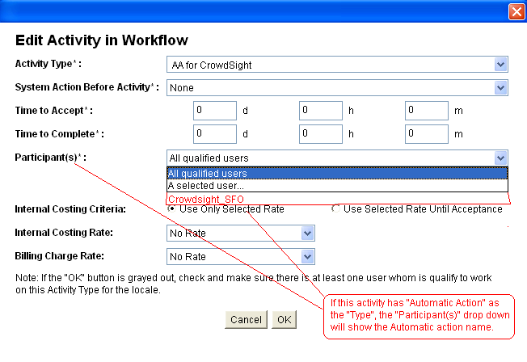

Note: For Automatic Action type of Activity, only one user can be assigned.
If this Activity has more than one users association, then the activity can't be saved. A error message should be displayed if "no user" or "multiple users" are associated to this activity.

Work to do:
Applet changes.

Add restrictions:
- When “Activity Type” is set to an activity whose type (“TYPE” column in “activity” table) is “AUTOMATIC_ACTION”, the “Participant(s)” should only show the activity’s automatic action, others won’t be shown.
- When click “OK” button, judge if there is at least one GlobalSight user is attached to this activity. If not, workflow is not allowed to save. This will make sure there is at least one user can receive mails, get translated xliff files from CS and upload them to GS for updating.

The attached user(s) will receive mails from CrowdSight. When the user receives mails from CS, the user will get the translated xliff files to upload to GS to finish the activity.
But the question is that if there are more than one users are attached to the activity, CrowdSight should send mails to all the available users? Or we should limit to only one user to an automatic action activity?

Estimated Time: 2 days

Use case:

- Create an Automatic Action for CrowdSight.
- Automatic Action Name: Crowdsight_SFO
- Email Address: annie.lin@welocalize.com
- Description: Automatic Action for sending translation content to Crowdsight admin

- Create an Activity Type for CrowdSight.
- Activity Type: AA_for_CrowdSight
- Set type to "Automatic Action"
- Select Automatic Action name of "CrowdSight_SFO"

- Assign the Activity type to a user's role (per locale). In this case, the Activity "Type" is Automatic Action, only one user can be assign.

- Create a workflow and select Activity Type that is setup for Automatic Action. In the Participant drop down, it should only show Automatic Action name. GS will also check to make sure only one user is associated to this activity for this locale.

When the workflow is at the activity set for Crowdsight automatic action, GS will zip up the xliff package (all the xlf files in xliff 1.2 format and annotation option). GS will save the zip file in a location and send the link via email. The email is already set in the Automatic action setup.

Zip file saving location in GlobalSight:
C:\GlobalSight\jboss\jboss_server\server\default\deploy\globalsight.ear\globalsight-web.war\_Exports_\<company_name>\

The zip file should have job name and target locale information like <job_name>_<target_locale>.zip, ie abc1234_de_DE.zip

The email will also indicate the GS username for downloading the zip file.

User who received the email will click the link to downlaod the zip file.

Authentication may be required.

Once the zip file is downloaded, user can upload the zip file to Crowdsight for translation and review.

The translation(Tm data only, no translation unit variant info) will be saved directly to GS TM via webservices API.

Once GlobalSight user has the exported zip file from Crowdsight, the user will login to Globalsight and go to "My Activities" to find the activity. Once in the activity, the Globalsight user can then upload the zip file back to GlobalSight. This will populate the translation_unit_variant table rows for this job. This is needed to create the ourput of the translated file.

Work to do:
Export files to xliff zip file which is related with Locale, Activity. Note that user info who has role of this activity should be added to every xliff file. (2 days)

Add link to mail sender. (I guess Walter need more time to research to know all places he must change.). (2 days)

How to download the file via link? (2 days)

Estimated Time: 6 days

So I estimate all the time we need is 13-15 man-days, about 3 weeks.

What CrowdSight need to do?

[Don] Once all the segments are translated in Crowdsight, Crowdsight will export them into a zip file (contains xlf files) and send an email (with link) to GlobalSight user whose info is transferred in xliff files.

Crowdsight requirement: Will need Crowdsight send an email with link so the GlobalSight user can click the link and download the zip file.

