Ambassador–Documentum Adapter
Overview
The Ambassador-Documentum Adapter was developed to provide seamless integration between Ambassador and Documentum (Webtop). The users of Webtop can initiate translation jobs and receive translated documents without leaving their Webtop workspace. Translation activities are completely managed by Ambassador and transparent to Webtop users.
Development Process
Requirement Analysis
Requirements were communicated through face to face meetings, Business Requirement Document, conference calls and emails. The deliverable of this phase was an Architectural/Functional Design Specification.

Technical Design, Implementation and QA
After the Architectural/ Functional Design Specification was accepted by the client, a Technical Design Specification and a Test Plan were produced and reviewed internally by the project Architect. All the implementation and QA work was handled by the development team without the client’s involvement. The project was broken down to 2 iterations. The first iteration covered the essential features. The second iteration covered the remaining (advanced) features.

Functionality and Design
Interaction Model
The Webtop Plug-in, once installed, adds a custom Ambassador menu to Webtop. A user can submit to Ambassador source documents for translation via a simple dialog. The translated documents are transferred back to Webtop automatically once the translation jobs are complete.

The following diagram illustrates the interaction model:

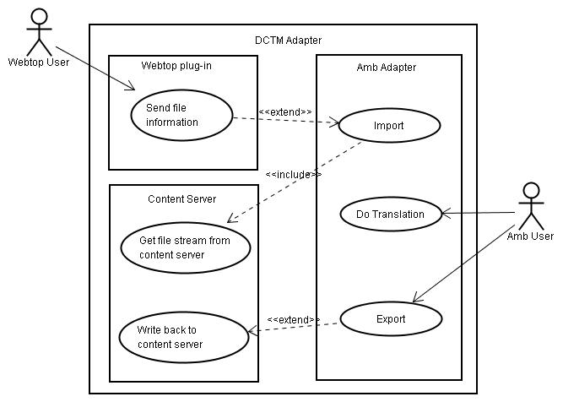

Architecture
The Ambassador-Documentum Adapter consists of two components:
- Documentum Webtop Plug-in
- Ambassador Adapter

The Webtop Plug-in is implemented as a custom Webtop Component. In addition to providing custom UI for submitting documents for translation, it also handles communication with Ambassador via Web Services. The Ambassador Adapter handles communication between Ambassador and Documentum (Content Server). The following diagram shows the solution architecture:
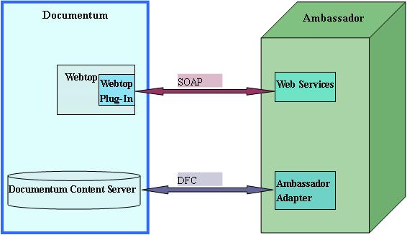

Feature List
- Document content and metadata translation
- Configurable target language set based on the type and the folder of the source document
- Source document lock-down during translation
- Translation job cancellation
- Automatic write-back of translated documents
- Relationship tracking between source documents and translated documents

