
www.globalsight.com

GlobalSight DesktopIcon
User guide for
Connect to CVS
Open source initiative user guide for Connect to CVS

A user guide of Connect to CVS

Table of Contents
Overview 3
Prerequisites 3
Connection to CVS 4
CVS Configuration 5
1. Authentication 5
2. Create Repositories: 6
3. Add Module 9
4. Module Mapping 13
5. Submit to Create Job 25

Overview

Connect to CVS is a newly-added function in GlobalSight version 7.1.4 and 7.1.5. It allows to connect to a CVS repository, get contents from CVS server, CVS module mapping and submit to create job to GlobalSight and then update contents back to CVS server.

“Connect to CVS” is available at submenu of “Jobs” menu. User login to DesktopIcon must have “Connect To CVS” (under “Data Sources” item in Permission Group) enabled.

Prerequisites
You must have WINCVS installed. GlobalSight server must be running release 7.1.5 or later.

Connection to CVS

“Connect to CVS” appears at submenu of “Jobs” menu, after check/enable “Connect To CVS” permission under “Data Sources” item in Permission Group.

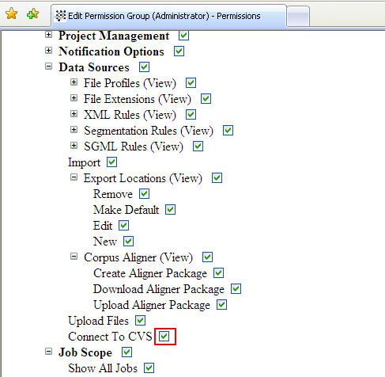

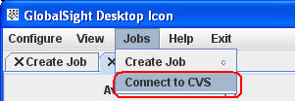

CVS Configuration

Authentication
Click on the Authentication tab
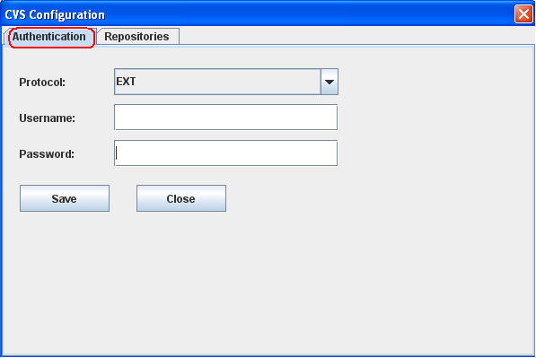

Choose Protocol, enter the Username and Password in Authentication menu, and click
“Save” button.

Example:
Prorocol: PSERVER
Username: globalsight
Password: <password for the CVS user>

Create Repositories:
- Click on the Repositories tab.

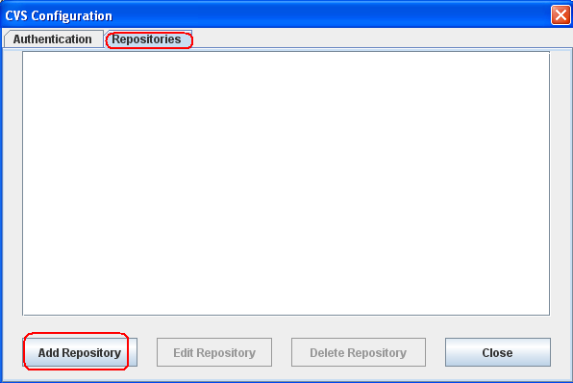

- Click “Add Repository” button.

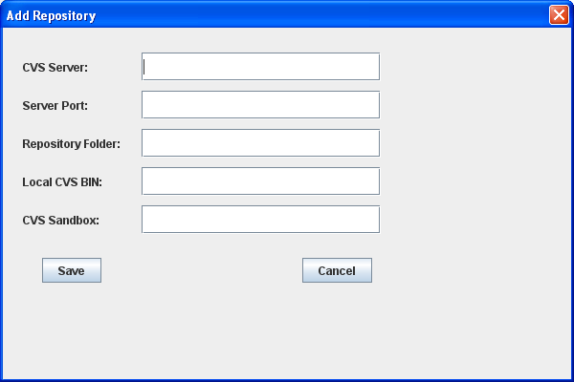

Fill out CVS Server, Server Port, Repository Folder, Local CVS BIN, CVS Sandbox, and click the “Save” button.

CVS Server is the IP address or hostname of CVS server.

Server Port is the port of CVS server. 2401 is the default port number for PSERVER protocol, 22 is the default port number for EXT protocol.

Repository Folder is the storage location which contains the modules CVS server manages.

Note: Make sure you have installed CVSNT on your local computer.

Local CVS BIN is the path of cvs.exe, ie C:\Program Files\CVSNT.

CVS Sandbox is the path of your local folder/directory where you want to checkout.

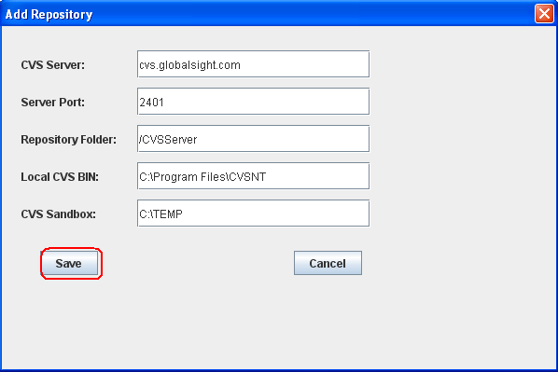

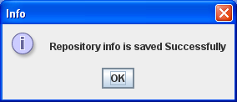

A Repository is displayed as:
:pserver:globalsight@cvs.globalsight.com:/CVSServer;C:\TEMP;C:\Program Files\CVSNT

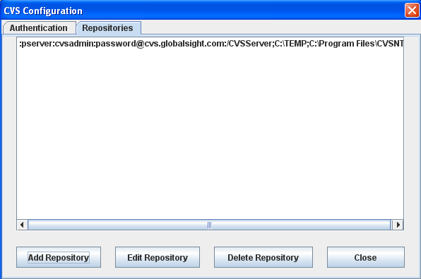

Edit or Delete Repository by clicking “Edit Repository” or “Delete Repository” button.
Click the "Close" button to close the CVS Configuration.

Add Module

- Invoke Add Module menu by Click “Add Module” button.

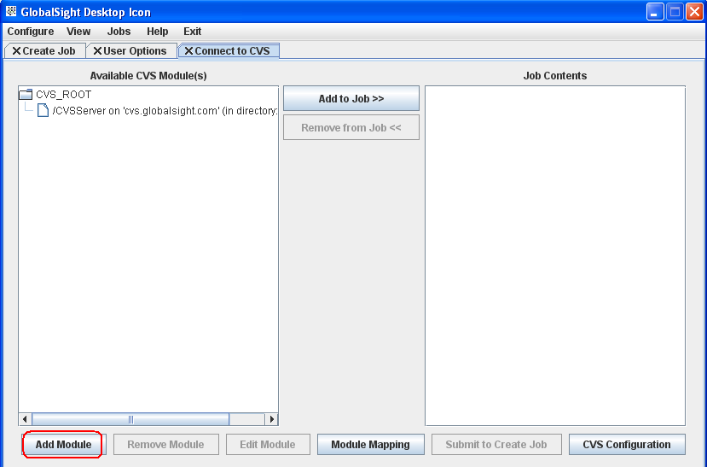

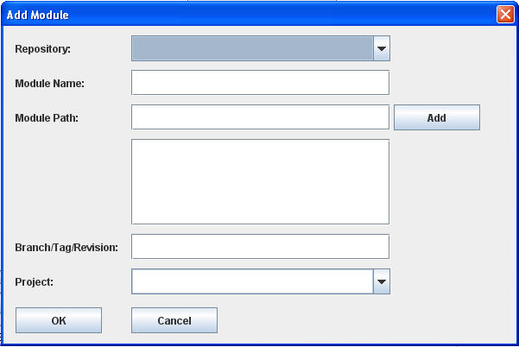

Select newly-added Repository and fill out Module Name.
Fill out valid Module Path and click “Add” button. Adding multiple Module Paths is supported.
Fill out Branch/Tag/Revision. Fill out Project or select project if project(s) is available.

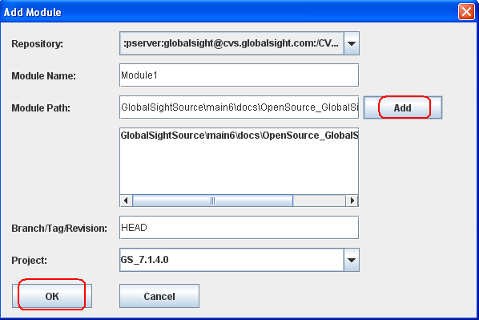

An example of Module setting:

Repository: :pserver:globalsight@cvs.globalsight.com:/CVSServer;C:\TEMP;C:\Program Files\CVSNT
Module Name: Module1
Module Path: Globalsightsource\main6\docs\OpenSource_GlobalSight\User Guides
Branch/Tag/Revision: HEAD
Project: GS_7.1.4.0

“CVS Working Output” window will appear automatically after click “OK” button.
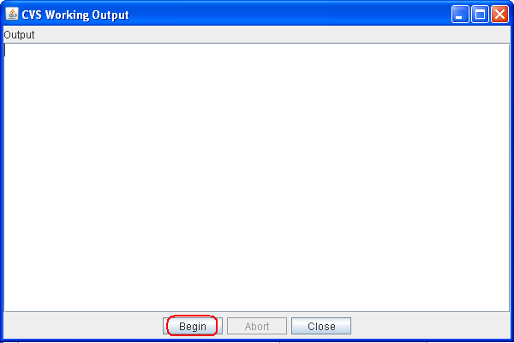

Click on "Begin" button to begin Checkout of files. You can cancel the CVS Output by clicking the “Abort” button.

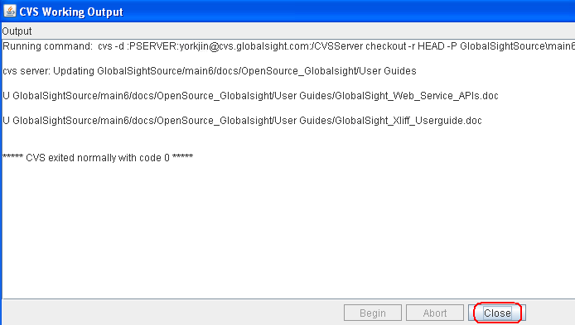

In this example, two doc files have been checked out from CVS server.
Click on "Close" to close the current window.

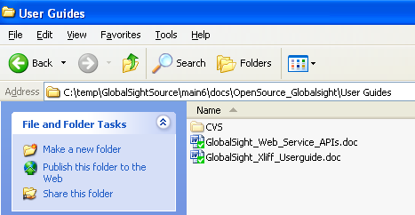

To check out the Module1 again, high light the "Module1" and click on "Edit Module" button.

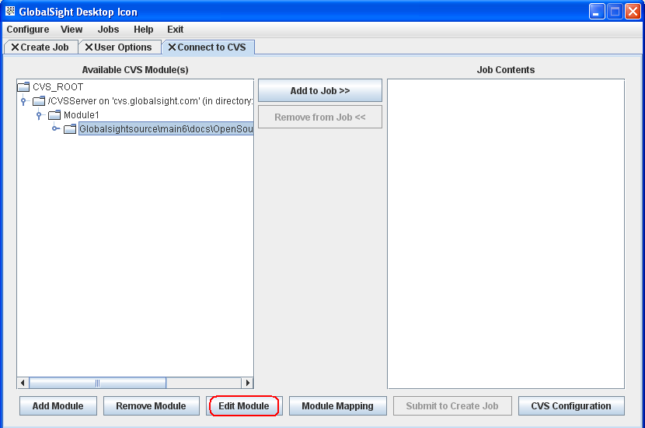

Module Mapping
You can map a directory or file name rule to a module on the CVS server, so that when a job was exported, the file will be uploaded to the specific target module automatically.

Invoke Module Mapping function by clicking the “Module Mapping” button.

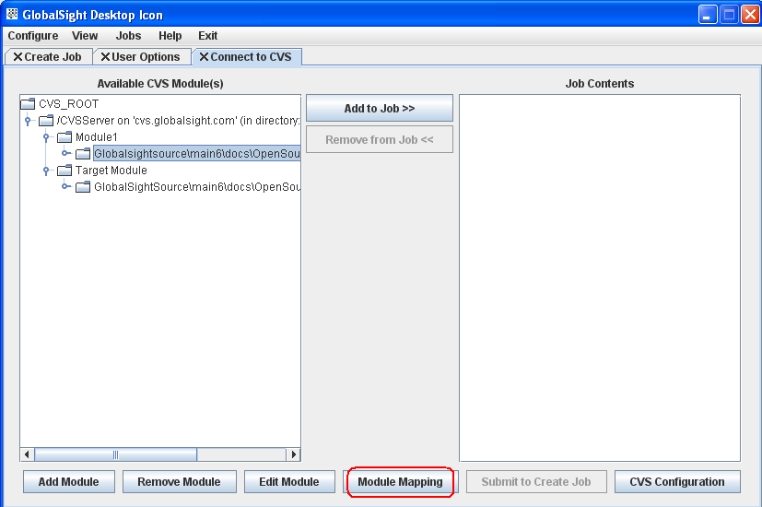

Module Mapping dialog window :

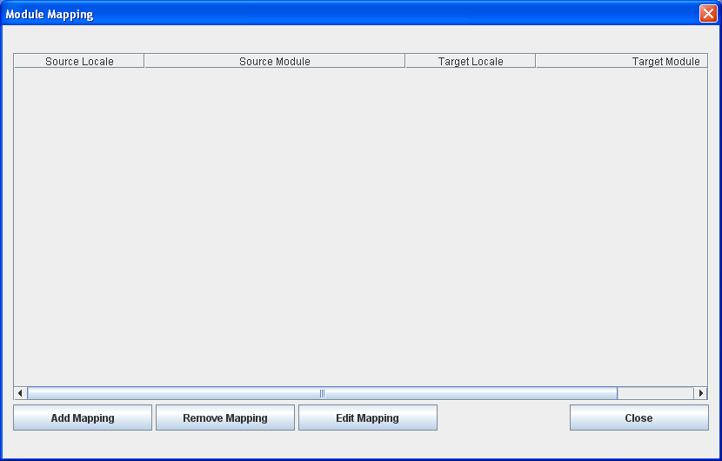

Source Locale: Locale of source file
Source Module: Path of source file in CVS server
Target Locale: Locale of target file
Target Module: Target directory in CVS server, which stores the final localized files from the exported jobs.

Use the Add Mapping, Edit Mapping and Remove Mapping dialog boxes to add new, edit or delete existing module mapping on the CVS server.
- Add Mapping
Click “Add Mapping” button to invoke “Add Module Mapping” window

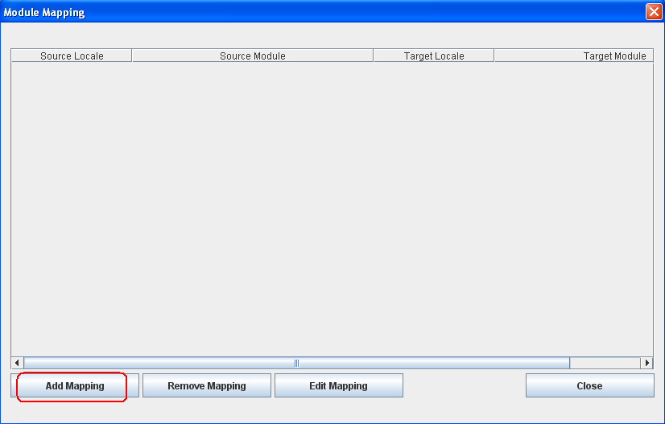

Click “Select Source Module…” button to choose the source module directory

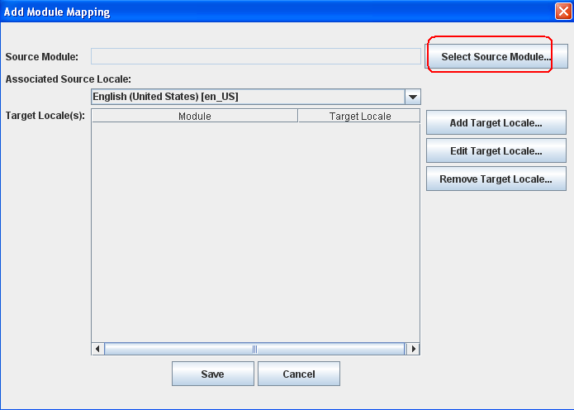
Such as: \GlobalSightSource\main6\docs\OpenSource_GlobalSight\User Guides. Then click OK in Select Source Module dialog.

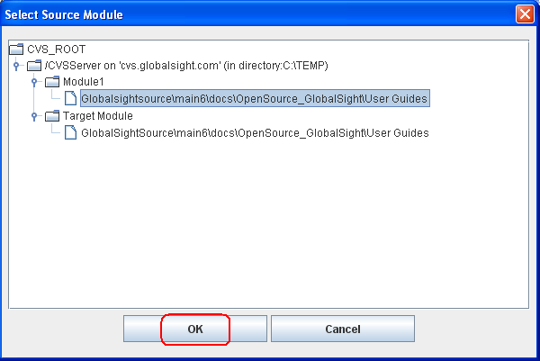

Choose the Associated Source Locale in Add Module Mapping window, for example, English (United States) [en_US]

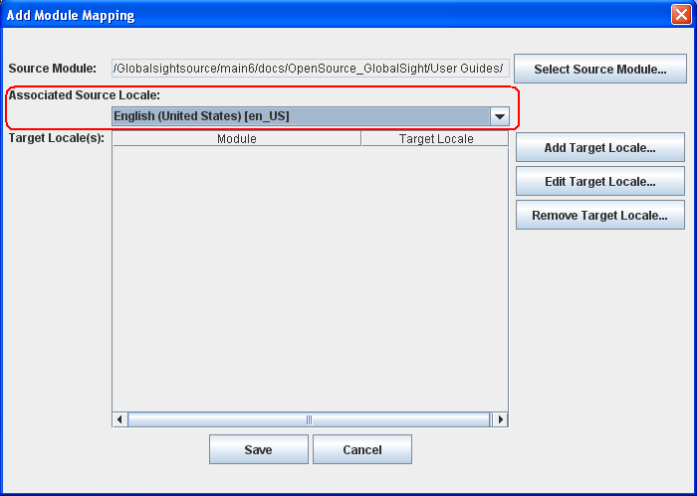
- Add Target Locale
Click “Add Target Locale…” button to add the info of target module:

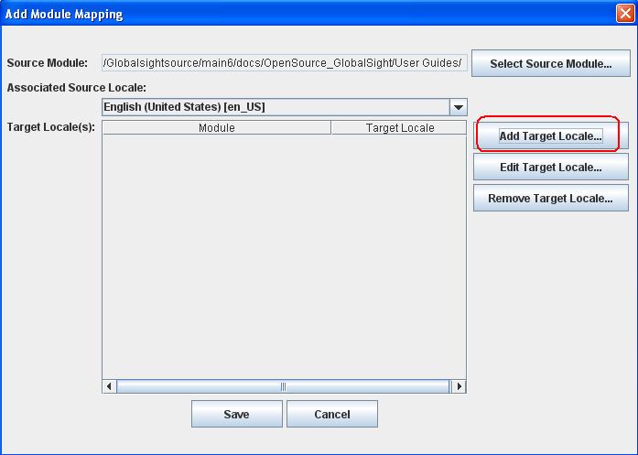

Click “Select Target Module…” button to choose the target module in Select Target Module window

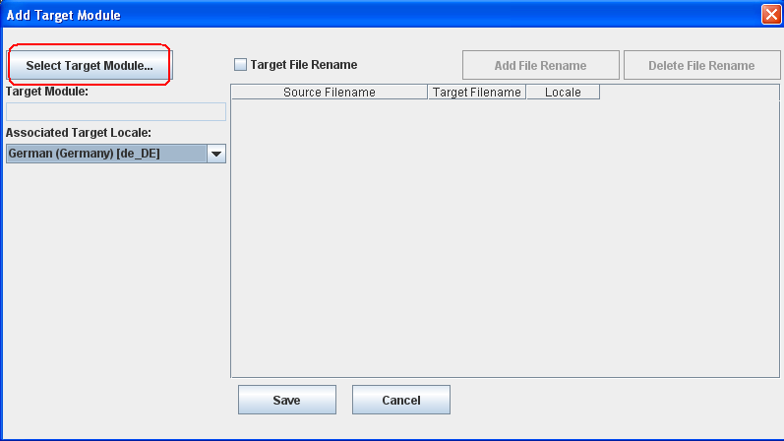

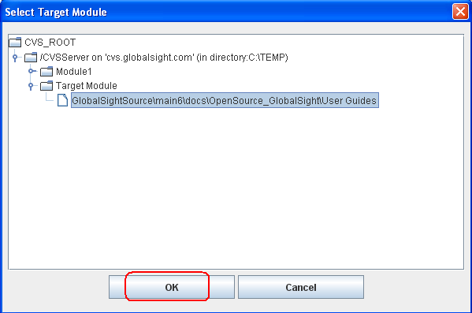

Click OK.

Then select the “Associated Target Locale”, eg, German (Germany) de_DE

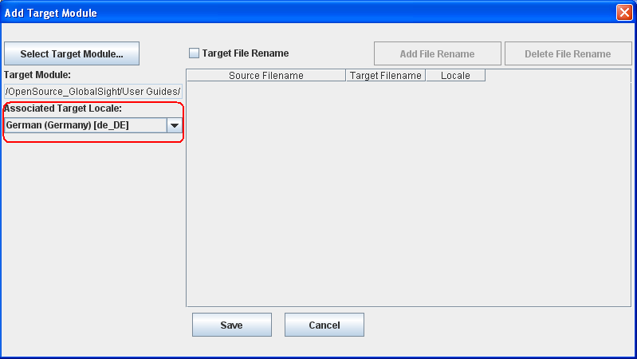

If you want to change the target file name when updating to CVS server, check “Target File Rename”, and click “Add File Rename” button to identify the rename rule. Click Save to add the file rename rule.

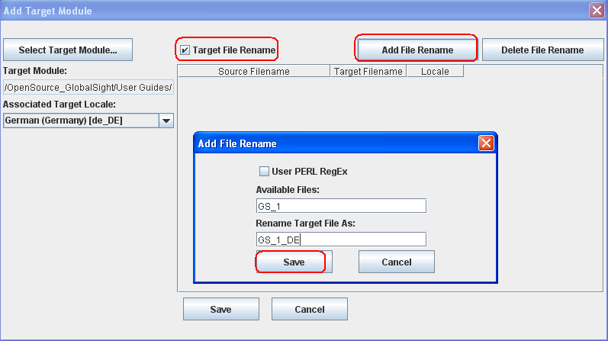

Or you could also choose to use PERL Regular Expression style in Add File Rename dialog:

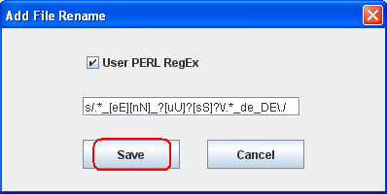

Click Save to add the file rename rule to the list.

Click Save in Add Target Module.
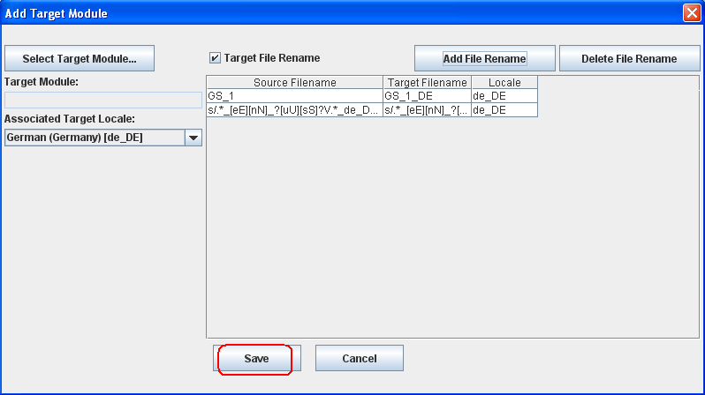

Then the target module info shows in “Add Module Mapping” window.
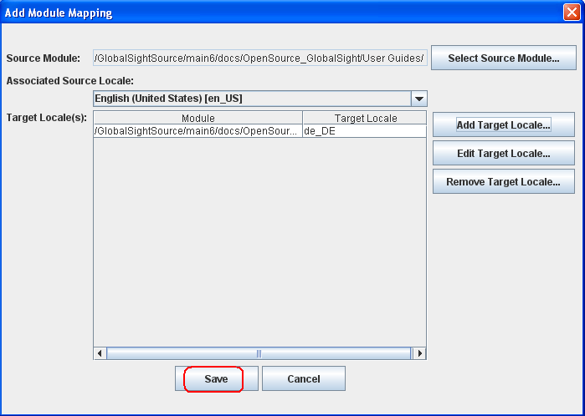
Click Save.

- The mapping info displayed in “Module Mapping” window:

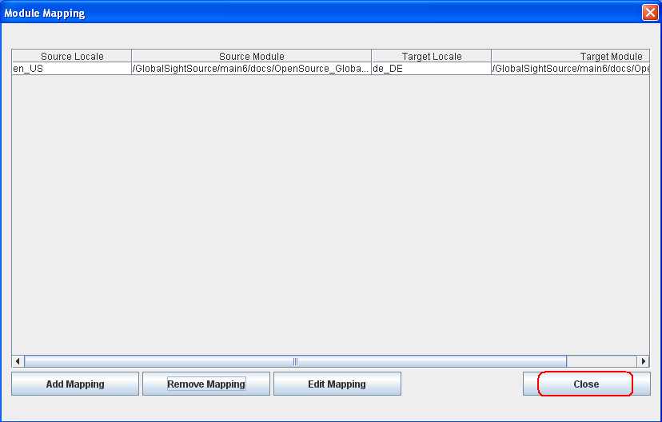

Click Close.

- Edit Target Locale
If you want to change the saved target file info, just select the record in the list and click “Edit Target Locale…” button.
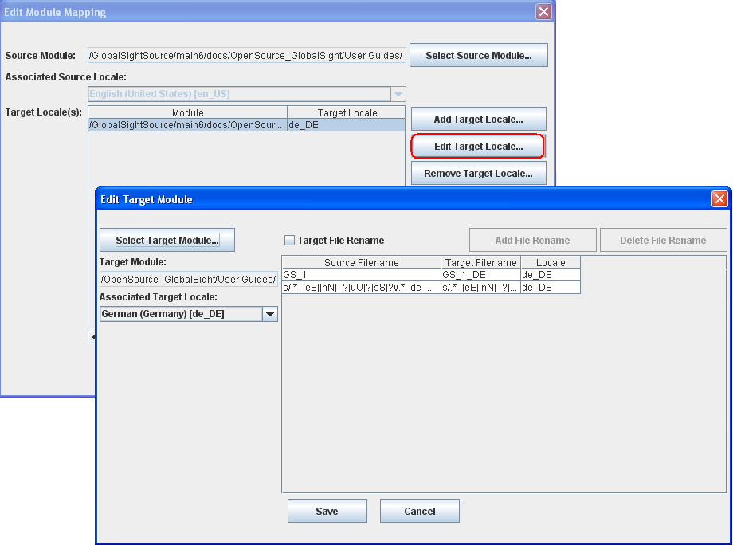

- Remove Target Locale
Select an existed target locale record you want to remove and click the “Remove Target Locale…” button.
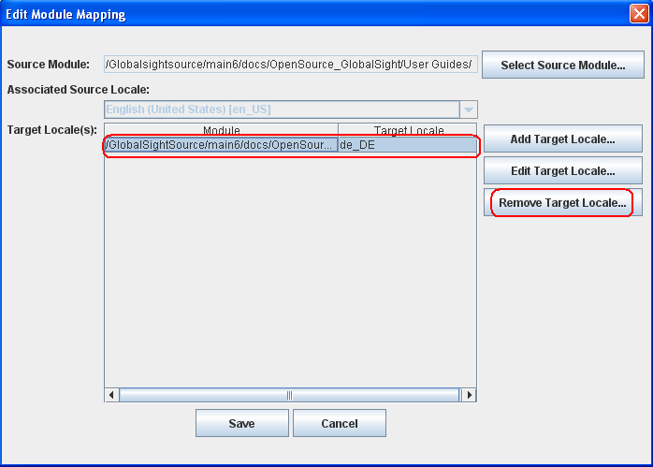

- Edit and Remove Module Mapping
In Module Mapping window, use the Remove Mapping or Edit Mapping dialog boxes to remove or edit an existing module mappings on the CVS server.

Edit Mapping
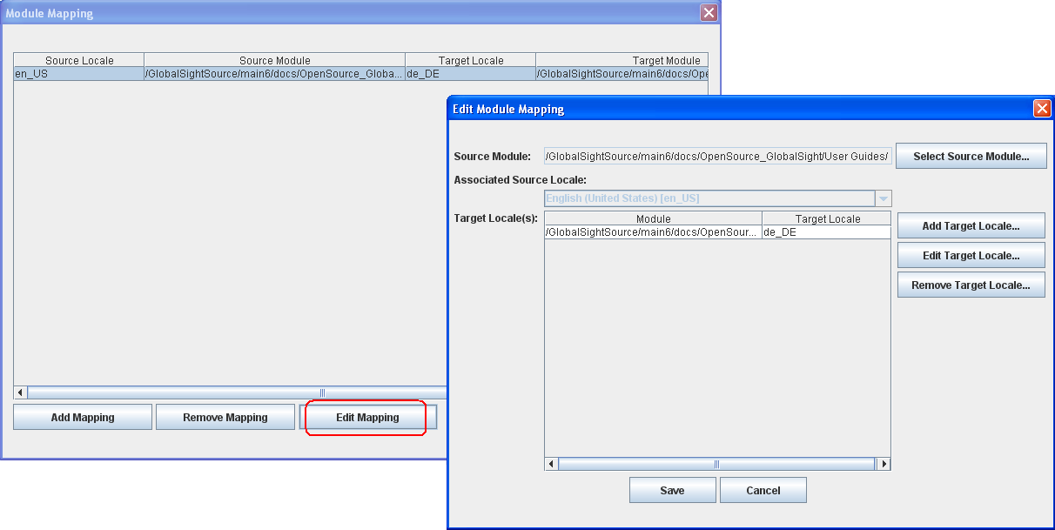

Remove Mapping
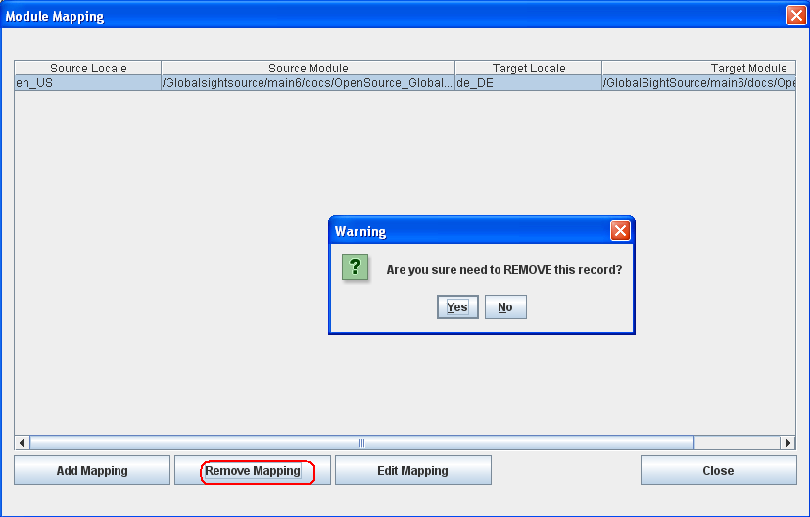

Submit to Create Job

Select files and add them by clicking “Add to job”.

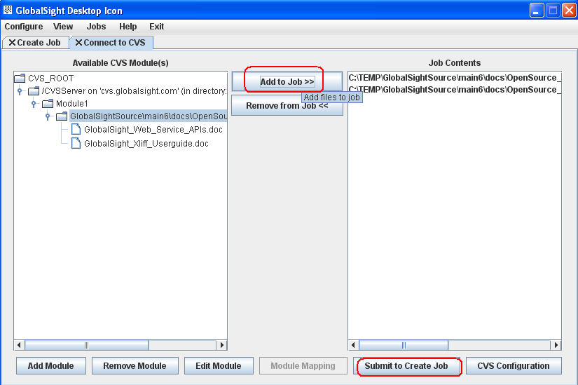

Click on “Submit to Create Job” to start GlobalSight DesktopIcon Job creation process.

