
www.globalsight.com

GlobalSight DesktopIcon
User Guide

Version 7.1.5.0
Open source initiative for
managing, translating &
delivering global content

More details available at: http://www.globalsight.com

Overview
DesktopIcon is a Windows or Mac application designed to simplify tasks such as submitting and retrieving projects from GlobalSight. It does this more quickly and easily than the browser-based GlobalSight application. It utilizes the web services API which GlobalSight provides.
This document assumes DesktopIcon is already installed on your PC or Mac. If that is not the case, please refer to the Desktop Icon Installation Guide.

Note: In order for Desktopicon to connect to your GlobalSight server, your Administrator needs to allow access at the server for your computer. Instructions for this can be found in the “Configuring GlobalSight Web Services” section of the GlobalSight Installation Guide.
Functions in Menu Bar
1. Configure
In this section, you can configure GlobalSight DesktopIcon to log on to a remote GlobalSight Server and process jobs.
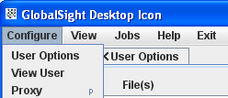

You should configure GlobalSight Server with connection and user information for individuals who will be using desktop icon. These are Users who have already been setup in GlobalSight.

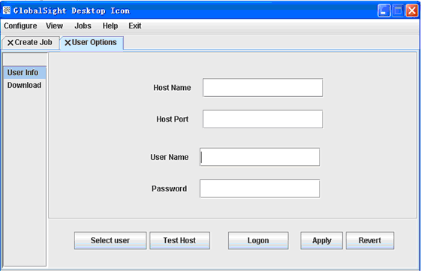

Host Name: The name given to your instance of GlobalSight (e.g. “ABC Corp”)
Host Port: The port to communicate to GlobalSight with (e.g. “80” or “8080”)
User Name: The name you will be logging into GlobalSight with. Must be a valid user within GlobalSight and with proper permission privileges.
Password: The GlobalSight user password.

Note: You must save the configuration to run DesktopIcon 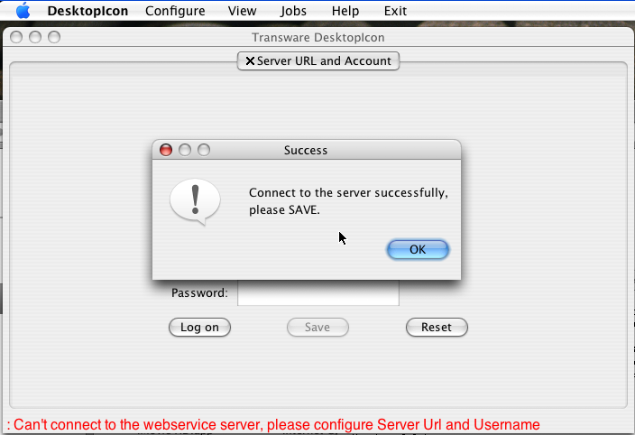

2. View
Desktop Icon allows you to view reports and jobs which are at various stages of the process.
View in Window XP
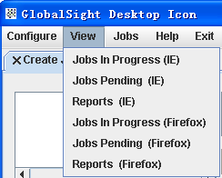
View in Mac OS
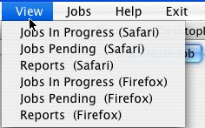

3. Create Jobs
There is only one submenu in “Jobs” menu, named “Create Job”. It makes creating jobs easier than from the GlobalSight application. Follow these steps to create a job:
a) Select files from file chooser (or you can Drag and Drop into the Files box).
b) Map files to file profiles.
c) Enter job name and job comments
d) Select target locale(s).
e) Click “Create” button.

That is all it takes to create a job. Of course, up to this point you have only submitted a job to GlobalSight, if there are no error messages you can view the job from menu “View -> Jobs in Progress”.
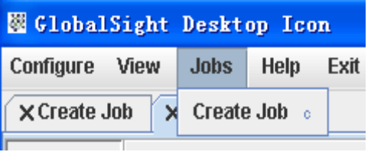

3.1 Three ways to add file(s):

3.1.1 Drag a file to icon directly;
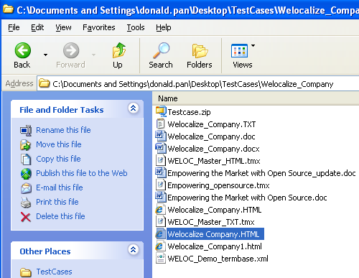
3.1.2 Select the files to be translated through the “Add File(s)” button.
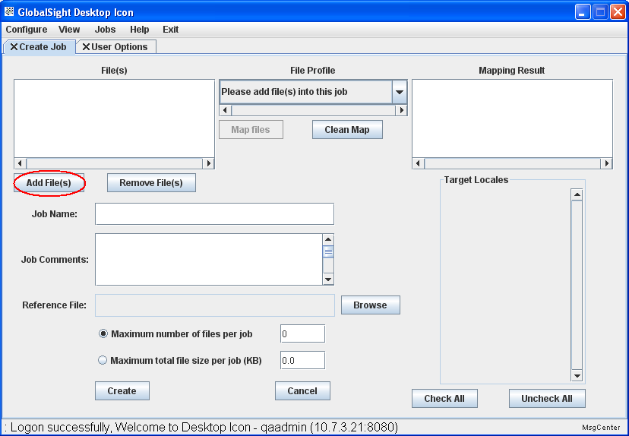
3.1.3 Drag and Drop files, folder(s) or zip(s) from file system to DesktopIcon or copy files, folder(s) or zip(s) (Ctrl + c) and then Ctrl + v in DesktopIcon.

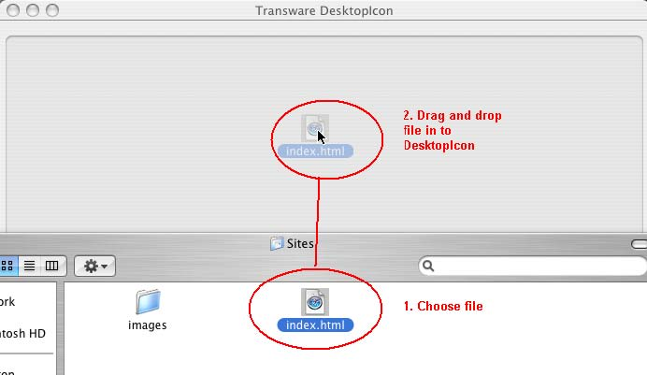

3.2 Map files to File Profile

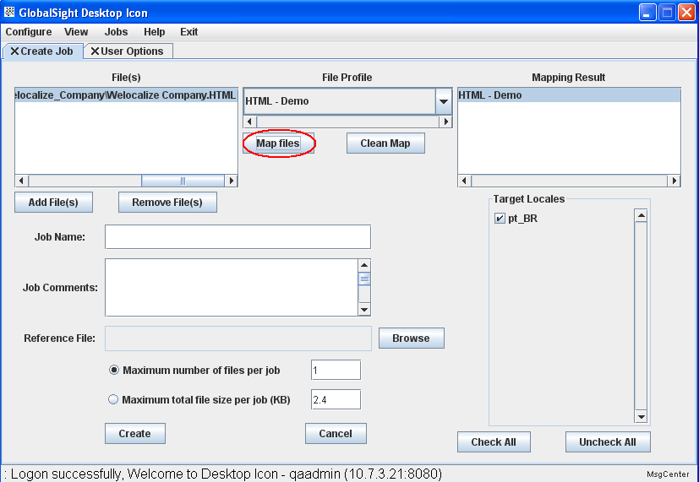
3.3 Type Job Name and add comments (optional), select target locale(s) and then press “Create” button.

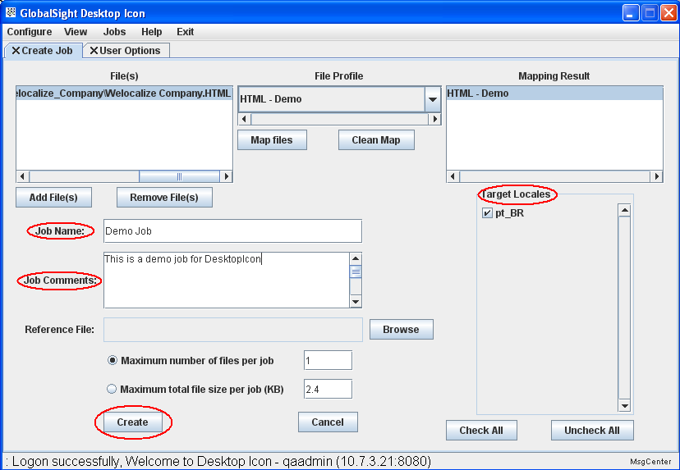
3.4 With "Maximum number of Files per job" or "Maximum total file size per job (KB)", you can create job(s) in GlobalSight based on this setting.
3.5 A progress bar dialogue will display job uploading progress.

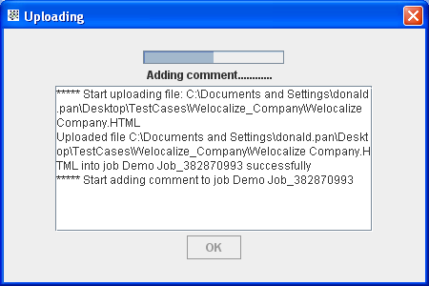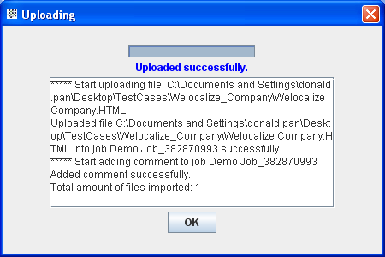
4. Set proxy
Set a proxy to use Desktop Icon at the “Configure” menu -> “Proxy”. Applying a new proxy setting needs a restart of Desktop Icon to make it effective.
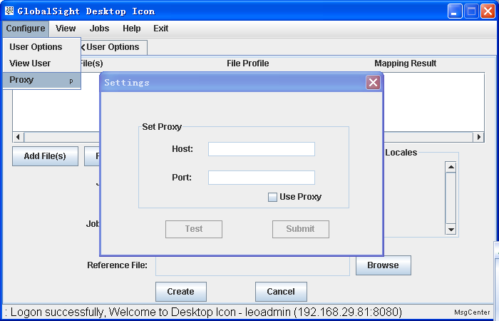
5. Help and Exit
You can get help from “Help” menu and some information about DesktopIcon. Exit DesktopIcon using “Exit” menu.
NOTE: UI is based on Java 1.6

