TM Core Structure

Shigemichi Yazawa
GlobalSight System4 4.5

Table of Contents
1 Introduction 3
1.1 Overview 3
1.2 Objectives 3
1.3 References 3
2 Terms 3
3 Use Cases 3
3.1 Use Case 1 – n/a 3
4 Design Overview 4
4.1 Introduction 4
4.1.1 TM Data 4
4.1.2 Segment TM 4
4.1.3 Page TM 5
4.1.4 Conceptual diagram 5
4.2 Assumptions 5
4.3 Public Interfaces 6
4.3.1 User Interface 6
4.3.2 Code-Level Interfaces 6
5 Object Model 6
5.1 Classes and Interfaces 6
5.2 Class/Interface Descriptions 7
5.2.1 BaseTu 7
5.2.2 ProjectTmTu 7
5.2.3 BaseTuv 8
5.2.4 ProjectTmTuv 8
5.2.5 BaseTm 8
5.2.6 ProjectTm 8
5.2.7 PageTm 9
6 Dynamic Model 9
7 Deployment Considerations 9
8 Non-functional Requirements 9
9 Database table schema 9
9.1 Segment TM Schema 10
9.2 Page TM Schema 11

Introduction

Overview
This document is one of a series of documents describing a new TM design for System4 4.5. A list of the documents are as follows:
TM Core Structure
TM Data Population
TM Indexing
TM Leveraging
TM Management
In this document, a core structure of TM is explained.

Objectives
This design document describes fundamental data structure of TM, top of which various TM operations are built on.

References
To better understand overall design, consult high-level design document “TM Design for System4 4.5” (tm_design_4.5.html).

Terms
Job Data Segment data used in active jobs for editing and page construction. They are not TM data.
Segment TM A regular repository of TM data. Data in this TM are mainly used to leverage files that are imported into the system for the first time (fresh import).
Page TM A repository that stores the most recently completed page data. Data in this TM are used to leverage files that have been imported into the system previously (re-import).
Project TM Logical container of Segment TM data. Segment TM is consisted of one or more Project TMs.

Use Cases

Use Case 1 – n/a

Design Overview

Introduction

TM Data
There are two kinds of TM data. One is Segment TM and the other is Page TM. Segment TM is used to leverage files that are imported into the system for the first time (fresh import). Page TM is used to leverage files that have been imported into the system previously (re-import).
Segment data in both TM are populated at the job completion. TM data are independent. They don't refer to job data and also they are not referred to by any other data including leverage_match (a table that stores leverage results). That way, TM data can be modified and deleted as needed without any side effect.

Segment TM
Segment TM is a collection of segment data that have been brought into the system. Segment TM is logically separated in one or more Project TMs. Each Project TM cannot have duplicate segment data in it, but it is allowed to store identical segments in different Project TMs.
Segment TM has two different kinds of data, translatable and localizable. To leverage imported data, translatable data are queried using their indexes and localizable data are queried using their exact match keys. When translatables and localizables are searched through concordance search, their indexes are used so a partial text string can be used to search for segments. For this reason, both translatables and localizables are indexed.
Segment data are not whitespace normalized in the TM. Whitespace differences are absorbed in indexing and leveraging. The TM preserves the original segment forms.
A unit of segment data is consisted of one source segment and corresponding one or more target segments. There isn't any limitation of number of target locales that can be associated with a source locale segment. If there are two different translations for a given source segment in a given target locale, the two target segments in the same target locale are associated with the source segment. There also isn't any limitation of number of differently translated segments in the same locale that can be associated with a source segment. For example, one en_US source segment can be associated with one fr_FR segment, one de_DE segment and three ja_JP segments. In this case, Japanese has three different translations for an en_US source segment.
When a job is completed, job data are added to segment TM. The data are merged into existing segment TM data in such a way as not to create duplicate data in a Project TM. When adding a unit of data (one source and some corresponding targets), a new entry is created in the TM if an identical source segment doesn't exist yet. If an identical source segment exists, corresponding target segments are examined and if an identical target segment exists, nothing will be added. Otherwise the target segments are added to the existing unit. That may be a new target locale entry or an addition of a different translation to existing target segments. The equality of segments are measured by exact match key and type of segments. Even the exact match key is the same but the type is different, they are considered as different segments. By doing this, we can perform segment type aware leveraging and filter the query with type on concordance search.
A segment is indexed when it is added to the TM. Not only source but also target segments are indexed so target segments can be queried in concordance search and multilingual leveraging can be achieved.

Page TM
Page TM segments are the latest completed job data. They are used to leverage re-imported pages.
Page TM data are logically separated by page. A page is identified by a combination of page external id and source locale. That is, if the same page is imported twice using different source languages (in reality it doesn't likely happen), they are considered as different pages. Re-imported pages are leveraged using exact match keys.
Page TM segments are populated when a job is completed. When the segments are populated, the old target locale segments for the page, if exist, are discarded. The segments are populated in such a way that the duplicate segments in a page are consolidated into one segment. This ensures that no any duplicates are returned from the database when leveraging segments.
[Note: There is redundancy in segment data in Segment TM and Page TM. Both segment data are populated when a job is completed. That is, the same segments are stored in both Segment TM and Page TM. This redundancy makes the leveraging process simpler and probably faster.]
As with the case in Segment TM, if the type of the segment is different, they are considered as different segments even if the texts are exactly the same.
Although only exact match keys are used for leveraging Page TM data, Page TM segments are indexed nonetheless. Indexes are used for concordance search.

Conceptual diagram
Segment TM
Page TM
Project TM 1
Page 1
Project TM 2
Page 2
Project TM 3
Page 3

Assumptions
N/A

Public Interfaces

User Interface
N/A

Code-Level Interfaces
See 5.2 Class/Interface Description

Object Model
Note: trivial setter and getter methods are omitted from the class diagram and descriptions.

Classes and Interfaces

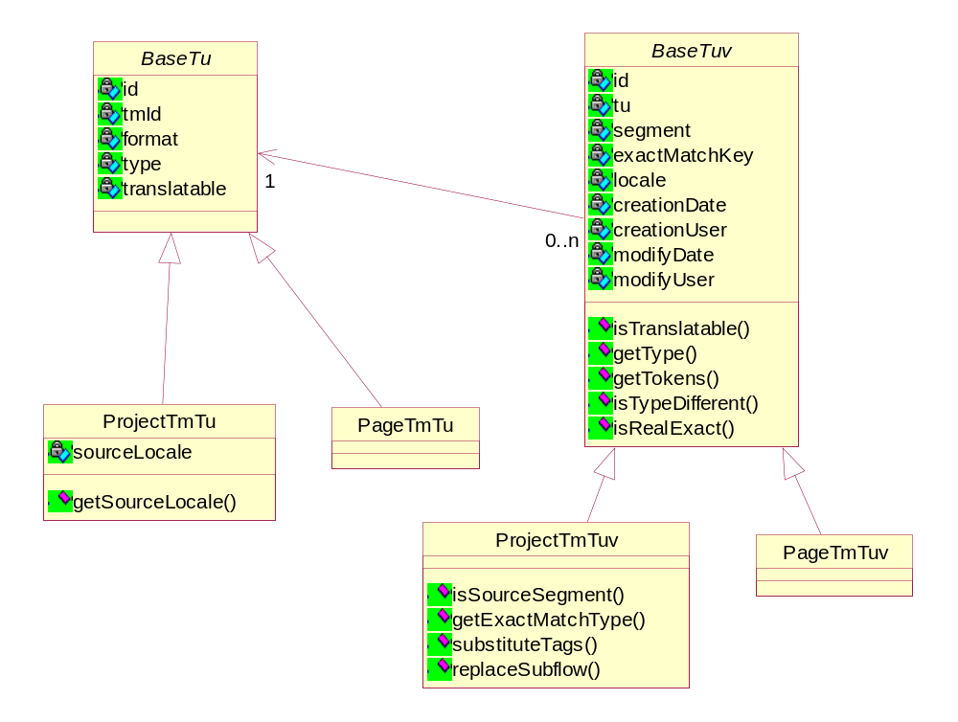
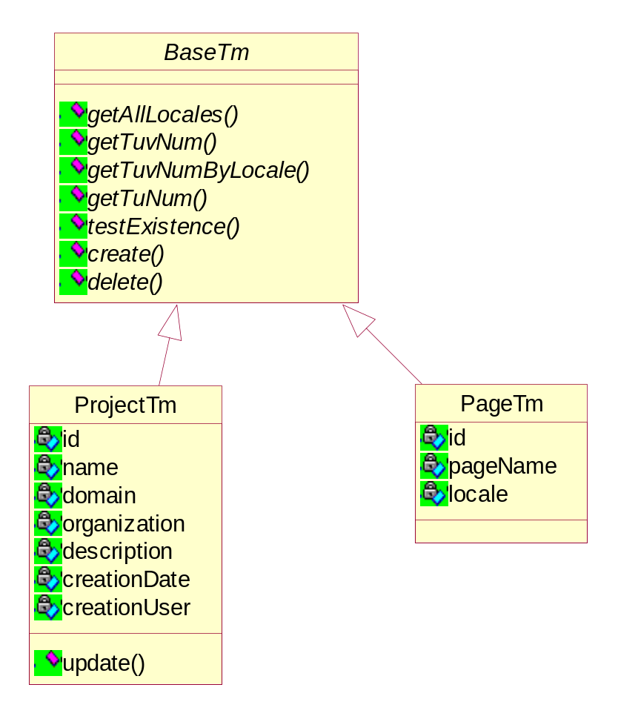

Class/Interface Descriptions

BaseTu
Description: Abstract class for ProjectTmTu and PageTmTu
Attributes:
- long id - TU id
- long tmId - TM id
- String format - format of the segment (HTML, XML, java properties, etc)
- String type - type of the segment (text, url-a, etc)
- boolean translatabel - wheather the segment is translatable or localizable

ProjectTmTu
Description: Translation Unit in Project TM
Attributes:
- String sourceLocale - source locale of the TU (e.g. en_US)
Methods:
- String getSourceLocale() - returns the source locale of the TU

BaseTuv
Description: Abstract class for ProjectTmTuv and PageTmTuv
Attributes:
- long id - TUV id
- BaseTu tu - Reference to BaseTu
- String segment - segment text in TMX
- long exactMatchKey - CRC value of the segment
- String locale - locale of the segment
- Date creationDate - creation date of the segment
- String creationUser - user who created the segment
- Date modifyDate - modify date of the segment
- String modifyUser - user who modified the segment
Methods:
- boolean isTranslatable() - returns true if the segment is translatable
- String getType() - returns the type of the segment
- Collection getTokens() - returns tokens of the segment (for indexing)
- boolean isTypeDifferent(BaseTuv) - returns true if the type of the segment is different from the arg
- boolean isRealExact(BaseTuv) - returns true if this object and the arg is exactly the same

ProjectTmTuv
Description: Translation Unit Variant in Project TM
Methods:
- boolean isSourceSegment() - returns true if this is source segment
- MatchType getExactMatchType(BaseTuv, LeverageOptions) - returns match type and match percentage comparing to the other segment in arg1 using leverage options in arg2
- void substituteTags(BaseTuv) - substitute tags of the segment using tags in the arg
- void replaceSubflow(String, int, int) - replace a subflow designated by x value arg2 and the ordinal arg3 with a string arg1

BaseTm
Description: Interface for ProjectTm and PageTm
Methods:
- Collection getAllLocales() - returns all locales used in the TM
- long getTuvNum() - returns the number of TUVs in the TM
- long getTuvByLocale(String) - returns the number of TUVs in a arg1 locale in the TM
- long getTuNum() - returns the number of TUs in the TM
- boolean testExistence() - returns true if the TM already exists
- void create() - create the TM in the database
- void delete() - delete the TM and TUs and TUVs that belong to the TM

ProjectTm
Description: A project TM in Segment TM repository
Attributes:
- long id - Project TM id
- String name - Project TM name
- Stinrg domain - domain of the Project TM
- String organization - organization the Project TM belongs to
- String description - description of the Project TM
- Date creationDate - creation date of the Project TM
- String creationUser - a user who created the Project TM
Methods:
- void update() - update the attributes in the database

PageTm
Description: A Page TM
Attributes:
- long id - Page TM id
- String pageName - page name
- String locale - source locale of the page

Dynamic Model
N/A

Deployment Considerations
N/A

Non-functional Requirements
N/A

Database table schema
Note1: Access to the TM tables are done via JDBC. TopLink is not used.
Note2: Translatable and localizable segments are stored in the different tables in the hope of reducing the size of each table. This will add a little complexity to the segment retrieval logics.

Segment TM Schema
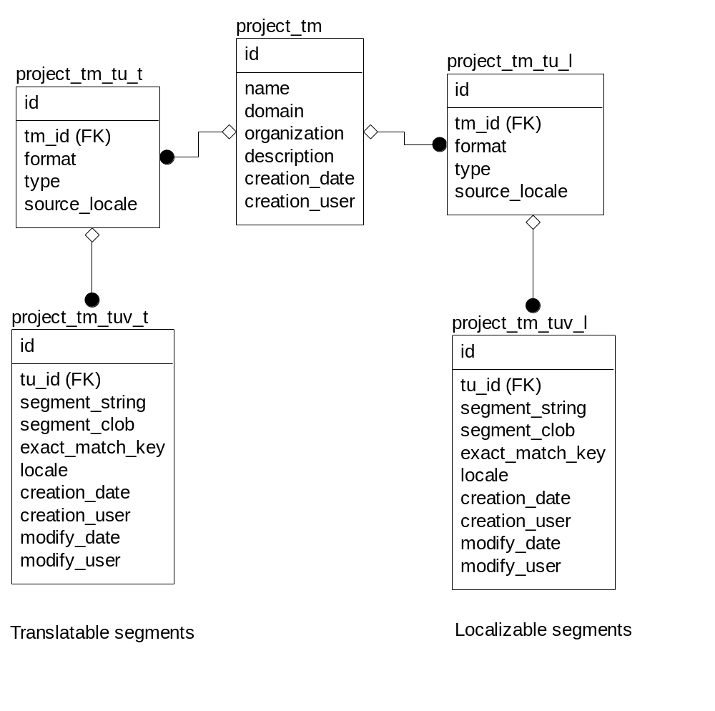

Page TM Schema
