TM Data Population and Indexing

Shigemichi Yazawa
GlobalSight System4 4.5

Table of Contents
1 Introduction 3
1.1 Overview 3
1.2 Objectives 3
1.3 References 3
2 Terms 3
3 Use Cases 3
3.1 Use Case 1 - Job completion 4
3.2 Use Case 2 – TM Import 4
3.3 Use Case 3 – Add segment data through GUI 4
3.4 Use Case 4 – Modify segment data through GUI 4
4 Design Overview 4
4.1 Introduction 4
4.1.1 Segment TM population 4
4.1.2 Page TM population 5
4.1.3 Indexing 6
4.2 Assumptions 7
4.3 Public Interfaces 7
4.3.1 User Interface 7
4.3.2 Code-Level Interfaces 7
5 Object Model 8
5.1 Classes and Interfaces 8
5.2 Class/Interface Descriptions 8
6 Dynamic Model 8
6.1 Add a group of segments to a Project TM 8
6.2 Add all segments of a page to a Page TM 8
6.3 Index a segment 9
7 Deployment Considerations 9
8 Non-functional Requirements 9
9 Table Schema 9

Introduction

Overview
This document is one of a series of documents describing a new TM design for System4 4.5. A list of the documents is as follows:
TM Core Structure
TM Data Population and Indexing
TM Leveraging
TM Management
In this document, a TM data population and Indexing is explained.

Objectives
This design document describes how the segment data get into the TMs how each segment is indexed.

References
To better understand overall design, consult high-level design document “TM Design for System4 4.5” (tm_design_4.5.html).

Terms
Job Data Segment data used in active jobs for editing and page construction. They are not TM data.
Segment TM A regular repository of TM data. Data in this TM are mainly used to leverage files that are imported into the system for the first time (fresh import).
Page TM A repository that stores the most recently completed page data. Data in this TM are used to leverage files that have been imported into the system previously (re-import).
Project TM Logical container of Segment TM data. Segment TM is consisted of one or more Project TMs.

Use Cases
This section describes all cases where the TMs are populated with segment data and/or segment data are indexed.

Use Case 1 - Job completion
The TMs are populated with segment data when a job is completed. Currently, there are two kinds of job completion is System4, one is a regular job completion by Export and the other is by Export Source.
Note that the TMs are not populated when a job is canceled. Job cancellation includes a regular job cancellation by pushing Discard button and through Delayed Import.

Use Case 2 – TM Import
TM data is imported from external files in TMX or other formats. TM Alignment is included in this use case. TM Aligner produces TMX files.

Use Case 3 – Add segment data through GUI
TM Management GUI provides Segment Add screen. The user can add segments to a TM manually through the GUI.

Use Case 4 – Modify segment data through GUI
TM Management GUI provides a way to modify segment data (search & replace, individual edit). Whenever a segment is modified, the segment is re-indexed.

Design Overview

Introduction
The TMs are populated in the use cases described above. When a job is completed, TM data are stored in both Segment TM and Page TM. When TM data is imported or added through GUI, they are stored in Segment TM.
When a new segment is added to TM, whether it’s Segment TM or Page TM, the segment is indexed. When a segment is modified, the segment is re-indexed.
TM data don't refer to job data. TM data are independent from the other part of the system.

Segment TM population
TM import and manual segment addition specifies a Project TM to which segments are added. TM Profile specifies a Project TM to which segments are added when a job is completed. TM Profile is associated with L10N Profile. TM Profile also specifies if un-localized segments (segments that have not been touched by translators) are added to Segment TM.
The data are merged into existing segment TM data in such a way as not to create duplicate data in a Project TM. When adding a unit of data (one source and some corresponding targets), a new entry is created in the TM if an identical source segment doesn't exist yet. If an identical source segment exists, corresponding target segments are examined and if an identical target segment exists, nothing will be added. Otherwise the target segments are added to the existing unit. That may be a new target locale entry or an addition of a different translation to existing target segments. The equality of segments is measured by exact match key and type of segments. Even the exact match key is the same but the type is different, they are considered as different segments. By doing this, we can perform segment type aware leveraging and filter the query with type on concordance search.
Translatable data are stored in project_tm_tu_t and project_tm_tuv_t tables and localizable data are stored in project_tm_tu_l and project_tm_tuv_l tables. By storing these two kinds of data in separate tables, we can expect to have a smaller number of data in each table.
Segment data are not whitespace normalized in the TM. Whitespace differences are absorbed in indexing and leveraging. The TM preserves the original segment forms.
When a segment with subflows is added to the TM, subflows are separated out from the main text, form their own segments and they are added to the TM independently. For example, a segment with one subflows become two independent segments. This way, we can leverage the main text and subflows independently and get better leverage results.
TU

TUV – en
“en <sub>en sub</sub> text”
TUV – fr
“fr <sub>fr sub</sub> text”

Subflow separation makes two independent segments.

TU
TU

TUV – en
“en <sub></sub> text”
TUV – en
“en sub”
TUV – fr
“fr <sub></sub> text”
TUV – fr
“fr sub”

A segment is indexed when it is added to the TM. Not only source but also target segments are indexed so target segments can be queried in concordance search and multilingual leveraging can be achieved.

Page TM population
Page TM is populated with TM data when a job is completed. TM data are stored under an appropriate page. Page is identified by external page id and source locale. If a page doesn't exist in Page TM, it is automatically created. TM Profile specifies if un-localized segments (segments that have not been touched by translators) are added to Page TM.
When the segment data are added, the old target locale segments for the page, if exist, are discarded. The segments are added in such a way that the duplicate segments in a page are consolidated into one segment. This ensures that no any duplicates are returned from the database when leveraging segments.
[Note: There is redundancy in segment data in Segment TM and Page TM. Both TMs are populated with the same data. That is, the same segments are stored in both Segment TM and Page TM. This redundancy makes the leveraging process simpler and probably faster.]
As with the case in Segment TM, if the type of the segment is different, they are considered as different segments even if the texts are exactly the same.
Translatable data are stored in page_tm_tu_t and page_tm_tuv_t tables and localizable data are stored in page_tm_tu_l and page_tm_tuv_l tables. By storing these two kinds of data in separate tables, we can expect to have a smaller number of data in each table.
Segment data are not whitespace normalized in the TM. In Page TM, only exactly the same segments including whitespaces are leveraged.
Subflows are not separated out from the main segments in Page TM as they are in Segment TM. In Page TM, only exactly the same segments including subflows are leveraged.
Although only exact match keys are used for leveraging Page TM data, Page TM segments are indexed nonetheless. Indexes are used for concordance search.

Indexing
Index is used to find similar segments (leveraging) or locate segments that includes given words or phrases (concordance search). To make index of a segment, the segment text is sliced up into small piece of tokens. We use trigram (three character unit) as token.
Before a segment text is tokenized, all formatting code in the segment text is removed, and also the text is whitespace normalized and case folded.

Code removal
Formatting codes are not indexed. Only texts are indexed.
For Segment TM data, since subflows are already removed from the segment, formatting codes are simply removed from the main text.
For Page TM data, subflows are removed from the main segment and stored somewhere. After removing codes from the main text, subflows are appended to the main text separated by a space. This is good enough because indexes for Page TM data are not used for leveraging, but only for concordance search.

Whitespace normalization
In whitespace normalized text, there is only one leading and trailing whitespace at each end of the text and consecutive whitespaces are shrunk into one SPACE (U+0020) character. Whitespace characters are all Unicode characters that have White_space property in Extended Character Properties list. Whitespace normalization enables to achieve whitespace insensitive search.

Case Folding
Case of characters in the segment text is folded to lower case. Locale sensitive case folding method must be used, such as java.lang.Stiring#toLowerCase(java.util.Locale). Case folding enables to achieve case insensitive search.

Tokenizing
We use three letter n-gram method (trigram) to tokenize text. N-gram method cut a text up into over wrapping fixed length tokens.
Example:
Text: “ sample text ”
Tokens: “ sa”, “sam”, “amp”, “mpl”, “ple”, “le “, “e t”, “ te”, “tex”, “ext”, “xt “
As the example above shows, tokenization produces (length of the text – 2) numbers of tokens.
Adding a space at the beginning and the end of the text is important. This way, we can guarantee that tokens are always three character length even if the original text is just one character. And also a greater benefit is that we can always find one or two letter terms in concordance search if the language we query uses a space as word delimiter.
However, if we query a language that doesn't use word delimiter such as Chinese and Japanese, we cannot find one or two letter terms. What we can do is to look for these terms using LIKE clause in index table and look up the segment ids that contains those terms, or we leave it as a restriction.

Assumptions
N/A

Public Interfaces

User Interface
Data population at job completion doesn't have its own UI. UI for TM import and manual addition are discussed in TM Management document.

Code-Level Interfaces
See 5.2 Class/Interface Description

Object Model

Classes and Interfaces

Class/Interface Descriptions

Dynamic Model

Add a group of segments to a Project TM
  - When populating from job data, discard segments with state of NOT_LOCALIZED from the list of segments if the user selects not to save un-localized segments in TM Profile.
  - Walk through the list of segments and separate out subflows from the main segment and add these subflow only segments to the list.
  - Remove duplicate segments from the list.
  - For each segment in the list, look for an identical source segment in a specified Project TM by querying exact match key and type. To make sure that the segments are identical, compare the text strings. The same exact match keys don't guarantee the same texts.
  - If an identical source segment is not found in the TM, create one and index it.
  - For each target locale of the segment, look for an identical target segment corresponding to the source segment.
  - If there isn't identical target segment, create one and index it. If there is one already and adding segments from job data and the state of the segment is LOCALIZED, update modify_date and modify_user field using the ones in the job data.

Add all segments of a page to a Page TM
  - Look for a specified page in Page TM. If it doesn't exist, create one.
  - Delete all target segments that are to be added in the page if any.
  - Discard segments with state of NOT_LOCALIZED from the list of segments if the user selects not to save un-localized segments in TM Profile.
  - Remove duplicate segments from the list.
  - For each segment in the list, look for an identical source segment in a specified Page TM by querying exact match key and type. To make sure that the segments are identical, compare the text strings. The same exact match keys don't guarantee the same texts.
  - If an identical source segment is not found in the TM, create one and index it.
  - Add corresponding target segments to the source segment and index them.

Index a segment
- Remove codes from the text.
- Normalize whitespaces in the text.
- Fold the case in the text.
- Tokenize the text.
- Persist them in a locale specific index table.

Deployment Considerations
N/A

Non-functional Requirements
N/A

Table Schema
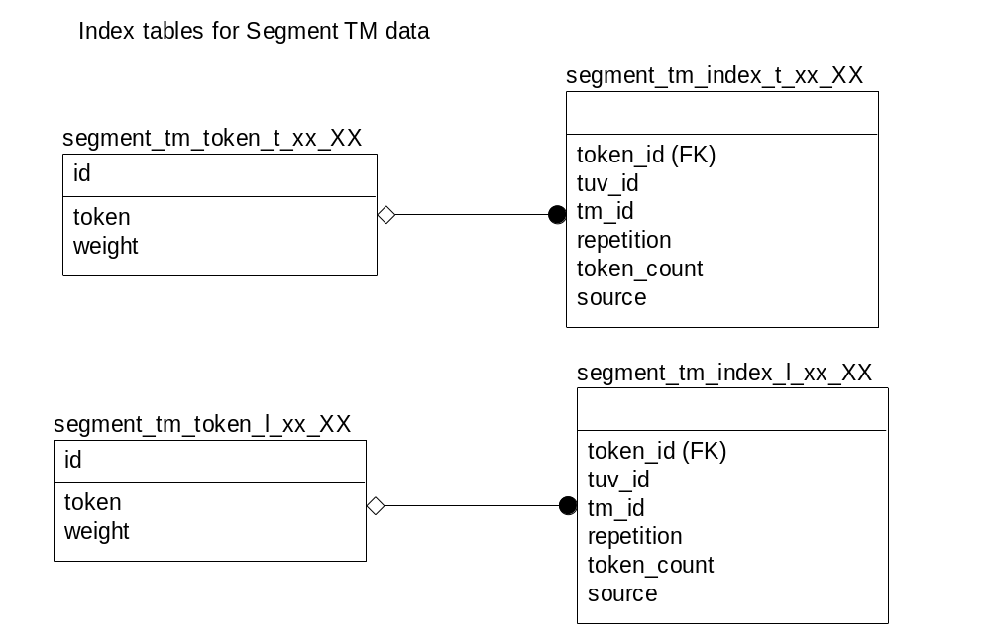
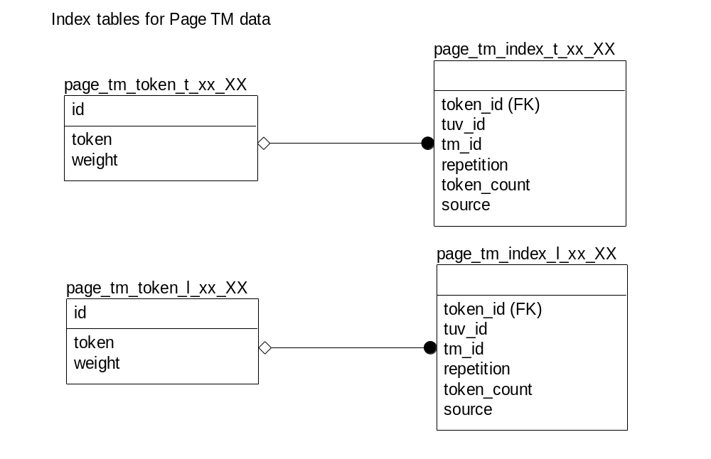

- Index tables are physically separated by locale to reduce the size of each table. Since index tables are always queried by only one locale, there is no need to have tokens with different locales in a same table. xx_XX in the above table diagram is substituted with a real locale name, e.g. en_US. Tables are dynamically created as needed.
- Indexes for translatable and localizable segments are stored in the different tables. This will further reduce the number of rows in each table. This is good for leveraging because only indexes used for leveraging is for translatable segments in Segment TM.
- Token table and index table (that holds information which tuv contains which tokens) are separated. This way, we can keep the size of token table pretty decent for languages that use limited number of characters. For example, let’s assume English uses only 50 characters (case folding in mind). Then the maximum number of rows in the token table is 252,500 (50 x 50 x 50). Now index table can be huge. I don’t know if the join of two tables makes things slow down. It might be faster if we don’t separate token and index. We need to test.
- Repetition column is to record the count of the particular token appeared in the particular tuv.
- Token_count column is to record the total number of tokens in the particular tuv.
- Weight column is for a future use. If we weigh each token, we can get better concordance search results.
- Source column indicates if the segment is source locale. Multilingual leveraging needs to know this information.

