TM Leveraging

Shigemichi Yazawa
GlobalSight System4 4.5

Table of Contents
1 Introduction 4
1.1 Overview 4
1.2 Objectives 4
1.3 References 4
2 Terms 4
3 Use Cases 4
3.1 Use Case 1 – Fresh Import 4
3.2 Use Case 2 – Re-import 5
4 Design Overview 5
4.1 Introduction 5
4.2 Page TM leveraging 5
4.3 Segment TM leveraging 5
4.3.1 Fuzzy Matching Example 5
4.3.2 Subflow separation 6
4.4 Leverage Type 6
4.5 Leverage Options 7
4.5.1 Type Insensitive Leveraging 7
4.5.2 Case Insensitive Leveraging 7
4.5.3 Whitespace Insensitive Leveraging 7
4.5.4 Code Insensitive Leveraging 8
4.5.5 Multiple exact matches 9
4.5.6 Latest match for re-import 9
4.5.7 Multilingual leveraging 9
4.6 Tag Substitution 10
4.7 Assumptions 10
4.7.1 Statistics 10
4.7.2 Online Editor 10
4.7.3 Offline file 11
4.8 Public Interfaces 11
4.8.1 User Interface 11
4.8.2 Code-Level Interfaces 13
5 Object Model 14
5.1 Classes and Interfaces 14
5.2 Class/Interface Descriptions 14
5.2.1 Leverager 14
5.2.2 PageTmLeverager 15
5.2.3 SegmentTmLeverager 15
5.2.4 LeverageMatchSaver 15
6 Dynamic Model 16
6.1 Scenario 16
7 Algorithms 17
7.1 Leverage a page 17
7.2 Page TM leveraging 18
7.3 Segment TM leveraging 18
7.4 Tag Substitution 19
7.5 Compose Complete Segment 19
8 Deployment Considerations 20
9 Non-functional Requirements 20
10 Table Schema 20

Introduction

Overview
This document is one of a series of documents describing a new TM design for System4 4.5. A list of the documents is as follows:
TM Core Structure
TM Data Population and Indexing
TM Leveraging
TM Management
In this document, a TM leveraging is explained.

Objectives
This design document describes how TMs are used to leverage translation information into newly imported data.

References
To better understand overall design, consult high-level design document “TM Design for System4 4.5” (tm_design_4.5.html).

Terms
Job Data Segment data used in active jobs for editing and page construction. They are not TM data.
Segment TM A regular repository of TM data. Data in this TM are mainly used to leverage files that are imported into the system for the first time (fresh import).
Page TM A repository that stores the most recently completed page data. Data in this TM are used to leverage files that have been imported into the system previously (re-import).
Project TM Logical container of Segment TM data. Segment TM is consisted of one or more Project TMs.

Use Cases
This section lists where the leveraging occurs.

Use Case 1 – Fresh Import
When a file is imported into the system first time, it’s called fresh import. Even if the contents of the file is exactly the same but the file names are different or imported from a different directory, these files are considered as different. The source locale also accounts for the freshness of the import. If a file is imported with a source locale, for example, en_US and imported again later with a source locale en_GB, both of them are treated as fresh import. Fresh import uses data in Segment TM only.

Use Case 2 – Re-import
When a file is imported that has been already imported into the system before, it’s called re-import. Re-imported file is leveraged mainly from Page TM.

Design Overview

Introduction
The purpose of the leveraging is to reuse text that has been translated before as much as possible. The leveraging happens when files are imported into System4. The newly imported segments are matched against TMs and the results are stored in a table called leverage_match for the later use.
There are two different leveraging methods, one is Page TM leveraging and one is Segment TM leveraging.

Page TM leveraging
Page TM is used to leverage a file that has been imported before. Since Page TM data are taken from the previous translation process, it is expected that the matched translations are highly accurate. If matches for some segments cannot be found due to the addition of new contents to the file, matches for those segments are queried in Segment TM.
Page TM matches are queried based on exact match keys. Indexes are not used.

Segment TM leveraging
Segment TM is used to leverage a file that has never been imported before. Segment TM leveraging is a process to measure the similarity between the two text based on trigram indexes. The similarity is represented as percentage. The similarity 100% is an exact match. To compute the similarity, we use Dice's coefficient, which is defined as
S = 2C / (A + B)
where A is the number of tokens in the text to be leveraged, B the number of tokens in the matched text, and C the number of tokens shared by A and B.

Fuzzy Matching Example
Take two strings “testest” and “steste” and tokenize them.
A “testest” “tes” x 2, “est” x 2, “ste” x 1
B “steste” “tes” x 1, “est” x 1, “ste” x 2
The number of tokens in A is 5, in B is 4. The shared tokens are “tes” x 1, “est” x 1, “ste” x1. The number of shared token is 3. Thus the similarity is
2 x 3 / (5 + 4) = 0.666… (67%)

Subflow separation
Subflow texts are stored separately from the main segment in Segment TM (See TM Data Population and Indexing document). The main texts and subflow texts are leveraged independently (as if they are different segments) to get better leveraging result. For example, a link in <a> tag in HTML document gets changed and the file is re-imported, the main text contains the <a> tag still gets an exact match.

Leverage Type
From user's perspective, we currently have only exact or fuzzy match. A user can only assume that 99% fuzzy can be multiple translation or whitespace difference. We need more leverage types to show them what the leveraging result exactly is.
100% exact match
Byte-by-byte exactly the same. This is the match from Segment TM.
Page TM exact match
Byte-by-byte exactly the same. This is the match from Page TM.
Multiple translations
More than one translations are detected for a single source segment.
Type difference
Only types of segments are different. Examples of types include url-a, css-border, text, etc. A user option can turn this into 100% exact match.
Case difference
Only case of the text is different. A user option can turn this into 100% exact match.
Whitespace difference
Only whitespaces are different. A user option can turn this into 100% exact match.
Code difference
Only formatting codes such as <b> in HTML are different. Code difference includes:
- Missing code
- Added code
- Location difference
- Code order difference
- Code content difference
- Any combination of the above
Some cases such as location difference can be turned into 100% exact match by a user option.
Fuzzy match
Text are different (real fuzzy).
Leverage result should carry these leveraging categories as its property and users should be able to see them in the editor.
[Note: Page TM leveraging has only Page TM exact match, Type Difference or Multiple translations by its nature. All other categories are the result of Segment TM leveraging.]

Leverage Options
The following is a list of leveraging options. They are defined by users in TM Profile that is associated with L10n Profile.

Type Insensitive Leveraging
If this option is selected, segments different only in their type become 100% exact match.
If this option is not selected, the user can choose how many percentage penalty is given to this match. If the user choose 3% as penalty, the percentage of a match is 97%. With or without the option turned on, the match state is TYPE_DIFFERENCE.
This option is applied to the leveraging from both Segment TM (fresh import) and Page TM (re-import).

Case Insensitive Leveraging
If this option is selected, segments different only in case of letters in the text become 100% exact match.
If this option is not selected, the user can choose how many percentage penalty is given to this match. If the user choose 3% as penalty, the percentage of a match is 97%. With or without the option turned on, the match state is CASE_DIFFERENCE.
This option is applied only to the leveraging from Segment TM (fresh import).

Whitespace Insensitive Leveraging
If this option is selected, segments different only in whitespace become 100% exact match. When matching segments, trailing and leading whitespaces are ignored and the difference of the number of consecutive whitespaces is ignored. But the existence of whitespaces is not ignored.
For example, the following segment pairs are considered as 100% exact match if this option is turned on (whitespaces in the examples are represented as underscore '_' character).
"Hello,_world." and "Hello,__world."
"Hello,_world." and "_Hello,_world._"
But the following is NOT 100% exact match.
"Hello,_world." and "Hello,world."
If this option is not selected, the user can choose how many percentage penalty is given to this match. If the user choose 3% as penalty, the percentage of a match is 97%. With or without the option turned on, the match state is WHITE_SPACE_DIFFERENCE.
This option is applied only to the leveraging from Segment TM (fresh import).

Code Insensitive Leveraging
If this option is selected, some cases of formatting code difference can become 100% exact match. The followings are the code difference that can be 100% exact match.
- Location difference
- Code order difference
- Code content difference (but not subflow)
- Any combination of the above
To become 100% exact, corresponding tags in the original segment and the matched segment must be exactly the same or can be substituted. See more on Tag Substitution. Note that the tag substitution is always performed regardless of this option.
The followings are examples of segment pairs that can be 100% exact match if this option is turned on.
All work and <B>no play</B> make Jack a dull boy.
All work and no play make <B>Jack</B> a dull boy.
All work and <B>no play</B> make <I>Jack</I> a dull boy.
All work and <I>no play</I> make <B>Jack</B> a dull boy.
All work and <B>no play</B> make Jack a dull boy.
All work and <STRONG>no play</STRONG> make Jack a dull boy.
But the followings are not 100% exact match even if this option is turned on (missing tag, tag type is different).
All work and <B>no play</B> make Jack a dull boy.
All work and no play make Jack a dull boy.
All work and <B>no play</B> make Jack a dull boy.
All work and <I>no play</I> make Jack a dull boy.
Users can choose how many percentage penalty is given to this match. The penalty is subtracted from 100% if matches can not become 100% (in the case of missing tags, etc) or this option is turned off. If the user choose 3% as penalty, the percentage of a match is 97%. With or without the option turned on, the match state is CODE_DIFFERENCE.
This option is applied only to the leveraging from Segment TM (fresh import).

Multiple exact matches
Multiple exact matches are more than one exact match in which the source texts are the same but the translations are different. Users can choose the leveraging behavior from the following options to handle multiple exact matches.
pick the latest
pick the most recently edited segment and make it 100% exact match. All the other matches are demoted.
pick the oldest
pick the least recently edited segment and make it 100% exact match. All the other matches are demoted.
demote
all matches are demoted.
Users can choose how many percentage penalty is given to demoted matches. If the user choose 3% as penalty, the percentage of a demoted match is 97%. With or without the option turned on, the match state is MULTIPLE_TRANSLATION.
This option is applied only to the leveraging from Segment TM (fresh import).

Latest match for re-import
If this option is selected, Page TM is not used for leveraging re-import. Instead, the leverager tries to find the most recently edited matches in Segment TM (remember everything in Page TM are already in Segment TM).
This option is applied only to the leveraging for re-import.

Multilingual leveraging
Regular leveraging leverages from a language marked as source to languages marked as target in the TM. Multilingual leveraging allows to leverage from any language to any language that are in the TM, even from target to source or from target to target. For example, when there are English source and French and German target TM data, Multilingual Leveraging allows to leverage from French source to German target. Since this leveraging is somewhat less reliable than the regular leveraging, this feature must be explicitly turned on by user.
This option is applied only to the leveraging from Segment TM (fresh import).

Tag Substitution
When formatting codes are different in the original and matched segment, tags in the matched segment are substituted for tags in the original segment as much as possible. The following two TMX marked-up segments are considered as exactly the same (100% exact match) because of the tag substitution.
<bpt type="bold">{\b </bpt>Special<ept>}</ept> text
<bpt type="bold">&lt;B></bpt>Special<ept>&lt;/B></ept> text
The first segment is RTF and the second one is HTML. Since both segments have the same "bold" type codes, tags in the matched segment can be replaced with the ones in the original segment. This example is taken from "TMX specification".
This feature is also useful when matching between the same format segments. If the user changed only codes in the original document and re-import it, he might expect all segments get 100% exact match. For example, the following segments can be 100% exact match.
<bpt type="span">&lt;SPAN class=TEXT1></bpt>text<ept>&lt;/SPAN></ept>
<bpt type="span">&lt;SPAN class=TEXT2></bpt>text<ept>&lt;/SPAN></ept>
When a tag is substituted for another,
- their type must be the same.
- the number of subflows in the tags must be the same.
- the type of each corresponding subflow must be the same.
- subflow contents are not substituted.
Tags that cannot be substituted are removed from the matched segment.

Assumptions
Due to the subflow separation for leveraging and the new leverage types added in this release, several modules outside of TM need to be modified.

Statistics
For an accurate statistics of leveraging, <sub> tag in GXML needs to have wordcount attribute. wordcount attribute value in <segment> and <localizable> tag shouldn’t include the wordcounts of its subflow texts. Also, statistics module needs to be changed to calculate wordcounts of the main text and subflow text separately.

Online Editor
The online editor should be able to color code the main text and subflow text differently if their leverage results are different. Also, match result selection should be provided for subflows too.
Match types should be displayed for each TM matches.

Offline file
The offline resource files should provide a list of TM matches to subflows too.
Match types should be provided for each TM matches.

Public Interfaces

User Interface
TM Profile is newly added in the 4.5 release, in which users can set various options regarding TM. TM Profile is associated with L10n Profile. An assignment of a TM in Project screen is removed.
Users can choose the following options

TM Population options
Project TM for storage
Users can choose a Project TM to store segments after the job completion.
Save un-localized segments to Project TM
A checkbox to indicate whether un-localized segments are stored in the Project TM (for fresh import).
Save un-localized segments to Page TM
A checkbox to indicate whether un-localized segments are stored in the Page TM (for re-import).

General Leverage options
Exclude Item Types
A list of types that are excluded from leveraging.
Leverage Localizable
A checkbox that indicates to leverage localizable segments.

Leverage options for fresh import
Project TMs to leverage from
Users can choose one or more Project TMs to leverage from.
Type insensitive leveraging
A checkbox to indicate whether type insensitive leveraging is performed. See more on Type Insensitive Leveraging.
Type difference penalty
This option is enabled when "Type insensitive leveraging" is off. Users can enter a percentage penalty for type difference. See more on Type Insensitive Leveraging.
Case insensitive leveraging
A checkbox to indicate whether case insensitive leveraging is performed.
Case difference penalty
This option is enabled when "Case insensitive leveraging" is off. Users can enter a percentage penalty for case difference.
Whitespace insensitive leveraging
A checkbox to indicate whether whitespace insensitive leveraging is performed. See more on Whitespace Insensitive Leveraging.
Whitespace difference penalty
This option is enabled when "Whitespace insensitive leveraging" is off. Users can enter a percentage penalty for whitespace difference. See more on Whitespace Insensitive Leveraging
Code insensitive leveraging
A checkbox to indicate whether code insensitive leveraging is performed. See more on Code Insensitive Leveraging.
Code difference penalty
Users can enter a percentage penalty for code difference. See more on Code Insensitive Leveraging.
Multilingual leveraging
A checkbox to indicate whether multilingual leveraging is performed. See more on Multilingual Leveraging.
Multiple Exact Matches
Users can choose options, "pick the latest", "pick the oldest", "demote" for handling multiple exact matches. See more on Multiple exact matches.
Multiple Exact Matches penalty
Users can enter a percentage penalty for demoted multiple exact matches. See more on Multiple exact matches.
Fuzzy match threshold
Users can enter the fuzzy match threshold.
Number of matches
Users can enter the number of matches. No more than these number of matches are returned.

Leverage options for re-import
Latest match
A checkbox to indicate whether latest match is performed. See more on Latest Match for re-import.
Type insensitive leveraging
A checkbox to indicate whether type insensitive leveraging is performed. See more on Type Insensitive Leveraging.
Type difference penalty
This option is enabled when "Type insensitive leveraging" is off. Users can enter a percentage penalty for type difference. See more on Type Insensitive Leveraging.
No Multiple Exact Matches
If this option is checked and multiple translations are detected, an arbitrary segment is picked as an exact match. The other segments are demoted with a penalty defined below. With or without this option is selected, the leveraging state of the matches is MULTIPLE_TRANSLATION.
Multiple Exact Matches penalty
Users can enter a percentage penalty for demoted multiple exact matches. See more on Multiple exact matches.

Code-Level Interfaces
See 5.2 Class/Interface Description

Object Model

Classes and Interfaces
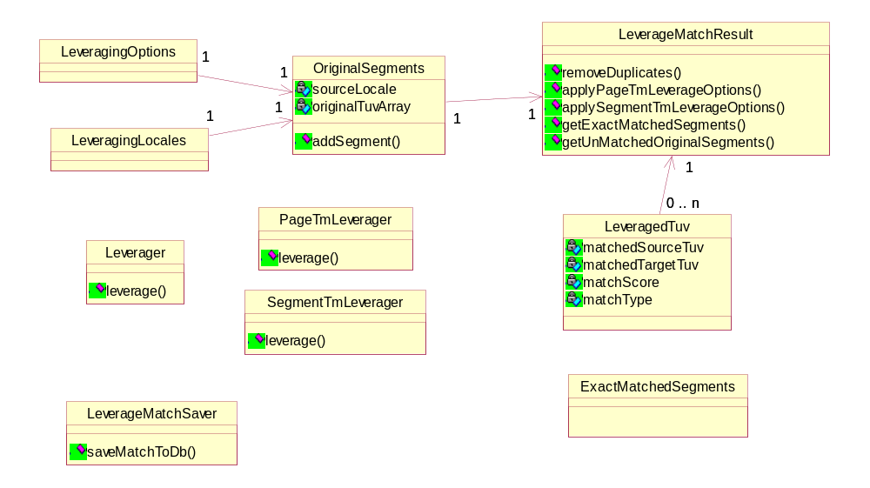

Class/Interface Descriptions

Leverager
Description: A class responsible for leveraging

Methods:

ExactMatchedSegments leverage(
SourcePage p_sourcePage,
GlobalSightLocale p_sourceLocale,
LeveragingLocales p_leveragingLocales,
LeverageOptions p_leverageOptions);

Leverage a page. Get matches from appropriate TMs, store matches in leverage_match table and return target segments that are leveraged with exact matches.

Params:
p_sourcePage - source page object. External_page_id and a collection of source TUVs are retrieved from this object.
p_sourceLocale – source locale of the page.
p_leveragingLocales – leveraging locales defined in each workflow.
p_leverageOptions – tm profile object. It contains user selected leverage options

Return:
ExactMatchedSegments object which contains a collection of target segment strings that are leveraged with exact matches. These strings are copied over to target job data (translation_unit_variant).

PageTmLeverager
Description: A class responsible for leveraging from Page TM

Methods:

LeverageMatchResults leverage(
OriginalSegments p_originalSegments,
String p_pageName);

Leverage some segments from Page TM. Finds matches from a specified Page TM and returns the result in LeverageMatchResults object.

Params:
p_originalSegments - a collection of original source segments. This object has LeverageOptions and LeveragingLocales in it.
p_pageName – page name.

Return:
LeverageMatchResults object which contains all match result information.

SegmentTmLeverager
Description: A class responsible for leveraging from Segment TM

Methods:

LeverageMatchResults leverage(
OriginalSegments p_originalSegments);

Leverage some segments from Segment TM. Finds matches from specified Project TMs in the Segment TM and returns the result in LeverageMatchResults object.

Params:
p_originalSegments - a collection of original source segments. This object has LeverageOptions and LeveragingLocales in it.

Return:
LeverageMatchResults object which contains all match result information.

LeverageMatchSaver
Description: A class responsible for saving leverage matches to the database

Methods:

void saveMatchesToDb(
LeverageMatchResults p_leverageMatchResults);

Save leverage matches to leverage_match table.

Params:
p_leverageMatchResults - LeverageMatchResults object which contains all match result information.

Dynamic Model

Scenario
This section describes how the fresh import and re-import are performed.
- PageImporter sends leverage request to Leverager.
- Create OriginalSegments from SourcePage.
- If latest match for re-import option is not selected, Leverager sends leverage request to PageTmLeverager. If the page is not imported before PageTmLeverager returns an empty LeverageMatchResult.
- Get OriginalSegments that contains original TUVs that didn’t get matches from PageTmLeverager.
- Sends leverage request to SegmentTmLeverager.
- Merge two LeverageMatchResult objects returned by PageTmLeverager and SegmentTmLeverager. Save match results to the database.
- Create ExactMatchedSegments object from the merged LeverageMatchResult.
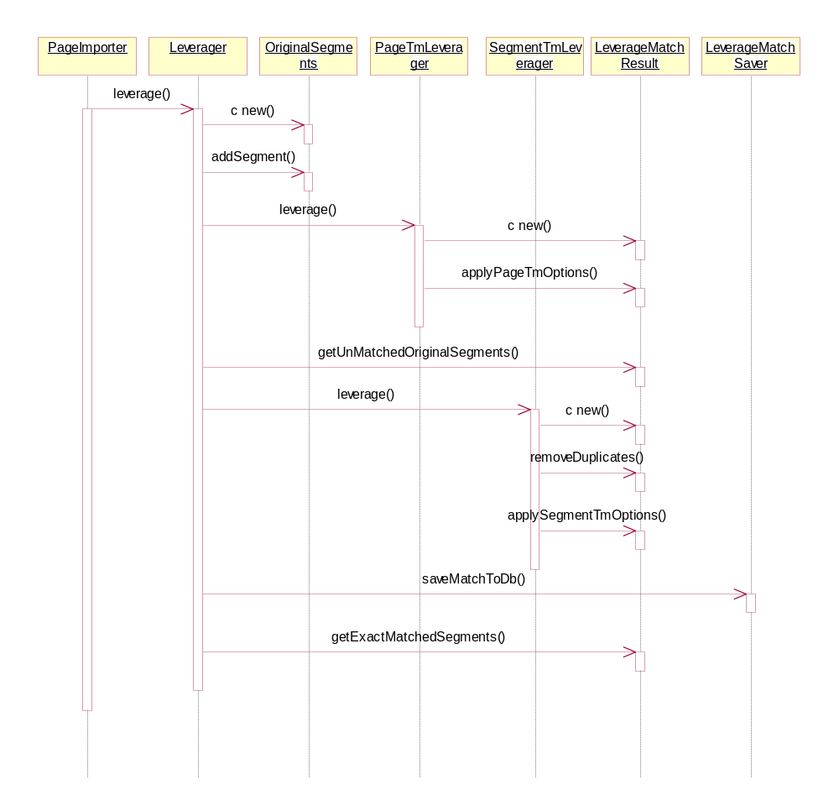

Algorithms

Leverage a page
- Get a collection of original source TUVs from SourcePage object and remove ones with types listed in Exclude Item Types options in Tm Profile.
- To get a better leverage performance, remove all duplicates from the list of original source TUVs. Duplicate here means the segments that have the same exact match key and type. Ids of removed segments must be stored somewhere to make duplicate match results for the removed segments and save them in leverage_match table later.
- If a page has been imported before and latest match for re-import is not selected, do Page TM leveraging.
- else, do Segment TM leveraging.
- Take the result of leveraging above, make necessary duplicate match results mentioned in the step #2 and store them to leverage_match table.
- Compose complete segments for the segments in which the main segments are exact matches. Take all exact matches (including composed segments) and create ExactMatchedSegments object and return it.

Page TM leveraging
- For each translatable segment, retrieve source segments in the Page TM that have the same exact match keys as the original segment, along with corresponding target segments in the TM.
- Test if the type of the retrieved segment is different from the original segment. If it is, make all matched target segments either an exact match or demote according to the Type Insensitive leveraging option in Tm Profile.
- For each matched target segment, test if they are multiple translations, If they are, and if No Multiple Exact matches option is selected, pick any segment and make it an exact match and demote others. If No Multiple Exact Matches option is not selected, demote all segments.
- If Leverage Localizable option is selected, repeat #1 through #3 for localizable segments.
- If there are segments that didn’t find matches, do Segment TM leveraging for them.

Segment TM leveraging
- For each translatable segment, pull out subflows from the main segment just as we do when populating Segment TM. See “TM Population and Indexing” document. All segments will have x-id and subflow order attributes as seen in leverage_match table schema.
- Retrieve source segments in the Segment TM that are similar to the original segment by querying index table using Dice’s coefficient formula. When querying index tables, only indexes that belong to Project TMs that are specified in Project TMs to leverage from option in TM Profile. If Multilingual Leveraging option is turned off, only indexes that are marked as source locale are queried. Only the matches that have the similarity measures that exceed the value entered in Fuzzy Match Threshold option are considered as the match candidates.
- For each target locale,
  - Remove duplicates (there can be the same segments in different TMs).
  - Keep only a number of matches specified in Number of Matches option. Discard the rest.
  - Take all 100% matches and see if they are Type Difference, Case Difference, Whitespace Difference or Code Difference. Give them appropriate match state and make them either stay 100% or take penalty from the score according to the options the user chose.
  - If there are more than one 100% matches, either keep one of them 100% and demote the rest or demote all of them according to Multiple Exact Matches option.
  - Tag Substitute matches with 100% score so exact matches can be copied to target job data segments and p-tag error check can be skipped.
- If Leverage Localizable option is selected, retrieve source segments for localizables in the Segment TM that have the same exact match keys as the original segment, along with corresponding target segments in the TM. When querying Segment TM, only Project TMs that are specified in Project TMs to leverage from option in TM Profile are queried. If Multilingual Leveraging option is turned off, only segments that are marked as source locale are queried.
- Test if the type of the retrieved segment is different from the original segment. If it is, make all matched target segments either an exact match or demote according to the Type Insensitive leveraging option in Tm Profile.
- For each matched target segment, test if they are multiple translations, If they are, either keep one of them 100% and demote the rest or demote all of them according to Multiple Exact Matches option.

Tag Substitution
A prerequisite of this method is that the target segment is 100% match to the original segment so that each tag in the original segment has a corresponding tag in the target segment (except for eraseable tags).
- Take an original source segment and corresponding target match.
- Search for the tags in the original and target segment that meet the following condition and replace the one in the target segment with the one in the original segment.
  - Types are the same.
  - The number of subflows in the tags is the same.
  - The type of each corresponding subflow is the same.
- Record the substituted tags in the target segment and repeat #2 until all tags are substituted.

Compose Complete Segment
A prerequisite of this method is that the main segment of the matched target locale must be 100% exact match.
- For each target segment with subflows that finds matches in Segment TM, take its original source segment, all exact matches for the main segment and subflows.
- Take the main segment and patch exact matches for subflows in. Patch the original subflows in where the exact matches are not found.

Deployment Considerations
Leverage_match table needs to be dropped and recreated with new attributes. All jobs must be completed before updating to 4.5. Or the leveraging results of active jobs are lost.

Non-functional Requirements
N/A

Table Schema
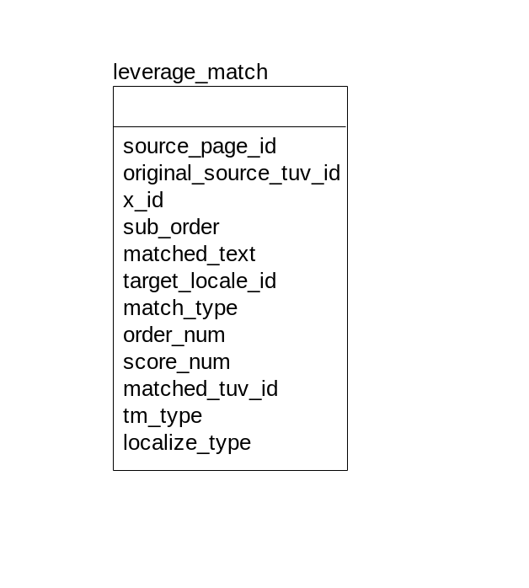
- Original_source_tuv_id is an reference to an id in translation_unit_variant (job data) table.
- X_id is x attribute value in TMX tag (bpt, ph, etc). sub_order is an order of a subflow in the tag x_id designates. A combination of original_source_tuv_id, x_id and sub_order can specify a certain subflow. X_id and sub_order starts with 1. If x_id is 0, it specifies a main segment. If x_id is –1, it indicates that the matched_text is a whole segment containing all subflow texts.
- Matched_tuv_id is a reference to an id in one of TUV table in TM. It is only informational. This is used only for debug purpose and shouldn’t be used in our production code. Tm_type (Segment TM or Page TM) and localize_type (translatable or localizable) help locate a table matched_tuv_id belongs to.

