TM Management

Version History | Date | Comments
1.0 | 4/22/2003 | TM Management design overview.
1.1 | 4/30/2003 | Added hotspots section.

1. Overview 2
1.1. TM Management 2
1.2. TM Statistics 2
1.3. TMX Import 2
1.4. TMX Export 2
1.5. TM Maintenance 3
1.6. Concordance Lookup 3
2. Implementation Design - Backend 5
2.1. TU and TUV Structure 5
2.2. TU and TUV Attributes 5
2.3. TM Definition 5
2.4. TM 5
2.5. TM Manager 6
2.6. TM Import 6
ImportOptions 7
2.7. TM Export 8
ExportOptions 9
2.8. TM Maintenance Manager 9
3. Implementation Design – Hotspots 10
3.1. Concurrency and Synchronization 10
3.2. Writing to the TM 11
3.3. Reading from the TM 12
3.4. TM Maintenance Query Management 12
4. Implementation Design – GUI 14
4.1. Overview 14
4.2. TM Management 14
4.3. TM Import 15
4.4. TM Export 16
4.5. TM Maintenance 18

Overview
TM Management addresses the management of TMs and TM data on a large scale. For leveraging and other data-related questions, see the TM Design documentation.

The following functionality is described in this document:

- TM creation, deletion, and modification
- (TM Profiles management)
- TM Statistics
- Import and export of TM data
- TM Maintenance
- Search and Replace
- Concordance Search

TM Management
- Create a new TM
  - Specify name, description, organization
  - Specify source language (and target languages?)
  - Specify user-defined attributes for TUs and TUVs
- Delete an existing TM including all its data
- Modify existing TM
  - Add target languages (delete target languages) ?
  - Add, delete, rename user-defined attributes

- (Maybe allow manipulation of TM Profiles through this API).

TM Statistics
Provides a quick overview over the data contained in a TM.
- Source language and target languages
- Number of TUs, number of TUVs, number of TUVs per language

TMX Import
Import TMX data from various vendors into a TM:
- Support TMX variants: native TMX+GXML, TMX Level 1 & 2, Trados TMX.
- Attribute population and manipulation: set creation and modification timestamps, set user-defined attributes
- Import options: if a duplicate TUV exists,
  - overwrite the TU
  - merge new and existing TUs
  - discard the new TU
- Interactive process: import screen shows progress bar and error messages.

TMX Export
Export TMX data from a TM to external files:
- Support TMX variants and levels: native TMX+GXML, TMX level 1 and level 2
- Filter options that select which TUs and TUVs get exported:
  - export all TUs
  - filter by TU attributes
  - filter by source (and/or target) language
- Interactive process: export screen shows progress bar and error messages. Shows export statistics (no. of TUs, TUVs) and provides access to the export file.

TM Maintenance
Terminology and TM data share many common properties, but strangely enough, TM data has traditionally been kept opaque, and common data access and manipulation functions are often missing. It is not possible to inspect the TM database. It is not possible to bring up TUs in a viewer window (very much like a Terminology Viewer), or to edit or delete individual TUVs and TUs.

TU and TUV editing gives TM Managers the means to control and improve the quality of the data in TMs. It provides standard data management functions like viewing and editing of TUs/TUVs, approving entries and removing duplicate or incorrect data.
- Provides generic browsing of all TUs and TUVs in a TM
- Provides concordance search and normal search functionality (fuzzy, exact, regular expression)
- Provides filtering of all TUs by the following criteria:
  - Creation date, creation user, modification date, modification user
  - User-defined TU attributes (is present, equals, does not equal…)
  - Source and/or target TUV contains a given search string
- TUV display can be restricted to a source and target locale.
- TU Editor
  - Allows deleting entire TUs, or TUVs from TUs
  - Allows adding, modifying and clearing user-defined attributes on TU/TUV (e.g., approval status, read-only marker)
  - Provides a validation function to find similar TUs and to allow the TM Manager to merge or remove any unwanted duplicates (also useful for controlled authoring, the consistent use of “preferred phrases” guarantees later TM matches)
  - Provides a search and replace function: source TUVs can be searched for and filtered, then the content of the source and target TUVs can be modified.
- TUV Editor
  - Allows modifying the TUV value
  - (Allows adding new TUVs in new languages)

Concordance Lookup
Allows localization participants to search the TM for concordances in a separate browser window (accessed through the System 4 UI). TUs will be displayed as a browsable list with next and previous buttons. The concordance window will also provide access (for privileged users) to the TM Maintenance dialog.
- Provides concordance search
- Provides filtering of TUs by the following criteria:
  - Creation date, creation user, modification date, modification user
  - User-defined TU attributes (is present, equals, does not equal…)
- TUV display is restricted to the relevant source and target locale.

Implementation Design - Backend
Note: the TM Management object model is the same as that of Terminology. For import and export, the common logic has been factored out into com.globalsight.importer and com.globalsight.exporter. The import logic is being used by Terminology and Snippets; the export logic is being used by Terminology.

TU and TUV Structure
See Shigemichi’s TM design documents.

TU and TUV Attributes
TUs and TUVs should carry user-defined attributes and at least one system-defined attribute called “Status” with values “new”, “reviewed”, “approved”, and “read-only”.

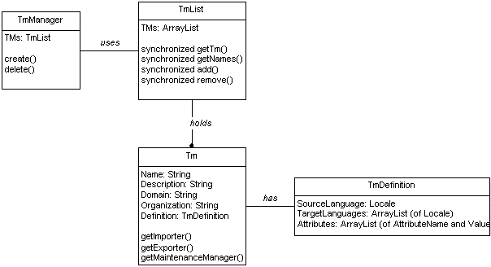

TM Definition
The TM Definition specifies which languages are known to be in the TM, and what user-defined attributes should be maintained on TUs and TUVs:
- Languages known to be stored in the TM: one language is marked as “source”, the others are target.
- Attribute names and the list of allowed attribute values.

TM
The TM object holds standard descriptive attributes like name, description, domain, organization, and also a TM Definition object. The TM hands out helper objects that implement import, export, and maintenance (editing, search & replace). The TM object and all helper objects are responsible to ensure proper read/write synchronization on the data and the TmDefinition, so that the definition cannot be altered as long as an import is in progress.

TM Manager
The TM Manager manages TMs in a TmList object. The TmManager is responsible for creating and deleting TMs, ensuring that no two threads create (or delete) the same TM at the same time. It is also responsible for creating any necessary physical tables to store the TM data.

TM Import
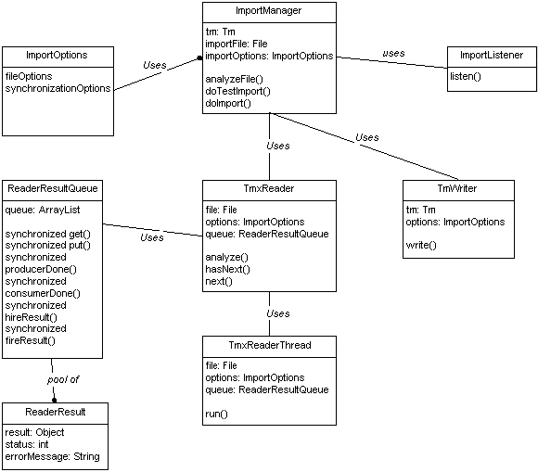

Importing TMX data is implemented as a pipeline between a TMX Reader and a TM Writer. The process is orchestrated by an ImportManager, which also sends status information in regular intervals to an Import Listener, so an interactive UI can be updated and progress be monitored.

The Reader is responsible for reading TUs from a TMX file. It performs error checking and any necessary conversions (e.g., from Trados TMX to real TMX). The reader’s first action is to analyze the input file, which consists of verifying its syntactic validity and determining the number of entries it contains.

When the actual import takes place, the reader delegates reading to a separate ReaderThread, which asynchronously reads TUs from the input file and puts them into the ReaderResultQueue. This design ensures optimal concurrency between reader and writer, while controlling the use of available resources (memory, cpu) and allowing a clean shutdown of the pipeline in case of fatal errors or user intervention.

The ImportManager retrieves entries from the Reader (which itself retrieves them from the ReaderResultQueue) and sends them to the writer, either one by one or in batch mode. If the number of entries processed so far indicates an update to the UI should be sent, the ImportManager sends a synchronous notification to the ImportListener.

The Writer is responsible for saving TUs to the TM, according to the synchronization options specified in the ImportOptions object. It provides 2 methods, a single-entry write() and a batch-mode writeEntries(). Only the single-entry write() needs to be implemented.

ImportOptions
Holds file and synchronization options.
- FileOptions: describe the input file, file type, encoding.
- Synchronization Options: describe how TUs are added to the TM:
  - Overwrite: TUs from the file overwrite TUs in the TM if the source segment is the same.
  - Merge: TUs from the file are merged with TUs in the TM, so any new TUVs in a TU are added to the existing TUs.
  - Discard: TUs from the file are discarded, if TUs with the same source segment already exist in the TM.

TM Export
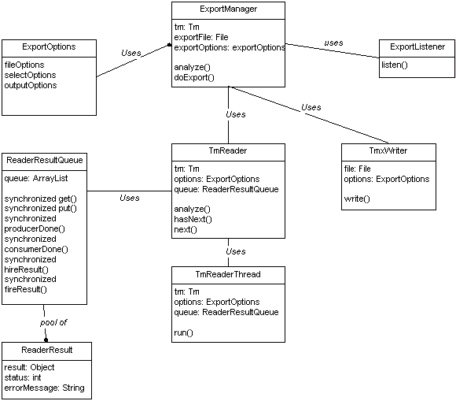

Exporting TM data is implemented as a pipeline between a TM Reader and a TMX Writer. The process is orchestrated by an ExportManager, which also sends status information in regular intervals to an Export Listener, so an interactive UI can be updated and progress be monitored.

The Reader is responsible for reading TUs from a TM database according to the select options specified in the ImportOptions object. The reader’s first action is to analyze the validity of the select options and to determine the number of entries that will be exported.

When the actual export takes place, the reader delegates reading to a separate ReaderThread, which asynchronously reads TUs from the TM and puts them into the ReaderResultQueue. This design ensures optimal concurrency between reader and writer, while controlling the use of available resources (memory, cpu) and allowing a clean shutdown of the pipeline in case of fatal errors or user intervention.

The ExportManager retrieves entries from the Reader (which itself retrieves them from the ReaderResultQueue) and sends them to the writer, either one by one or in batch mode. If the number of entries processed so far indicates an update to the UI should be sent, the ExportManager sends a synchronous notification to the ExportListener.

The Writer is responsible for saving TUs to the TMX file, according to the file options and output options specified in the ExportOptions object. It provides 2 methods, a single-entry write() and a batch-mode writeEntries(). Only the single-entry write() needs to be implemented.

ExportOptions
Holds file, select, and output options.
- FileOptions: describe the output file, file type, encoding.
- Select Options: describe which TUs are selected from the TM:
  - Mode: specifies whether “all” TUs are to be read, or whether a “filter” should be applied.
  - Language: a kind of filter which reads all TUs that have a TUV in a given language.
  - Filter: specifies any filter expressions to apply, e.g. “attribute=value”, “modification date > mm/dd/yy” or “TU does (not) contain a TUV in French”.
- Output Options: describe how TUs and TUVs are to be written to the output file, e.g. if user and system-defined attributes should be output, which level of TMX to use etc.

TM Maintenance Manager
TODO.

Implementation Design – Hotspots

Concurrency and Synchronization
With the introduction of multiple readers and writers in the Gold TM design, the issue of controlling concurrent access must be addressed.

We distinguish between database readers and writers, and data readers and writers.

Database Readers: all processes that need to get TM properties like name, description, or the list of all TM names in the system, and their properties.
Example: the “TM Management” main screen.

Database Writers: all processes that modify TM properties like name, desciption, contained target languages, user-defined attributes, etc. Database writers in general (this holds for Terminology too), may need to update all of the database data, e.g. apply default attributes to all TUs or delete all TUVs in a given locale.
Example: the “Modify TM” screen (and TM Maintenance?).

Data Readers: all processes that read TU data from a TM under the assumption that the current TM definition remains unchanged, and that only few or none of the TUs in the TM change. There are quick readers like the Leverager, and slow readers like Import/Export, and TM Maintenance.
Example: Import TM, Export TM, TM Maintenance, Leverager, Statistics

Data Writers: all processes that write TU data to a TM under the assumption that the current TM definition remains unchanged. There are quick writers that update only a single TU, and slow writers, like TM Import.
Example: TM Importer, TM Maintenance, TM Updater

The traditional way (the Trados way, that is) of managing concurrency is to let fast transactions use primitive data synchronization and to require slow transactions to open the TM in exclusive mode, under control of the PM. This model is known and understood by users and can therefore be used for an initial implementation. There are some technical caveats, and the model only fits well into the overall translation process when multiple TMs are present (Trados users typically have one TM per locale pair, or a well-managed central TM that gets split into subsets as needed). With only a few or a single TM in the system, the model can seriously harm concurrency.

The technical considerations consist of properly locking the TM and TM data as reader and writer, and to define the action when locking fails.

Leveraging: leveraging should register itself as a reader of the TM. If the TM is locked by a writer, leveraging should be skipped. Import should not fail.

TM Update: when the TM gets updated during export, the updater should register itself as data writer. If the TM is already locked by a writer, the updater should stop (not fail). Pages should maintain a “TM updated” status (like the “TU indexed” status) and there should be an explicit “Update TM” button on the Jobs screen so the PM can run the TM update manually.

TM Import: should register itself as database reader and data writer (and lock out the TM Updater).

TM Export: should register itself as both data and database reader.

TM Management: should register itself as database writer.

TM Maintenance: should register itself as data or database writer, depending on which operation gets performed (search & replace, or update of individual TUs).

Writing to the TM
According to the synchronization modes described above, each write to the TM first needs to check if a TU exists in the TM that has the same source TUV as the new TU.

For each source TUV S in TU T:
Compute the exact match key K of S
Retrieve the TU T_{tm} from the TM that has the source TUV with exact match key K.

If the synchronization option is “discard”, and a TU T_{tm} was found, discard T.

If the synchronization option is “overwrite”
If a TU T_{tm} was found, delete T_{tm} and all its TUVs
Add T as new TU to the TM.

If the synchronization option is “merge”,
fully retrieve all TUVs of T_{tm} if not done so already
for all locales L in T:
for all TUVs in locale L in T:
If the TUV does not exist in T_{tm}, add it as new TUV to T_{tm}.

Example of merging:
T_{tm}
TUV_{en_US}: Abracadabra
TUV_{de_DE}: Abracadabra

Merged with

T
TUV_{en_US}: Abracadabra
TUV_{de_DE}: Abracadabra!
TUV_{de_DE}: Simsalabim!

Result:

T_{tm}
TUV_{en_US}: Abracadabra
TUV_{de_DE}: Abracadabra
TUV_{de_DE}: Abracadabra!
TUV_{de_DE}: Simsalabim!

Reading from the TM
Reading from the TM involves two kind of filters:
- Primary filter (“language filter”): if set, only TUs containing a TUV in a given locale are retrieved; if not set, all TUs are retrieved.
- Secondary filter (“selection filter): the list of TUs is further reduced by removing TUs that fail to fulfil certain conditions based on:
  - Creation date, creation user, modification date, modification user
  - Tests on user-defined attributes (exists, equals, does not equal)
  - Tests on presence of TUVs in a given language

Naïve evaluation of these filters will create one SQL statement for the primary filter and evaluate the secondary filters in memory, on the retrieved TU and TUV objects.

A better implementation should attempt to combine the primary and secondary filters into one SQL statement so that a minimal number of candidate TUs is returned. Any filter expressions that cannot be efficiently added to the SQL statement still need to be evaluated in memory. The physical tables should contain dedicated columns for timestamps, as well as for user-defined attributes (limited to, say, 5), so that the primary and secondary filters can be efficiently combined.

Example: retrieve all TUs created by “cvdl” after 1/1/2003:
SELECT id FROM translation_unit
WHERE tm_id = 123
AND creation_user = ‘cvdl’
AND creation_date >= TO_DATE(‘1/1/2003’)

Example: retrieve all TUs that have a TUV in German and belong to project X:
SELECT DISTINCT tu.id
FROM translation_unit tu, translation_unit_variant tuv
WHERE tuv.tm_id = 123
AND tuv.locale_id = 32
AND tu.id = tuv.tu_id
AND tu.attr1 = ‘X’

TM Maintenance Query Management
Although these queries are similar to the TM Export queries (they too use primary and secondary filters), their evaluation and processing gets complicated by the highly interactive nature of TM Maintenance.

The user experience should be one of a two-level query: first, run the primary filter and select all TUs with a given source language. Show this as a browsable list, indicating how many TUs there are in total. If the user then applies a secondary filter, the first list should be further restricted, and an updated count of total TUVs should be shown. This second list must also be browsable in real-time.

It is unclear yet how much “real-time” response the system will be able to provide, since it may be more efficient to recompute primary queries as soon as a secondary filter is applied.

Browsing the TUs should be implemented based on scrollable RecordSets. The TmMaintenanceManager maintains a reference to the ResultSet and retrieves the necessary data as the user scrolls forward and backward. The TmMaintenanceManager itself should be kept in the user’s session (like the ImportManagers already are). Care must be taken to free allocated resources when the session times out.
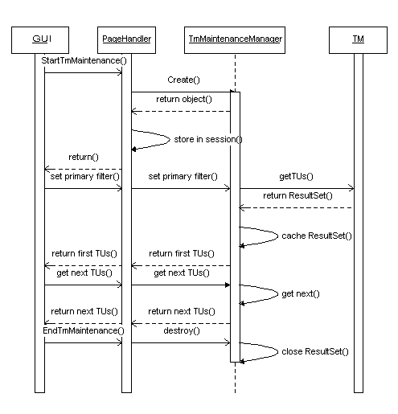

Implementation Design – GUI

Overview
The UI is web-based and supports 3 main activities:
- TM Management: the main screen accessible from the administrator’s or project manager’s system menu that allows creation, modification, deletion of TMs and leads to the import and export screens.
- Concordance Search: a separate window to search a TM for concordances, independent of any translation activity. This window is accessible from the Localization Participant’s menu and other locations like the online editor’s resource screen or the segment editor.
- TM Maintenance: a window to browse TM data and to edit TUs.

TM Management
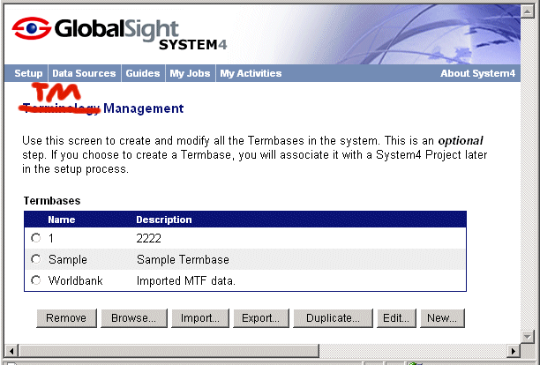

TM Import
Step 1
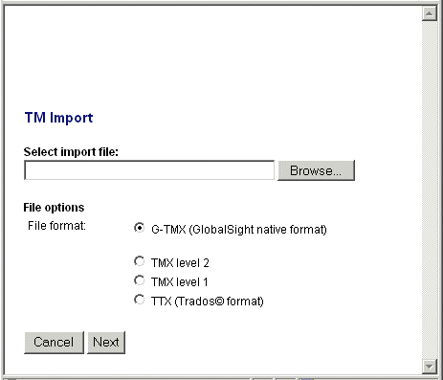

Step 2
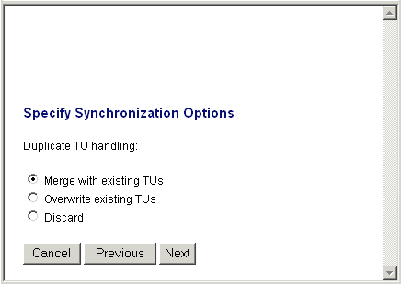

Step 3 = same as terminology import; progress bar, messages.

TM Export
Step 1
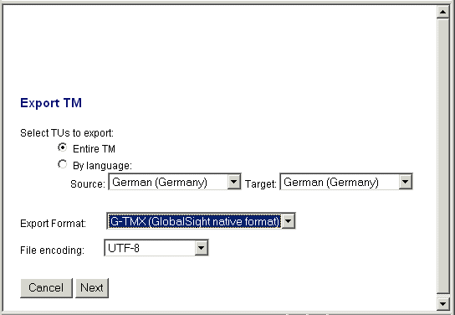

Step 2
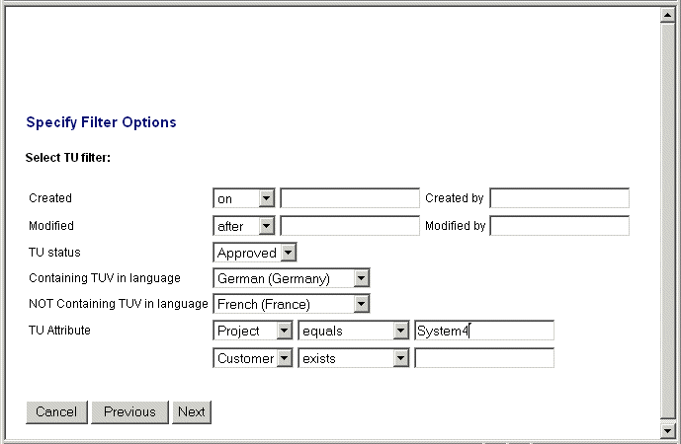

Step 3
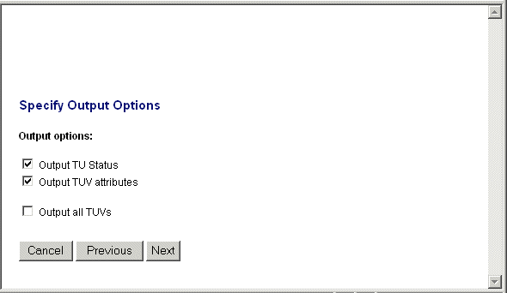

Step 4 = same as terminology export; progress bar, messages, link to download file.

TM Maintenance
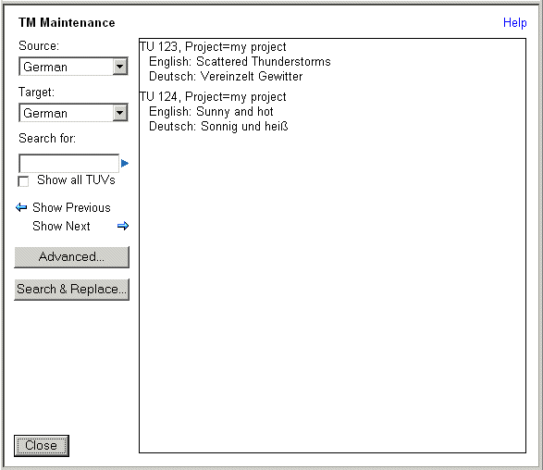

Advanced Filter Options (or, Advanced Search Options):
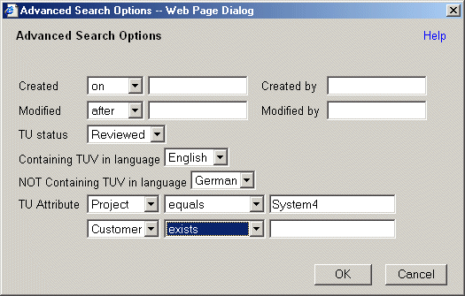

Search & Replace Dialog:
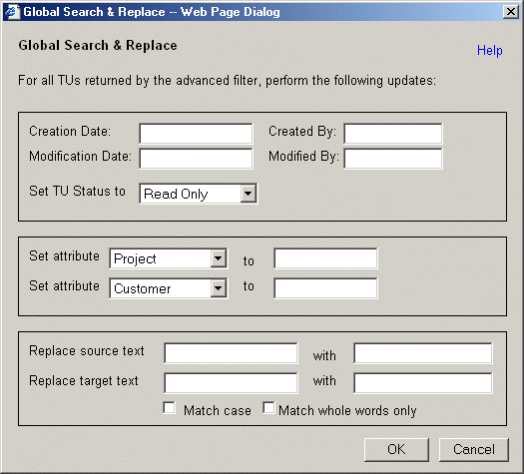

TU Editor, accessible by clicking on a TU:
