GlobalSight Automation Testing

Revision History
# | Date | By | Description
1.0 | 29 July. 09 | Dawn Cao | First draft

Table Of Content
Table Of Content 2
Introduction 3
Coverage with Test Automation 4
Regression Testing 4
Fixed issue verification 4
System Requirements & Initial Setup 4
Hardware 4
Software 4
Setup ……………………………………………………………………………………..7
Pre-setup ……………………………………………………………………………………..7
Maual Testing Scope(TBD). 8
Need optimize points: 9

Introduction
The document will give one plan preparing automation testing script which will be used to do a full testing for one new GlobalSight release build or patch to make sure new bugs can be found earlier and old issues do not happen on new release.

Script will be developed with SilkTest.

Coverage with Test Automation
Scope that are covered by the Automation Module are regression testing and some fixed issue verification.

Regression Testing
These are the tests that are run for the main function check. Testcases will be sased on
- Smoke testing_GlobalSight.xls
- GlobalSight Project Test Cases_20081104.docx. It was developed in 2008 and may be used as automation testcase.
May add or delete some testcase when develop script.

Fixed issue verification
Search and find some important bug in bug tracker or typical issue in the past to test to know they do not happen in the new release again.

System Requirements & Initial Setup

Hardware
The machine used to run the tests must have the configuration mentioned below at the minimum.

- 1GB. Ram
- 5 GB of free disk space.

Software
- Windows XP( Default language is English).
- TCP/IP Network installed.
- Latest GlobalSight build.
- SilkTest2008R2SP1_TR
- IE7

FrameWork

Note: Create one folder to be used as work directory, and map it to S drive.
- FrameWork structure

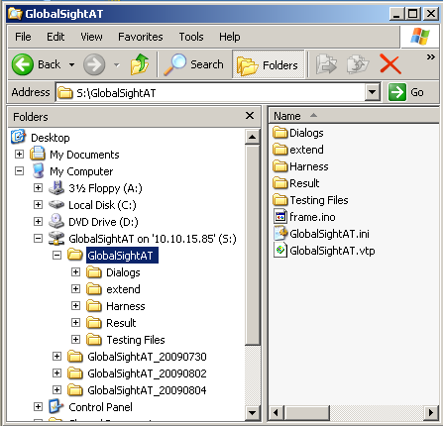

Dialogs: It will include all module definition files.
Extend: Enable extensions file setup.
Harness: It will include frame and project plan.
Result: It will include testcase running result.

- In silktest, structure looks like
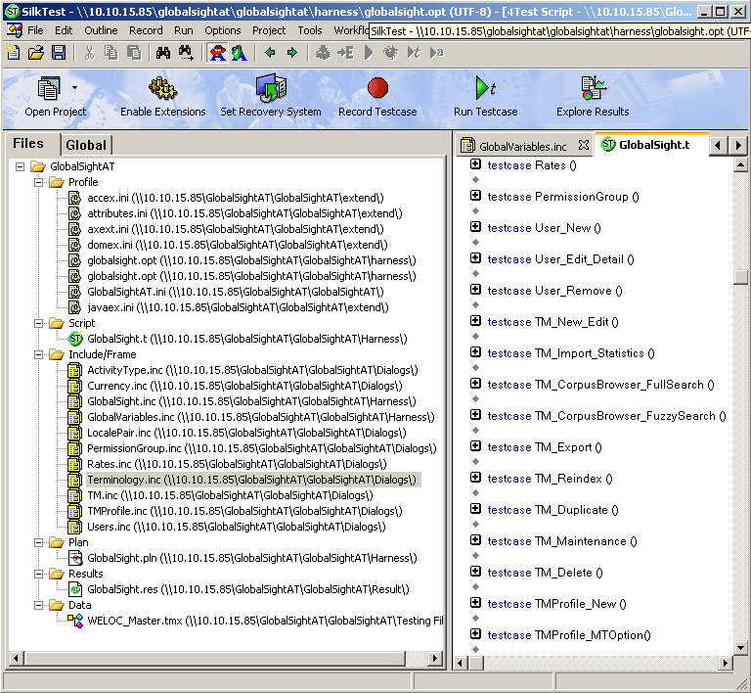

- Copy GlobalSightAT to local disk and Add corresponding files under GlobalSightAT project.

Setup
- Install IE7.
- Install Silktest
- Do “Enable Extensions” to make sure Runtime set as below.
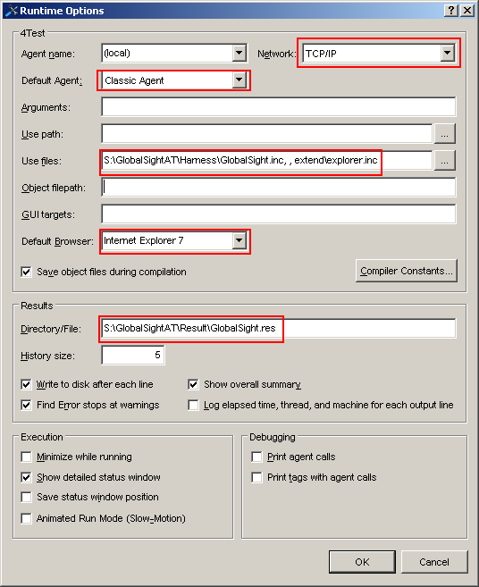

- Copy GlobalSightAT Kit to local disk and share and map drive to S:
- Set Options by “Options -> Open Options Set -> S:\GlobalSightAT\Harness\GlobalSight.opt”
- Set display resolution to 1280*1024.
- Exit any other Application running.
- Turn off Screen saver programs.
- Logon with admin user and give full permission for “Administrator” to make sure to do full testing for possible functions.

Pre-setup
- Create one company and make sure
- 4 locale pairs have been created
- 28 Activity Types have been created.
- US Dollar has been created.
- 12 workflows have been created.

- Set CompanyName in GlobalVariables.inc file.
- Setup URL in GlobalSight.inc
- Install JRE manually.

Maual Testing Scope(TBD)
1. Setup -> Snippet Import.
[Dawn] No testing file.

- Data Source -> SGML

[Dawn] The function is not often used.
- Terminology_Edit

[Dawn] After terminology is edited, it can’t be saved. See GBS-565. After the bug is fixed, the testcase needs to be modified.

- Terminology -> Maintenance and Input Modules: The function is not often used. And I am not sure its work theory.

Schedule
- Phase 1: Develop script Regression Testing section when time is allowed before 7.1.6.0 is released.

1. The first week(Aug. 3 ~ Aug. 7). Complete all possible modules under "Setup" menu.
2. The second week(Aug. 10 ~ Aug. 14). Complete all possible modules under "Data Source", "Guides", "My Jobs", "My Activity" and "Reports".
3. The third week(Aug. 17 ~ Aug. 21). Complete logic job and activities use cases.
4.The fourth week(Aug. 24 ~ Aug. 28). Go though and optimize script.
- Phase 2: View bugs fixed on 7.1.4.0 and 7.1.5.0 and create testcase.

Need optimize points:
- Locale Pair: remove. How to select the en-zh? [Dawn]
- TM_Export: 1) “Download Export File” does not work. 2) How to define “Save as” windows?
- TM_Delete: if Demo does not exist, how to control if? Add exception.
- TMProfile_Edit: add job check point.
- TMProfile_MTOption: add job check point.
- Terminology_Export: 1) “Download Export File” does not work. 2) How to define “Save as” windows?

