Art Text file for: JDAftertreatment_DLM
Resource: JDAftertreatment_DLM

Translator instructions (Please Read):
Please replace the English term in the “Translation” column with the translation.

Please maintain any special formatting (e.g. colour, bold, italics, capitals) and character spacing in the translation of the English terms.

Text in red refers to questions and queries for you to answer and DOES NOT represent translatable text. Should there be no text in red, then there are no questions or queries and you can ignore this instruction.

English Text | Translation
Slide12.jpg
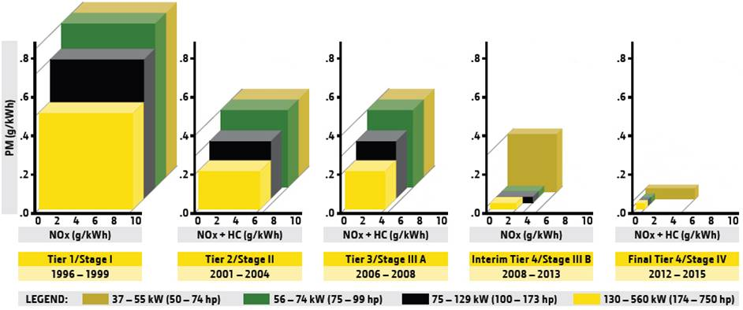
PM (g/kWh) | PM (g/kWh)
NOx (g/kwh) | NOx (g/kwh)
NOx + HC (g/kwh) | NOx + HC (g/kwh)
Tier 1/Stage I | Tier 1/Stage I
Tier 2/Stage II | Tier 2/Stage II
Tier 3/Stage III A | Tier 3/Stage III A
Interim Tier 4/Stage III B | Interim Tier 4/Stage III B
Final Tier 4/Stage IV | Final Tier 4/Stage IV
LEGEND | LEGEND
37 – 55 kW (50 – 74hp) | 37 – 55 kW (50 – 74hp)
Slide 13_01.jpg
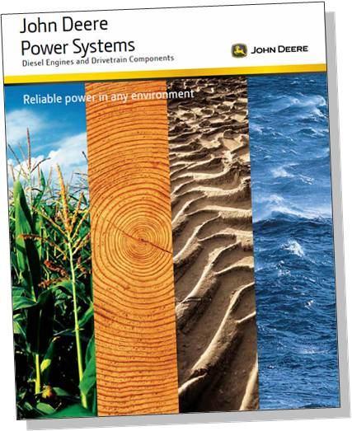
John Deere  Power Systems | John Deere  Power Systems
Diesel Engines and Drivetrain Components | Diesel Engines and Drivetrain Components
Reliable power in any environment | Reliable power in any environment
Slide 13_02.jpg
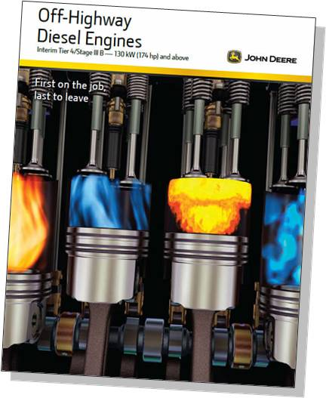
Off-Highway  Diesel Engines | Off-Highway  Diesel Engines
Interim Tier 4/Stage III B – 130Kw(174 hp) and above | Interim Tier 4/Stage III B – 130Kw(174 hp) and above
First on job  last to leave | First on job  last to leave
Slide 13_03.jpg
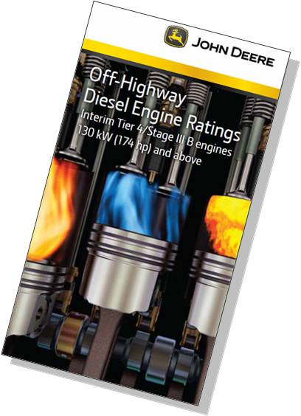
Off-Highway  Diesel Engine Ratings | Off-Highway  Diesel Engine Ratings
Interim Tier 4/Stage III B  130Kw(174 hp) and above | Interim Tier 4/Stage III B  130Kw(174 hp) and above
Slide 14_01.jpg
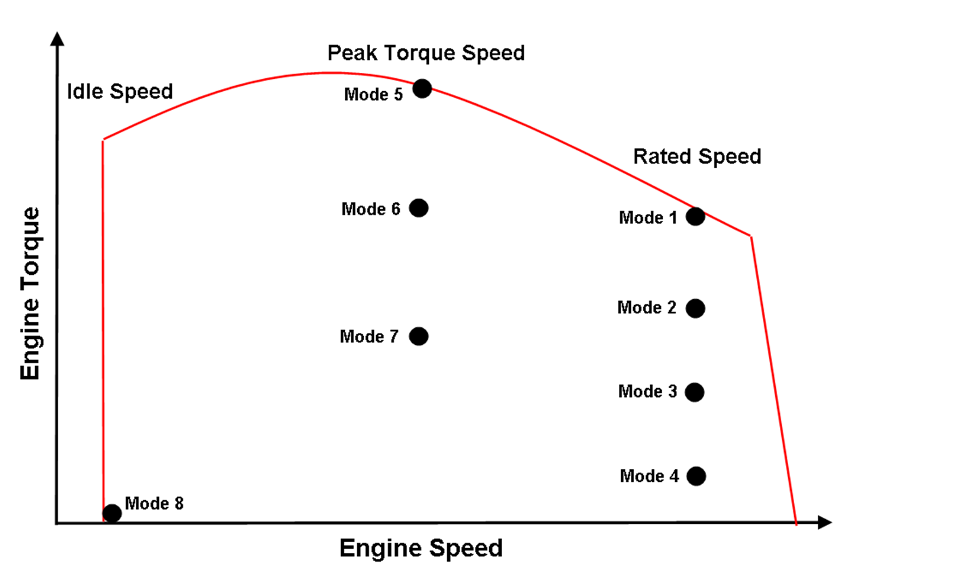
Engine Torque | Engine Torque
Idle Speed | Idle Speed
Engine Speed | Engine Speed
Peak Torque Speed | Peak Torque Speed
Rated Speed | Rated Speed
Mode 1 | Mode 1
Slide 14_02.jpg
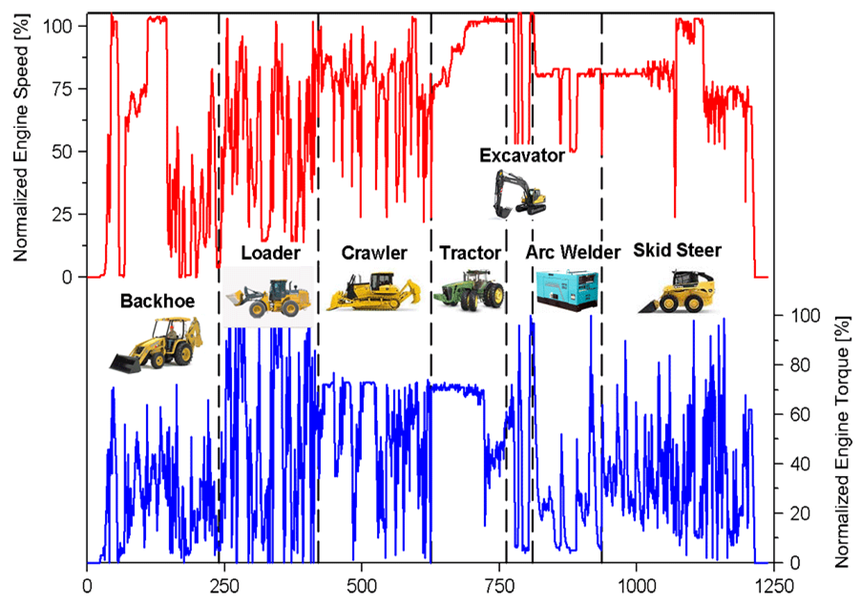
Normalized Engine Speed[%] | Normalized Engine Speed[%]
Normalized Engine Torque[%] | Normalized Engine Torque[%]
Excavator | Excavator
Backhoe | Backhoe
Loader | Loader
Crawler | Crawler
Tractor | Tractor
Arc Welder | Arc Welder
Skid Steer | Skid Steer
Slide 15_01.jpg
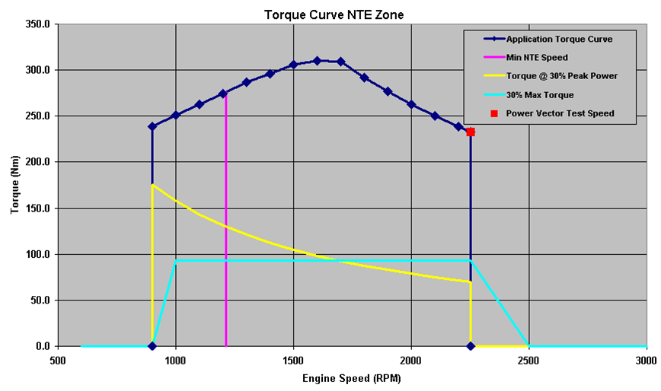
Torque (Nm) | Torque (Nm)
Engine Speed (RPM) | Engine Speed (RPM)
Torque Curve NTE Zone | Torque Curve NTE Zone
Application Torque Curve | Application Torque Curve
Min NTE Speed | Min NTE Speed
Torque @ 30% Peak Power | Torque @ 30% Peak Power
30% Max Torque | 30% Max Torque
Power Vector Test Speed | Power Vector Test Speed
Slide 16_01.jpg

Environment | Environment
EUROPA > European > Commission > Environment | EUROPA > European > Commission > Environment
California  Air Resources Board | California  Air Resources Board
UNITED STATES  ENVIRONMENTAL PROTECTION AGENCY | UNITED STATES  ENVIRONMENTAL PROTECTION AGENCY
Slide 107_01.jpg
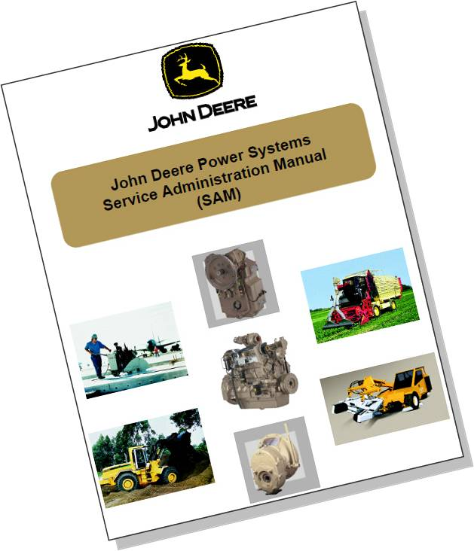
John Deere Power Systems  Service Administration Manual  (SAM) | John Deere Power Systems  Service Administration Manual  (SAM)
Slide 107_02.jpg
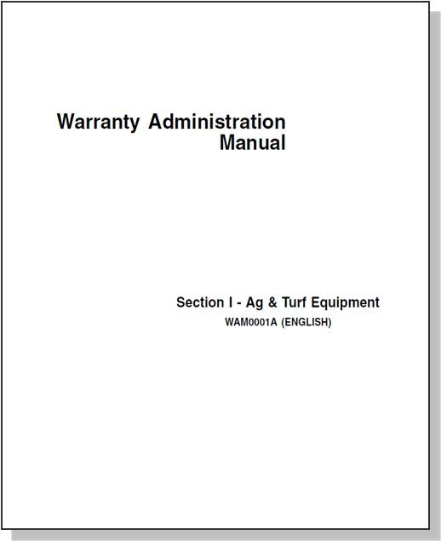
Warranty Administration  Manual | Warranty Administration  Manual
Section I – Ag & Turf Equipment  WAM0001A (ENGLISH) | Section I – Ag & Turf Equipment  WAM0001A (ENGLISH)
Slide 17_01.jpg, Slide 18_01.jpg, Slide 26_01.jpg, Slide 27_01.jpg, Slide 28_01.jpg, Slide 29_01.jpg
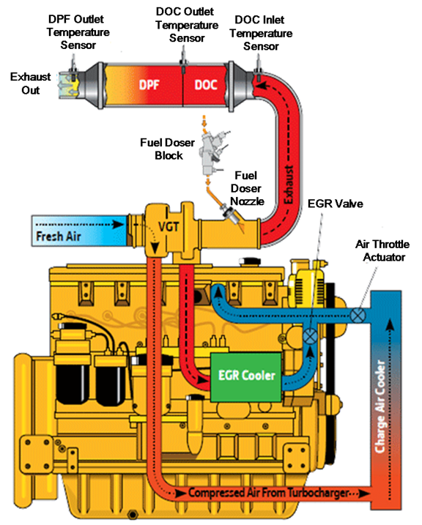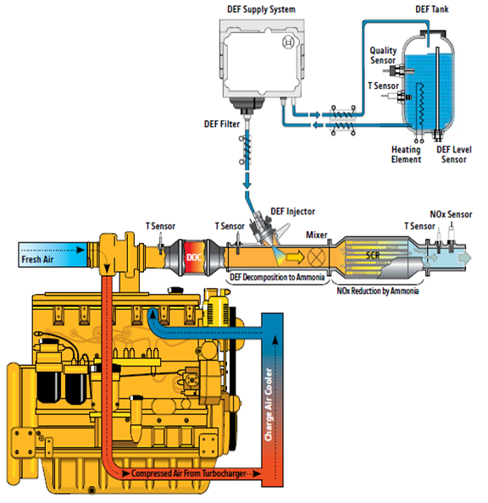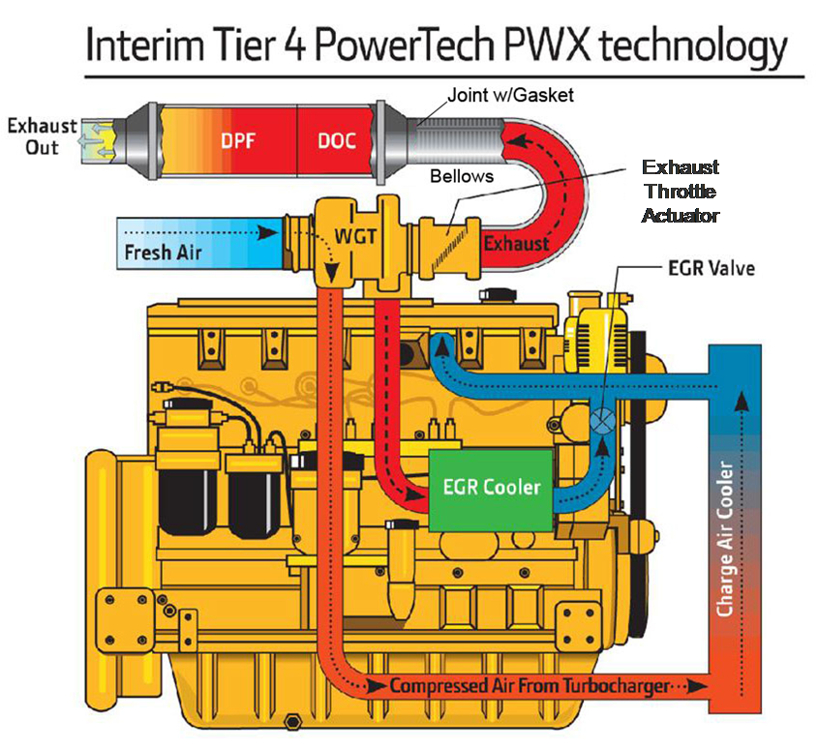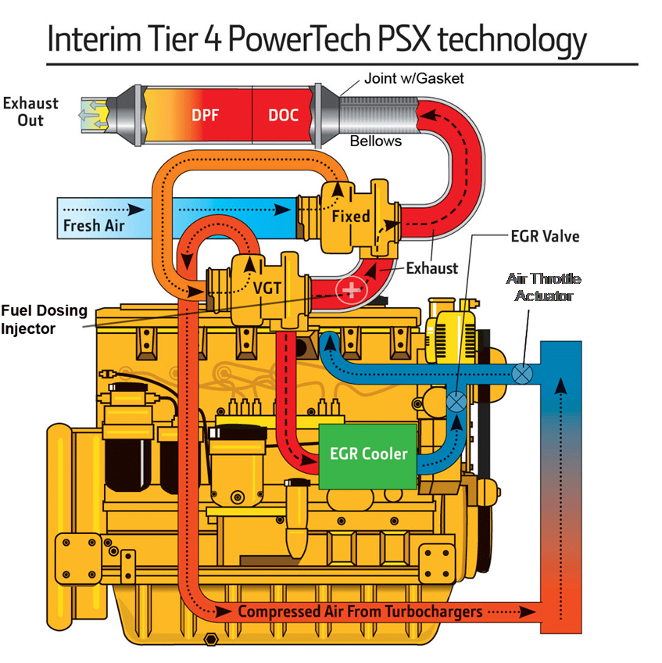
Fresh Air | Fresh Air
VGT | VGT
DPF | DPF
DOC | DOC
Exhaust | Exhaust
EGR Cooler | EGR Cooler
Compressed Air From Turbocharger | Compressed Air From Turbocharger
Charger Air Cooler | Charger Air Cooler
Exhaust Out | Exhaust Out
DPF Outlet Temperature Sensor | DPF Outlet Temperature Sensor
DOC Outlet Temperature Sensor | DOC Outlet Temperature Sensor
DOC Inlet Temperature Sensor | DOC Inlet Temperature Sensor
Fuel Doser Block | Fuel Doser Block
Fuel Doser Nozzle | Fuel Doser Nozzle
EGR Valve | EGR Valve
Air Throttle Actuator | Air Throttle Actuator
T Sensor | T Sensor
DEF Injector | DEF Injector
Mixer | Mixer
SCR | SCR
DEF Decomposition to Ammonia | DEF Decomposition to Ammonia
NOx Reduction by Ammonia | NOx Reduction by Ammonia
NOx Sensor | NOx Sensor
Heating Element | Heating Element
DEF Level Sensor | DEF Level Sensor
DEF Tank | DEF Tank
Quality Sensor | Quality Sensor
DEF Filter | DEF Filter
DEF Supply System | DEF Supply System
Joint w/Gasket | Joint w/Gasket
Bellows | Bellows
Exhaust Throttle Actuator | Exhaust Throttle Actuator
WGT | WGT
Interim Tier 4 PowerTech PWX technology | Interim Tier 4 PowerTech PWX technology
Fuel Dosing Injector | Fuel Dosing Injector
Fixed | Fixed

