# 1.Parameters of servo motor

Stroke: 500mm

Speed: 3000 laps/min

Load: 700N

Lap: 50; When the motor runs for 1 laps, the electric actuator will extend by 10mm

Communication frequency: 250k ; Because the communication frequency of the joystick is 250k, and the joystick and the motor use the same bus, the frequencies of the two must be kept consistent.

In order to change the communication frequency, prepare a RS485 to USB module in advance.

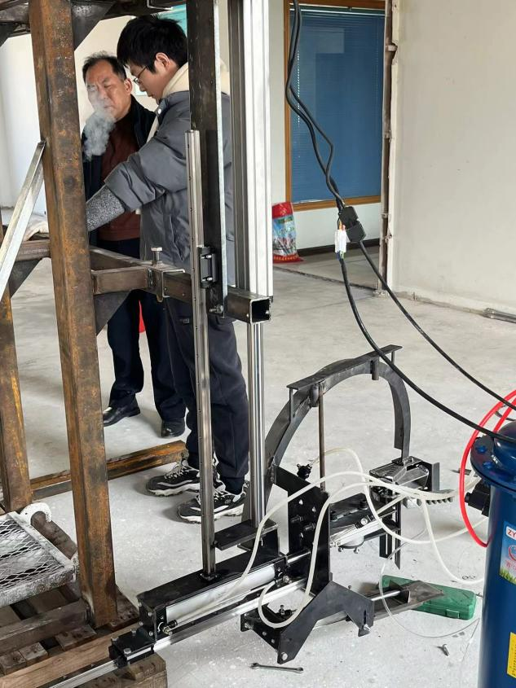.

actuator

2.Description of lib

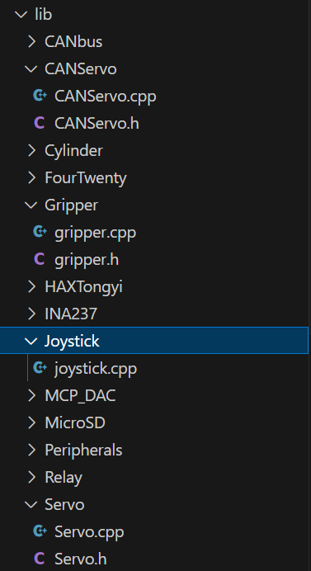

CANServo.h: It was written by Han Long, but I didn't use it.

Gripper.h: I wrote the code from line 89 to the end. class Gripper is used for the old machine.

HAXTongyi: It is an example provided by the manufacturer.

Servo: function of controlling servo motor

Joystick.cpp: controlCylinders() is used for testing

# 3.Process of controlling the motor

Step1: Turn on the motor power and then turn on the EE box power.

Note: The controller of the motor can only receive the NMT instruction from the PCB after it is started, and can only start CAN communication after successfully receiving the instruction.

Step2: Wait

Note: use the current code, after about twenty seconds, the motor will be enabled, and after another twenty seconds or so, you can control the motor using the joystick

Step3: After operating the actuator to 0 position(Stroke: 500mm), turn off the power

Note: The motor currently used is a relative value motor.