# 1.Parameters of servo motor

Stroke: 500mm

Speed: 3000 laps/min

Load: 700N

Lap: 50; When the motor runs for 1 laps, the electric actuator will extend by 10mm

Communication frequency: 250k ; Because the communication frequency of the joystick is 250k, and the joystick and the motor use the same bus, the frequencies of the two must be kept consistent.

In order to change the communication frequency, prepare a RS485 to USB module in advance.

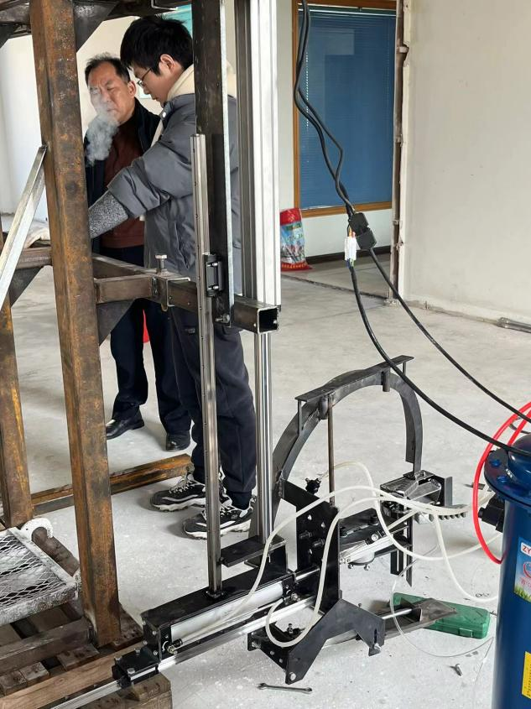.

actuator

2.Description of lib

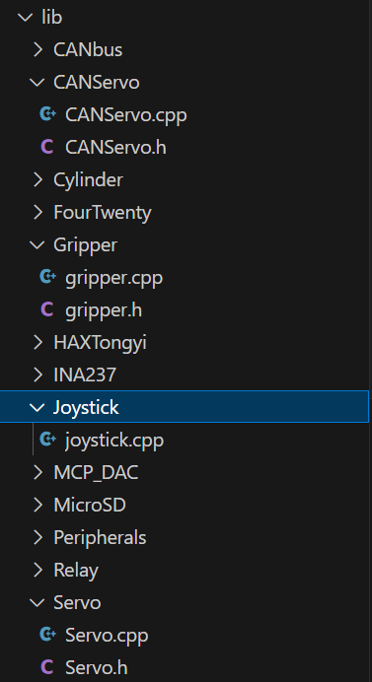

CANServo.h: It was written by Han Long, but I didn't use it.

Gripper.h: I wrote the code from line 89 to the end. class Gripper is used for the old machine.

HAXTongyi: It is an example provided by the manufacturer.

Servo: function of controlling servo motor

Joystick.cpp: controlCylinders() is used for testing

# 3.Process of controlling the motor

Step1: Turn on the motor power and then turn on the EE box power.

Note: The controller of the motor can only receive the NMT command from the PCB after it is started, and can only start CAN communication after successfully receiving the command.

Step2: Wait

Note: use the current code, after about twenty seconds, the motor will be enabled, and after another ten seconds, you can control the motor using the joystick.

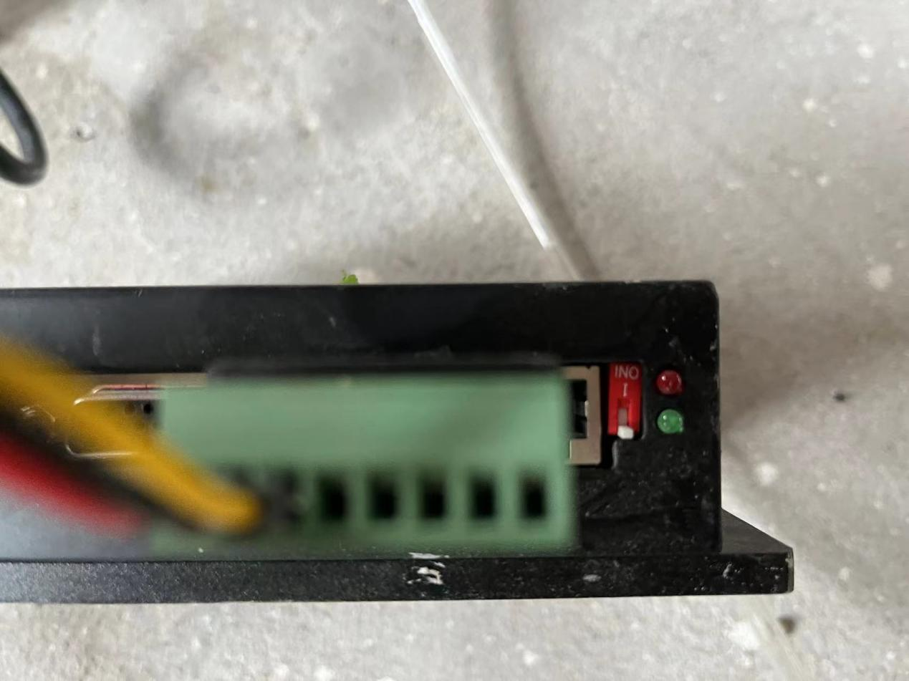

The red LED is an alarm light. When it flashes, it indicates that the motor or controller is running in error. The current solution is to power off and restart.

The green LED is the controller operation indicator. When it is always on, it indicates that the motor is already in the enabled state.

Step3: control

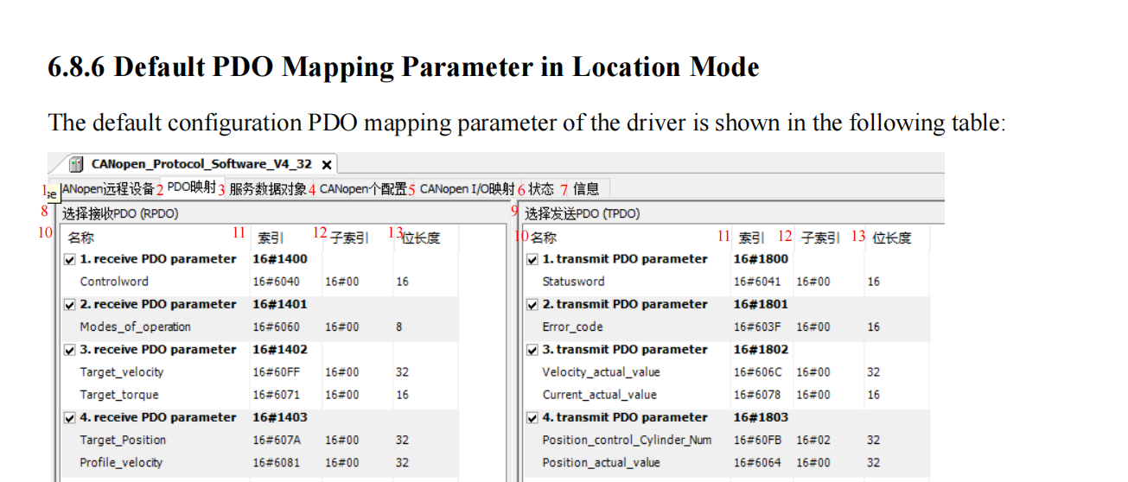

Use PDO; position Mode

Step4: After operating the actuator to 0 position(Stroke: 500mm), turn off the power

Note: The motor currently used is a relative value motor.

# code

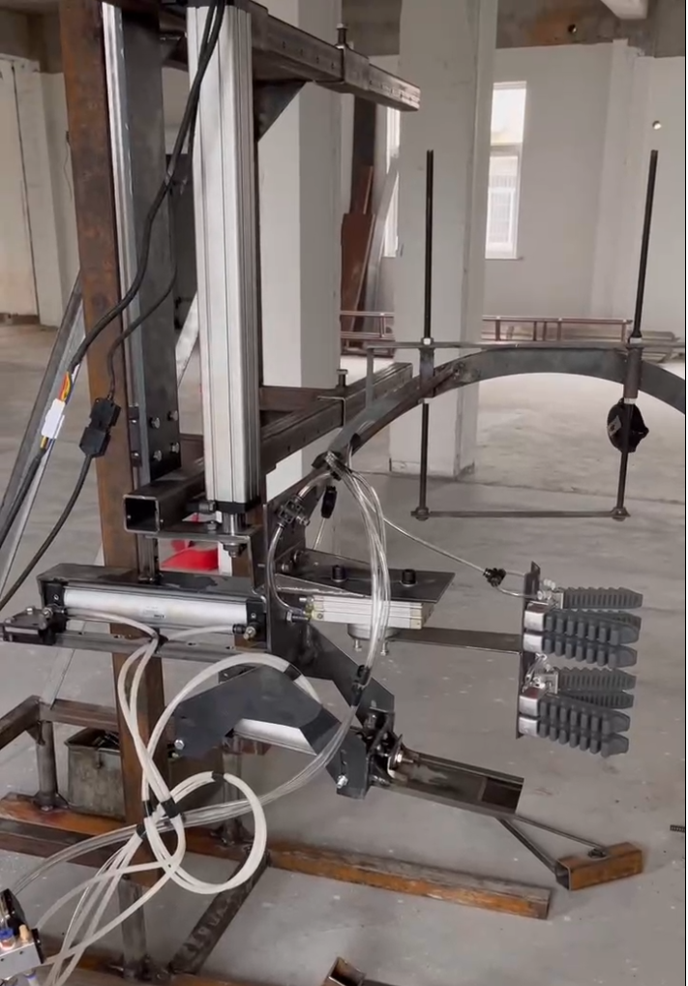

PIN EXTEND

PIN SECOND_CUTTER

PIN GRIPPER_POS & PIN GRIPPER_NEG

PIN ROTATION

* 1. definition of pin

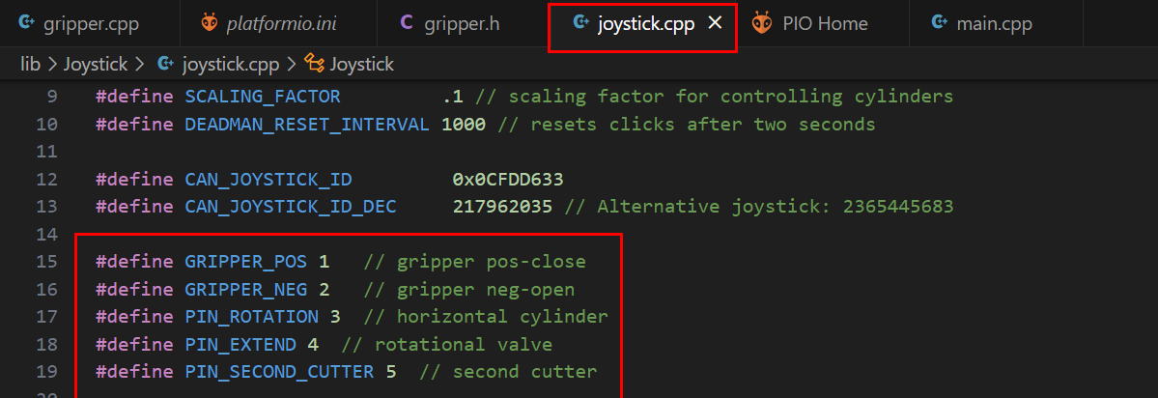

* 1. Sequence

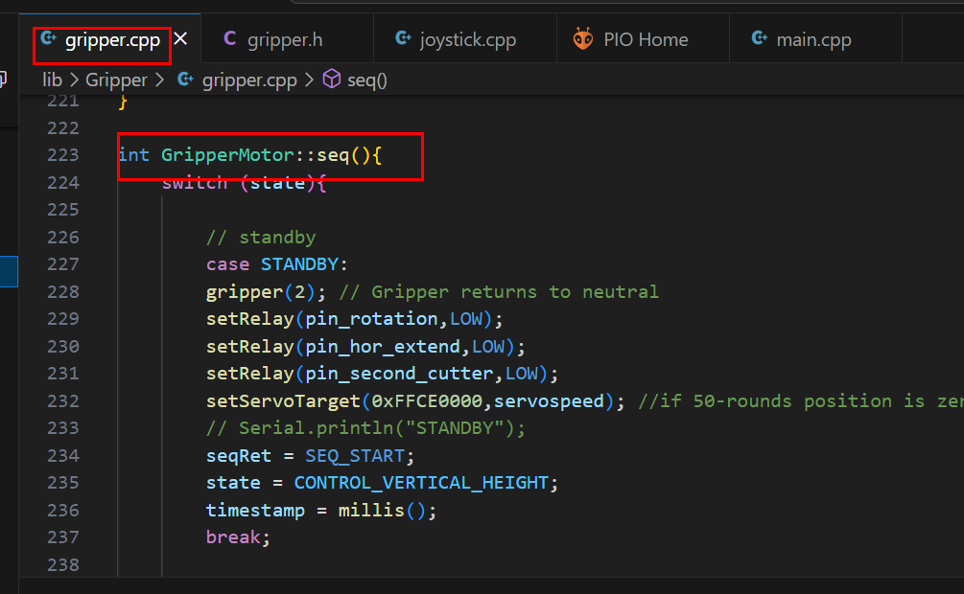

* 1. Time control of sequence

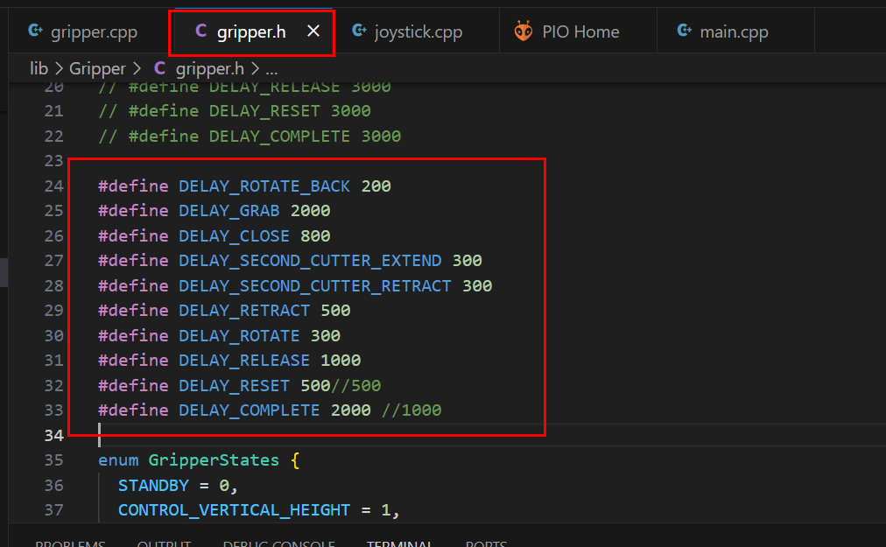

* 1. Set the limit position of the motor

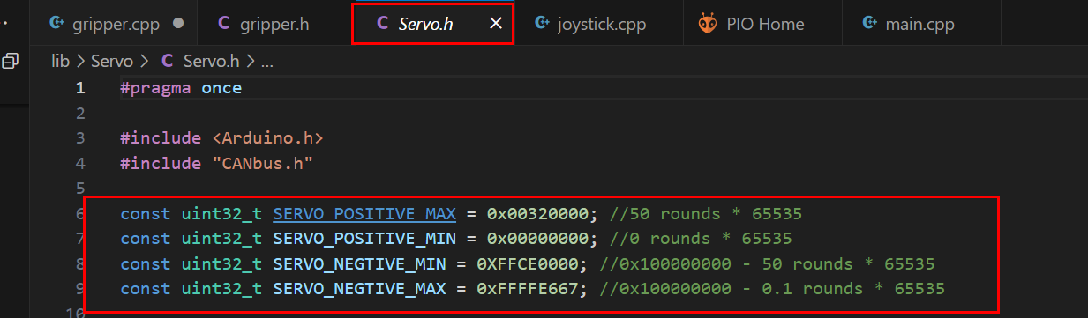

* 1. Set the speed of the motor

Generally set the motor to run at the fastest speed.

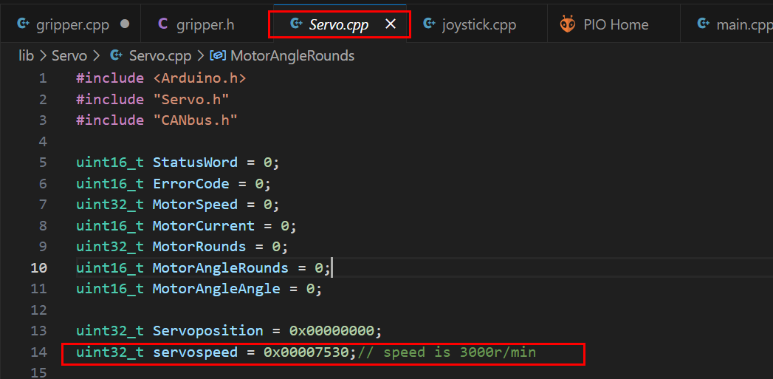

* 1. Feedback value of motor

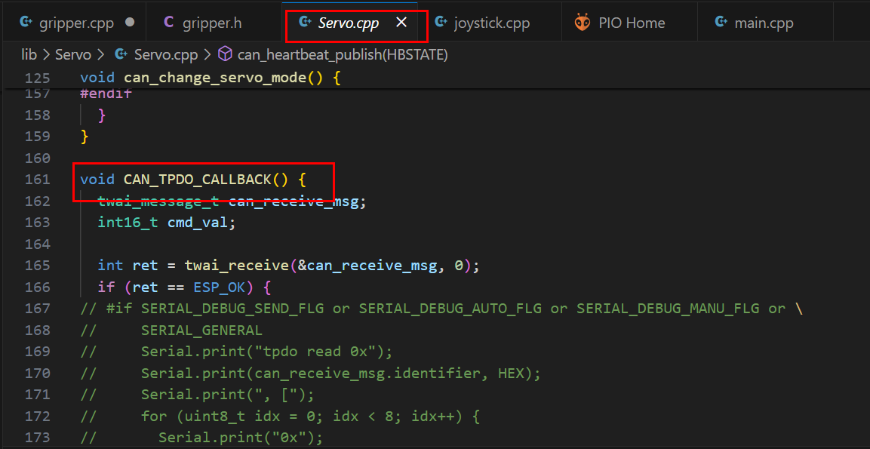

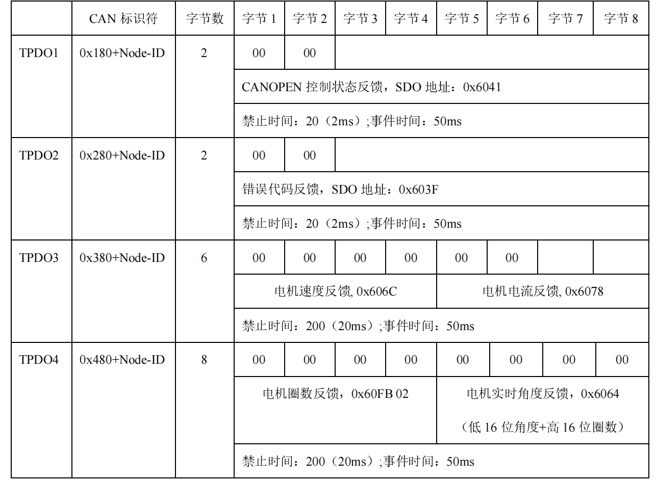

# Set the zero position

* 1. Currently,the position is set as the zero position when the stroke is 50cm.As shown in the picture.



There are two reasons for this setting. 1)The load of the motor is very heavy (about 20 kilograms), so when the power of the motor is turned off, the actuator will automatically slide to the bottom. 2)When the stroke is the maximum value, it is easier to calculate the command value for controlling the motor. For example, setting the stroke to 20cm means that the motor is retracted by 30 laps.

Note:The newly purchased backup motor is different from the one currently in use. The manufacturer said that the new motor has a "brake", which prevents the actuator from sliding to the bottom when the motor is powered off.

# Set the zero return mode

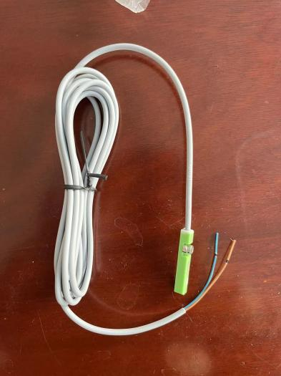

Connection:

P1 and P22 are short-circuited

P15 is connected to the brown wire

P20 is connected to the blue wire

Select zero return mode 1

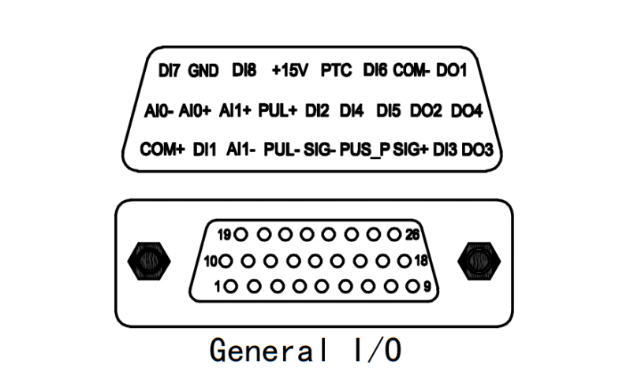









The zero return mode can only be enabled through the SDO communication mode

6.1 test process

Step 1 ：Fix the sensor to the motor

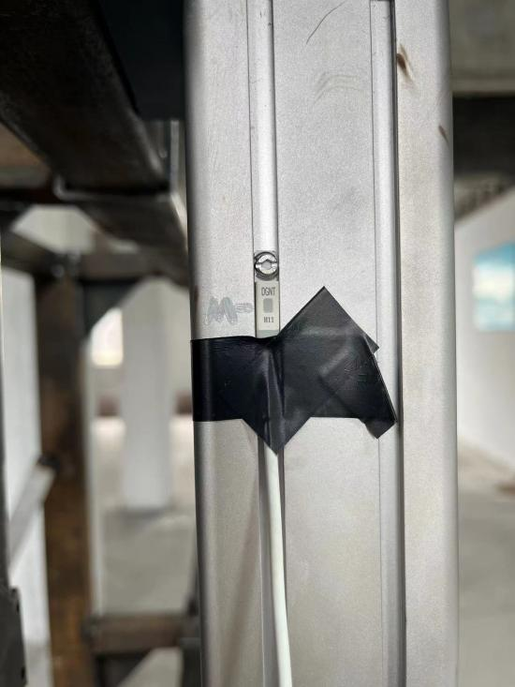

Note:The position marked with a white mark in the picture is the highest fixed position of the sensor. If the sensor is fixed higher than this mark, the controller may give an alarm；

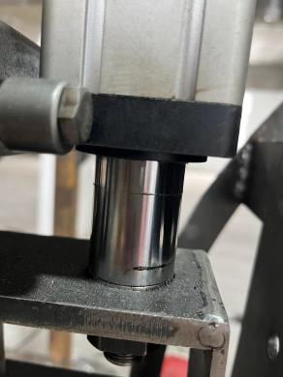 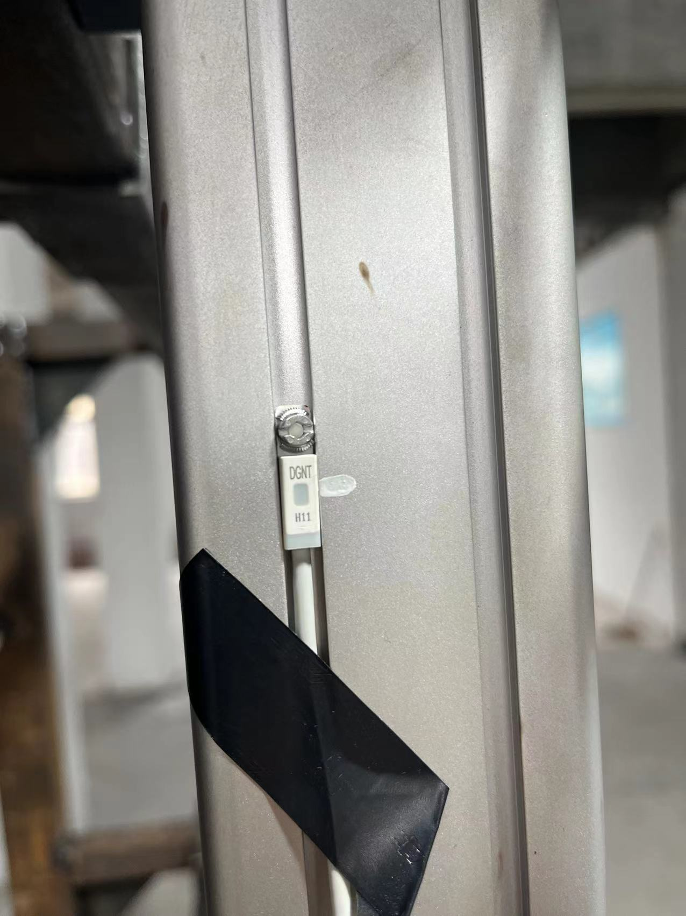

Current position

Step 2：Before executing the zero return mode, check the stroke of the motor

Note:After executing the zero return mode, the motor will continue to retract until the sensor signal is found. However, if the signal cannot be found during the retraction process, the controller will give an alarm；In other words, the position of the sensor must be higher than the position of the magnet inside the motor；

Step 3 ：Execute zero return mode

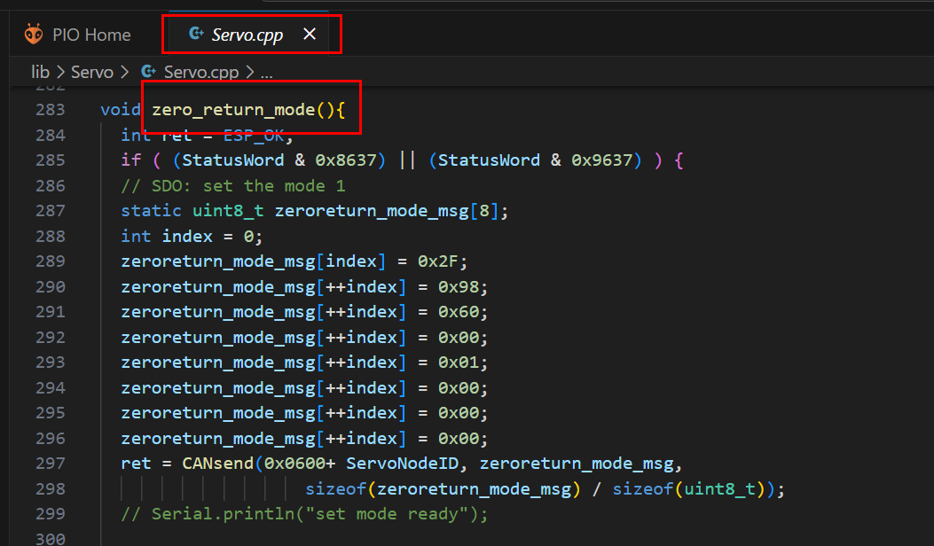

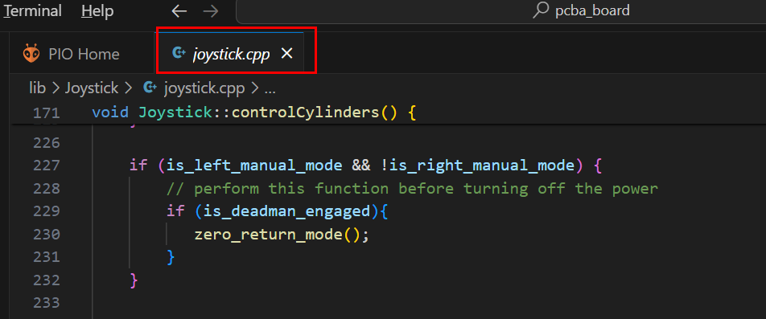

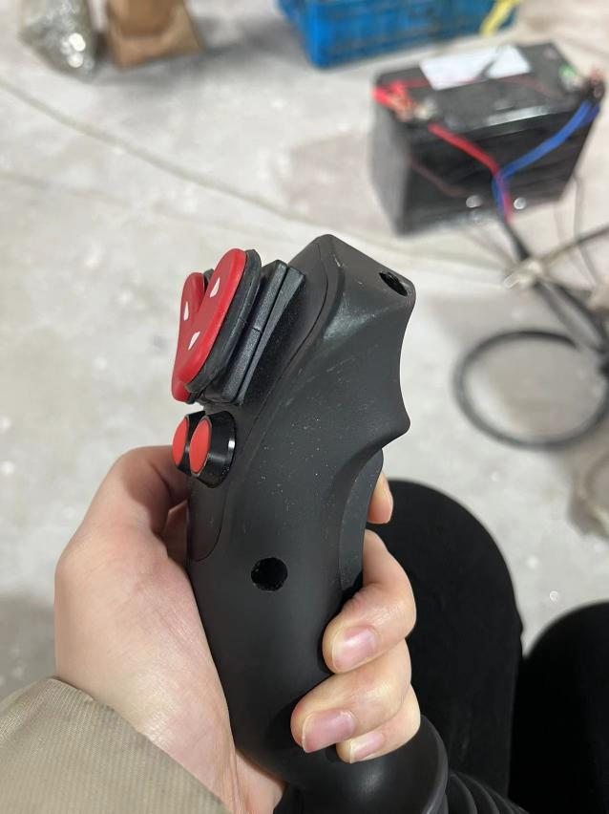

Note:The zero return mode must be executed after the servo motor is enabled,the status word should be 0x8637(1000011000110111) or 0x9637(1001011000110111)；I don't know the difference between them yet, I will inquire with the manufacturer later.

6.2 Some response messages of CAN communication

Set the mode 1 :

Command：0x060A(ID) 0x2F 98 60 00 01 00 00 00

Return: 0x058A(ID) 0x60 98 60 00 00 00 00 00

Set the motor speed :

Command：0x060A(ID) 0x23 99 60 00 DO 07 00 00

Return: 0x058A(ID) 0x60 99 60 00 00 00 00 00

Set the homing offset :

Command：0x060A(ID) 0x23 7C 60 00 00 00 00 00

Return: 0x058A(ID) 0x60 7C 60 00 00 00 00 00

Execute zero return mode :

Command：0x060A(ID) 0x2F FB 60 04 01 00 00 00

Return: 0x058A(ID) 0x60 98 60 00 00 00 00 00