**Title of project**

man2woman & woman2man translation with cycle GAN

**Problem statement**

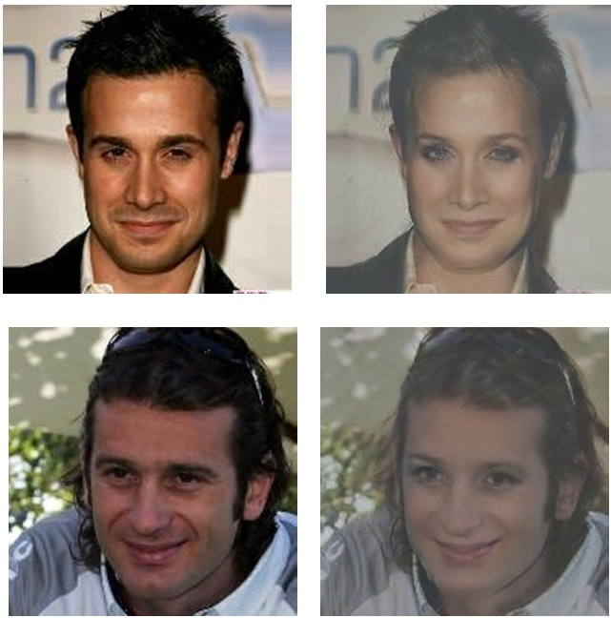 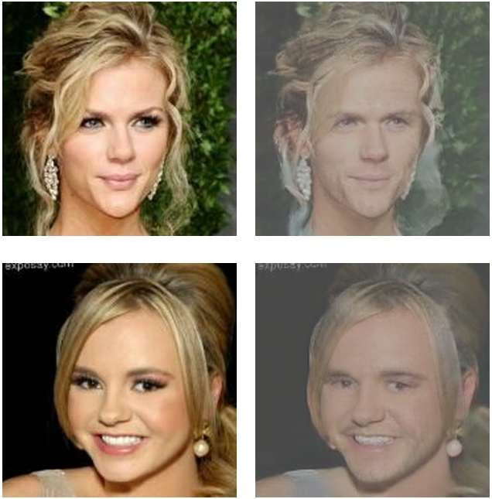

Using conditional cycle GAN and unpaired images, train a model, which can translate a man to a woman, or vice verse.

**Dataset**

Large-scale CelebFaces Attributes (CelebA) Dataset

**Evaluation Metrics**

1. FID
2. Loss(include generator loss, discriminator loss, cycle_consistent loss)