Sprint 3 Plan

SlugSense Smart Irrigation

Team: WebSwag

Release: Alpha

Sprint Completion date: 7/24/2017

Revision: 1

* Goals
  + Ensure the graph and the week data are presented and linked correctly.
  + Use Google material design for the log in page.
  + Make the alert/notification button work correctly.
  + Make the overall web page more material designed friendly (UI).
  + Final testing for release product.
* Task Listing
  + As a user, I want to have a better looking and functional login page so that I can efficiently enter the web page. (13 S.P.) (Priority #2)

Design a log in page using mentors’ mockup and material design.

* + As a user, I want alerts to be shown on the dashboard so I will have a clear idea if anything goes wrong (8 S.P.) (Priority #4)

Set up bonds and get the correct notification number.

* + (Code review and final wrap up) As a user, I want to see a functional website so that I can count on the product's reliability. (5 S.P.) (Priority #1 after Wednesday 7/21/2017)

Final testing and wrap up for release.

Make sure the website is functional.

* + As a user, I would like the web application to be overall simple, clear and uniform in regards to design and visualizing data. (21 S.P.) (Priority #3)

Change graph and other necessary according to material design and UI.

* + As a user, I want to be able to clearly read a chart with useful data without confusion or obstruction. (3 S.P.) (Priority #1 from 7/17-7/19)

Update week data correctly.

* Total hours for user story: 49 hrs.
* Team Roles
  + Tingting Wang, Hunter Bingham - Scrum master of Sprint 3, developer
  + DeShawn Rivers - Product Owner, Developer
  + David Rameriz - Developer
  + Zach Holbrook - Developer
  + Wookjin Jang - Developer
* Initial Task Assignment
  + David Ramirez, Tingting Wang, Deshawn rivers: Use Google material design for the log in page
  + Hunter Bingham: Ensure the graph and data are presented and linked correctly
  + Zach Holbrook, Wookjin Jang: Make the alert/notification button work correctly
  + All team members: Make the overall web page more material designed friendly
  + All team members: Final wrap up for the project, test and get the most updated version for final presentation
* Scrum Board:

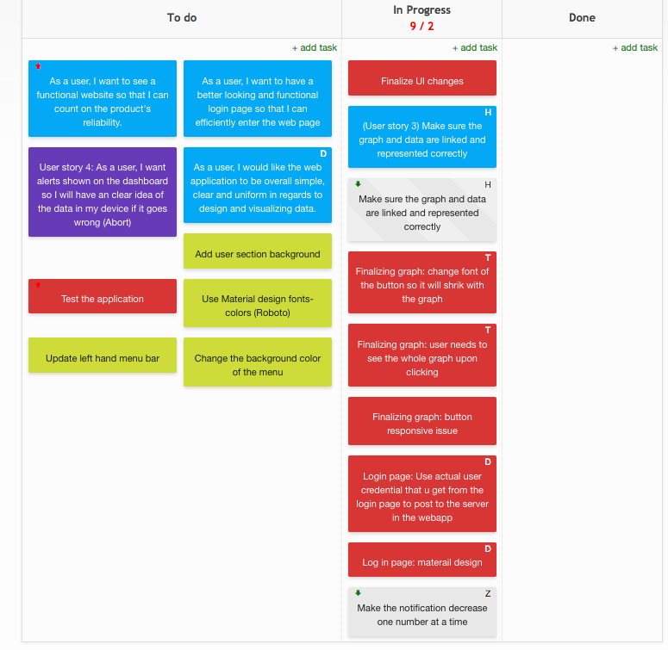

* Scrum Times:
  + Mon: 10am - 1pm
  + Tues: 1:30pm - 4pm
  + Weds: 10am - 1pm
  + Thurs: 1:30pm - 4pm
  + Fri: 12pm - 4pm
  + Sun: 4pm - 8pm