## Compare of the speed with multiprocessing or without

Without

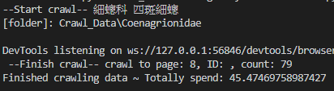

With

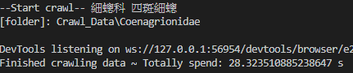

🡪Almost two times faster by using the multiprocessing

With

