CSCI 3290 Final Project

Name: Ng Ting Yuk SID:1155032539

I finished these two basic parts, Fabricate Google cardboard glasses and Binocular Stereoscope Images.

For Generate Stereoscope Images using a Single Image & Depth Map, I used GIMP to produce Stereoscope Images.

And for Add a Stereo Logo to a video / Add Synchronized Stereo Subtitles, I used MATLAB to finish this.

Extra Credit:

I have find more stereo image pairs to show 3D, one is my work and others are from other website.

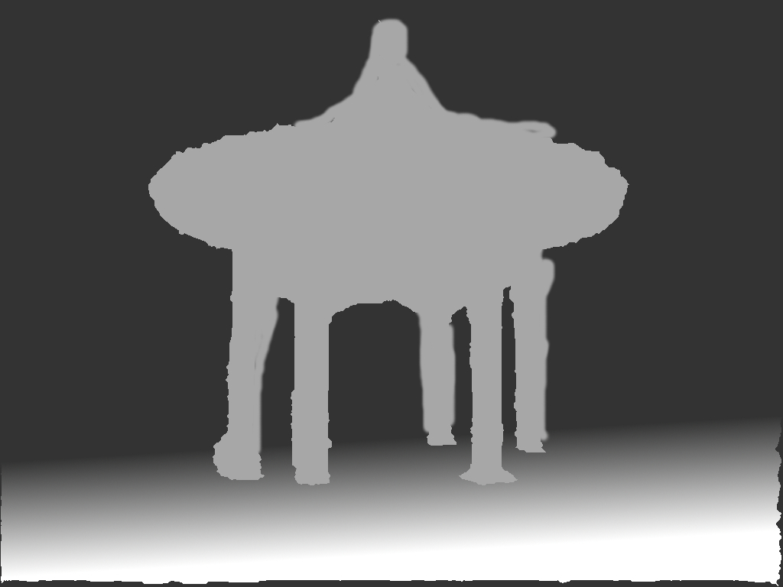

Design a friendly user-interface for your Android app.

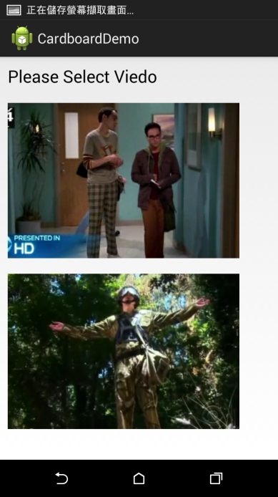 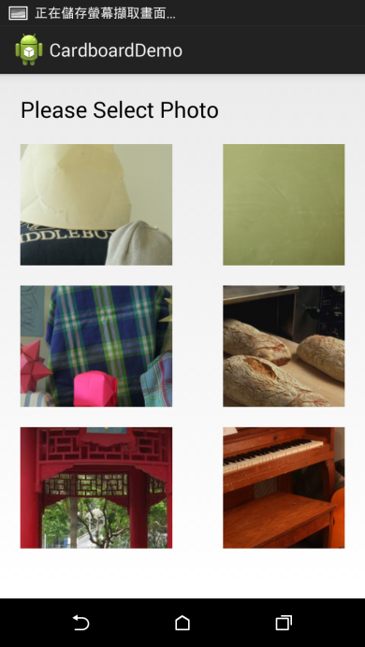

You can choose image in this page.

Change the logos to animation in front of the video

I added this logo in the video

<http://forum8.hkgolden.com/faces/lomore/bouncer.gif>

--- Code explanation ---

./cardboard.apk my android application

./playvideo.m matlab code to process my work in video

./cardboarddemo/ include my android app java code.

./layout/ include my android app layout XML