**CSCI3310 Mobile Computing & Application Development**

Assignment 1

Arkanoid

Due : Feb 10, 2017 11:55pm

Game app is the biggest constituent category in mobile application. Angry birds, besides being the popular mobile app, is also one of the game that utilized the physics in game design. The use of physics allows much more possibilities in game design as they enable a *sandbox* approach to the player. In this assignment, we will implement a simple, classic game “Arkanoid”, using Corona. The purpose is to let you have some experience on using middleware such as Corona, and touch based UI programming and physics.

Arkanoid is a classic arcade game released in 1986. The objective is to eliminate a number of obstacles in the level by the colliding action of a ball. A screenshot is shown as below.

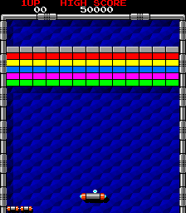

In the screenshot on left, the player controls the "Vaus", a space vessel that acts as the game's "paddle" which prevents a ball from falling from the playing field, attempting to bounce it against a number of bricks. The ball striking a brick causes the brick to disappear. When all the bricks are gone, the player goes to the next level, where another pattern of bricks appears. The boundary – top, left and right are bounded with solid walls, thus the balls will bounce off from them, preventing the ball from gone. Thus the only exit is the bottom, where the “Vaus” trying to guard. The player needs to move the Vaus in front of the ball so as to bounce it back to level interior.

In this assignment, in order to limit the difficulty, you are only required to implement the basic requirement as stated above. Moreover, there is no next level, when all the bricks are being removed, the game will simply just returning to the level start again i.e. the pattern of bricks remain the same as game start and repeat again. There is also no need for any additional features in original game such as powerup, etc.

To make the program simple, we make the following assumptions/conditions:

1. We use a screen resolution of 640 by 960.
2. When the game starts, the ball will be attached to the paddle i.e. Vaus. The ball should initially be attached to the paddle. The player needs to use a swipe action to fire the ball up. The ball will be fired by the user through a swipe gesture. The direction and speed of the gesture may be used to determine the movement of the ball or you may just randomly fire the ball (that the swipe action is just an *on/off action* in this case).
3. There should be a total of 4 times 10 bricks at the top of screen. With each brick having colors similar to that of original Arkanoid i.e. each row is of the same color. Here you may choose to use fix or random color. Each brick should be separated from the next or below by at least 2 pixels. A suggested width of brick is 50.
4. Paddle size should form a rectangle. A suggested size is 150 by 30 in Corona.
5. Ball radius can be 20. Suggested moving speed can be around 100 – 500.
6. Touch event can be used for controlling the paddle. Here we can simplify the interface by assuming that whenever in game, when the player’s finger touch the screen anywhere, the horizontal movement will then be used to control the paddle.

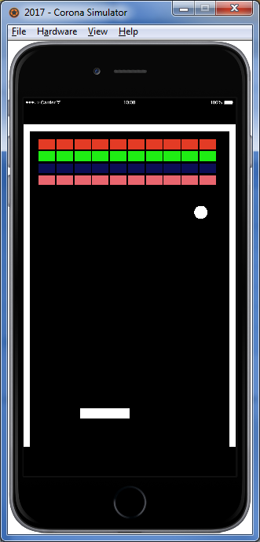

**Submission**

You should packed all your program and related files e.g. icon file, settings etc. into a folder named 3310_asg1, and zip the folder into the same named zip or rar file, and submitted it into our assignment collection slot in eLearning system before the deadline, Feb 10, 2017 11:55pm.

Late submissions will risk a mark deduction from 5% to 30% if they are being done within 24 hours after the deadline. Submission later than Feb 12 11:55pm won’t be considered.

Reference

<http://en.wikipedia.org/wiki/Arkanoid>

<https://docs.coronalabs.com/>