**CSCI3310 Mobile Computing & Application Development**

Assignment 2 (iOS)

CU Critters

Due : Mar 24, 2017 11:55pm

As CUHK is built near the hill and in the suburbs area, it is always populated with many amazing little critters that form an interesting addition to our campus. This assignment needs you to write an iOS App which can display a list of images of those little critters with **Swift 3**. The user should also be able to add their own captured images to the collections.

As a practice of various programming skills in this assignment, you need to use the table view controller to display a number of critter images as a table view on screen. When the user taps on the image of any entry, a detail scene will be shown. The user should be able to edit the list entry. In the table view, a user should be able to delete any entry, as well as add new entry to the list.

In this program, you need to set up a list of **4 items** when the program starts up. Among them, three of them are coming together with this assignment package as shown below. There is another image that need be downloaded from the Internet to populate the list. Your program can choose to only display the table scene after finishing all download, or adding the entry once they are done.

The user can also add his or her own newly captured image from the photo library to the collection by using the Add function. The Add button is shown on the top right of the screen in table view. Once the user tap on the button, a new scene with all descriptions of the entry in unfilled state will be shown using a navigation controller. The user can then enter the description and image to the entry. Clicking the “Save” button will save a new entry to the list as well as saving the modified list to the app’s document directory.

The program should also have data persistence feature in that after the first run (at least four entries in table), the data will be saved in app’s local document directory. During the next run, the last table which the user had made modifications will be there.

**Requirements**

Basically this assignment is just the combination of the two tutorials on iOS app development with some extensions.

1. At program first start, your program should display three sample images together with an image downloaded from Internet through the URL below:  
   <http://www.cse.cuhk.edu.hk/~shor/baby.jpg>  
   Note that the connection must be in http, not https.  
   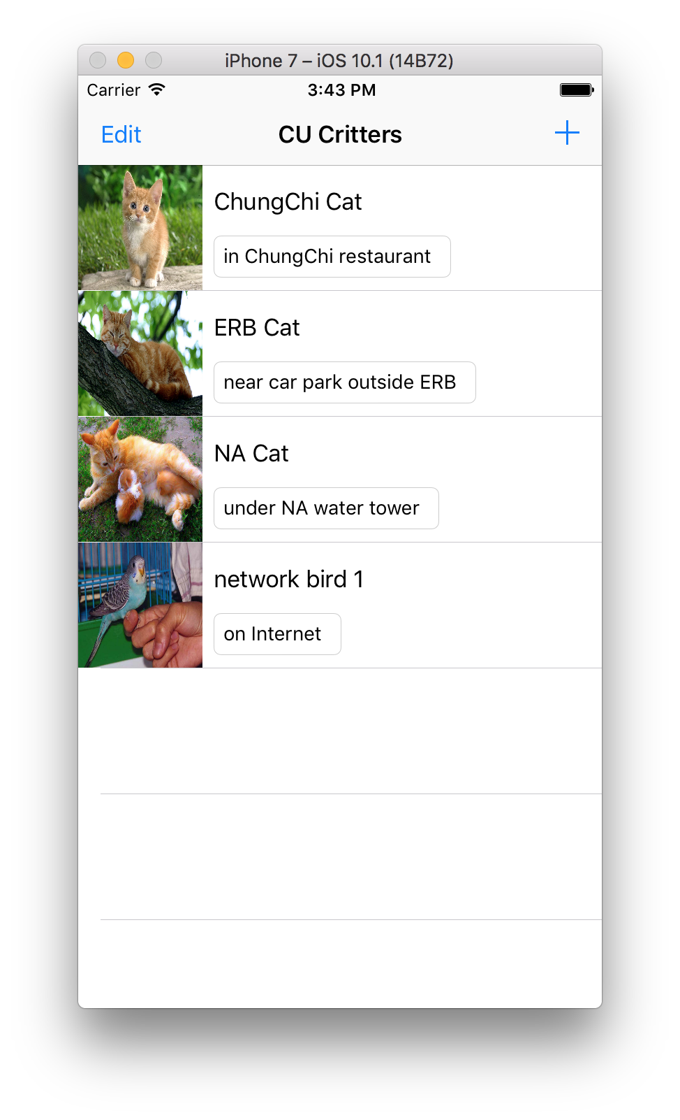
2. Your program should be able to segue to a details scene for any item clicked.
3. Besides showing details, your program should be able to let user edit (tap on existing item in table view) item or add new item(tap on ‘+’ button in table list view).
4. Your program should be able to let user delete any entry in the table.  
   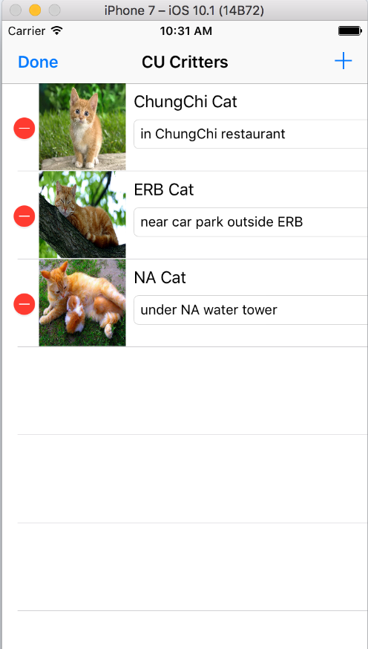
5. Your program should be able to save the edited table into app’s local document directory. If you add a few new critters to the app and quit, the entries added will be there the next time you open the app.

**Submission**

You should packed all your app folder and related files into an archive named “3310_asg2.zip” , and submitted it into our assignment collection slot in Blackboard system before the deadline, Mar 24, 2017 11:55pm.

Late submissions will risk a mark deduction from 5% to 30% if they are being done within 24 hours after the deadline. Submission later than Mar 27 11:55pm won’t be considered.