Class Code: A391-002 Lesson Number: 8
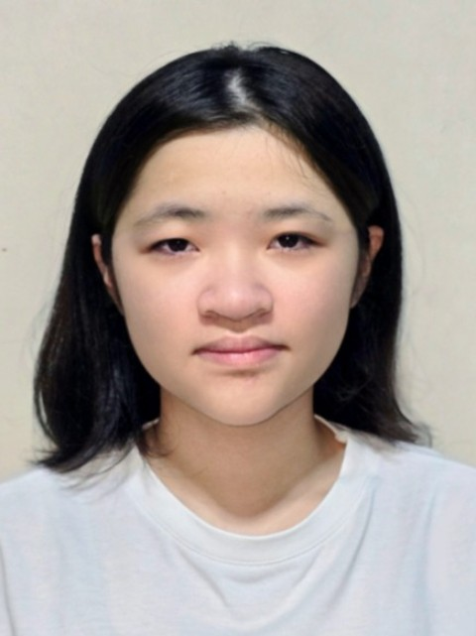  CHANG CHING EN  25027276 | 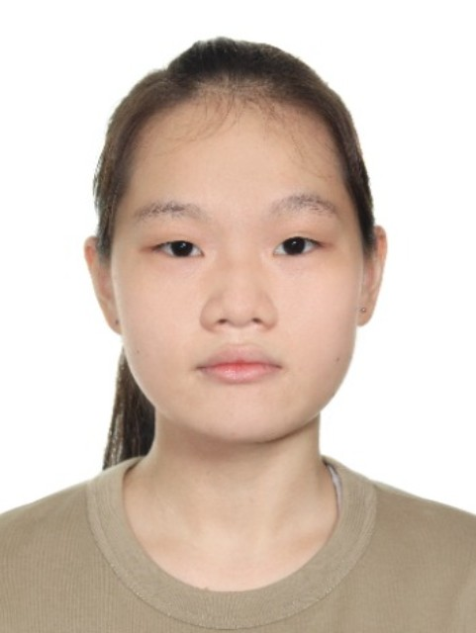  CHLOE SOH  24030823 | 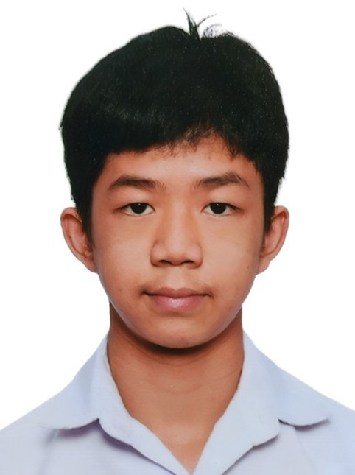  CHOMKLIN NANTHAKAN  25019764 | 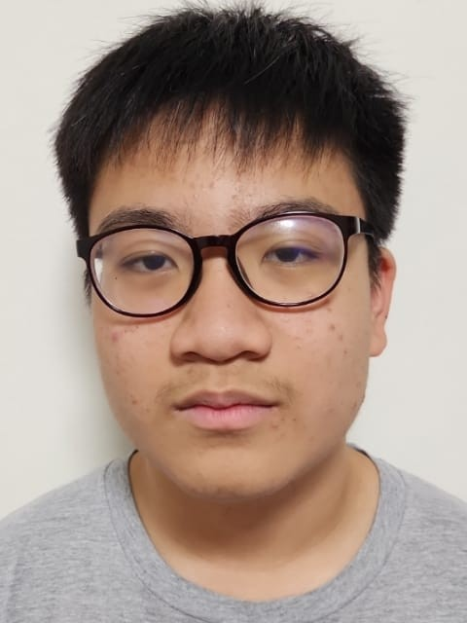  CHUA KAI XUAN ALDAN  25042764 | 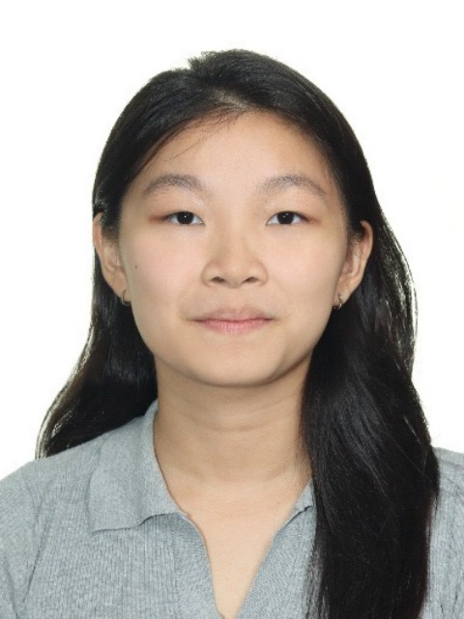  CHUA SHIN YU SHERLYNNE  25014581 | 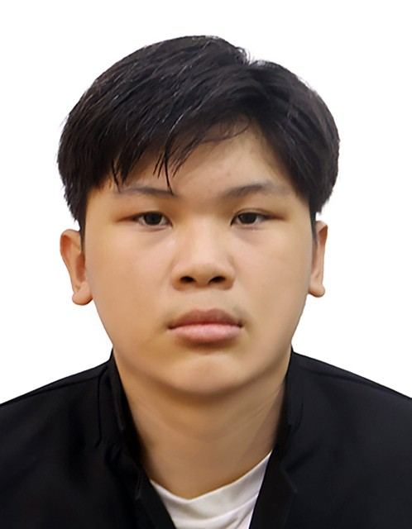  DARYL CHAN YIN TUCK (CHEN YANDE)  25007608
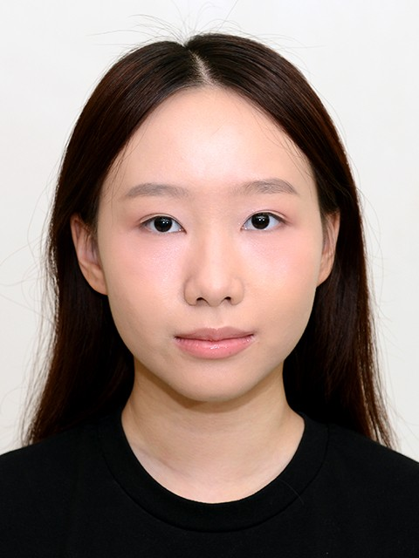  EMBER TAN YI EN  25034024 | 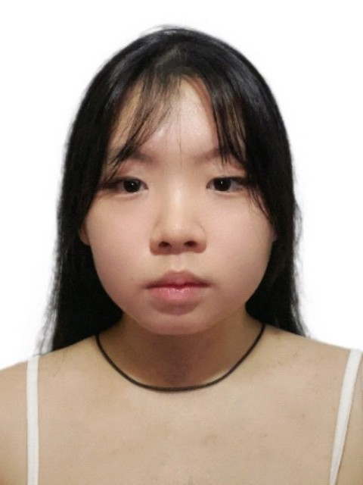  GERMAINE LAU WEN HUI  25012999 | 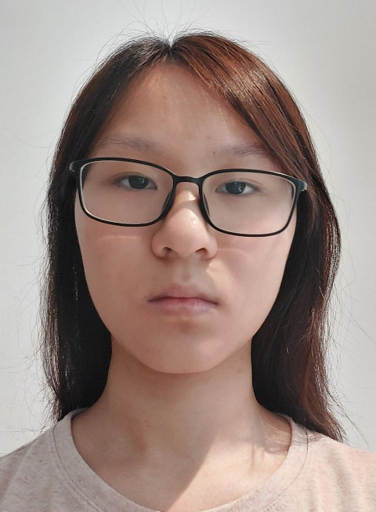  GOH KYLIE  25024279 | 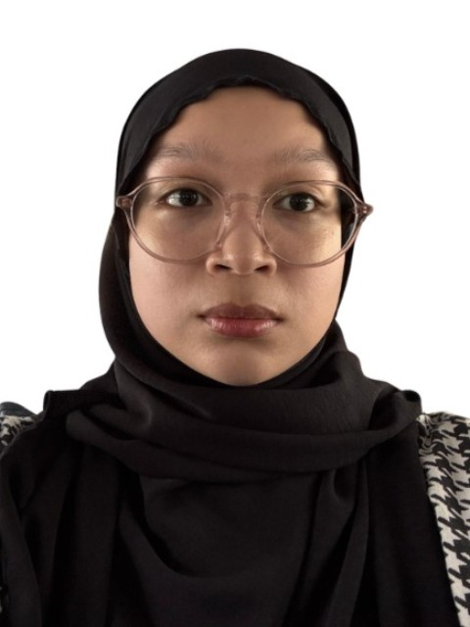  HALIMATUL MAISARAH BINTE AZMAN  25049084 | 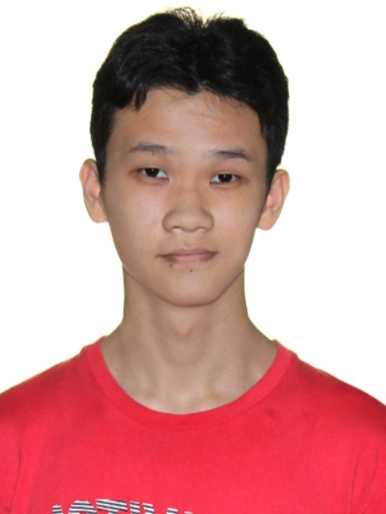  LEOW ING RUNN  25016212 | 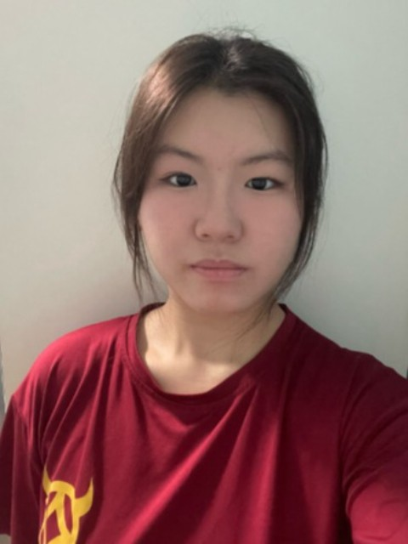  LIN ZIROU  25032428
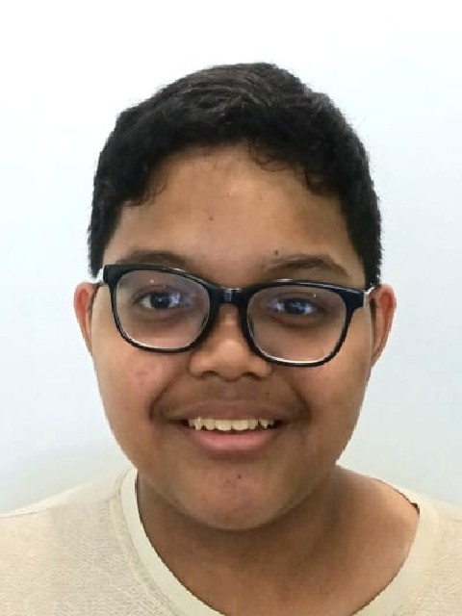  MUHAMMAD AKHDAN SALIHIN BIN MOHAMAD AKHIR  25002859 | 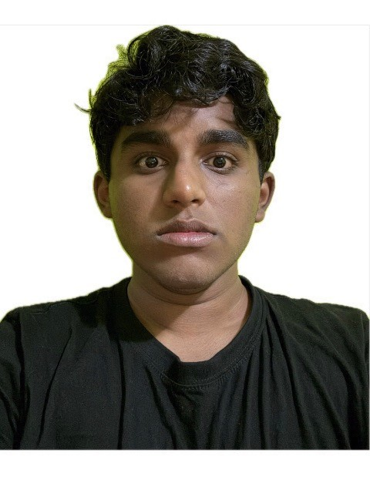  MUHAMMAD ARSHAD BIN UTHUMANGANY  25011641 | 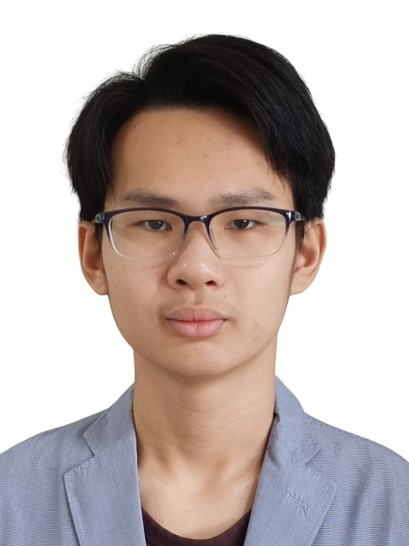  NICHOLAS NEO WEI HENG  25000221 | 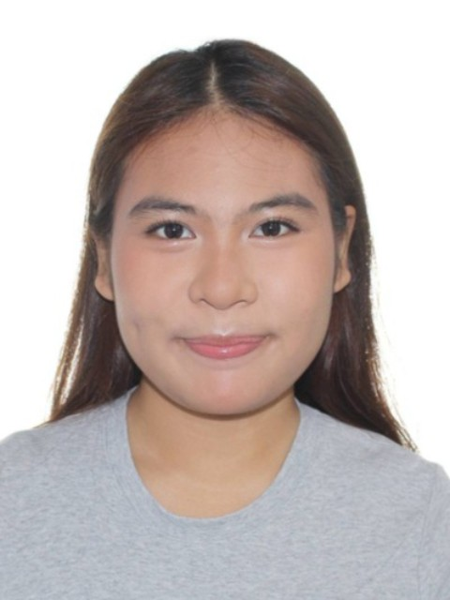  NURYN' INSYIERAH BINTE NUR'ASRI  25017079 | 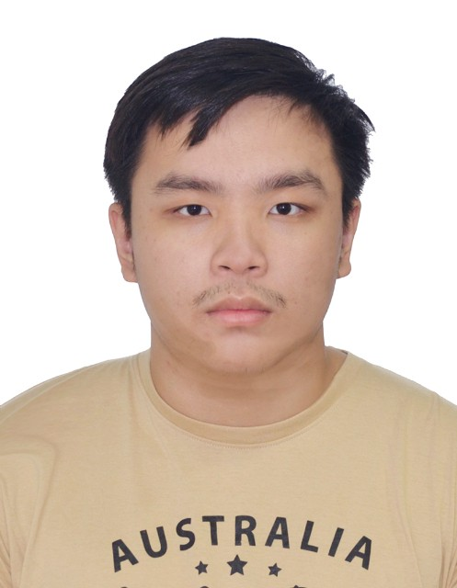  PANG BO JING  24027302 | 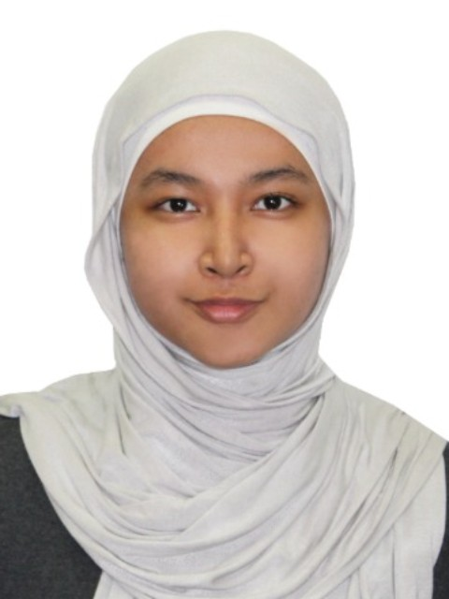  RUQA TASNIA BINTE FAISAL REZA  25017350
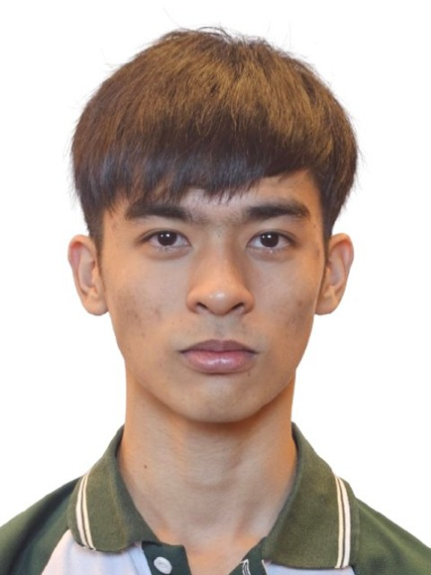  SIM HAO EN  25011566 | 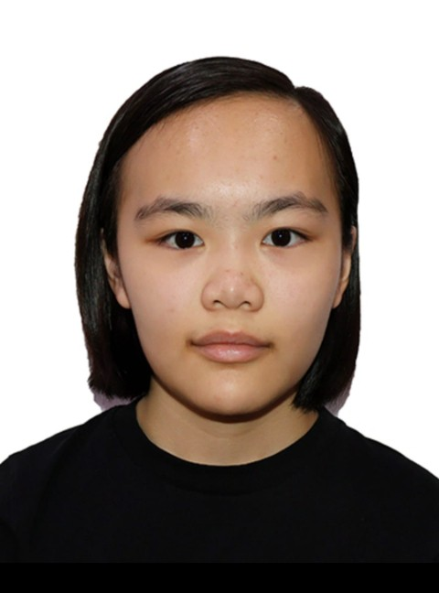  SNG JOO CHENG  25026366 | 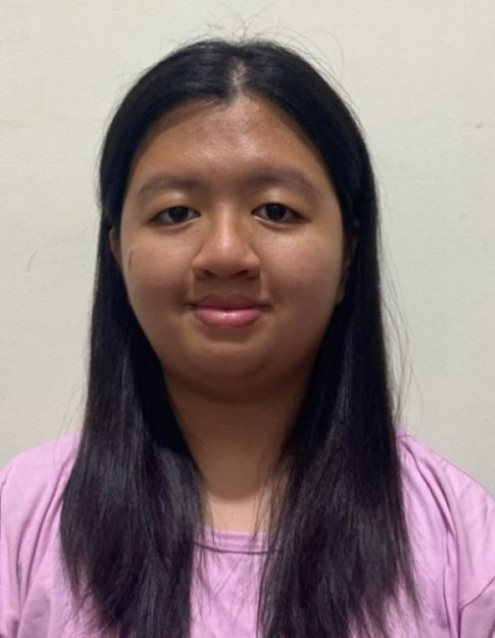  TAN CAI LING ASHLEY  25021870 | 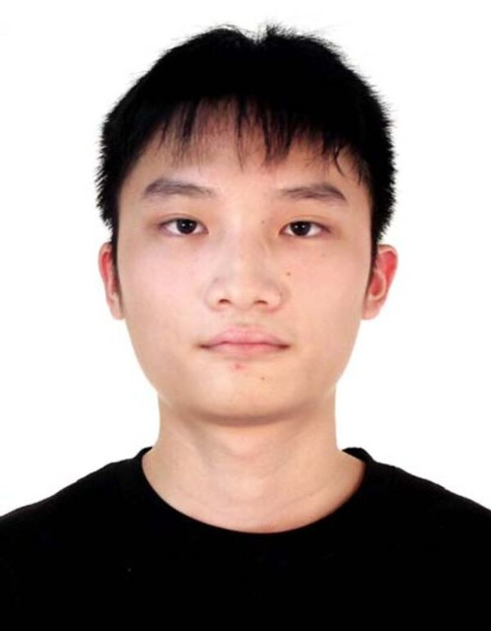  TONG KAI FU  25000776 | 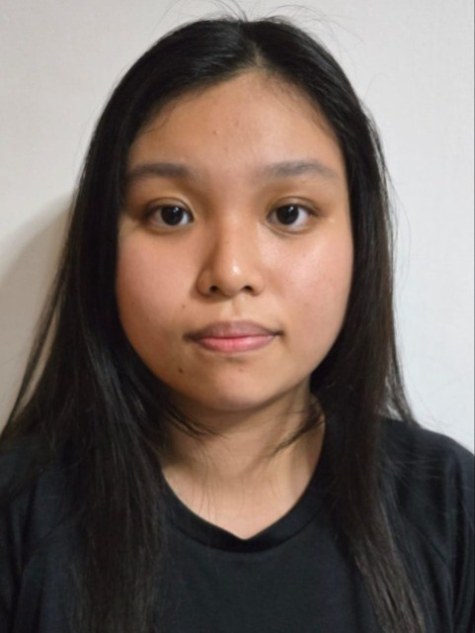  VICKI LEE WEI QI  25024685 | 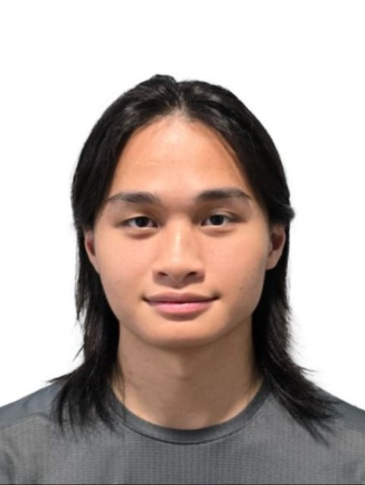  YEO XIU QI LANDRIC  24039721

