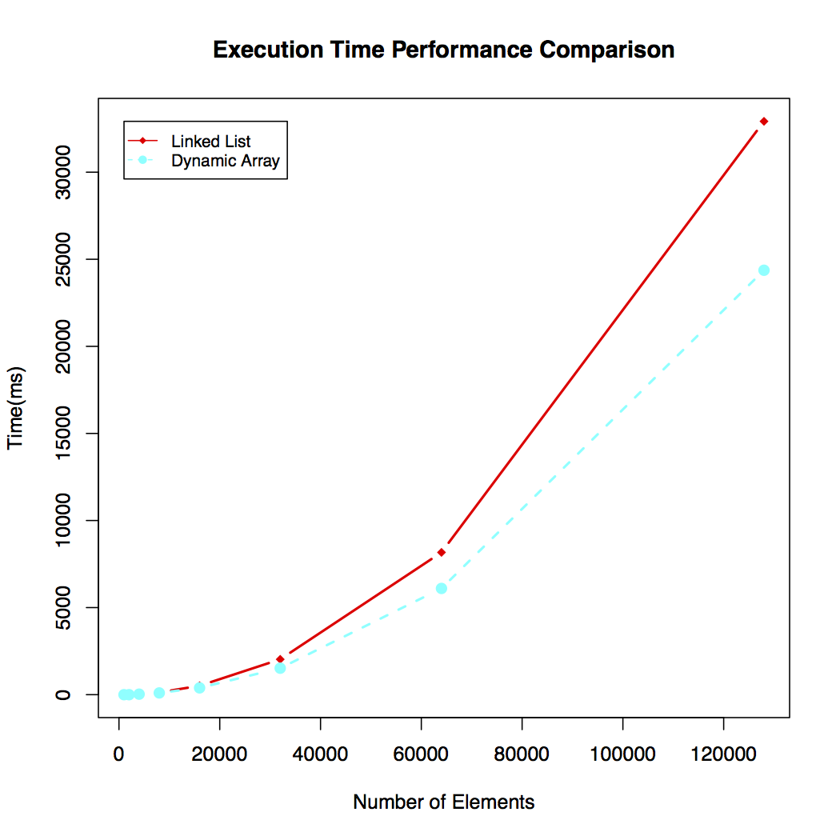

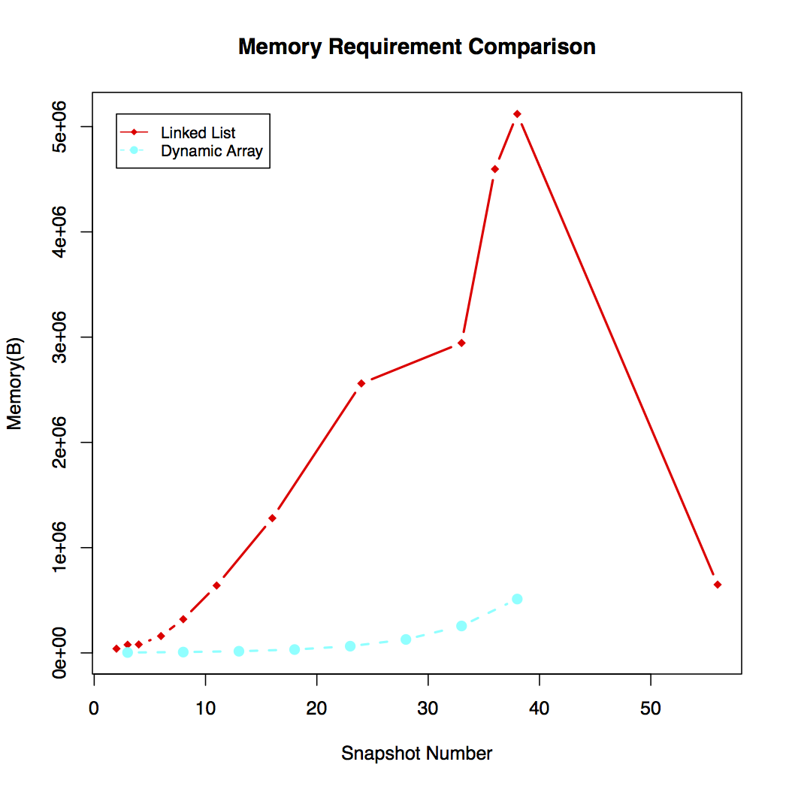

1. Which of the implementations uses more memory? Explain why.

Linked list used more memory than dynamic array. The reason is that linked list needs extra head and tail sentinels, and two extra pointers pointed to previous link and next link for each node. While dynamic array only need to allocate enough memory for data.

1. Which of the implementations is the fastest? Explain why.

For performing n calls to add() and n calls to contains(), dynamic array is the fastest. For add(), dynamic array has O(1+) complexity while linked list has O(1) complexity. But for contains(), we have random access to the data in dynamic array while we have to access elements sequentially starting from the first node in linked list.

1. Would you expect anything to change if the loop performed remove() instead of contains()? If so, what? (Note, it's very easy to run this experiment given the code we've provided!)