1. Overview
In this article, we will learn the important object-oriented concept Inheritance.
Inheritance - IS-A relationship between a superclass and its subclasses.
We will learn what is Inheritance and types of Inheritance with examples.

2. Intent/Definition
Inheritance - IS-A relationship between a superclass and its subclasses.
The process where one object acquires the members of another; plus can have its own.

Explanation
Inheritance is a reusability mechanism in object-oriented programming in which the common properties of various objects are exploited to form relationships with each other.
The abstract and common properties are provided in the superclass, which is available to the more specialized subclasses.
When we say that class B is inherited from another class A, then class B is referred to as a derived class (or subclass) and class A is called as a base class (or superclass).
By inheritance, the derived class receives the behavior of the base class, such that all the visible member methods and variables of the base class are available in the derived class. Apart from the inherited behavior, the derived class specializes its behavior by adding to or overriding base class behavior.

Real world example
- Dog (subclass) is-a of type Animal (superclass). So Dog can inherit (reuse) members of Animal class; plus it can have its own new behavior and properties.
- In the Java library, you can see extensive use of inheritance. Below figure shows a partial inheritance hierarchy from java.lang library. The Number class abstracts various numerical (reference) types such as Byte, Integer, Float, Double, Short, and BigDecimal.
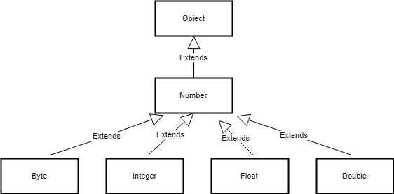

3. Implementation
Example 1: Let's understand inheritance by example.
Dog class is inheriting behavior and properties of Animal class and can have its own too.
/**
* Test class for inheritance behavior - Dog class is inheriting behavior
* and properties of Animal class and can have its own too.
*
*
*/
public class Inheritance {

public static void main(String[] args) {
Animal dog = new Dog();
dog.setId(123); // inherited from super class
dog.sound(); // overrided behavior of sub class
}
}

/**
* This is parent (also called as super or base) class Animal
*
*/
class Animal {
int id;

public int getId() {
return id;
}

public void setId(int id) {
this.id = id;
}

public void sound() {
System.out.println("By default it is mute");
}
}

/**
* This is subclass (also called as derived or child or extended) Dog which is extending Animal
*
*/
class Dog extends Animal {

// Own behavior
private void bark() {
System.out.println("Dog '" + getId() + "' is barking");
}

// Overriding super class behavior
@Override
public void sound() {
bark();
}
}
The keyword used for inheritance is extends. Syntax :
class derived-class extends base-class
{
//methods and fields
}
Example 2: In this example, the Programmer is the subclass and Employee is the superclass. The relationship between the two classes is Programmer IS-A Employee. It means that Programmer is a type of Employee.
class Employee{
float salary=40000;
}
class Programmer extends Employee{
int bonus=10000;
public static void main(String args[]){
Programmer p=new Programmer();
System.out.println("Programmer salary is:"+p.salary);
System.out.println("Bonus of Programmer is:"+p.bonus);
}
}

4. Types of Inheritance in Java
Below are the different types of inheritance which are supported by Java.

4.1 Single Inheritance
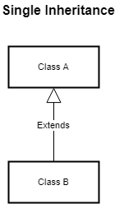
In single inheritance, subclasses inherit the features of one superclass. In the image below, class A serves as a base class for the derived class B.

4.2 Multilevel Inheritance

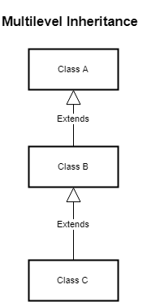
In Multilevel Inheritance, a derived class will be inheriting a base class and as well as the derived class also act as the base class to other class. In below image, class A serves as a base class for the derived class B, which in turn serves as a base class for the derived class C. In Java, a class cannot directly access the grandparent’s members.

4.3 Hierarchical Inheritance
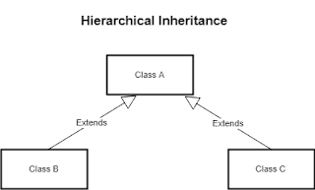
In Hierarchical Inheritance, one class serves as a superclass (base class) for more than one subclass. In below image, class A serves as a base class for the derived class B and class C.

4.4 Multiple Inheritance (Through Interfaces)
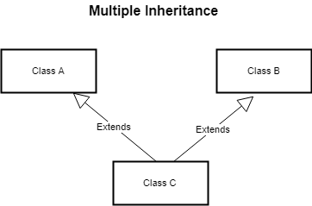
In Multiple inheritances, one class can have more than one superclass and inherit features from all parent classes. Please note that Java does not support multiple inheritances with classes. In Java, we can achieve multiple inheritances only through Interfaces. In the image below, Class C is derived from class A and class B.

4.5 Hybrid Inheritance(Through Interfaces)

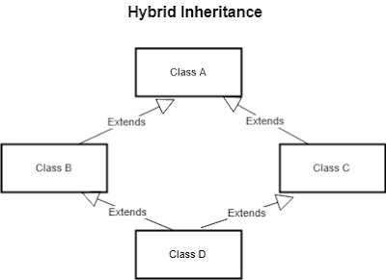
It is a mix of two or more of the above types of inheritance. Since java doesn’t support multiple inheritances with classes, the hybrid inheritance is also not possible with classes. In java, we can achieve hybrid inheritance only through Interfaces.

Why multiple inheritance is not supported in java?
To reduce the complexity and simplify the language, multiple inheritance is not supported in java.
Consider a scenario where A, B and C are three classes. The C class inherits A and B classes. If A and B classes have same method and you call it from child class object, there will be ambiguity to call method of A or B class.
Since compile time errors are better than runtime errors, java renders compile time error if you inherit 2 classes. So whether you have same method or different, there will be compile time error now.
class A{
void msg(){System.out.println("Hello");}
}
class B{
void msg(){System.out.println("Welcome");}
}
class C extends A,B{//suppose if it were

Public Static void main(String args[]){
C obj=new C();
obj.msg();//Now which msg() method would be invoked?
}
}

