|  |  |
| --- | --- |
| **Price** | 45$ |
| **Size of blades:** | 40cm |
| **Voltage-Frequency:** | 220V-50Hz |
| **Power:** | 45W |
| **Air flow:** | 55 m3/min |
| **Eeratio** | 1,22 m3/min/W |
| **Number of Speeds** | 3 |
| **Control** | Remote |
| **Color** | Gray |
| **Brand** | Asia |
| **Country** | Vietnam |
|  |  |

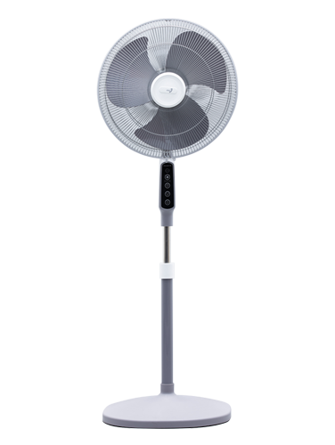D16028–XV0

* Featured
* Exquisite, elegant design suitable for modern interior space
* Refershing with cool super strong wind
* Quiet operation with extremely noise
* Warranty infomations
* We promise that the above information is completely true
* Consumers are allowed to return goods within 7 days
* 1 year free warranty