|  |  |
| --- | --- |
| **Price** | 30$ |
| **Size of blades:** | 40cm |
| **Voltage-Frequency:** | 220V-50Hz |
| **Power:** | 45W |
| **Air flow:** | 66.7 m3/min |
| **Eeratio** | 1,32 m3/min/W |
| **Number of Speeds** | 3 |
| **Switch types** | Remote |
| **Color** | Gray |
| **Brand** | Asia |
| **Country** | Vietnam |
|  |  |

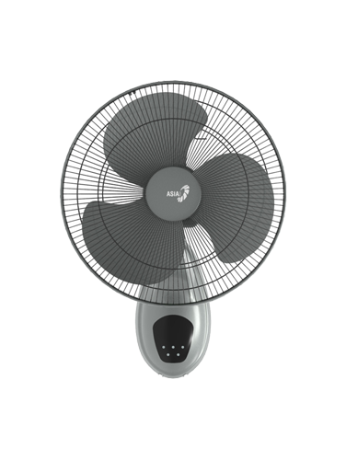L16019-XV0

* Featured
* Extremely Powerful Airflow for intense refreshment
* High durability Motor with Permawick Oil Technology
* Maximum safety thanks to Thermal fuse protection
* Warranty infomations
* We promise that the above information is completely true
* Consumers are allowed to return goods within 7 days
* 1 year free warranty