Họ và tên: Lê Thanh Tính
MSSV: 1250080199
Lớp: 12_ĐH_CNTT4
BÀI THỰC HÀNH ORACLE BUỔI 4

Bài 1: VIEW

Câu 1.1: Tạo view vw_course_summary - thông tin tổng quan môn học
CREATE OR REPLACE VIEW vw_course_summary AS
SELECT co.courseno,
co.description,
co.cost,
COUNT(DISTINCT cl.classid) AS so_lop,
COUNT(e.studentid) AS tong_sv
FROM course co
LEFT JOIN class cl ON co.courseno = cl.courseno
LEFT JOIN enrollment e ON cl.classid = e.classid
GROUP BY co.courseno, co.description, co.cost
ORDER BY tong_sv DESC;
-- Kiem tra view:
SELECT * FROM vw_course_summary; Kết quả:
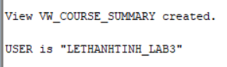
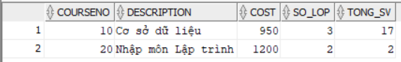

Câu 1.2: Tạo view vw_student_status - thông tin sinh viên và tình trạng học tập
CREATE OR REPLACE VIEW vw_student_status AS
SELECT s.studentid,
s.firstname || ' ' || s.lastname AS ho_ten,
COUNT(e.classid) AS so_lop_hoc,
NVL(SUM(co.cost), 0) AS tong_hoc_phi,
ROUND(AVG(e.finalgrade), 2) AS diem_tb
FROM student s
JOIN enrollment e ON s.studentid = e.studentid
JOIN class cl ON e.classid = cl.classid
JOIN course co ON cl.courseno = co.courseno
GROUP BY s.studentid, s.firstname, s.lastname
HAVING COUNT(e.classid) >= 1
ORDER BY s.studentid;
SELECT * FROM vw_student_status;Kết quả:
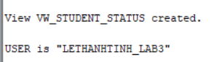
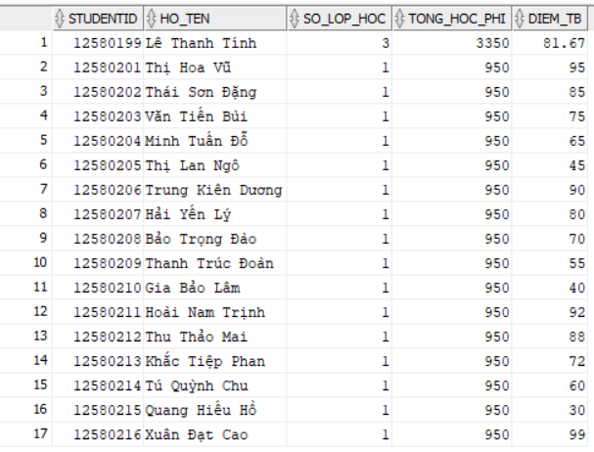

Câu 1.3: Tạo view vw_class_availability - lớp học còn chỗ trống
CREATE OR REPLACE VIEW vw_class_availability AS
SELECT cl.classid,
cl.courseno,
co.description,
i.firstname || ' ' || i.lastname AS ten_giao_vien,
cl.capacity,
COUNT(e.studentid) AS so_da_dk,
cl.capacity - COUNT(e.studentid) AS cho_trong,
CASE
WHEN cl.capacity - COUNT(e.studentid) > 0 THEN 'Con cho' ELSE 'Het cho'
END AS trang_thai
FROM class cl
JOIN course co ON cl.courseno = co.courseno
JOIN instructor i ON cl.instructorid = i.instructorid
LEFT JOIN enrollment e ON cl.classid = e.classid
GROUP BY cl.classid, cl.courseno, co.description,
i.firstname, i.lastname, cl.capacity
HAVING cl.capacity - COUNT(e.studentid) > 0
ORDER BY cl.classid;

SELECT * FROM vw_class_availability;
Kết quả:
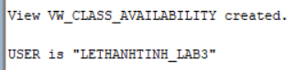
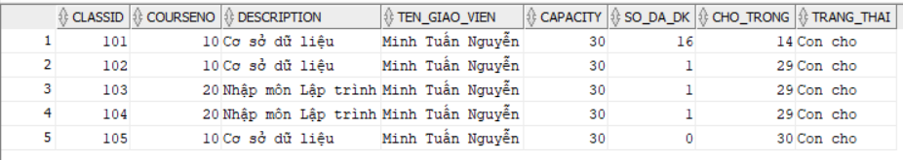

Câu 1.4: Tạo view vw_top_courses - chỉ đọc, top 5 môn được đăng ký nhiều nhất
CREATE OR REPLACE VIEW vw_top_courses AS
SELECT courseno, description, cost, tong_dk, hang
FROM (
SELECT co.courseno,
co.description,
co.cost,
COUNT(e.studentid) AS tong_dk,
RANK() OVER (ORDER BY COUNT(e.studentid) DESC) AS hang FROM course co
LEFT JOIN class cl ON co.courseno = cl.courseno
LEFT JOIN enrollment e ON cl.classid = e.classid
GROUP BY co.courseno, co.description, co.cost
)
WHERE hang <= 5
ORDER BY hang
WITH READ ONLY;

SELECT * FROM vw_top_courses;
Kết quả:
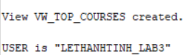
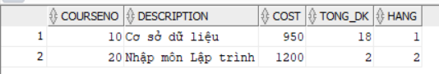

Câu 1.5: Tạo view vw_pending_enrollment với WITH CHECK OPTION và kiểm tra
CREATE OR REPLACE VIEW vw_pending_enrollment AS
SELECT studentid, classid, enrolldate, finalgrade,
createdby, createddate, modifiedby, modifieddate
FROM enrollment
WHERE finalgrade IS NULL
WITH CHECK OPTION;
SELECT * FROM vw_pending_enrollment;
-- INSERT 1: FinalGrade = NULL -> THANH CONG (thoa dieu kien WHERE)
INSERT INTO vw_pending_enrollment
(studentid, classid, enrolldate, createdby, createddate,
modifiedby, modifieddate)
VALUES (12580201, 102, SYSDATE, USER, SYSDATE, USER, SYSDATE);
-- INSERT 2: FinalGrade = 85 -> LOI ORA-01402 (vi pham WITH CHECK OPTION)
INSERT INTO vw_pending_enrollment
(studentid, classid, enrolldate, finalgrade,
createdby, createddate, modifiedby, modifieddate)
VALUES (12580202, 102, SYSDATE, 85, USER, SYSDATE, USER, SYSDATE); -- ORA-01402: view WITH CHECK OPTION where-clause violation Kết quả:
Tạo view:
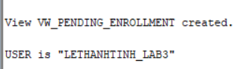
Insert 1:
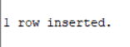

Insert 2:
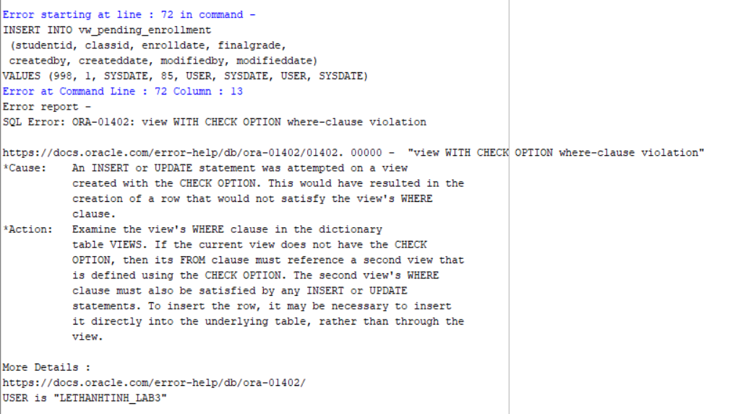

Bài 2: STORED PROCEDURE

Câu 2.1: Thủ tục enroll_student - đăng ký sinh viên vào lớp học
CREATE OR REPLACE PROCEDURE enroll_student
(p_studentid IN NUMBER,
p_classid IN NUMBER)
IS
v_check NUMBER;
v_capacity NUMBER;
v_enrolled NUMBER;
BEGIN
-- DK1: Sinh vien phai ton tai
SELECT COUNT(*) INTO v_check FROM student WHERE studentid = p_studentid;
IF v_check = 0 THEN
DBMS_OUTPUT.PUT_LINE('[LOI] Sinh vien ' || p_studentid || ' khong ton tai!');
RETURN;
END IF;
-- DK2: Lop hoc phai ton tai
SELECT COUNT(*) INTO v_check FROM class WHERE classid = p_classid;
IF v_check = 0 THEN
DBMS_OUTPUT.PUT_LINE('[LOI] Lop hoc ' || p_classid || ' khong ton tai!');
RETURN;
END IF;
-- DK3: Kiem tra con cho trong
SELECT capacity INTO v_capacity FROM class WHERE classid = p_classid;
SELECT COUNT(*) INTO v_enrolled FROM enrollment WHERE classid = p_classid;
IF v_enrolled >= v_capacity THEN
DBMS_OUTPUT.PUT_LINE('[LOI] Lop ' || p_classid || ' da day! (' || v_enrolled || '/' || v_capacity || ')');
RETURN;
END IF;
-- DK4: Sinh vien chua dang ky lop nay
SELECT COUNT(*) INTO v_check FROM enrollment
WHERE studentid = p_studentid AND classid = p_classid; IF v_check > 0 THEN
DBMS_OUTPUT.PUT_LINE('[LOI] Sinh vien da dang ky lop nay roi!'); RETURN;
END IF;
-- DK5: Sinh vien chua qua 3 lop
SELECT COUNT(*) INTO v_check FROM enrollment WHERE studentid = p_studentid;
IF v_check >= 3 THEN
DBMS_OUTPUT.PUT_LINE('[LOI] Sinh vien da dang ky du 3 lop!'); RETURN;
END IF;
-- Tat ca OK: INSERT
INSERT INTO enrollment
(studentid, classid, enrolldate, createdby, createddate,
modifiedby, modifieddate)
VALUES
(p_studentid, p_classid, SYSDATE, USER, SYSDATE, USER, SYSDATE);
COMMIT;
DBMS_OUTPUT.PUT_LINE('[OK] Dang ky thanh cong! SV ' || p_studentid || ' -> Lop ' || p_classid);
EXCEPTION
WHEN OTHERS THEN
ROLLBACK;
DBMS_OUTPUT.PUT_LINE('[LOI HE THONG] ' || SQLERRM); END enroll_student;
/
show user
-- Kiem tra:
BEGIN
enroll_student(12580202, 105); -- Hop le
enroll_student(999, 5); -- SV khong ton tai
enroll_student(12580202, 999); -- Lop khong ton tai
END;
/
Kết quả:
Tạo procedure:
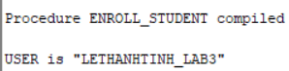
Hợp lệ:
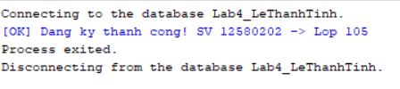
Sinh Viên không tồn tại:
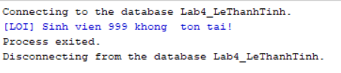
Lớp không tồn tại:
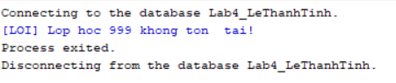

Câu 2.2: Thủ tục update_final_grade - cập nhật điểm tổng kết
CREATE OR REPLACE PROCEDURE update_final_grade
(p_studentid IN NUMBER,
p_classid IN NUMBER,
p_grade IN NUMBER)
IS
v_check NUMBER;
v_old_grade NUMBER;
BEGIN
-- Kiem tra diem hop le
IF p_grade < 0 OR p_grade > 100 THEN
DBMS_OUTPUT.PUT_LINE('[LOI] Diem khong hop le! Phai tu 0 den 100.');
RETURN;
END IF;
-- Kiem tra cap (StudentID, ClassID) ton tai trong ENROLLMENT
SELECT COUNT(*) INTO v_check FROM enrollment
WHERE studentid = p_studentid AND classid = p_classid;
IF v_check = 0 THEN
DBMS_OUTPUT.PUT_LINE('[LOI] Sinh vien chua dang ky lop nay!'); RETURN;
END IF;
-- Luu diem cu
SELECT finalgrade INTO v_old_grade FROM enrollment
WHERE studentid = p_studentid AND classid = p_classid;
-- Cap nhat ENROLLMENT
UPDATE enrollment
SET finalgrade = p_grade,
modifiedby = USER, modifieddate = SYSDATE
WHERE studentid = p_studentid AND classid = p_classid;
-- Dong bo sang bang GRADE bang MERGE INTO
MERGE INTO grade g
USING (SELECT p_studentid AS sid, p_classid AS cid FROM DUAL) src ON (g.studentid = src.sid AND g.classid = src.cid)
WHEN MATCHED THEN
UPDATE SET g.grade = p_grade,
g.modifiedby = USER, g.modifieddate = SYSDATE
WHEN NOT MATCHED THEN
INSERT (studentid, classid, grade, createdby, createddate,
modifiedby, modifieddate)
VALUES (p_studentid, p_classid, p_grade,
USER, SYSDATE, USER, SYSDATE);
COMMIT;
DBMS_OUTPUT.PUT_LINE('[OK] Da cap nhat diem SV ' || p_studentid || ' lop ' || p_classid
|| ': Cu=' || NVL(TO_CHAR(v_old_grade),'NULL') || ' -> Moi=' || p_grade);
EXCEPTION
WHEN OTHERS THEN
ROLLBACK;
DBMS_OUTPUT.PUT_LINE('[LOI] ' || SQLERRM);
END update_final_grade;
/
Kết quả:
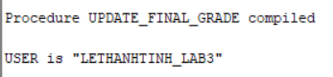

Câu 2.3: Thủ tục transfer_student - chuyển lớp cho sinh viên
CREATE OR REPLACE PROCEDURE transfer_student
(p_studentid IN NUMBER,
p_old_classid IN NUMBER,
p_new_classid IN NUMBER)
IS
v_check NUMBER;
v_capacity NUMBER;
v_enrolled NUMBER;
BEGIN
-- DK1: Sinh vien dang hoc o lop cu
SELECT COUNT(*) INTO v_check FROM enrollment
WHERE studentid = p_studentid AND classid = p_old_classid; IF v_check = 0 THEN
DBMS_OUTPUT.PUT_LINE('[LOI] Sinh vien khong dang hoc lop ' || p_old_classid);
RETURN;
END IF;
-- DK2: Lop moi con cho trong
SELECT capacity INTO v_capacity FROM class WHERE classid = p_new_classid;
SELECT COUNT(*) INTO v_enrolled FROM enrollment WHERE classid = p_new_classid;
IF v_enrolled >= v_capacity THEN
DBMS_OUTPUT.PUT_LINE('[LOI] Lop moi ' || p_new_classid || ' da day!');
RETURN;
END IF;
-- DK3: Sinh vien chua dang ky lop moi
SELECT COUNT(*) INTO v_check FROM enrollment WHERE studentid = p_studentid AND classid = p_new_classid; IF v_check > 0 THEN
DBMS_OUTPUT.PUT_LINE('[LOI] Sinh vien da o trong lop moi roi!'); RETURN;
END IF;
-- Tat ca OK: thuc hien chuyen lop
SAVEPOINT sp_truoc_chuyen;
-- Buoc 1: Xoa khoi lop cu
DELETE FROM enrollment
WHERE studentid = p_studentid AND classid = p_old_classid; SAVEPOINT sp_sau_xoa;
-- Buoc 2: Them vao lop moi
INSERT INTO enrollment
(studentid, classid, enrolldate, createdby, createddate, modifiedby, modifieddate)
VALUES
(p_studentid, p_new_classid, SYSDATE, USER, SYSDATE, USER, SYSDATE);
COMMIT;
DBMS_OUTPUT.PUT_LINE('[OK] Da chuyen SV ' || p_studentid || ' tu lop ' || p_old_classid
|| ' sang lop ' || p_new_classid);
EXCEPTION
WHEN OTHERS THEN
ROLLBACK TO sp_truoc_chuyen;
DBMS_OUTPUT.PUT_LINE('[LOI] Chuyen lop that bai: ' || SQLERRM); DBMS_OUTPUT.PUT_LINE('Da rollback ve trang thai ban dau.'); END transfer_student;
/
Kết quả:
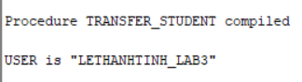

Câu 2.4: Thủ tục report_class_detail — in báo cáo chi tiết lớp học
CREATE OR REPLACE PROCEDURE report_class_detail
(p_classid IN NUMBER)
IS
v_check NUMBER;
v_course VARCHAR2(50);
v_courseno NUMBER;
v_gv VARCHAR2(50);
v_loc VARCHAR2(50);
v_cap NUMBER;
v_stt NUMBER := 0;
v_tong NUMBER := 0;
v_sum_d NUMBER := 0;
v_co_d NUMBER := 0;
v_grade_txt VARCHAR2(15);
BEGIN
-- Kiem tra lop ton tai
SELECT COUNT(*) INTO v_check FROM class WHERE classid = p_classid;
IF v_check = 0 THEN
DBMS_OUTPUT.PUT_LINE('Lop hoc ' || p_classid || ' khong ton tai!');
RETURN;
END IF;
-- Lay thong tin lop
SELECT co.description, co.courseno,
i.firstname || ' ' || i.lastname,
cl.location, cl.capacity
INTO v_course, v_courseno, v_gv, v_loc, v_cap
FROM class cl
JOIN course co ON cl.courseno = co.courseno
JOIN instructor i ON cl.instructorid = i.instructorid WHERE cl.classid = p_classid;
-- In header bao cao
DBMS_OUTPUT.PUT_LINE('=== BAO CAO LOP HOC: ' || p_classid || ' ===');
DBMS_OUTPUT.PUT_LINE('Mon hoc : ' || v_courseno || ' - ' || v_course); DBMS_OUTPUT.PUT_LINE('Giao vien: ' || v_gv);
DBMS_OUTPUT.PUT_LINE('Phong hoc: ' || NVL(v_loc, 'Chua xep phong'));
DBMS_OUTPUT.PUT_LINE('Suc chua : ' || v_cap || ' cho'); DBMS_OUTPUT.PUT_LINE(RPAD('-',50,'-'));
DBMS_OUTPUT.PUT_LINE('DANH SACH SINH VIEN:'); DBMS_OUTPUT.PUT_LINE(RPAD('STT',4) || ' | ' || RPAD('Ho Ten',20) || ' | ' || LPAD('Diem TK',8) || ' | Xep loai');
DBMS_OUTPUT.PUT_LINE(RPAD('-',50,'-'));
-- Duyet danh sach sinh vien
FOR rec IN (
SELECT s.firstname || ' ' || s.lastname AS ho_ten,
e.finalgrade
FROM enrollment e
JOIN student s ON e.studentid = s.studentid WHERE e.classid = p_classid
ORDER BY s.lastname, s.firstname
) LOOP
v_stt := v_stt + 1;
v_tong := v_tong + 1;
-- Xep loai
IF rec.finalgrade IS NULL THEN
v_grade_txt := 'Chua co diem';
ELSIF rec.finalgrade >= 90 THEN
v_grade_txt := 'A';
v_sum_d := v_sum_d + rec.finalgrade; v_co_d := v_co_d + 1; ELSIF rec.finalgrade >= 80 THEN
v_grade_txt := 'B';
v_sum_d := v_sum_d + rec.finalgrade; v_co_d := v_co_d + 1; ELSIF rec.finalgrade >= 70 THEN
v_grade_txt := 'C';
v_sum_d := v_sum_d + rec.finalgrade; v_co_d := v_co_d + 1; ELSIF rec.finalgrade >= 50 THEN
v_grade_txt := 'D';
v_sum_d := v_sum_d + rec.finalgrade; v_co_d := v_co_d + 1; ELSE
v_grade_txt := 'F';
v_sum_d := v_sum_d + rec.finalgrade; v_co_d := v_co_d + 1; END IF;
DBMS_OUTPUT.PUT_LINE(
LPAD(v_stt, 3) || ' | ' || RPAD(rec.ho_ten, 20) || ' | ' || LPAD(NVL(TO_CHAR(rec.finalgrade),'NULL'), 7) || ' | ' || v_grade_txt
);
END LOOP;
-- In footer bao cao
DBMS_OUTPUT.PUT_LINE(RPAD('-',50,'-'));
DBMS_OUTPUT.PUT_LINE('Tong so sinh vien : ' || v_tong);
IF v_co_d > 0 THEN
DBMS_OUTPUT.PUT_LINE('Diem trung binh lop: '
|| ROUND(v_sum_d / v_co_d, 2));
ELSE
DBMS_OUTPUT.PUT_LINE('Diem trung binh lop: Chua co diem'); END IF;
END report_class_detail;
/
-- Goi thu tuc:
BEGIN
report_class_detail(101);
END;
/
Kết quả:
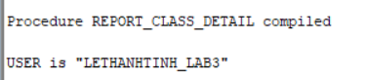
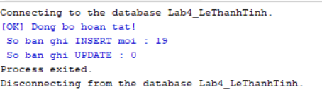
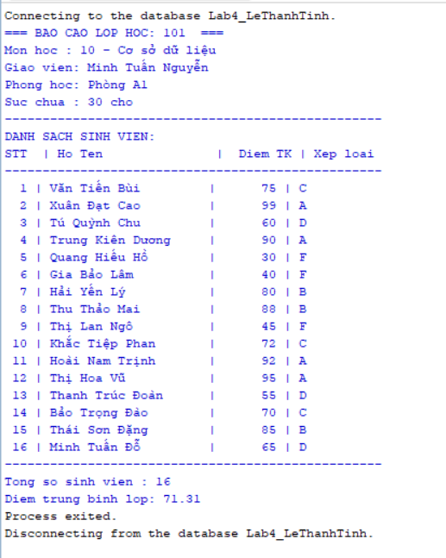

Kết quả:
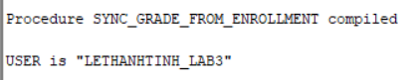

Bài 3: TRIGGER

Câu 3.1: Trigger trg_check_capacity - kiểm tra sức chứa khi đăng ký
CREATE OR REPLACE TRIGGER trg_check_capacity
BEFORE INSERT ON enrollment
FOR EACH ROW
DECLARE
v_capacity NUMBER;
v_enrolled NUMBER;
BEGIN
-- Lay suc chua lop hoc
SELECT capacity INTO v_capacity
FROM class WHERE classid = :NEW.classid;
-- Dem so SV hien da dang ky
SELECT COUNT(*) INTO v_enrolled
FROM enrollment WHERE classid = :NEW.classid;
-- Tu choi neu lop da day
IF v_enrolled >= v_capacity THEN
RAISE_APPLICATION_ERROR(
-20010,
'LOI: Lop ' || :NEW.classid || ' da day! ('
|| v_enrolled || '/' || v_capacity || ' cho)'
);
END IF;
END trg_check_capacity;
/
-- Kiem tra trigger (dang ky vao lop da day):
-- dầu tiên phải hạ sức chứa lớp 105 xuống còn 1 để giả lập lớp đầy
UPDATE class SET capacity = 1 WHERE classid = 105;
COMMIT;
-- tiếp theo là insert
INSERT INTO enrollment
(studentid, classid, enrolldate, createdby, createddate,
modifiedby, modifieddate)
VALUES (12580201, 105, SYSDATE, USER, SYSDATE, USER, SYSDATE);
Kết quả:
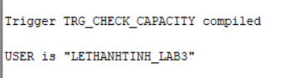

Câu 3.2: Trigger trg_grade_audit_log - ghi nhật ký thay đổi điểm
CREATE TABLE grade_audit_log (
log_id NUMBER GENERATED ALWAYS AS IDENTITY, studentid NUMBER(8),
classid NUMBER(8),
grade_cu NUMBER(3),
grade_moi NUMBER(3),
nguoi_sua VARCHAR2(30),
thoi_gian DATE
);
/
CREATE OR REPLACE TRIGGER trg_grade_audit_log
AFTER UPDATE OF finalgrade ON enrollment
FOR EACH ROW
BEGIN
-- Chi ghi log khi diem THUC SU thay doi
IF (:OLD.finalgrade IS NULL AND :NEW.finalgrade IS NOT NULL) OR (:OLD.finalgrade IS NOT NULL AND :NEW.finalgrade IS NULL)
OR (:OLD.finalgrade != :NEW.finalgrade)
THEN
INSERT INTO grade_audit_log
(studentid, classid, grade_cu, grade_moi, nguoi_sua, thoi_gian) VALUES
(:OLD.studentid, :OLD.classid, :OLD.finalgrade,
:NEW.finalgrade, USER, SYSDATE);
END IF;
END trg_grade_audit_log;
/

-- Kiem tra trigger:
UPDATE enrollment SET finalgrade = 85
WHERE studentid = 101 AND classid = 1;
COMMIT;
SELECT * FROM grade_audit_log;
Kết quả:
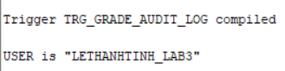

Câu 3.3: Trigger trg_prevent_course_delete - ngăn xóa môn học đang có lớp
CREATE OR REPLACE TRIGGER trg_prevent_course_delete
BEFORE DELETE ON course
FOR EACH ROW
DECLARE
v_so_lop NUMBER;
BEGIN
SELECT COUNT(*) INTO v_so_lop
FROM class WHERE courseno = :OLD.courseno;
IF v_so_lop > 0 THEN
RAISE_APPLICATION_ERROR(
-20020,
'Khong the xoa mon hoc ' || :OLD.courseno ||
' (' || :OLD.description || ') ' ||
'vi con ' || v_so_lop || ' lop hoc dang ton tai!'
);
END IF;
-- Neu v_so_lop = 0: trigger ket thuc binh thuong, Oracle tien hanh xoa END trg_prevent_course_delete;
/
-- Kiem tra: xoa mon co lop (se bao loi)
DELETE FROM course WHERE courseno = 10;
-- Kiem tra: xoa mon khong co lop (thanh cong)
-- đầu tiên là tạo một môn học nháp (Mã 99)
INSERT INTO course (courseno, description, cost, createdby, createddate, modifiedby, modifieddate)
VALUES (99, 'Mon hoc Nhap', 500, USER, SYSDATE, USER, SYSDATE);
COMMIT;

-- Tiếp theo là thực hiện xóa môn học nháp này
DELETE FROM course WHERE courseno = 99;Kết quả:
Tạo trigger
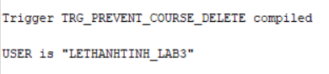
Kiểm tra xoá môn có lớp -> báo lỗi:
Kiểm tra xoá môn không có lớp -> thành công:
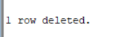

Câu 3.4: Trigger trg_update_grade_summary - cập nhật bảng thống kê tự động
CREATE TABLE class_grade_summary (
classid NUMBER(8) PRIMARY KEY,
so_sv NUMBER,
diem_tb NUMBER(5,2),
diem_cao_nhat NUMBER(3),
diem_thap_nhat NUMBER(3),
cap_nhat_luc DATE
);
/
CREATE OR REPLACE TRIGGER trg_update_grade_summary
FOR INSERT OR UPDATE OR DELETE ON enrollment
COMPOUND TRIGGER
v_classid NUMBER;

AFTER EACH ROW IS
BEGIN
IF INSERTING OR UPDATING THEN
v_classid := :NEW.classid;
ELSE -- DELETING
v_classid := :OLD.classid;
END IF;
END AFTER EACH ROW;

AFTER STATEMENT IS
v_so_sv NUMBER;
v_diem_tb NUMBER;
v_max_d NUMBER;
v_min_d NUMBER;
BEGIN
-- Bây giờ ta có thể thoải mái SELECT trên bảng enrollment
SELECT COUNT(finalgrade),
ROUND(AVG(finalgrade), 2),
MAX(finalgrade),
MIN(finalgrade)
INTO v_so_sv, v_diem_tb, v_max_d, v_min_d
FROM enrollment
WHERE classid = v_classid AND finalgrade IS NOT NULL;

-- Đồng bộ vào bảng thống kê
MERGE INTO class_grade_summary cgs
USING (SELECT v_classid AS cid FROM DUAL) src
ON (cgs.classid = src.cid)
WHEN MATCHED THEN
UPDATE SET so_sv = v_so_sv, diem_tb = v_diem_tb,
diem_cao_nhat = v_max_d, diem_thap_nhat = v_min_d, cap_nhat_luc = SYSDATE
WHEN NOT MATCHED THEN
INSERT (classid, so_sv, diem_tb, diem_cao_nhat, diem_thap_nhat, cap_nhat_luc)
VALUES (v_classid, v_so_sv, v_diem_tb, v_max_d, v_min_d, SYSDATE);
END AFTER STATEMENT;

END trg_update_grade_summary;
/
show user
-- Kiem tra trigger:
UPDATE enrollment SET finalgrade = 100 WHERE studentid=12580216 AND classid=101;
COMMIT;
SELECT * FROM class_grade_summary WHERE classid = 101;
Kết quả:
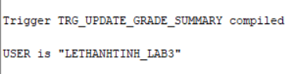

Bài 4: TỔNG HỢP

Câu 4.1: Hệ thống báo cáo hoàn chỉnh - View + Procedure + Cursor
Bước 1: Tạo view vw_instructor_workload:
CREATE OR REPLACE VIEW vw_instructor_workload AS
SELECT i.instructorid,
i.firstname || ' ' || i.lastname AS ho_ten,
COUNT(DISTINCT cl.classid) AS so_lop,
COUNT(e.studentid) AS tong_sv,
ROUND(AVG(e.finalgrade), 2) AS diem_tb_chung, CASE
WHEN COUNT(DISTINCT cl.classid) >= 3 THEN 'Ban nhieu' WHEN COUNT(DISTINCT cl.classid) = 2 THEN 'Binh thuong' ELSE 'Nhe nhang'
END AS muc_ban
FROM instructor i
LEFT JOIN class cl ON i.instructorid = cl.instructorid
LEFT JOIN enrollment e ON cl.classid = e.classid
GROUP BY i.instructorid, i.firstname, i.lastname
ORDER BY so_lop DESC;
SELECT * FROM vw_instructor_workload;
Bước 2: Thủ tục print_system_report:
CREATE OR REPLACE PROCEDURE print_system_report
IS
v_so_mon NUMBER;
v_so_lop NUMBER;
v_so_sv NUMBER;
v_so_gv NUMBER;
BEGIN
-- Lay so lieu tong the
SELECT COUNT(*) INTO v_so_mon FROM course;
SELECT COUNT(*) INTO v_so_lop FROM class;
SELECT COUNT(*) INTO v_so_sv FROM student;
SELECT COUNT(*) INTO v_so_gv FROM instructor;
-- In header

DBMS_OUTPUT.PUT_LINE('================================== ==========');
DBMS_OUTPUT.PUT_LINE(' BAO CAO TOAN HE THONG QUAN LY KHOA HOC');

DBMS_OUTPUT.PUT_LINE('================================== ==========');
DBMS_OUTPUT.PUT_LINE('Tong so mon hoc : ' || v_so_mon); DBMS_OUTPUT.PUT_LINE('Tong so lop hoc : ' || v_so_lop); DBMS_OUTPUT.PUT_LINE('Tong so sinh vien: ' || v_so_sv); DBMS_OUTPUT.PUT_LINE('Tong so giao vien: ' || v_so_gv); DBMS_OUTPUT.PUT_LINE(RPAD('-',50,'-'));
-- Phan 1: Thong ke giao vien (dung view vw_instructor_workload) DBMS_OUTPUT.PUT_LINE('THONG KE GIAO VIEN:'); FOR rec IN (SELECT * FROM vw_instructor_workload) LOOP DBMS_OUTPUT.PUT_LINE(
' ' || RPAD(rec.ho_ten, 25)
|| ' | ' || LPAD(rec.so_lop, 2) || ' lop'
|| ' | ' || LPAD(rec.tong_sv, 3) || ' SV'
|| ' | DTB: ' || NVL(TO_CHAR(rec.diem_tb_chung),'--')
BỘ || ' | ' || rec.muc_ban
);
END LOOP;
DBMS_OUTPUT.PUT_LINE(RPAD('-',50,'-'));
-- Phan 2: Top 3 mon hoc (dung view vw_top_courses)
DBMS_OUTPUT.PUT_LINE('TOP 3 MON HOC DUOC DANG KY NHIEU NHAT:');
FOR rec IN (SELECT * FROM vw_top_courses WHERE hang <= 3) LOOP DBMS_OUTPUT.PUT_LINE(
' ' || rec.hang || '. '
|| RPAD(rec.description, 30)
|| ' - ' || rec.tong_dk || ' luot dang ky'
);
END LOOP;

DBMS_OUTPUT.PUT_LINE('================================== ==========');
END print_system_report;
/
-- Chay bao cao:
SET SERVEROUTPUT ON SIZE 1000000;
BEGIN print_system_report; END;
/
Kết quả:
Tạo view:
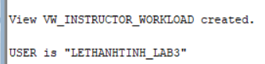
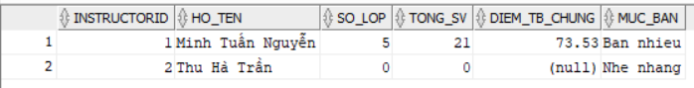
Tạo procedure:
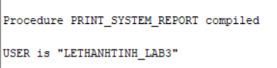
Chạy báo cáo:
