|  |  |  |
| --- | --- | --- |
| SMS | FB | **Slack** |
| sth I can play music regarding to the environment  ex. I tell it where I am, what am I doing, what I like  and it will automatically have a playlist and play for me  for example: gym mode, party mode, study mode | (voice base- feasibility)  talk to or sing to it, can they guess the song? | Play & control music with slackbot while studying |
| or just update the hottest music every week  #discoveries | **Like / follow artist** on the **FB** and automatically play the relevant songs from Spotify | just update the hottest music every week  #discoveries |
|  | **Share** song from Spotify through fb messenger |  |

**Proposal**

**Project Brainstorming Options:** (would like to discuss with Daragh)

**Summary:**

Musicbot is a music display application that’ll be your study buddies help play the right music for you while studying.

**Details:**

The application is designed to help CMU students who use slack often to enjoy listening to the right music while studying. Now, we use desktop Spotify website to play music, which needs to download the App or open a new tab with browser. It would be more intuitive if we can have a slack bot directly play the music we want for us, including turning the volume and choosing the playlist.

Therefore, it will work through Slack and a user will be able to play music within channel “#Spotify”. Also, the information of song typed in the Slack will be stored in the database.(manually input first for later call out, or auto renew after user using!?optional, depends on time) It will let the Slack bot remember the users’ preference while studying and be able to provide suggestions lists later. In addition, the app can update us the weekly hottest music through directly link to “discoveries weekly” - Spotify-existing functions to explore the music within our preferences.

**Storyboard:**

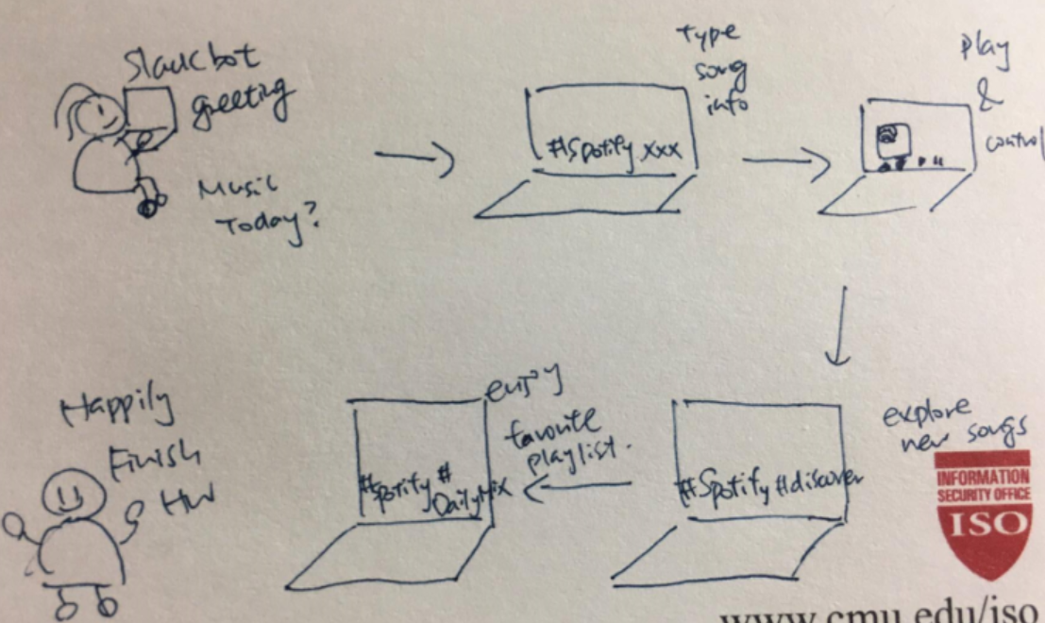

**Reference:**

Slackbot + Spotify

<https://www.youtube.com/watch?v=0qwvWW0Rz6w>

<https://www.youtube.com/watch?v=7cQfiU6S5d8>

<http://thenextweb.com/dd/2015/06/23/a-new-way-to-control-spotify-through-slack-integration/>

<http://benchmark.co.uk/blog/slackbox-spotify-playlist-collaboration-through-slack/>