- Time complexity and Space complexity:

- Time Complexity: Ye batata hai ki algorithm kitna time lega input ke size par depend karke
Hum exact milliseconds nahi nikalte — sirf growth rate dekhte hain.
- n = input ka size (array length, number of elements, etc.)
- O(...) = “Order of” / “depends on …”

Notation | Matlab (roughly) | Example
O(1) | Constant time (input size chahe jo ho, time same) | ek fixed index pe access karna arr[0]
O(n) | Linear time (input jitna bada, utna time) | ek baar poori array ko traverse karna
O(n²) | Quadratic time (time ≈ n×n) | nested loops jaise bubble sort
O(n log n) | n se thoda zyada (sorting algorithms jaise merge sort) | merge sort, quicksort average case
O(log n) | logarithmic time (input double karo to time thoda hi badhe) | binary search

So:
- O(n) = time directly proportional to elements ki number.
- O(n log n) = sorting level time — n elements * log factor (divide & conquer approach).

- Space Complexity: Ye batata hai ki kitni extra memory algorithm use karega input ke alawa
Notation | Matlab | Example
O(1) | Constant extra space (fixed memory) | loop variable, a few pointers
O(n) | Memory proportional to input size | n-size ka new array banaya
O(n²) | Memory ≈ n×n | 2D matrix bana liya

- Why we use Big O: Ye actual time/space numbers nahi deta, sirf trend deta hai
DSA me, algorithm ko input grow karne par kaise behave karta hai ye important hota hai

- Note: Quick Review
Complexity | Feel / Growth | Example
O(1) | same time always | access array element
O(log n) | very fast for big inputs | binary search
O(n) | linear growth | single loop
O(n log n) | little slower than linear but much faster than n² | merge sort
O(n²) | slow on big inputs | nested loops
O(2ⁿ) | exponential (very slow) | brute force subsets

- In Simple Words:
- O(1): 1 step hamesha
- O(n): n steps (jitna input, utni steps)
- O(n log n): n * log n steps (sorting type algorithms)
- O(n²): n * n steps (nested loops)
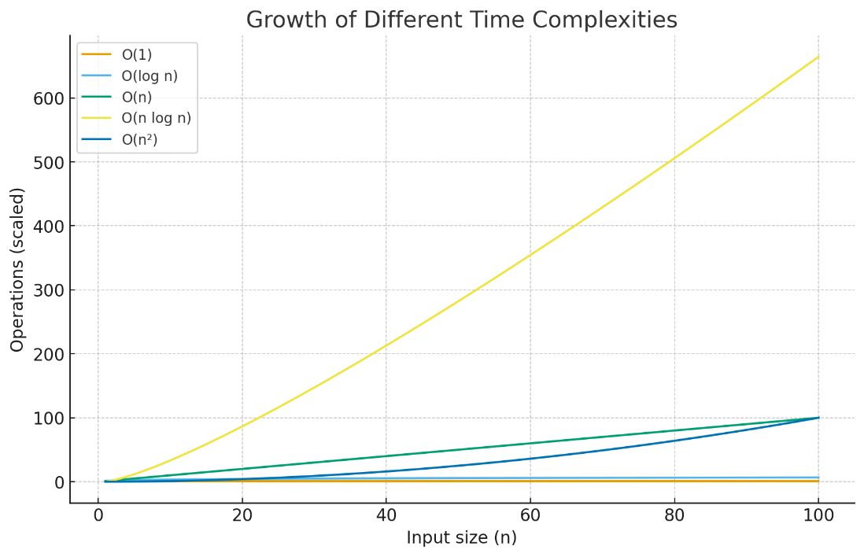
Here’s a graph showing how different time complexities grow as input size increases:
- O(1) stays flat (constant).
- O(log n) rises very slowly.
- O(n) grows linearly.
- O(n log n) grows a bit faster than linear.
- O(n²) shoots up very quickly (nested loops).

