**CA4 – Analysis with Pandas**

**Lehkec Martina**

**Happiness Report 2018 vs 2019**

Each country’s Happiness Score is calculated by summing the six variables in the table. Each of these variables reveals a population-weighted average score on a scale running from 0 to 10 that is tracked over time and compared against other countries.

These variables are:

* Economy: real GDP per capita
* Family: social support
* Health: healthy life expectancy
* Freedom: freedom to make life choices
* Trust: perceptions of corruption
* Generosity: perceptions of generosity

**Income** 🡪 specifically, the log of the per-capita GDP. Income has a virtuous, or vicious, impact on all of the following factors, but is, in itself, a strong indicator of a person's sense of well-being.

**A sense of trust in businesses and government** 🡪 there is mounting evidence that economic performance and growth are tied to higher levels of trust within the social framework.

**The expectation of good health** 🡪 there is a long-standing pile of research showing a strong relationship between the expectation of a healthy life and a sense of happiness. This is likely tied to better access to health care, better health behaviors, and better nutrition.

**A personal network of social support** 🡪 Social support has been shown to have a strong linkage to happiness. Having someone, or a network of someone’s, to count on in a time of need has a large impact on a person's sense of, and actual, well-being.

**The perception of freedom** 🡪 when folks are satisfied with their level of freedom to choose what to do with their lives, this personal liberty is a marked by an improvement to the social fabric.

**Giving and generosity** 🡪 Research has found that when people are benevolent and altruistic, characterized by giving money for a charitable purpose (beyond whatever self-interest they might expect in return), they tend to feel happier.

Both files have 11 columns and 156 values.

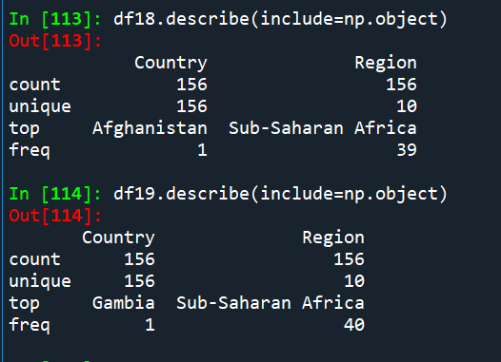

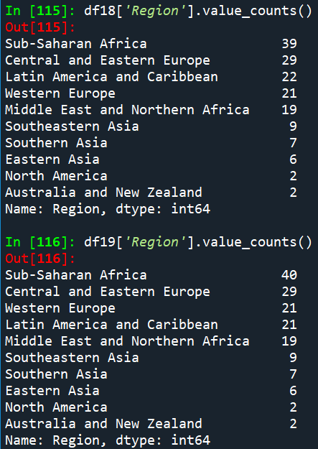

2018 - Sub-Saharan Africa has 39 countries

Latin America and Caribbean has 22 countries

2019 - Sub-Saharan Africa has 40 countries

Latin America and Caribbean has 21 countries

Difference between countries list in 2018 and 2019:

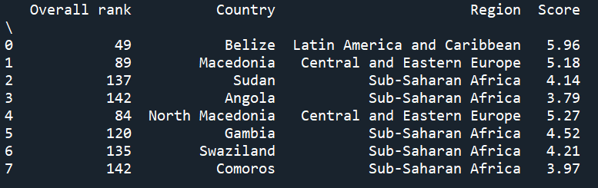

Heat maps

From the heat map it is visible that there is bigger correlation between GDP per capita and overall Score, as well as, higher the Score, longer the Healthy life expectancy. There is small change of correlation between variables from 2018 to 2019 where social support in correlation with GDP per capita has increased, and Healthy life expectancy has decreased.

2018

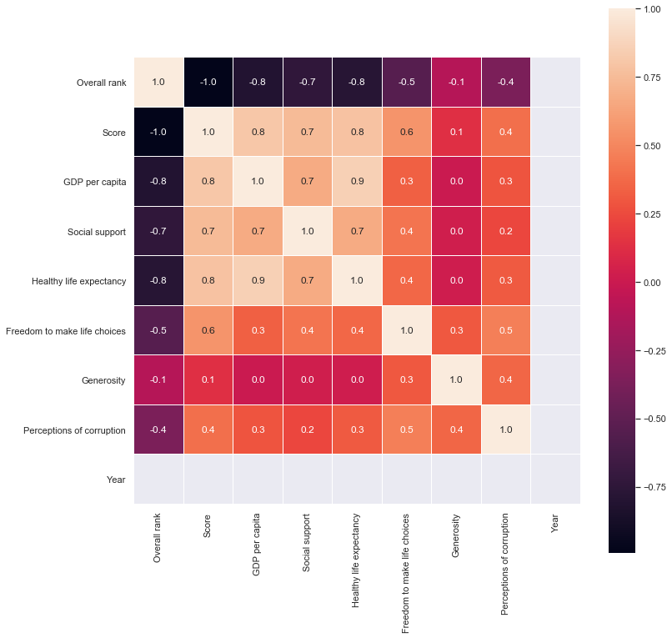

2019

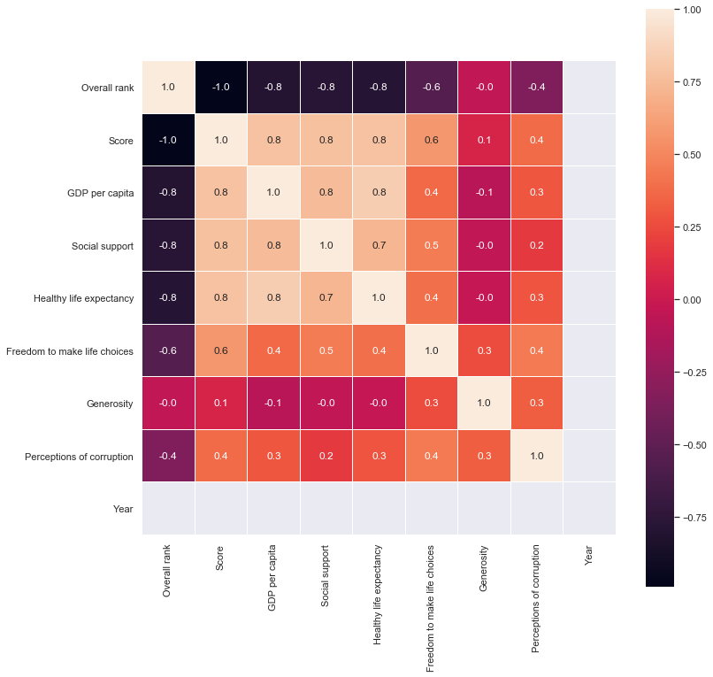

Image below is showing heat map results in separate graphs. Below is a correlation of Happiness Score and GDP per capita in blue color and correlation of Happiness Score and Healthy life expectancy in red color. It is confirming that those variables are higher when country score is higher.

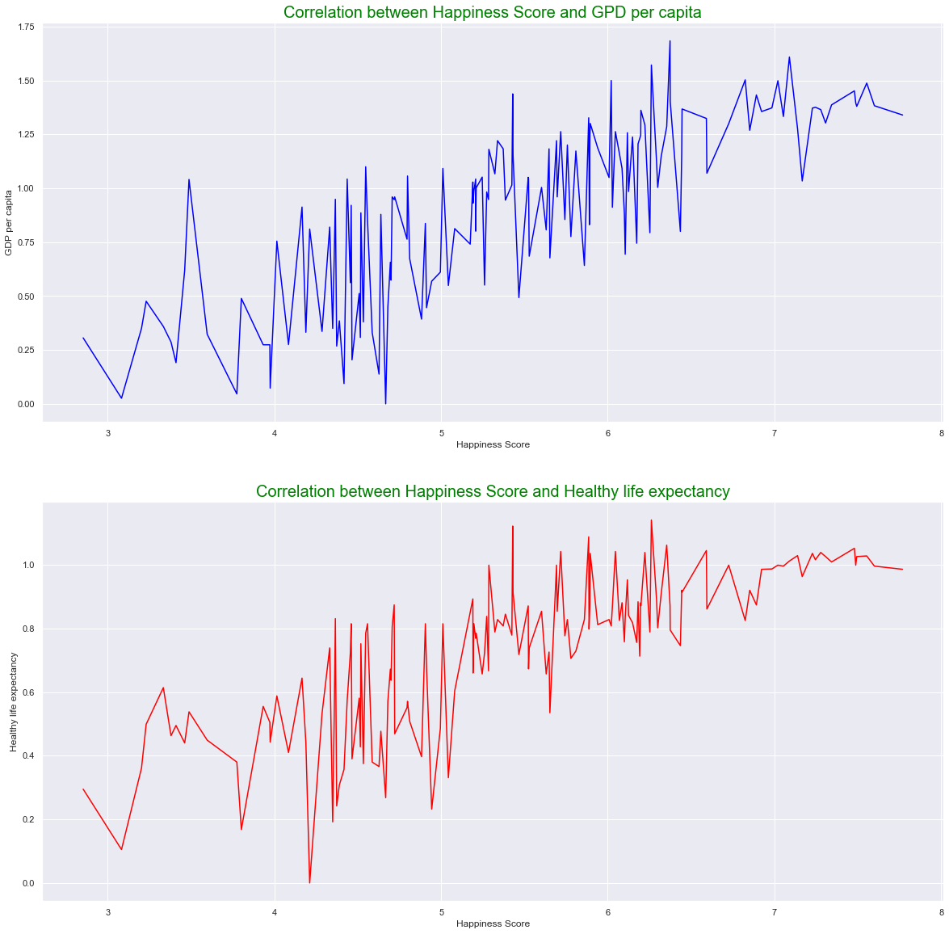

Number of countries per region in 2019. We can see that the biggest number of countries is in Sub-Saharan Africa and the smallest in Northern America and Australia and New Zealand.

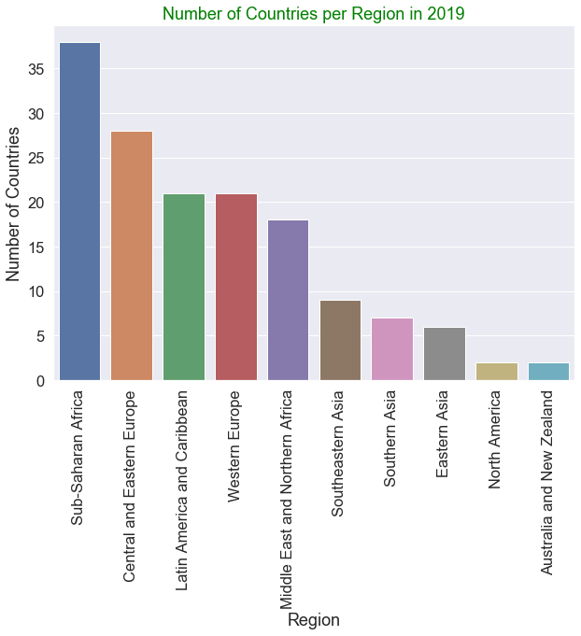

Ratio of Participating Countries to Regions in 2019

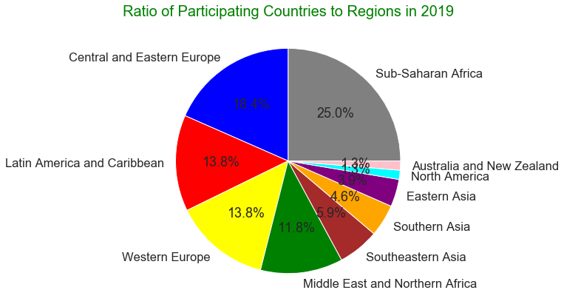

Counties Happiness Score according to the region where observations are on top of a box plot.

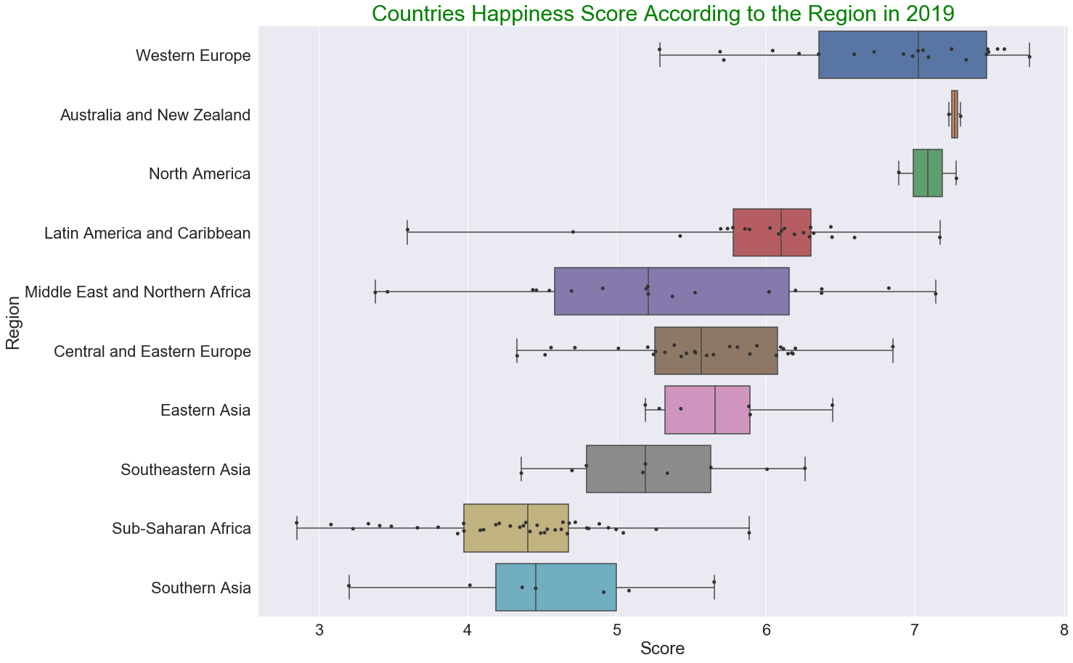

According to the score most happies countries are in Western Europe. As well, on the top are Australia and New Zealand and North America but there are only two countries in these regions so we need to take this into account.

Number of countries based on happiness score average in 2019.

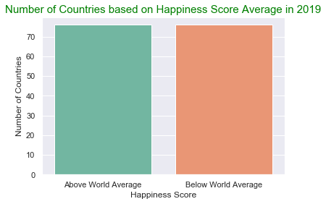

Image below contains an information about average variables values per region. It is interesting that Social support is very high in all regions.

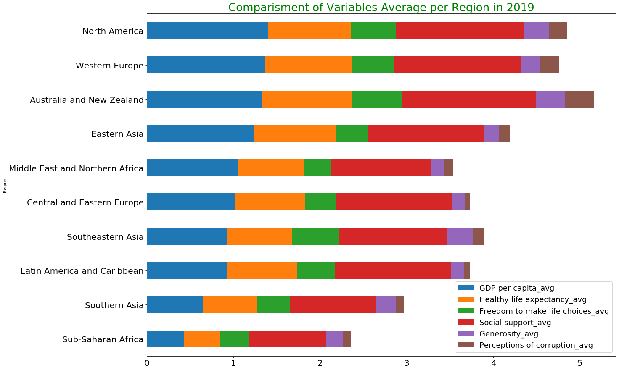

Image below shows a distribution of countries per created levels – low, normal and high. For visual there were used four variables of Score, Healthy life expectancy, GDP per capita and Social support, and compared by their averages and standard deviations.

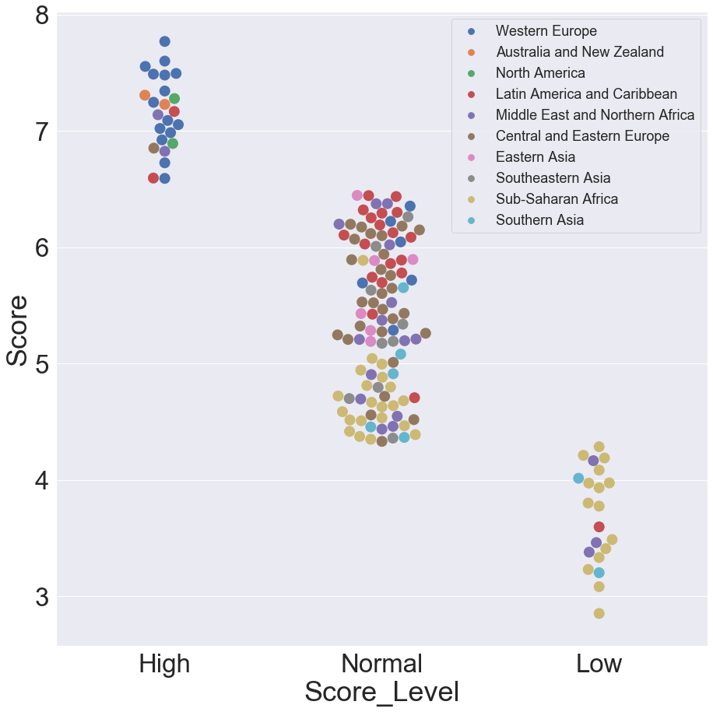

List of countries with all four variables that have “high” value:

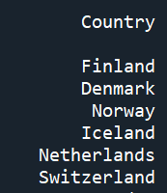

List of countries with all four variables that have “low” value:

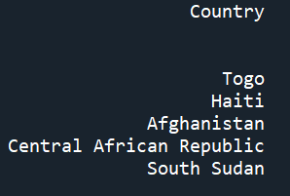

Average score in 2019 was 5.39, based on that score we can see that the ratio of countries under and above average is around the same.

Top 1 country based on a Score in each of the Regions in 2018:

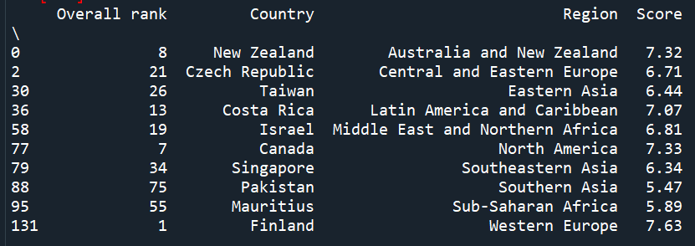

Top 1 country based on a Score in each of the Regions in 2019:

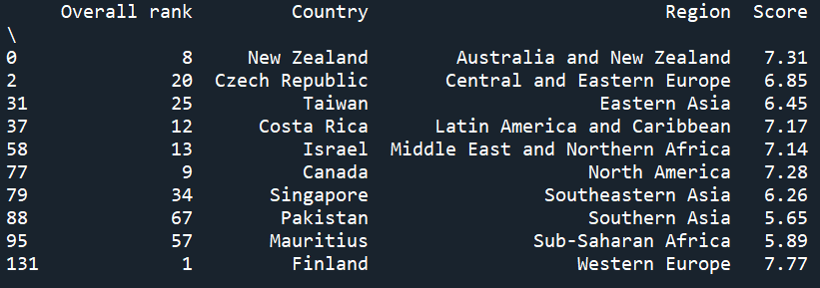

We can see there is no difference between countries list when comparing 2018 and 2019.

**Pivot tables**

Comparison of average Happiness Score per region of both 2018 and 2019 year.

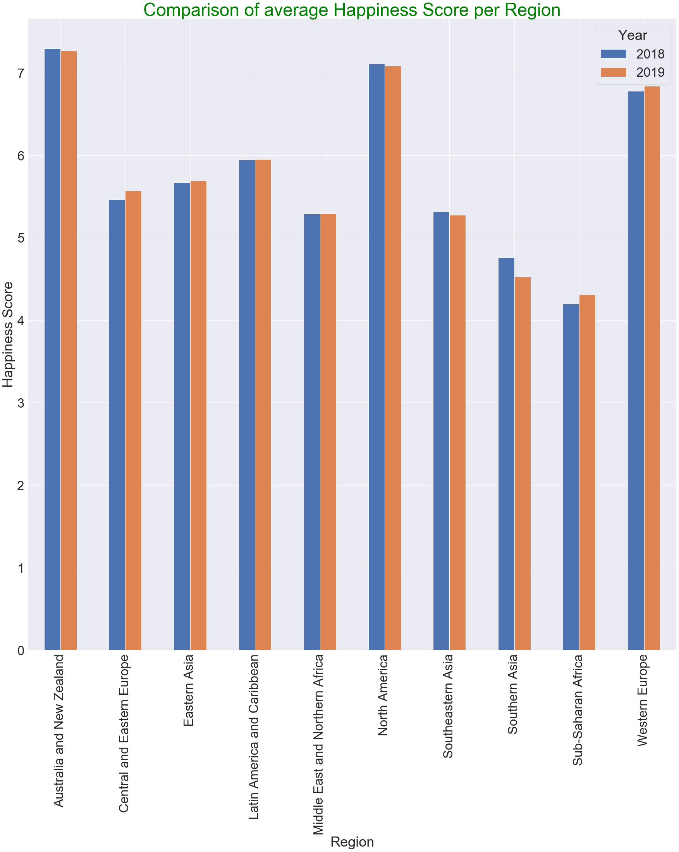

The visual representation helps reveal that the differences are minor.

Manipulating the data using aggregate functions.

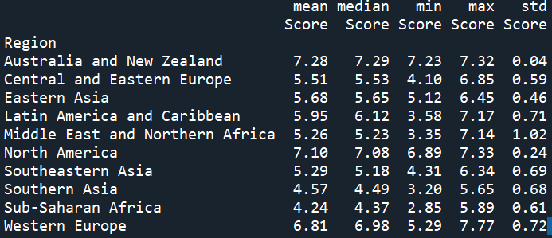

Both highest ranking regions with the lowest standard deviation only account for only two countries. Sub-Saharan Africa, on the other hand, has the lowest Happiness score, but it accounts for 39 countries. An interesting next step would be to remove extreme values from the calculation to see if the ranking changes significantly.

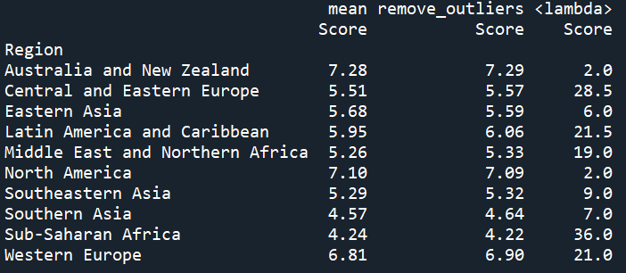

Removing the outliers mostly affected the regions with a higher number of countries, which makes sense. We can see Western Europe (average of 21 countries surveyed per year) improved its ranking. Unfortunately, Sub-Saharan Africa (average of 39 countries surveyed per year) received an even lower ranking when we removed the outliers.

Comparison of Croatia vs Ireland Happiness Score:

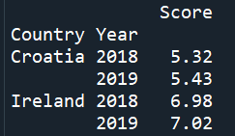

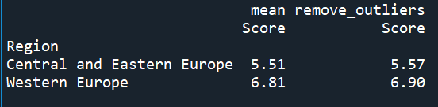

Croatia is under average score for its region – Central and Eastern Europe, but Ireland is above her Western Europe region.

From the comparison of Croatia and Ireland variables it is interesting that Freedom to make life choices has decreased in 2019 for both countries. As well, Social support has increased in Croatia, but decreased in Ireland.

I would question very low Perceptions of corruption in Croatia as is the 63 least corrupt nation out of 180 countries and Ireland is the 18 least corrupt nation out of 180 countries, according to the 2019 Corruption Perceptions Index reported by Transparency International so I would question the relevance of the data.

