**CA5 – Word Happiness Report of 2018 vs 2019 in R**

**Lehkec Martina**

Top 10 countries per score in 2019.

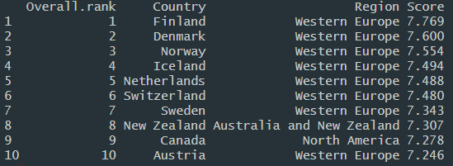

Average Happiness Score by Region in 2019

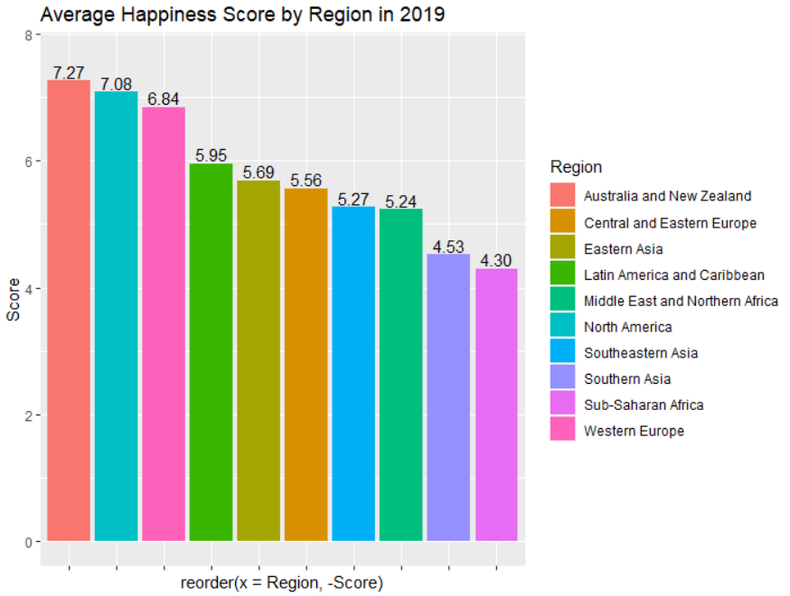

Overall Rank vs Happiness Score in 2019

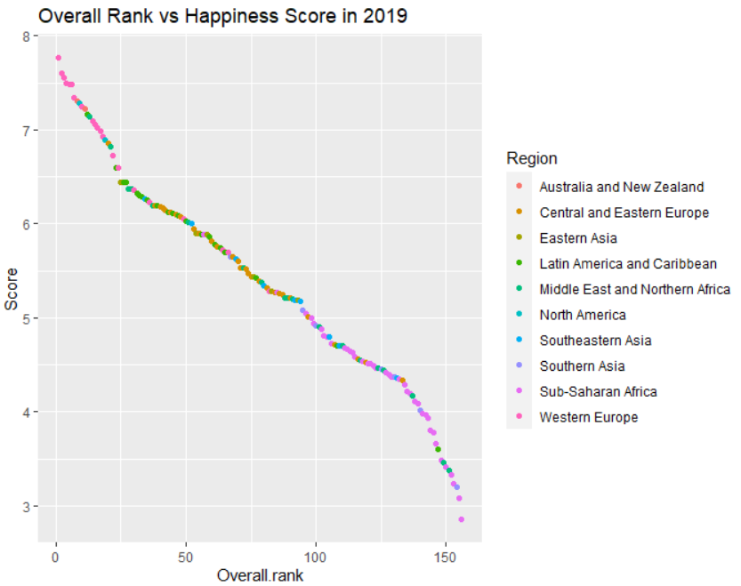

Perception of Corruption by Region in 201

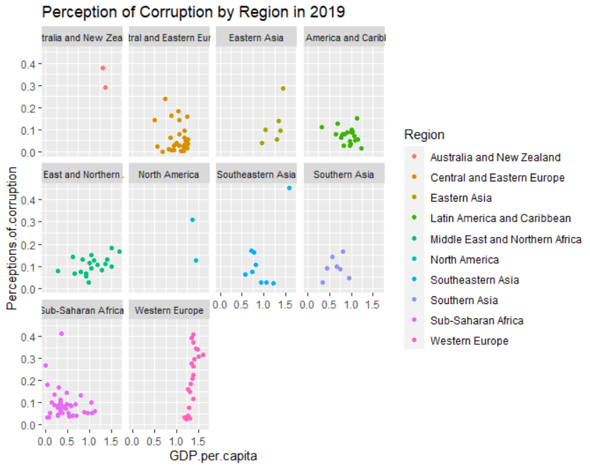

Regression of Life Expectancy vs Happiness Score in 2019

We can see that countries that have higher Happiness score like Australia and New Zealand, Central and Eastern Europe, Western Europe and Latin America and Caribbean have longer Life expectancy while countries that give smaller score have smaller Life expectancy, especially Sub-Saharan Africa.

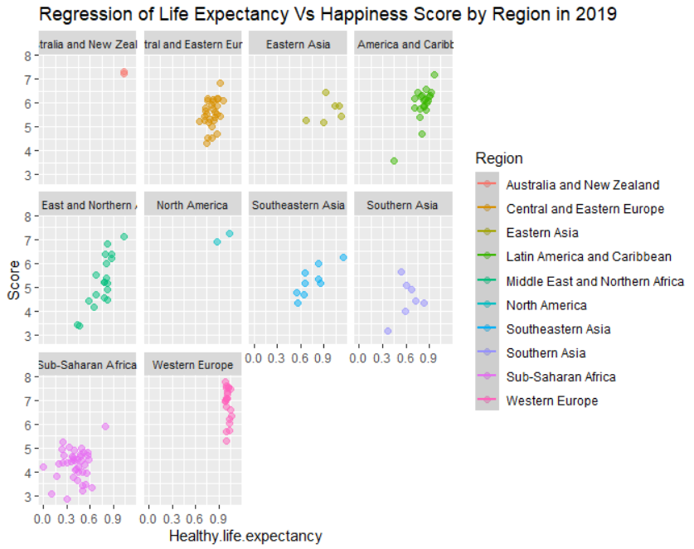

Countries with smallest and largest GDP per capita in 2018 and 2019.

|  |  |  |  |  |
| --- | --- | --- | --- | --- |
| **GDP per capita** | **2018** | | **2019** | |
| **Country** | **Overall Rank** | **Country** | **Overall Rank** |
| **Smallest** | Somalia | 98 | Somalia | 112 |
| **Largest** | United Arab Emirates | 20 | Qatar | 29 |

Countries with smallest and largest Social support in 2018 and 2019. We can see there is no difference between 2018 and 2019.

|  |  |  |  |  |
| --- | --- | --- | --- | --- |
| **Social Support** | **2018** | | **2019** | |
| **Country** | **Overall Rank** | **Country** | **Overall Rank** |
| **Smallest** | Central African Republic | 155 | Central African Republic | 155 |
| **Largest** | Iceland | 4 | Iceland | 4 |

Correlation between Happiness score and GDP per capita

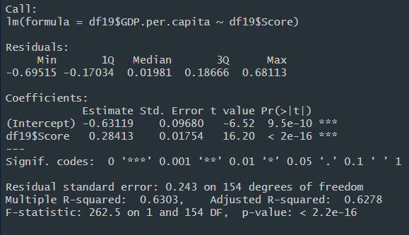

R-square = 0.63 and p-value is less than < 0.05 which shows that there is significant correlation between Happiness score and Economy (GDP per capita) of the country.

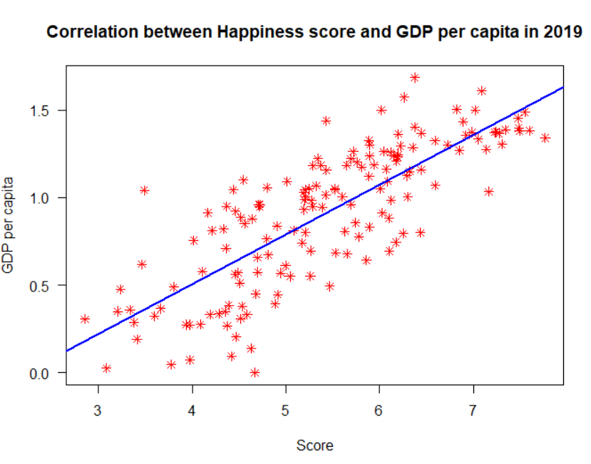

Multiple regression – correlation between Happiness Score, GDP per capita and Generosity

Since p-value is less than < 0.05 and adjusted R-Square is 0.65., it means that GPD per capita, Happiness score and Generosity have direct linear relationship between them.

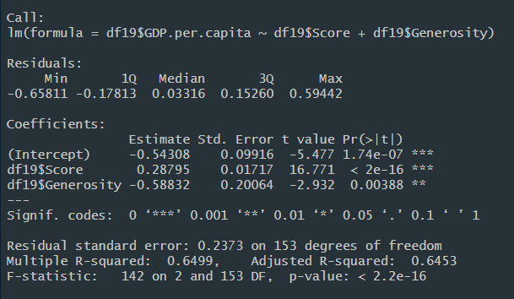

Graph shows that Western Europe countries are happier and more generous, while, on the other hand, Sub-Saharan population is less happy and less generous.

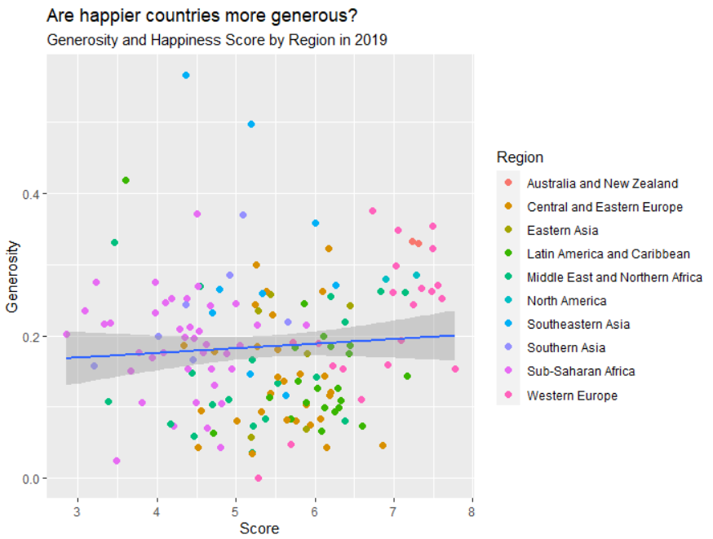

Happiness score in Croatia and Ireland in 2018

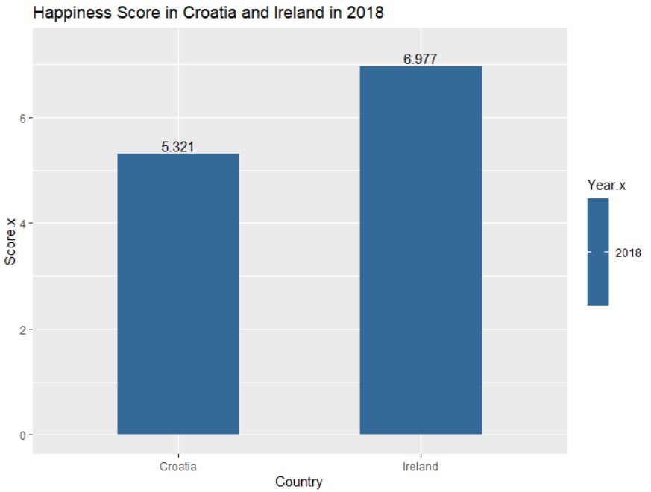

Happiness score in Croatia and Ireland in 2019

